God Will Be Our Redeemer
Ready for Jesus in the Latter Prophets December 10, 2023

²¹ Remember these things, O Jacob, and Israel, for you are my servant;
I formed you; you are my servant; O Israel, you will not be forgotten by me.
²² I have blotted out your transgressions like a cloud and your sins like mist;
return to me, for I have redeemed you.
Isaiah 41

The (mostly) horrible history of the Latter Prophets
¹ By the rivers of Babylon we sat and wept
when we remembered Zion.
² There on the poplars we hung our harps,
³ for there our captors asked us for songs,
our tormentors demanded songs of joy;
they said, “Sing us one of the songs of Zion!”
Psalm 137 (see also the summary in 2 Chronicles 36:15-16)

- David’s reign ended with the borders secure and supplies for a temple assembled in Jerusalem

- The short history of the Latter Prophets is not pretty, but God must have included it for a reason . . . .
Framework for this troubling history:
1000 BC David’s rise
930 Rehoboam provokes the division of the kingdom and leads Judah into idolatry
925 Egypt makes Judah a vassal state and takes treasure from the temple
722 Northern Kingdom falls to Assyrians under Tiglath-Pileser
701 Hezekiah is delivered from the Assyrians under Sennacherib
605 Nebuchadnezzar the Babylonian defeats Judah, first deportation includes Daniel
586 Nebuchadnezzar destroys Jerusalem
536 First returnees under Cyrus the Persian
516 Second Temple completed under Zerrubabel
483-473 Esther is queen in Persia
444 Walls of Jerusalem completed under Nehemiah
167 Maccabean revolt against Greek/Seleucid forces, the Hanukkah miracle

Transition: This history tells the story of my need for a redeemer (see 1 Corinthians 10:11)
God responds with the promise (and example!) of a Redeemer
²⁴ “This is what the Lord says—
your Redeemer, who formed you in the womb:
I am the Lord, who has made all things,
who alone stretched out the heavens,
who spread out the earth by myself,
²⁵ who foils the signs of false prophets
and makes fools of diviners,
who overthrows the learning of the wise
and turns it into nonsense,
²⁶ who carries out the words of his servants
and fulfills the predictions of his messengers,
who says of Jerusalem, ‘It shall be inhabited,’
of the towns of Judah, ‘They shall be built,’
and of their ruins, ‘I will restore them,’
²⁷ who says to the watery deep, ‘Be dry,
and I will dry up your streams,’
²⁸ who says of Cyrus, ‘He is my shepherd
and will accomplish all that I please;
he will say of Jerusalem, “Let it be rebuilt,”
and of the temple, “Let its foundations be laid.”’
Isaiah 44

- God has always introduced himself as “Redeemer” (Hebrew: go’el)
⁶ “Therefore, say to the Israelites: ‘I am the Lord, and I will bring you out from under the yoke of the Egyptians. I will free you from being slaves to them, and I will redeem you with an outstretched arm and with mighty acts of judgment. ⁷ I will take you as my own people, and I will be your God. Then you will know that I am the Lord your God, who brought you out from under the yoke of the Egyptians. ⁸ And I will bring you to the land I swore with uplifted hand to give to Abraham, to Isaac and to Jacob. I will give it to you as a possession. I am the Lord.’ ”
Exodus 6:6 (see also the story of Ruth’s “redeemer” in Ruth 3-4)

- God’s promise has always included the Holy Spirit
³ For I will pour water on the thirsty land, and streams on the dry ground;
I will pour out my Spirit on your offspring, and my blessing on your descendants.
Isaiah 44

- How God would do this was always a surprise!
Nevertheless, there will be no more gloom for those who were in distress. In the past he humbled the land of Zebulun and the land of Naphtali, but in the future he will honor Galilee of the Gentiles, by the way of the sea, along the Jordan—
² The people walking in darkness have seen a great light;
on those living in the land of the shadow of death a light has dawned.
Isaiah 9 (see also Ruth for the surprise of the “kinsman redeemer”)
How am I going to experience this promise and reality?
⁶⁸ “Praise be to the Lord, the God of Israel,
because he has come and has redeemed his people.
⁶⁹ He has raised up a horn of salvation for us
in the house of his servant David ⁷⁰ (as he said through his holy prophets of long ago),
⁷¹ salvation from our enemies and from the hand of all who hate us—
⁷² to show mercy to our fathers
and to remember his holy covenant, ⁷³ the oath he swore to our father Abraham:
⁷⁴ to rescue us from the hand of our enemies, and to enable us to serve him without fear
⁷⁵ in holiness and righteousness before him all our days.
Luke 1, Zechariah’s song after the birth of John

1. I start with the truth about God and myself
Q2: What must you know to live and die in the joy of this comfort?
A: Three things: first, how great my sin and misery are; second, how I am set free from all my sins
and misery; third, how I am to thank God for such deliverance.
Heidelberg Catechism, Lord’s Day 1, Q/A 2

2. Keep my eyes and heart open to find this Redeemer
¹³ Now that same day two of them were going to a village called Emmaus, about seven miles from Jerusalem. ¹⁴ They were talking with each other about everything that had happened. ¹⁵ As they talked and discussed these things with each other, Jesus himself came up and walked along with them; ¹⁶ but they were kept from recognizing him.
¹⁷ He asked them, “What are you discussing together as you walk along?”
They stood still, their faces downcast. ¹⁸ One of them, named Cleopas, asked him, “Are you only a visitor to Jerusalem and do not know the things that have happened there in these days?”
¹⁹ “What things?” he asked.
“About Jesus of Nazareth,” they replied. “He was a prophet, powerful in word and deed before God and all the people. ²⁰ The chief priests and our rulers handed him over to be sentenced to death, and they crucified him; ²¹ but we had hoped that he was the one who was going to redeem Israel. And what is more, it is the third day since all this took place.
Luke 24
3. How does this redeeming work of Jesus change my life?
¹³ Therefore, prepare your minds for action; be self-controlled; set your hope fully on the grace to be given you when Jesus Christ is revealed. ¹⁴ As obedient children, do not conform to the evil desires you had when you lived in ignorance. ¹⁵ But just as he who called you is holy, so be holy in all you do; ¹⁶ for it is written: “Be holy, because I am holy.”
¹⁷ Since you call on a Father who judges each man’s work impartially, live your lives as strangers here in reverent fear. ¹⁸ For you know that it was not with perishable things such as silver or gold that you were redeemed from the empty way of life handed down to you from your forefathers, ¹⁹ but with the precious blood of Christ, a lamb without blemish or defect. ²⁰ He was chosen before the creation of the world, but was revealed in these last times for your sake. ²¹ Through him you believe in God, who raised him from the dead and glorified him, and so your faith and hope are in God.
1 Peter 1 (see Titus 2:11-15 for another encouragement for the redeemed)
Resources for further study
The Bible Project’s videos on Isaiah are a great place to start your study: https://bibleproject.com/explore/video/isaiah/
Sproul has a wonderful, easy to read, theology of redemption at https://www.ligonier.org/learn/articles/blueprint-redemption and an article that connects redemption and incarnation at https://www.ligonier.org/learn/articles/humiliation-exaltation
Surgeon’s “Joy of Salvation” sermon on Isaiah 44 at https://www.biblebb.com/files/spurgeon/2450.htm
Nick Batzig has a short discussion of why we need a redeemer (from the Ruth story) at https://www.beautifulchristianlife.com/blog/3-reasons-why-everyone-needs-a-kinsman-redeemer
J.I. Packer’s “What did the Cross Achieve?” is a great place to begin a study of the language of redemption at http://www.the-highway.com/cross_Packer.html
B.B. Warfield has a good study of redemption at https://www.monergism.com/thethreshold/sdg/warfield/warfield_redeemer.html
This is the Times of Israel article from 2020 that I referenced in my sermon: https://www.timesofisrael.com
/by-the-rivers-of-babylon-why-a-2500-year-old-hebrew-poem-still-matters/

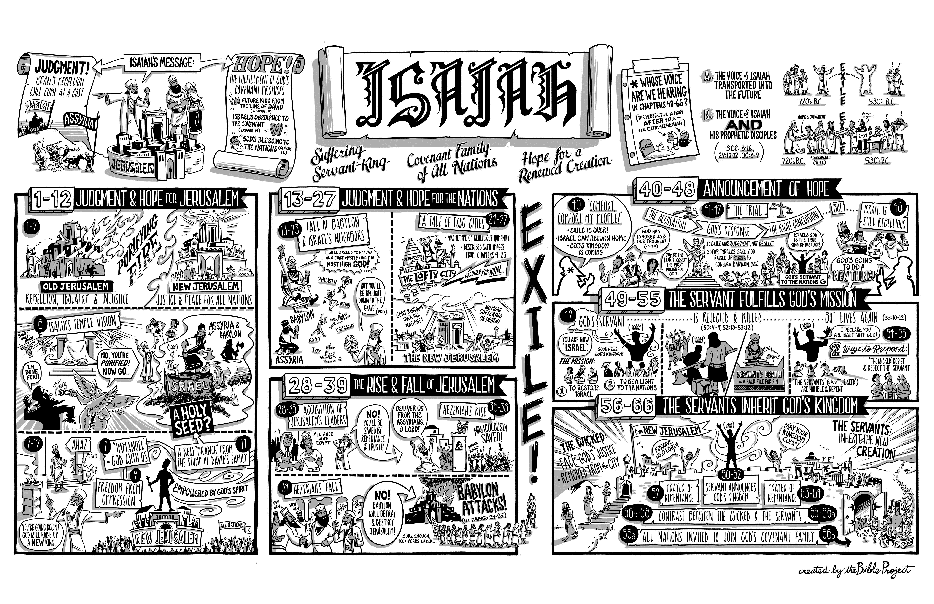

The Joy of Redemption
February 2, 1896 by C. H. SPURGEON (1834-1892)
at https://www.biblebb.com/files/spurgeon/2450.htm
"Sing, O ye heaven, for the LORD hath done it: shout, ye lower parts of the earth: break forth into singing, ye mountains, O forest, and every tree therein: for the LORD hath redeemed Jacob, and glorified himself in Israel."—Isaiah 44:23.
When the human mind is on the stretch of emotion, whether it be under the influence of grief or joy, it often thinks that the whole world is in sympathy with itself. It seems to wrap the mantle of the universe round about its spiritual nature as a garment. If it be joyous, it puts on nature as a spangled robe; and if it be wretched, it finds its sackcloth and ashes in the world round about it. You know how the prophet—poet as well as prophet—says of us in our joyous moments, "Ye shall go out with joy, and be led forth with peace: the mountains and the hills shall break forth before you into singing, and all the trees of the field shall clap their hands." When the heart is happy, nature seems to ring marriage peals in unison with the music within the heart. Let the eye be clear, and all nature will be bright. The earth seems glad when we are so. On the other hand, it is a part of the nature of grief to be able to transpose itself into the world around. Does not old Master Herbert cry,—
"O who will give me tears? Come, all ye springs,
Dwell in my head and eyes; come, clouds and rain:
My grief hath need of all the watery things
That nature hath produced. Let every vein
Suck up a river to supply mine eyes,
My weary, weeping eyes, too dry for me,
Unless they get new conduits, new supplies,
To bear them out, and with my state agree"?
Fain would he make the world weep with him when he wept, as others have made the world sorrow when they grieved, and rejoice when they were full of joy. The fact is, the world is one great organ, and it is man that plays it, and when he is full of joy and gladness, he puts his tiny fingers upon the keys, and wakes the world to a majesty of joy; or if his soul be gloomy, then he plays some pensive, dolorous dirge, and thus the world without keeps pace with the other little world within.
The prophet, in this chapter, had been studying the great redemption which God had wrought for his people, and he was so happy and delighted with it, so overjoyed, so charmed, so enraptured, that he could not help saying, "Sing, O ye heavens." There were the angels looking down on man with eyes of sympathy. "Sing," said he, "ye angels, that sinners can be saved, yea, that sinners have been saved! Rejoice to think that repenting sinners can have their sins forgiven them! Sing, ye stars, that all night long, like the bright eyes of God, look down on this poor world, so dark but for you! Sing, for God hath blessed your sister star, unwraps her from her gloom, and made her shine more radiant in mercy than any one of you! Sing, O blue sky of heights profound! O thou unnavigated ether, be thou stirred with song, and let space become one mighty mouth for melody! Sing, O ye heavens!" Then, when he must come down from those lofty heights, he looks upon the earth, and he says, "O earth, echo, echo with song, and ye lower parts of the earth, ye valleys and plains, the sea with its million hands, the deep places of the earth, and the hollow caverns thereof,—let them all sound with joy, because Jehovah hath redeemed man, and in mercy has come down to his poor erring creatures." And then, as if he heard all earth getting vocal with the voices of happy ones, and felt it would not do for the praise to be limited even to the tongues of men, he thinks of those mountains where man cannot climb, those virgin snows, undefiled by human feet, and he says, "Sing, ye mountains!" Then he thinks of the shaggy woods upon their brows, and he bids them sing in admiration,—"Sing, ye forests! Let every tree break forth in melody!"
Do you catch his thought? Do you not see how the great poet-prophet, in a mighty fervency of delight, wakes the whole earth, and even heaven itself, to one mighty burst of song? And what is the subject of it? "The Lord hath redeemed his people, and glorified himself in Israel." Oh, that I could stir in your hearts songs of joy for the redemption which God has wrought for his people, and for the glory which God has gotten to himself by this wonderful act of grace!
There are three redemptions which may well make all hearts rejoice: the first is, redemption by blood; the second is, redemption by power; and the third is the completion of the two, redemption in perfection.
I. The first is, REDEMPTION BY BLOOD.
You know the story. Man had sinned against his God, and God, the Just One, must punish sin. But it was agreed that, if a plan could be devised by which justice should be satisfied, mercy should have full play for all her kind designs. What a day was that when the eternal wisdom revealed to man the plan by which the Son of God should suffer instead of us, that so justice might have its claims discharged in full, and yet mercy enjoy its boundless, unlimited sway! Sing, ye heavens, because of the wisdom which devised so benevolent a scheme! Rejoice, O earth, because of the marvellous, matchless understanding which framed so wise a plan!
The terms or preamble thus agreed upon, it was necessary that someone should suffer instead of man, in order that man might escape. Will the Eternal Son undertake to do this? He is God; his glory is excessive; angels veil their faces as they adore him. Is it possible that he will ever become a man, to bleed, to be spit upon, to be scourged, to be crucified? Will he undertake to do it? He said unto his Father, "Lo, I come: in the volume of the book it is written of me, I delight to do thy will." "O my God!" Sing again, ye heavens! Let your hallelujahs rise aloft, ye angels! The Son of God has undertaken the redemption of men! That which was once only a scheme, has now become a covenant. That which was but a plan in the divine mind is now a compact between the Father and the Son.
But though Christ has undertaken it, will he perform it? The years roll on, the world gets grey, and yet he does not come. But on a sudden, when the shepherds were keeping their flocks by night, there was heard a sound up yonder, and straightway a multitude of the heavenly host appeared, singing, "Glory to God in the highest, and on earth peace, goodwill toward men!" What means this? It is Jesus, the Son of God, come to do what he undertook to do; and there he is, lying in a manger, wrapped in swaddling bands, and God is born into the world. God has become flesh. He, without whom was not anything made that was made, has come down to tabernacle among us, that we may behold his glory, the glory as of the only begotten of the Father, and yet a man of the substance of his mother, like ourselves. Sing, ye angels! Let the carols of that first Christmas night never cease, for that which was once a scheme, and then a covenant, has now commenced to be a work in real earnest.
He has come to do it, but will he ever fulfill it? Will he ever accomplish the stupendous obligation? Two and thirty years roll over him, during which he is despised and rejected of men, the Man of sorrows and acquainted with grief. But will he ever achieve that last, that dreadful task? Will he ever be able to perform it? Will he give his back to the smiters, and his cheeks to them that pluck off the hair? Will he verily be led like a sheep to the slaughter? Can it ever be that the Lord of life and immortality will actually die the death of a criminal, and be buried in a borrowed tomb? My brethren, not only will it be, but it has been. Recall to memory that eventful night when Judas betrayed him with a perfidious kiss, when, in Gethsemane, he was covered with a bloody sweat, a sweat caused by your sins and mine. Do you not see him led away by those who have arrested him? Do you not see the Lord of glory mocked and set at nought, made an object of ridicule, the jeer of sarcasm, and the butt of scorn? "Ecce Homo!" Behold the man covered with an old robe, the cloak of some common soldier, and his back laid bare to show you that it is covered with another crimson, the crimson of his own most precious blood, fetched by the accursed scourge from those blessed shoulders? Do you see him staggering along beneath the weight of that heavy cross, hurried and hounded through the streets of Jerusalem? Do you mark him as he bids the daughters of Jerusalem stay their tears, and weep not for him, but for themselves and their children? Can you not see him as they fling him on his back, stretch out his hands and feet to the wood, and then drive the cruel nails through their tenderest parts? Can you not see him as they lift him high between earth and heaven, and then dash the cross into its place, dislocating all his bones, till he cries out, "I am poured out like water, and all my bones are out of joint. Thou hast brought me into the duet of death"? Yes, he is accomplishing it all. Jehovah's wrath is pouring over him, wave after wave, and he is meekly bowing his head to it all! Jehovah's sword is being driven into his heart, and he is baring his breast to receive it, for your sakes and for mine! Sinner, he does it altogether. He can do it. He is doing it, he has done it, for he bowed his head, saying, "It is finished!" and gave up the ghost. That which was first a purpose, then a covenant, and then a work initiated, is now a work achieved. Jesus Christ has redeemed his people with his own most precious blood.
But they took his mangled corpse down from the cross. They put it in the tomb. It remained a question whether he really had accomplished the work, for if he had, God would set two seals to it: first, by his rising from the tomb, and secondly, by his ascending into heaven. See then, believer. On the third day, the mighty Sleeper unwound his grave-clothes; an angel came from heaven, and rolled away the stone, and in the glory of a life unshackled by the trammels of vanity to which our poor creatureship is made subject, he rose from the dead. And when he had shown himself to his disciples, and to others, for forty days, he took them out to Olivet, and as he communed with them and blessed them, he went up into heaven, and a cloud received him out of their sight. Can you not, in the devout exercise of imagination, track him past those clouds? Do you not see heaven's heroes as they meet him and welcome him? See you not his chariot waiting for him? Do you not behold him as he mounts it, and they sing in advance of him till they come to the crystal gates, and then, from over the gates, the watchers cry, "Who is this King of glory?" while others shout, "Lift up your heads, O ye gates; and be ye lift up, ye everlasting doors; and the King of glory shall come in!" Yes, in he rides, up to his Father's throne, and there he sits in state, God over all, blessed for ever; the Lamb once slain, no more to die. Sing, ye heavens, and be glad, O earth! The work which was accomplished is accepted. The deed which was finished is stamped and recognized by heaven, and now there is peace "through the blood of the everlasting covenant."
Ah! I know what would make some of you very happy. Should you come to-night to the cross, look up and trust Christ to save you, your joy would then be unspeakable. Never did a soul trust Christ in vain. You would receive pardon, you would get peace, you would feel as if heaven did sing, and as if earth did rejoice. You would say, "Here am I, a poor, guilty sinner, having nothing to trust to of my own, but I know my sins were laid on Christ, and if they were laid on Christ, they cannot be in two places at one time; consequently, they cannot be put on me when I trust in Jesus; they were put on his bleeding back, and they are gone, and there is not one left in the Book of God against me." O dear hearer, if thou believest in Christ, thou art perfectly absolved. Thou needest not a priest to say, "Absolvo te," "I absolve thee." There is no condemnation to them that are in Christ Jesus. Who can lay anything to the charge of God's elect, since Jesus died? If you rest in Jesus Christ, he has paid all your debts; you are out of debt; Christ has discharged all your liabilities, and you are free. Let your soul, then, be happy. Let your soul be so happy that it transfers its joy to all nature, and makes heaven and earth glad with its own gladness.
This is the first redemption—redemption by blood.
II. Let us strike another key, and celebrate the second theme that redemption unfolds,—REDEMPTION BY POWER.
Those for whom the Savior shed his blood, and so redeemed them by price, are by-and-by redeemed by power. The Spirit of God finds them, like other men, fond of sin; like other men, blind to the beauties of the Savior, deaf to the commands of Christ; but if Christ has bought them with his blood, he never paid for what he will not have. The price was too precious to be paid for those who are not saved. If Christ has paid his blood for a soul, he will have that soul. Neither will God's honor rob him of his purchase, nor will Christ be content to lose what he so dearly bought.
This second redemption, which is conversion and regeneration, is equally a subject of holy joy; very briefly I will set it forth. What sort of people are those whom Christ saves? Why, some of them were the very worst of the worst. Some of them were the companions of the lost; nay, they were lost themselves. But when the grace of God met with them, it washed them, and made new men of them. There is many a man who has been a captain in the devil's service, but whom the Lord has taken, and made a valiant man for the truth. Oh, what a great sinner John Newton was before his conversion! You who have read his life know that he went about as far as a man could go. What an offender was John Bunyan before this Lord met with him! What a blood-thirsty wretch was Saul of Tarsus! What a horrible life had the thief led with whom Christ met at the last! Now, when I think of these being saved, I feel as if I could say, "Sing, ye heavens, and be joyful, O earth!" Sometimes, at our church-meetings, when some brethren have told the story of their past lives, we have felt inclined to stop and sing. Some have said, "I never entered a place of worship for years; I cursed at the very thought of it; the Sabbath I never regarded; yea, the very name of God himself I despised; but eternal mercy met with me." "Sing, O ye heavens; for the Lord hath done it: shout, ye lower parts of the earth: break forth into singing, ye mountains, O forest, and every tree therein: for the Lord hath redeemed Jacob, and glorified himself in Israel." Ay, and the greatest wonder to every one of you will be that ever God's mercy saved you! I can understand very well his saving any of you; but I often cannot comprehend why he should save me. Oh! this will be the wonder of heaven to each one of us, to find ourselves there; and how will we say, "Sing, O heaven, and be joyful, O earth!" if once our poor guilty feet tread that golden pavement; and if, once being washed in the precious blood of Jesus, we shall be permitted to sit down with Abraham, and Isaac, and Jacob, in the kingdom of heaven! Oh, the joy to think that such sinners should be saved!
Does it not enhance the joy that they were in such a miserable plight before they were saved? They were prejudiced against the gospel, but God knew how to knock their prejudices over. They were blind, and would not see the beauties of it; but the Lord has a blessed way of opening blind eyes. Their hearts were as hard as granite, but God knew how to use the hammer, and shiver the rock in pieces. Very likely they derided the very idea of being converted, and yet they were made partakers of the saving change. Ay, and I have noticed that some of the most hardened are the very first who are met with; some of those who seemed the most unlikely subjects of divine grace have been chosen by divine sovereignty, and have been made wonders of divine power. Herein lies the matter that makes us sing and rejoice, because the blind have been made to see, the deaf have been made to hear, and the dead have been made to live. O ye forests, sing of this wonder of mercy!
And still further, think of what these souls are saved from. But for grace, the very hottest hell would have been our portion; but we are saved from it. We should have been made to drink of the bitter cup of wrath for ever; but we shall never drink a drop of it now. And then consider what the man of God is saved to. He is saved for heaven. He is made meet to be a partaker of the inheritance of the saints in light. His head shall wear the crown. His hands shall sweep the strings of harps of gold. Sins O heavens, and be joyful, O earth! Saved from hell and lifted up to heaven, let the bass notes of our songs go down to hell, and make the devils grind their teeth with rage, and let the alto notes go up to heaven, and make even the angels glad as they see how sinners saved exult in Jesus' name.
Mighty as is the power, are we not often constrained to marvel at the weakness of the instruments which the Lord employs? Sometimes a soul is saved by Christ's grace through a poor preacher, who is despised by many, and who in himself is humble, and weak, and feeble. By means of a tract, or a quotation from the Bible, or something of that sort, the heart is turned. Any instrument in the hand of God, though it seem most unlikely, is capable of bringing a soul to Christ. Oh, rejoice, ye heavens, for God is glorified in using poor instruments to work his will!
And then see how some are saved in the teeth of ten thousand obstacles. It seems as though they only escape by the skin of their teeth, as though all the devils in hell came after them, with their mouths open, like roaring lions, seeking to devour them. Yet the hand of divine grace has been upon them, and they have been saved. Are not some of you perfect miracles to yourselves? Do you not wonder that you have not gone back long ago? When you see what temptations you have had, and how base your hearts, are you not astonished that grace should have made you a Christian at all, and kept you in the way of righteousness until now? Oh! with the tears in our eyes, let us bless God that we are what we are; let our hearts be glad to-night, and let us make all nature seem glad, as we remember the hole whence we have been digged, and the mire or the clay whence we have been drawn by the irresistible, effectual grace of the Spirit of God.
III. And now, lastly, what a song will that be as heaven and earth, mountains and forests, rejoice WHEN THE BELIEVER IS PERFECTLY REDEEMED!
On earth he was still the subject of temptation, and he wrestled hard with inbred sins; but when death comes, he shall be perfect. There shall not be a rag of corruption, nor a relic of the old man. Brethren, will you not make the heavens and the earth ring when you find yourselves made like unto Christ; when you shall find that nothing that old Adam gave you is left, but that all sin is gone, and that you are like the angels of God? Surely there shall be no voice in heaven more exulting, more joyous, than that of men delivered from strong passions aid deep depravity, and made perfectly like the Lord Jesus.
And there we shall be perfectly free from all the cares and troubles of this mortal life. No sweat to wipe from aching brows! No tossing upon beds of weariness! No nights of languishing! No question of "What shall I eat, and what shall I drink, and wherewithal shall I be clothed?" "The Lord God shall wipe away all tears from their eyes." There shall be no more spiritual battles and conflicts. Death and hell shall no more annoy us, nor sinners vex the righteous with their ungodly conversation.
"Far from a world of grief and sin,
With God eternally shut in,
They are for ever blest."
Oh, blissful hour! Oh, happy moment! when—
"We shall be near and like our God!"
Brethren, does it not make you long to be gone, when you think of the perfection of redemption? The body will be redeemed. It will rise from the dead. This poor dishonored body will be made like unto Christ's glorious body; and then body and soul together shall, like twin angels, glorify God throughout eternity.
"There shall I bathe my weary soul,
In seas of heavenly rest;
And not a wave of trouble roll
Across my peaceful breast."
Do you not wish you had wings to fly away? Well, it is but for a few minutes that you are detained here. "Minutes!" you say. "Why, they are months and years!" Ay, but what are they? When once they are gone, they shall be but as a watch in the night. You shall think of them then as God thinks of them now, as but a very small moment. Courage! Wait with patience, and you shall make all eternity sing because the Lord hath redeemed his people, and glorified himself in Israel.
Alas! I fear there are some of you who will have no part or lot in this matter! If you would have this last redemption, begin with the first. Faith first! Look to the price,—to the blood,—and then the Holy Spirit will graciously give you the redemption which is by power. Your faith will be the first proof that you are so redeemed, and will lead you on until you attain that perfection for which we groan, that adoption for which we wait, to wit, the redemption of the body. Bought with the blood of Jesus, quickened into newness of life by the power of his resurrection, and at length gathered unto Jesus, to be with him where he is, the joy of his salvation shall swell into a mighty chorus, in which heaven and earth shall ring out their loud-sounding music, while our tongues shall sing Immanuel's praise for ever and ever. Amen.

By the rivers of Babylon: Why a 2,500-year-old Hebrew poem still matters
By David W. Stowe 28 July 2020, 5:10 am
at https://www.timesofisrael.com/by-the-rivers-of-babylon-why-a-2500-year-old-hebrew-poem-still-matters/

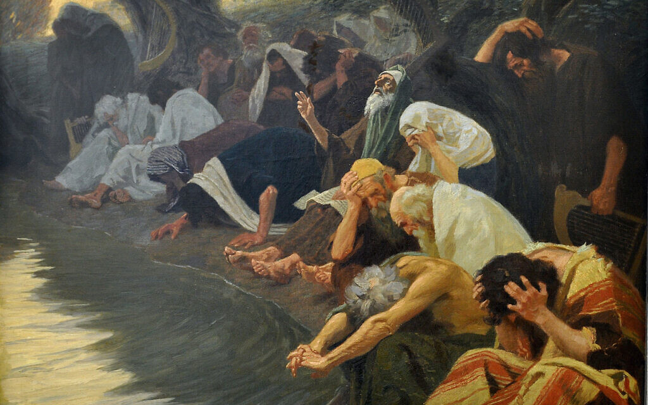
By the rivers of Babylon, painting by Gebhard Fugel, c. 1920 (Wikimedia/ creative commons)
THE CONVERSATION via AP — At sundown on July 29, Jews around the world will observe Tisha B’av, the most somber of Jewish holidays. It commemorates the destruction of the two temples in Jerusalem, first by the Babylonians and then, almost seven centuries later, in CE 70, by the Romans.
Jews will remember these two historic calamities along with many others, including their slaughter during the First Crusade; the expulsions from England, France and Spain; and the Holocaust.
The pattern of forced migration was set by the Babylonian conquest of 587-586 BCE, when the elite of Judah were marched to Babylon and the temple destroyed. Like the story of Moses and the Exodus from Egypt, which happened several centuries earlier, the Babylonian exile dwells at the heart of Judaism. The trauma served as a crucible, forcing the Israelites to rethink their relationship to Yahweh, reassess their standing as a chosen people and rewrite their history.
Psalm 137, the subject of my most recent book, “Song of Exile,” is a 2,500-year-old Hebrew poem that deals with the exile that will be remembered on Tisha B’av. It has long served as an uplifting historical analogy for a variety of oppressed and subjugated groups, including African-Americans.

Origins of the psalm
Psalm 137 is only one out of 150 psalms in the Bible to be set in a particular time and place. Its nine verses paint a scene of captives mourning “by the rivers of Babylon,” mocked by their captors. It expresses a vow to remember Jerusalem even in exile, and closes with fantasies of vengeance against the oppressors.
The exile story, which echoes through the Bible, is central to the major prophets Jeremiah, Ezekiel, Daniel, Lamentations and Isaiah. And the aftermath of exile, when Cyrus the Great conquered Babylon and allowed the Judeans to return to Israel, is narrated in books of Ezra and Nehemiah. Bible scholar Rainer Albertz estimates that “about 70 percent of the Hebrew Bible tackles the questions of how the catastrophe of exile was possible and what Israel can learn from it.”

Inspiring music
Because the psalm deals with music – a famous verse asks, “How could we sing the Lord’s song in a foreign land?” – it has been like “poetic catnip,” intriguing to musicians and composers. Bach, Dvorak and Verdi all wrote musical settings for it. Verdi’s first popular opera, “Nabucco,” retells the story of the captivity.
Popular music versions have been recorded by American singer and songwriter Don McLean (and used in a memorable scene in “Mad Men”). It has featured in the musical “Godspell.” Dozens of artists have recorded their own version of “Rivers of Babylon.” This includes a Rastafarian-tinged version by the Jamaican group the Melodians and a version by Boney M that became a blockbuster disco hit in 1978.

Message for social justice
The psalm has also inspired numerous political leaders and social movements, and immigrants as varied as Irish and Korean have identified with the story.
America’s first homegrown composer, William Billings, who lived during the War of Independence, created an anthem that puts Bostonians in the role of oppressed Judeans and the British oppressors in the role of Babylonians. “By the Rivers of Watertown we sat down and wept when we remember’d thee O Boston….”
On the anniversary of America’s independence, the abolitionist leader Frederick Douglass made the psalm the centerpiece of his most famous speech, “What to the Slave Is the Fourth of July?”
Douglass told the audience at Corinthian Hall in Rochester, New York, on July 5, 1852, that for a free black like himself, being expected to celebrate American independence was akin to the Judean captives being mockingly coerced to perform songs in praise of Jerusalem.
About 100 years later, in the wake of World War II, the dissident actor and singer Paul Robeson saw deep parallels between the plight of Jews and African-Americans and loved to perform Dvorak’s setting of the psalm.
Some of the most celebrated African-American preachers, including C. L. Franklin of Detroit (Aretha Franklin’s father), also preached on the psalm. In Franklin’s case, he answered the psalm’s central question of whether to sing with a resounding yes. So did Jeremiah Wright, who was Barack Obama’s pastor when he lived in Chicago.

Valuing the act of remembrance
So, what is the central message of the psalm for today’s world?
The problem of what to remember, what to forgive and how to achieve justice has never been more vexing.
By the original rivers of Babylon, now war-torn regions of Iraq and Syria devastated by the Islamic State, stories emerge of captives taking refuge in the river. The forced migration of millions of people from the region, mainly from Syria, is having worldwide consequences. These include helping the rise of anti-immigration populism across Europe and in the United States.
Meanwhile, Bible scholars are working to interpret a trove of recently discovered cuneiform tablets that give a more nuanced picture of what life was really like in Babylon for the Judean exiles. And rightly so. For in the midst of all the injustices that confront us every time we check news headlines, remembering is as crucial as forgiving.
That was Frederick Douglass’ point as well. He said of his enslaved compatriots, “If I do forget, if I do not faithfully remember those bleeding children of sorrow this day, ‘may my right hand forget her cunning, and may my tongue cleave to the roof of my mouth!’”
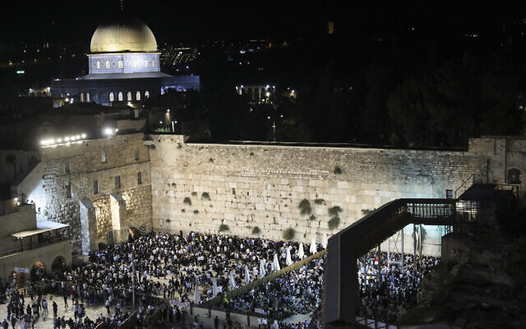
Thousands pray at the Western Wall on the eve of Tisha B’Av in the Old City of Jerusalem, on August 10, 2019. ( Noam Revkin Fenton/Flash90)
Remembering their history is what many Jews worldwide will do when they observe Tisha B’av. And that is the message of Psalm 137 as well. It captures succinctly the ways people come to grips with trauma: turning inward and venting their rage.
There is a reason the psalm continues to resonate with people, even today

