One Body, Many Gifts
The Gathering, Pt. 3, 1 Corinthians 12:1-31 November 5, 2023
There are different kinds of gifts, but the same Spirit.
There are different kinds of service, but the same Lord.
There are different kinds of working, but the same God works all of them in all men.
1 Corinthians 12:4-6

One Spirit, one body, many gifts, many parts
¹² The body is a unit, though it is made up of many parts; and though all its parts are many, they form one body. So it is with Christ. ¹³ For we were all baptized by one Spirit into one body—whether Jews or Greeks, slave or free—and we were all given the one Spirit to drink.
¹⁴ Now the body is not made up of one part but of many . . . . ¹⁸ But in fact God has arranged the parts in the body, every one of them, just as he wanted them to be. ¹⁹ If they were all one part, where would the body be? ²⁰ As it is, there are many parts, but one body.
²¹ The eye cannot say to the hand, “I don’t need you!” And the head cannot say to the feet, “I don’t need you!” ²² On the contrary, those parts of the body that seem to be weaker are indispensable, ²³ and the parts that we think are less honorable we treat with special honor. And the parts that are unpresentable are treated with special modesty, ²⁴ while our presentable parts need no special treatment. But God has combined the members of the body and has given greater honor to the parts that lacked it, ²⁵ so that there should be no division in the body, but that its parts should have equal concern for each other. ²⁶ If one part suffers, every part suffers with it; if one part is honored, every part rejoices with it.
²⁷ Now you are the body of Christ, and each one of you is a part of it. ²⁸ And in the church God has appointed first of all apostles, second prophets, third teachers, then workers of miracles, also those having gifts of healing, those able to help others, those with gifts of administration, and those speaking in different kinds of tongues. ²⁹ Are all apostles? Are all prophets? Are all teachers? Do all work miracles? ³⁰ Do all have gifts of healing? Do all speak in tongues? Do all interpret? ³¹ But eagerly desire the greater gifts.
1 Corinthians 12

- Paul is still assuming we will agree (compare 1:10 with 12:25)

2. Gifts (literally “grace-gifts”) are the primary way in which we administer grace (see 1 Peter 4:7-11)

3. Paul assumes that the Spirit’s gifts are plural while the fruit is singular (see Galatians 5)

4. How we respect those parts of the body deserving “special modesty” is as counter-cultural today as
it was in Corinth

5. These gifts (called pneumatikos and charismata) are the way the Spirit empowers the church for ministry
How the body works (from biology to ecclesiology)
- The body reflects is designer and purpose
⁷ Now to each one the manifestation of the Spirit is given for the common good. ⁸ To one there is given through the Spirit the message of wisdom, to another the message of knowledge by means of the same Spirit, ⁹ to another faith by the same Spirit, to another gifts of healing by that one Spirit, ¹⁰ to another miraculous powers, to another prophecy, to another distinguishing between spirits, to another speaking in different kinds of tongues, and to still another the interpretation of tongues. ¹¹ All these are the work of one and the same Spirit, and he gives them to each one, just as he determines.
1 Corinthians 12

- The body has to take in and metabolize energy
⁴ I always thank God for you because of his grace given you in Christ Jesus. ⁵ For in him you have been enriched in every way—in all your speaking and in all your knowledge— ⁶ because our testimony about Christ was confirmed in you. ⁷ Therefore you do not lack any spiritual gift as you eagerly wait for our Lord Jesus Christ to be revealed. ⁸ He will keep you strong to the end, so that you will be blameless on the day of our Lord Jesus Christ. ⁹ God, who has called you into fellowship with his Son Jesus Christ our Lord, is faithful.
1 Corinthians 1

- The body grows (but what happens if some parts are not working as they should?!?)
¹⁴ Then we will no longer be infants, tossed back and forth by the waves, and blown here and there by every wind of teaching and by the cunning and craftiness of men in their deceitful scheming. ¹⁵ Instead, speaking the truth in love, we will in all things grow up into him who is the Head, that is, Christ. ¹⁶ From him the whole body, joined and held together by every supporting ligament, grows and builds itself up in love, as each part does its work.
Ephesians 4

- The body is designed to serve, not to be served
¹⁰ Each one should use whatever gift he has received to serve others, faithfully administering God’s grace in its various forms. ¹¹ If anyone speaks, he should do it as one speaking the very words of God. If anyone serves, he should do it with the strength God provides, so that in all things God may be praised through Jesus Christ. To him be the glory and the power for ever and ever.
1 Peter 4

- The body has Jesus for the head, that means the leadership’s job is to steward and equip
¹¹ It was he who gave some to be apostles, some to be prophets, some to be evangelists, and some to be pastors and teachers, ¹² to prepare God’s people for works of service, so that the body of Christ may be built up ¹³ until we all reach unity in the faith and in the knowledge of the Son of God and become mature, attaining to the whole measure of the fullness of Christ.
Ephesians 4

Answering several important questions
1. How do we get from “one” to “many”?
⁴ There are different kinds of gifts, but the same Spirit. ⁵ There are different kinds of service, but the same Lord. ⁶ There are different kinds of working, but the same God works all of them in all men.
1 Corinthians 12

2. Which gift is most important?
³¹ So whether you eat or drink or whatever you do, do it all for the glory of God. ³² Do not cause anyone to stumble, whether Jews, Greeks or the church of God— ³³ even as I try to please everybody in every way. For I am not seeking my own good but the good of many, so that they may be saved.
1 Corinthians 10

3. There are “if one part suffers” implications beyond the local church
But God has combined the members of the body and has given greater honor to the parts that lacked it, ²⁵ so that there should be no division in the body, but that its parts should have equal concern for each other. ²⁶ If one part suffers, every part suffers with it; if one part is honored, every part rejoices with it.
1 Corinthians 12

4. A healthy body is God’s evangelistic plan
⁴² They devoted themselves to the apostles’ teaching and to the fellowship, to the breaking of bread and to prayer. ⁴³ Everyone was filled with awe, and many wonders and miraculous signs were done by the apostles. ⁴⁴ All the believers were together and had everything in common. ⁴⁵ Selling their possessions and goods, they gave to anyone as he had need. ⁴⁶ Every day they continued to meet together in the temple courts. They broke bread in their homes and ate together with glad and sincere hearts, ⁴⁷ praising God and enjoying the favor of all the people. And the Lord added to their number daily those who were being saved.
Acts 2

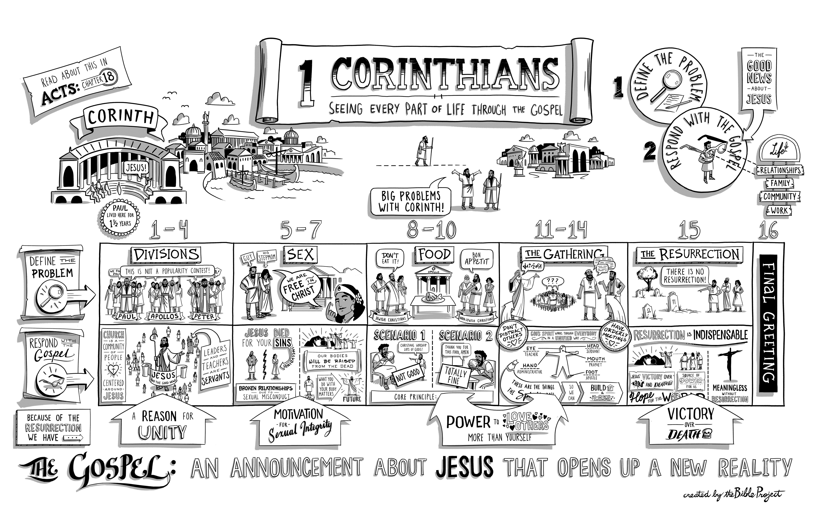

Resources for further study
The Bible Project team does a great job of introducing 1 Corinthians at https://bibleproject.com/guides/book-of-1-corinthians/
Spurgeon and Newton have several 1 Corinthians sermons at https://www.biblebb.com/brefindex/1co.htm
Ryle’s study 1 Corinthians 10:14 is a good summary of the book at https://www.monergism.com/flee-idolatry
I appreciate Alexander Maclaren’s application of this passage at https://www.preceptaustin.org/1_corinthians_maclaren_3#tug72
John Piper has a very good 1 Corinthians series at https://www.desiringgod.org/scripture/1-corinthians/messages
Keller has a wonderful piece on spiritual gifts at www.trinitypca.org/wp-content/uploads/2016/09/0e1508579_discerning-and-exercising-spiritual-gifts.pdf
Doug has referenced these commentaries:
Simon Kistemaker’s New Testament Commentary (Baker, 1993)
Anthony Thiselton’s NIGTC volume (Eerdmans, 2000)
Harold Mare’s commentary in the EBC series (Zondervan, 1976)
Derek Prime has a shorter study “Opening Up 1 Corinthians” (Day One, 2005)
Doug likes the ESV Study Bible’s introduction to 1 Corinthians and included it in these notes.

1 Corinthians
Introduction from the ESV
Author and Title
The first word of 1 Corinthians states that Paul is its author. There is no good reason to doubt this. The theological concerns of the letter, the energy of its style, its vocabulary, and its historical connections with the other Pauline letters and Acts mark it as Pauline. The traditional title of the letter means that it is the first of two canonical letters by Paul to the Corinthians, not that it was Paul’s first letter to them (see 5:9).
Date
Paul wrote 1 Corinthians from the city of Ephesus in the Roman province of Asia (16:8, 19) sometime before the final day of Pentecost (16:8; cf. Lev. 23:11, 15), and therefore in the spring. It is unclear whether this was the spring of a.d. 53, 54, or 55. He wrote, in any case, near the end of his three-year ministry in Ephesus (1 Cor. 16:5–9; cf. Acts 19:21–22).
Theme
First Corinthians covers a number of topics (see “Key Themes”). One theme emerges from these discussions, however, as Paul’s dominant concern. Paul wants this church, divided because of the arrogance of its more powerful members, to work together for the advancement of the gospel. He wants them to drop their divisive one-upmanship, build up the faith of those who are weak, and witness effectively to unbelievers.
Purpose, Occasion, and Background
Corinth sat on the isthmus connecting the Greek mainland with the Peloponnesian peninsula. This location made it a flourishing crossroads for sea traffic between the Aegean region and the western Mediterranean. It was a place where many cultures and religions mingled. Since it was a Roman colony, Roman law and customs were important, particularly among the upper classes, but “many ‘gods’ and many ‘lords’ ” found a home in Corinth (8:5). The worship of these gods was fully integrated into governmental affairs, civic festivals, trade guilds, and social clubs, and everyday life in general. Corinth was also a destination for traveling professional orators who charged a fee for attendance at their entertaining rhetorical displays and advised people on how to advance socially.
Into this milieu Paul brought the gospel of Jesus Christ, and soon a church was established. He was aided in his work by two new-found friends from Rome, Priscilla and Aquila, who, like Paul, were displaced Jews and tentmakers by trade (Acts 18:1–4, 18–19, 24–28; Rom. 16:3; 2 Tim. 4:19). Paul, Priscilla, and Aquila spent 18 months in Corinth in the early 50s and then, after a brief trip to Judea and Syria, Paul traveled to Ephesus. Priscilla and Aquila were already there (Acts 18:19; 1 Cor. 16:19) and, by the time Paul arrived, they had already met the skillful Christian apologist Apollos, who had also been in Corinth (Acts 18:24–19:1; 1 Cor. 1:12; 3:4–6, 22; 4:6; 16:12).
Paul settled in Ephesus for three years (Acts 20:31) and at some point wrote to the Corinthians the otherwise unknown letter that he mentions in 1 Corinthians 5:9. It is not known what prompted the letter but it dealt with sexual immorality, a persistent problem for the Corinthian church (5:1–13; 6:12–20). Sometime later, Paul received an oral report indicating that the Corinthians had not only misunderstood his first letter (5:10) but were plagued with serious problems of division, sexual immorality, and social snobbery (1:10; 5:1; 11:18). Around the same time, a letter arrived from the Corinthians that displayed considerable theological confusion about marriage, divorce, participation in pagan religions, order within corporate worship, and the bodily resurrection of Christians (7:1; 8:1; 12:1; 15:12, 35).
In response to these troubling developments, Paul felt compelled to write a substantial letter to Corinth, making the case that much of their conduct was out of step with the gospel. At the root of their disunity lay an arrogance (3:21; 4:6, 8, 18–19; 5:2, 6) that was incompatible with God’s free gifts to them in Christ: wisdom, righteousness, sanctification, and redemption (1:30; 4:7). In addition, a self-centered insistence on their own rights (6:12; 8:9; 9:12; 10:23) at the expense of the weak (8:10; 11:22) and marginalized (14:16, 23) revealed that their own social advancement rather than the gospel’s advancement was their top priority.
At the root of much of the immorality and idolatry in Corinth, moreover, lay a lack of appreciation for the holiness that God requires of his people. Though the particulars of the Mosaic law were no longer to define the boundaries for God’s people (7:19), the law’s underlying theme that God’s people were to be “set apart”—a people marked off from their culture—remained in place (5:1–2, 13; 7:19; 10:1–5). In addition, the dwelling of God’s Spirit within each believer (6:19) and the new unity that believers have with the resurrected, living Christ (6:14–17; 15:30–34) implied that the Corinthians needed to make a clean break from the moral impurity of their culture.
Despite the often stern tone of the letter (4:18–21; 5:2; 11:17, 22; 15:36), Paul was thankful to God for the Corinthians (1:8) and felt a deep personal affection for them (16:24). Because of this love, and for the purpose of God’s glory (10:31), Paul wanted the Corinthians to become a well-constructed dwelling place for God’s Spirit (3:12, 16) and to be “guiltless in the day of our Lord Jesus Christ” (1:8).
Timeline
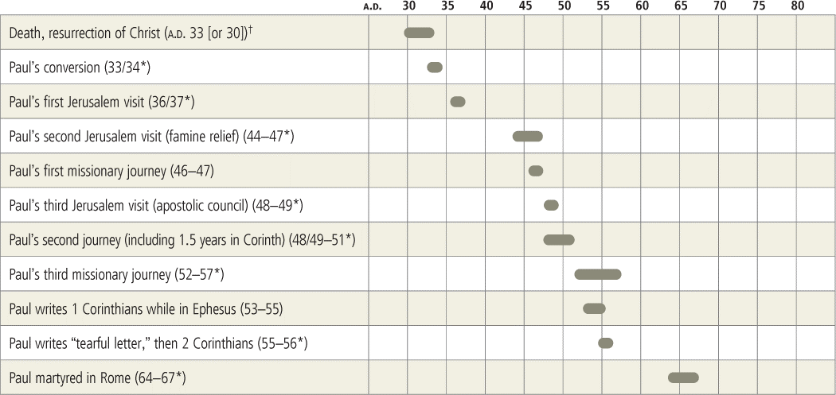

The Ancient City of Corinth
The Acrocorinth is a small but steep mountain 1,886 feet (575 m) high on the Peloponnesian peninsula in southern Greece. Ancient Corinth was built at the mountain’s foot, benefiting also from the natural spring that provided water for the town. In Paul’s day Corinth, though a couple of miles inland, oversaw the territory connecting the Adriatic port of Lechaion on the west with the Aegean port of Cenchreae to the east (see Acts 18:18). Ships were often portaged between these seaports across this narrow stretch of the Peloponnesian isthmus, approximately 3.7 miles (6 km) wide at its narrowest. Several rulers in the first century a.d. foolishly attempted to construct a canal across the isthmus, but this was not successfully accomplished until the nineteenth century.
The famed Greek city of Corinth, renowned for its artistry in bronze, its wealth, and its wanton sexuality, was destroyed in 146 b.c. during a war with Rome. The city was re-founded as a Roman colony in 44 b.c. by Roman freedmen, and the distinct archaeological strata in the city center testify to this gap in its history. Inscriptions from the first hundred years of the new colony were mostly in Latin, although strong marks of Greek culture were also evident in the art and life of the city.
First-century Corinth followed a Roman city plan based on a rectangular grid. Typical urban structures were built (or reconstructed), such as shops, stoas, basilicas, a bouleuterion (for the city council meetings), a gymnasium, baths, latrines, and a theater. A few large houses from this period have also been excavated. The center of town boasted the refashioned Peirene Fountain as a pleasant place from which to draw spring water. To this day a raised speaker’s platform stands in the main forum, and a nearby inscription refers to this platform as the rostra (equivalent to a bēma or tribunal); this is probably the very location where Gallio judged Paul to be innocent (Acts 18:12–17). Some other significant archaeological remains date from post-NT times, such as the odeion (a small covered theater).
In Paul’s day the great Doric-style temple (to Athena or Apollo) from the sixth century b.c. remained a central feature in Corinth, and multiple temples to other deities dotted the city. Indeed, when the author Pausanias wrote about Corinth in the mid-second century a.d., his description of the city read like a tour guide of pagan monumental sacred sites. Corinth boasted an important sanctuary of Asklepios (the god of healing), where people would come to offer sacrifices to the god and to seek medical care. Marks of the imperial cult were evident, especially if some are correct in identifying the substantial Temple E as being dedicated to Augustus’s sister Octavia (though it may have been for Jupiter). The famous Hellenistic-era temple of Aphrodite atop the Acrocorinth had been rebuilt as a rather small structure during the first-century a.d. Scholars debate whether Strabo’s first-century a.d. account of 1,000 temple prostitutes refers to the earlier Hellenistic temple of Aphrodite or to the Roman one of Paul’s day; the former seems more probable (Strabo, Geography 8.6.20c; see also Athenaeus, Deipnosophistae 13.573c–574c). In any case, in Roman times wanton sexuality would have been common at such a port city.
Key Themes
1. Since the church is the dwelling place of God’s Spirit, the people who make up the church should work for unity by building each other up. | 1:10–4:21 (esp. 3:10–16; 14:12)
2. Christians should build up the church in four practical ways:

a. they should be sensitive to those of fragile faith. | 8:1–9:18; 10:28, 33
b. they should win unbelievers through culturally sensitive evangelism. | 9:19–23; 10:27, 32–33
c. they should conduct worship services in such a way that unbelievers present might come to faith. | 14:16, 23–25
d. their corporate worship should use spiritual gifts not for personal display, or evaluating who has a better gift, but to build up the church. | 11:2–16; 12:12–30; 14:1–35
3. Sexual relations form a union between man and woman as profound as the union of the believer with Christ, and so sexual activity should be confined to marriage. | 5:1–13; 6:12–20; 7:5, 9, 36
4. Baptism and the Lord’s Supper are important, but both are subordinate to personal trust in the gospel and to living in the way that God commands. | 1:14–17; 10:1–5; 11:17–34; 15:29–34
5. The bodily resurrection of Jesus (and of his followers) from the dead is a critical component of Christian faith and practice. | 6:14; 15:1–58
History of Salvation Summary
Christians are God’s own people, the family of God, the body of Christ (12:12–31), and the temple of the Holy Spirit (3:16). As those who fulfill the OT pattern for the people of God, they are to be a holy community (1:2), reflecting God’s character (1 Pet. 1:15–16). (For an explanation of the “History of Salvation,” see the Overview of the Bible.)
Literary Features
First Corinthians is a pastoral letter to a spiritually troubled church. Like other NT Epistles, it is an “occasional” letter, and one can quite readily piece together the things that occasioned 1 Corinthians by noting signals in the text. The letter is highly relevant today, as it deals with such issues as the relationship between Christians and their surrounding pagan culture, divisions within the church, the ordering of church practices such as the Lord’s Supper, and the use of spiritual gifts. The letter also deals with matters of personal morality, such as sex, marriage, celibacy, and the virtues (esp. love).
First Corinthians follows the form of a typical first-century epistle, though its content is governed by the specific situation in the Corinthian church. For example, the usual epistolary elements of salutation, thanksgiving, and paraenesis (set of moral exhortations) receive scant treatment. The body of the letter is taken up with situations and questions from the Corinthian church that Paul addresses, and the epistolary close (ch. 16) is extensive because of business Paul has with the church. The rhetorical modes of exhortation and instruction dominate the letter. Chapter 13 is an encomium (a written tribute) in praise of love.
The book makes extensive use of rhetorical techniques such as contrast, repetition, and analogy. It draws sharp contrasts between truth and error, and between moral good and evil. Because Paul regards the Corinthian Christians as being out of line in a number of areas, the letter exhibits a strong corrective tone.
The Setting of 1 Corinthians
c. a.d. 53–55
Paul wrote 1 Corinthians during his third missionary journey, near the end of his three-year ministry in Ephesus (Acts 19:21–22). Both Corinth and Ephesus were wealthy port cities steeped in pagan idolatry and philosophy. Corinth benefited both militarily and economically from its strategic location at one end of the isthmus that connected the southern Greek peninsula to the mainland.

Outline
I. Epistolary Introduction to the Letter’s Main Themes (1:1–9)
A. Greeting: apostleship, sanctity, and unity (1:1–3)
B. Thanksgiving: speech, knowledge, and spiritual gifts (1:4–9)
II. Divisions over Christian Preachers (1:10–4:21)
A. The problem reported (1:10–17a)
B. God’s wisdom answers the problem (1:17b–4:21)
1. The nature of God’s wisdom (1:17b–2:16)
2. God’s wisdom applied to Apollos, Paul, and the Corinthians (3:1–4:21)
III. A Report of Sexual Immorality and Legal Wrangling (5:1–6:20)
A. Incest, arrogance, and the need for discipline (5:1–13)
B. Trivial cases before unrighteous judges (6:1–11)
C. Sexual immorality and the body’s resurrection (6:12–20)
IV. Three Issues from a Corinthian Letter (7:1–11:1)
A. Marriage, divorce, and unchangeable circumstances (7:1–24)
B. The betrothed and widows (7:25–40)
C. Food offered to idols (8:1–11:1)
V. Divisions over Corporate Worship (11:2–14:40)
A. Head coverings and worship (11:2–16)
B. Social snobbery at the Lord’s Table (11:17–34)
C. Elevating one spiritual gift above others (12:1–14:40)
VI. The Futility of Faith If the Dead Are Not Raised (15:1–58)
A. The truthfulness of the traditions about Christ’s resurrection (15:1–11)
B. Christ’s resurrection and the resurrection of believers (15:12–34)
C. The nature of the resurrection body (15:35–58)
VII. The Collection for the Saints and Travel Plans (16:1–12)
VIII. Closing Admonitions and Greetings (16:13–24)

THE UNIVERSAL GIFT
Alexander Maclaren at https://www.preceptaustin.org/1_corinthians_maclaren_3#tug72
‘The manifestation of the Spirit is given to every man to profit withal.’—1 COR. xii. 7.
The great fact which to-day[1] commemorates is too often regarded as if it were a transient gift, limited to those on whom it was first bestowed. We sometimes hear it said that the great need of the Christian world is a second Pentecost, a fresh outpouring of the Spirit of God and the like. Such a way of thinking and speaking misconceives the nature and significance of the first Pentecost, which had a transient element in it, but in essence was permanent. The rushing mighty wind and the cloven tongues of fire, and the strange speech in many languages, were all equally transient. The rushing wind swept on, and the house was no more filled with it. The tongues flickered into invisibility and disappeared from the heads. The hubbub of many languages was quickly silent. But that which these things but symbolised is permanent; and we are not to think of Pentecost as if it were a sudden gush from a great reservoir, and the sluice was let down again after it, but as if it were the entrance into a dry bed, of a rushing stream, whose first outgush was attended with noise, but which thereafter flows continuous and unbroken. If churches or individuals are scant of that gift, it is not because it has not been bestowed, but because it has not been accepted.
My text tells us two things: it unconditionally and broadly asserts that every Christian possesses this great gift—the manifestation is given to every man; and then it asserts that the gift of each is meant to be utilised for the good of all. ‘The manifestation is given to every man to profit withal.’
I. Let me, then, say a word or two, to begin with, about the universality of this gift.
Now, that is implied in our Lord's own language, as commented upon by the Evangelist. For Jesus Christ declared that this was the standing law of His kingdom, to be universally applied to all its members, that ‘He that believeth on Him, out of him shall flow rivers of living water’; and the Evangelist's comment goes on to say, ‘This spake He of the Spirit which they that believe on Him should receive.’ There is the condition and the qualification. Wherever there is faith, there the Spirit of God is bestowed, and bestowed in the measure in which faith is exercised. So, then, in full accordance with such fundamental principles in reference to the gift of the Spirit of God, comes the language of my text, and of many another text to which I cannot do more than refer. But let me just quote one or two of them, in order that I may make more emphatic what I believe a great many Christian people do not realise as they ought—viz. that the gift of God's Holy Spirit is not a thing to be desired, as if it were not possessed or confined to select individuals, or manifested by exceptional and lofty attainments, but is the universal heritage of the whole Christian Church. ‘Know ye not that ye are the temple of the Holy Ghost?’ ‘We have all been made to drink into one Spirit,’ says Paul again, in the immediate context. ‘If any man have not the Spirit of Christ, he is none of His,’ says he, unconditionally. And in many other places the same principle is laid down, a principle which I believe the Christian Church to-day needs to have recalled to its consciousness, that it may be quickened to realise it in its experience far more than is the case at present.
Let me remind you, too, that that universality of the gifts of the Divine Spirit is implied in the very conception of what Christ's work, in its deepest and most precious aspects to us, is. For we are not to limit, as a great many so-called earnest evangelical teachers and believers do—we are not to limit His work to that which is effected when a man first becomes a Christian—viz. pardon and acceptance with God. God forbid that I should ever seem to underrate that great initial gift on which everything else must be built. But I am not underrating it when I say, ‘Let us prophesy according to the proportion of faith,’ and the ‘proportion of faith’ has been violated, and the perspective and completeness of Christian truth, and of Christ's gifts, have been, alas! to a very large extent distorted because Christian people, trained in what we call the evangelical school, have laid far too little emphasis on the fact that the essential gift of Christ to His people is not pardon, nor acceptance, nor justification, but life; and that forgiveness, and altered relationship to God, and assurance of acceptance with Him, are all preliminaries. They are, if I may recur to a figure that I have already employed, the preparing of the channel, and the taking away of the obstacles that block its mouth, in order to the inrush of the flood of the river of the water of life.
This life that Christ gives is the result of the gift of the Spirit. So ‘If any man have not the Spirit of Christ he is none of His.’ The life is the gift considered from our side, and the Spirit is the gift considered from the divine side. ‘Every man that hath the Son hath life’; because the law of the Spirit of life in Christ has made him free from the law of sin and death. So you see if that is true—and I for my part am sure that it is—then all that vulgar way of looking at the influences of the Holy Spirit upon men, as if they were confined to certain exceptional people, or certain abnormal and extraordinary and elevated acts, is swept away. It is not the spasmodic, the exceptional, the rare, not the lofty or transcendentally Christlike acts or characters that are alone the manifestation of the Spirit.
Nor is this gift a thing that a man can discover as distinct from his own consciousness. The point where the river of the water of life comes into the channel of our spirits lies away far up, near the sources, and long before the stream comes into sight in our own consciousness, the blended waters have been inseparably mingled, and flow on peacefully together. ‘The Spirit beareth witness with our spirits’; and you are not to expect that you can hear two voices speaking, but it is one voice and one only.
Now, that universality of this divine gift underlies the very constitution of the Christian Church. ‘Where the Spirit of the Lord is there is liberty,’ said Paul. It is because each Christian man has access to the one Source of illumination and of truth and righteousness and holiness, that no Christian man is to become subject to the dominion of a brother. And it is because on the servants and on the handmaidens has been poured out, in these days, God's Spirit and they prophesy, that all domination of classes or individuals, and all stiffening of the free life of God's Church by man-made creeds, are contrary to the very basis of its existence, and an attack on the dignity of each individual member of the Church. ‘Ye have an unction from the Holy One’ is said to all Christian people—and ‘ye need not that any man teach you,’ still less that any man, or body of men, or document framed by men, should be set up as normal and authoritative over Christ's free people.
Still further, and only one word—Let me remind you of what I have already said, and what is only too sadly true, that this grand universality of the Spirit's gift to all Christian people does not fill, in the mind of the ordinary Christian man, the place that it ought, and it does not fill it, therefore, in his experience. I say no more upon that point.
II. And now let me say a word, secondly, about the many-sidedness of this universal gift.
One of the reasons why Christian people as a whole do not realise the universality as they ought is, as I have already suggested in a somewhat different connection, because they limit their notions far too much of what the gift of God's Spirit is to do to men. We must take a wider view of what that Spirit is meant to effect than we ordinarily take, before we understand how real and how visible its universal manifestations are. Take a leaf out of the Old Testament. The man who made the brass-work for the Tabernacle was ‘full of the Spirit of God.’ The poets who sung the Psalms, in more than one place, declare of themselves that they, too, were but the harps upon which the divine finger played. Samson was capable of his rude feats of physical strength, because ‘the Spirit of God was upon him.’ Art, song, counsel, statesmanlike adaptation of means to ends, and discernment of proper courses for a nation, such as were exemplified in Joseph and in Daniel, are, in the Old Testament, ascribed to the Spirit of God, and even the rude physical strength of the simple-natured and sensuous athlete is traced up to the same source.
But again, we see another sphere of the Spirit's working in the manifestations of it in the experience of the primitive Church. These are, as we all know, accompanied with miracles, speaking with tongues and working wonders. The signs of that Spirit in those days were visible and audible. As I said, when the river first came into its bed, it came like the tide in Morecambe Bay, breast-high, with a roar and a rush. But it was quiet after that. In the context we have a whole series of manifestations of this Divine Spirit, some of them miraculous and some being natural faculties heightened, but all concerned with the Church as a society, and being for the benefit of the community.
But there is another class. If you turn to the Epistle to the Galatians, you will find a wonderful list there of what the Apostle calls ‘the fruit of the Spirit,’ beginning with ‘love, joy, peace.’ These are all moral and religious, bearing upon personal experience and the completeness of the individual character.
Now, let us include all these aspects in our conception of the fruit of the Spirit's working on men—the secular, if we may use that word, as exhibited in the Old Testament; the miraculous, as seen in the first days of the Church; the ecclesiastical, if we may so designate the endowments mentioned in the context, and the purely personal, moral, and religious emotions and acts. The plain fact is that everything in a Christian's life, except his sin, is the manifestation of that Divine Spirit, from whom all good thoughts, counsels, and works do proceed. He is the ‘Spirit of adoption,’ and whenever in my heart there rises warm and blessed the aspiration ‘Abba! Father!’ it is not my voice only, but the voice of that Divine Spirit. He is the Spirit of intercession; and whenever in my soul there move yearning desires after infinite good, child-like longings to be knit more closely to Him, that, too, is the voice of God's Spirit; and our prayers are then ‘sweet, indeed, when He the Spirit gives by which we pray.’ In like manner, all the variety of Christian emotions and experiences is to be traced to the conjoint operation of that Divine Spirit as the source, and my own spirit as influenced by, and the organ of, the Spirit of God. If I may take a very rough illustration, there is a story in the Old Testament about a king, to whom were given a bow and arrow, with the command to shoot. The prophet's hand was laid on the king's weak hand, and the weak hand was strengthened by the touch of the other; and with one common pull they drew back the string and the arrow sped. The king drew the bow, but it was the prophet's hand grasping his wrist that gave him strength to do it. And that is how the Spirit of God will work with us if we will.
III. Finally, consider the purpose of all the diverse manifestations of the one universal gift.
‘To profit withal’—for his own good who possesses it, and for the good of all the rest of his brethren.
Now, that involves two plain things. There have been people in the Christian Church who have said, ‘We have all the Spirit, and therefore we do not need one another.’ There may be isolation, and self-sufficiency, and a host of other evils coming in, if we only grasp the thought, ‘The manifestation of the Spirit is given to every man,’ but they are all corrected if we go on and say, ‘to profit withal.’ For every one of us has something, and no one of us has everything; so, on the one hand, we want each other, and, on the other hand, we are responsible for the use of what we have.
You get the life, not in order that you may plume yourself on its possession, nor in order that you may ostentatiously display it, still less in order that you may shut it up and do nothing with it; but you get the life in order that it may spread through you to others.
'The least flower with a brimming cup may stand, And share its dew-drop with another near.'
We each have the life that God's grace may fructify through us to all. Power is duty; endowment is obligation; capacity prescribes work. ‘The manifestation of the Spirit is given to every man to profit withal.’
You can regulate the flow. You have the sluice; you can shut it or open it. I have said that the condition, and the only condition, of possessing the fulness of God's Spirit is faith in Jesus Christ. Therefore, the more you trust the more you have, and the less your faith the less the gift. You can get much or little, according to the greatness or the smallness, the fixity or the transiency, of your desires. If you hold the empty cup with a tremulous hand, the precious liquid will not be poured into it—for some of it will be spilt—in the same fulness as it would be if you held it steadily. It is the old story—the miraculous flow of the oil stopped when the widow had no more pots and vessels to bring. The reason why some of us have so little of that Divine Spirit is because we have not held out our vessels to be filled. You can diminish the flow by ignoring it, and that is what a host of so-called Christian people do nowadays. You can diminish it by neglecting to use the little that you have for the purpose for which it was given you. Does anybody profit by your spiritual life? Do you profit much by it yourselves? Has it ever been of the least good to anybody else in the world? ‘The manifestation of the Spirit is given to’ you, if you are a Christian man or woman, more or less. And if you shut it up, and do never an atom of good with it, either to yourselves or to anybody else, of course it will slip away; and, sometime or other, to your astonishment, you will find that the vessels are empty, and that the Spirit of the Lord has departed from you. ‘Grieve not the Holy Spirit of God, whereby ye are sealed unto the day of redemption.’
Footnote 1: Whitsunday.

Crossway Bibles. (2008). The ESV Study Bible (pp. 2187–2191). Wheaton, IL: Crossway Bibles.

