Learning From A Reluctant Prophet
The Reluctant Prophet, Pt. 1: Jonah 1:1-4 September 10, 2023

Reading Jonah so that we learn Jonah’s lessons
¹ The word of the Lord came to Jonah son of Amittai: ² “Go to the great city of Nineveh and preach against it, because its wickedness has come up before me.”
³ But Jonah ran away from the Lord and headed for Tarshish. He went down to Joppa, where he found a ship bound for that port. After paying the fare, he went aboard and sailed for Tarshish to flee from the Lord.
Jonah 1

1. Jonah really was a prophet, so he knew that preaching is dangerous and powerful

2. Watch for what God is doing, usually behind the scenes

3. Watch for what is gadōl and what is ra’ah

4. Watch for the “direction signals” in Jonah

A little background
²³ In the fifteenth year of Amaziah son of Joash king of Judah, Jeroboam son of Jehoash king of Israel became king in Samaria, and he reigned forty-one years. ²⁴ He did evil in the eyes of the Lord and did not turn away from any of the sins of Jeroboam son of Nebat, which he had caused Israel to commit. ²⁵ He was the one who restored the boundaries of Israel from Lebo Hamath to the Sea of the Arabah, in accordance with the word of the Lord, the God of Israel, spoken through his servant Jonah son of Amittai, the prophet from Gath Hepher.
2 Kings 14

¹⁰ Then Amaziah the priest of Bethel sent a message to Jeroboam king of Israel: “Amos is raising a conspiracy against you in the very heart of Israel. The land cannot bear all his words. ¹¹ For this is what Amos is saying:
“ ‘Jeroboam will die by the sword,
and Israel will surely go into exile, away from their native land.’ ”
¹² Then Amaziah said to Amos, “Get out, you seer! Go back to the land of Judah. Earn your bread there and do your prophesying there. ¹³ Don’t prophesy anymore at Bethel, because this is the king’s sanctuary and the temple of the kingdom.”
¹⁴ Amos answered Amaziah, “I was neither a prophet nor a prophet’s son, but I was a shepherd, and I also took care of sycamore-fig trees. ¹⁵ But the Lord took me from tending the flock and said to me, ‘Go, prophesy to my people Israel.’ ¹⁶ Now then, hear the word of the Lord. You say,
“ ‘Do not prophesy against Israel, and stop preaching against the house of Isaac.’
¹⁷ “Therefore this is what the Lord says:
“ ‘Your wife will become a prostitute in the city, and your sons and daughters will fall by the sword.
Your land will be measured and divided up, and you yourself will die in a pagan country.
And Israel will certainly go into exile, away from their native land.’ ”
Amos 6

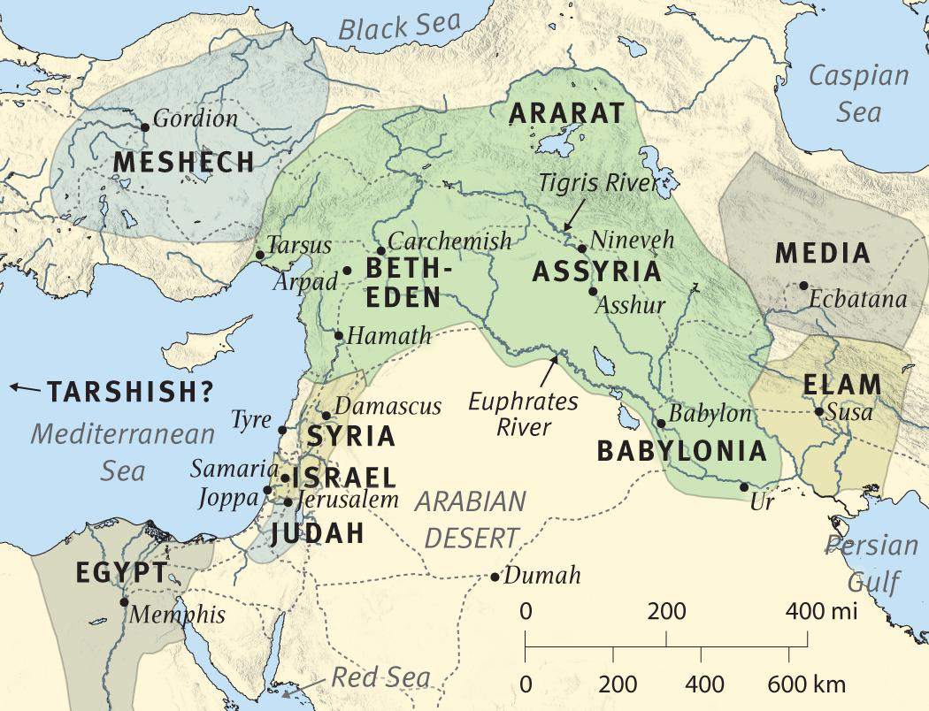

Learning with Jonah
1. Jonah knows that he can’t please Jeroboam II and the Lord
¹⁴ Amos answered Amaziah, “I was neither a prophet nor a prophet’s son, but I was a shepherd, and I also took care of sycamore-fig trees. ¹⁵ But the Lord took me from tending the flock and said to me, ‘Go, prophesy to my people Israel.’ ¹⁶ Now then, hear the word of the Lord. You say,
“ ‘Do not prophesy against Israel, and stop preaching against the house of Isaac.’ ”
Amos

2. Jonah knows that God’s message is always good news
³ For I know my transgressions,
and my sin is always before me.
⁴ Against you, you only, have I sinned
and done what is evil in your sight,
so that you are proved right when you speak
and justified when you judge.
Psalm 51 (Paul quotes this text in Romans 3:4)

3. Jesus is the “sign” that gives meaning to the story of Jonah
Side question: Does Jesus’ understanding of Jonah mean that it is more than just an allegory?
²⁹ As the crowds increased, Jesus said, “This is a wicked generation. It asks for a miraculous sign, but none will be given it except the sign of Jonah. ³⁰ For as Jonah was a sign to the Ninevites, so also will the Son of Man be to this generation. ³¹ The Queen of the South will rise at the judgment with the men of this generation and condemn them; for she came from the ends of the earth to listen to Solomon’s wisdom, and now one greater than Solomon is here. ³² The men of Nineveh will stand up at the judgment with this generation and condemn it; for they repented at the preaching of Jonah, and now one greater than Jonah is here.
Luke 11

4. Jonah learns running from God’s revealed will is dangerous
⁷ Where can I go from your Spirit? Where can I flee from your presence?
Jeremiah 28

5. The “great wind” begins to teach Jonah lessons about God’s salvation
“What I have vowed I will make good.
Salvation comes from the Lord.”
Jonah 2:9, the prophet’s profession after God provides through the storm

Resources for further study
The Bible Project team does a great job of introducing Jonah at https://bibleproject.com/guides/book-of-jonah/
Spurgeon has five sermons on Jonah at this Monergism site: https://www.biblebb.com/brefindex/jon.htm
Doug’s Logos library includes a helpful Bible study by Paul Mackrell (Day One Publishing, 2007)
Erik Manning has an interesting discussion of the scientific questions around the Jonah sign/miracle at https://crossexamined.org/the-mind-blowing-meaning-behind-the-sign-of-jonah/
Doug likes the ESV Study Bible’s introduction to Jonah included below.

ESV Study Bible introduction:
Theme
The Lord is a God of boundless compassion not just for “us” (Jonah and the Israelites) but also for “them” (the pagan sailors and Ninevites).
Purpose, Occasion, and Background
The primary purpose of the book of Jonah is to engage readers in theological reflection on the compassionate character of God, and in self-reflection on the degree to which their own character reflects this compassion, to the end that they become vehicles of this compassion in the world that God has made and so deeply cares about.
Jonah prophesied during the reign of Jeroboam II (2 Kings 14:23–28), who ruled in Israel (the northern kingdom) from 782 to 753 b.c. Jeroboam was the grandson of Jehoahaz, who ruled in Israel from 814 to 798 b.c. Because of the sins of Jehoahaz, Israel was oppressed by the Arameans (2 Kings 13:3). But because of the Lord’s great compassion (2 Kings 13:4, 23), Israel was spared destruction and delivered from this oppression (2 Kings 13:5). This deliverance came through a “savior” (2 Kings 13:5), who may have been Adad-nirari III (810–783 b.c.), king of Assyria.
Jeroboam’s father, Jehoash (798–782 b.c.), capitalized on this freedom from Aramean oppression and began to expand Israel’s boundaries, recapturing towns taken during the reign of Jehoahaz (2 Kings 13:25). Though Jeroboam “did what was evil in the sight of the Lord” (2 Kings 14:24), he nevertheless expanded Israel even farther than his father did, matching the boundaries in the days of David and Solomon (2 Kings 14:25); this was “according to the word of the Lord, the God of Israel, which he spoke by his servant Jonah the son of Amittai, the prophet, who was from Gath-hepher” (2 Kings 14:25). Thus Jonah witnessed firsthand the restorative compassion of God extended to his wayward people.
In God’s providence, the expansion by Jeroboam was made easier because of Assyrian weakness. The Assyrians were engaged in conflicts with the Arameans and the Urartians. There was also widespread famine, and numerous revolts within the Assyrian Empire (where regional governors ruled with a fair degree of autonomy). Then there was an auspicious eclipse of the sun during the reign of Ashur-dan III (771–754 b.c.). This convergence of events supports the plausibility of the Ninevites being so responsive to Jonah’s call to repent.
It was not until some years later that Tiglath-pileser (745–727 b.c.) would gain control and reestablish Assyrian dominance in the area, and his son Shalmaneser V (727–722) was the king responsible for the conquest of Israel and the destruction of Samaria in 722. Thus Jonah prophesied in an era when Assyria was not an immediate threat to Israel and when Israel enjoyed peace and prosperity because of the compassion of God.
Genre
The genre of Jonah is debated. The book has been read as an allegory, using fictional figures to symbolize some other reality. According to this interpretation, Jonah is a symbol of Israel in its refusal to carry out God’s mission to the nations. The primary argument against this view is that Jonah is clearly presented as a historical and not a fictional figure (see the specific historical and geographical details in 1:1–3; 3:2–10; 4:11; cf. also 2 Kings 14:25). Another proposal is that the book is a parable to teach believers not to be like Jonah. Like allegories, parables are also based on fictional and not historical characters. Parables, however, are typically simple tales that make a single point, whereas the book of Jonah is quite complex and teaches a multiplicity of themes.
The book of Jonah has all the marks of a prophetic narrative, like those about Elijah and Elisha found in 1 Kings, which set out to report actual historical events. The phrase that opens the book (“the word of the Lord came to”) is also at the beginning of the first two stories told about Elijah (1 Kings 17:2, 8) and is used in other prophetic narratives as well (e.g., 1 Sam. 15:10; 2 Sam. 7:4). Just as the Elijah and Elisha narratives contain extraordinary events, like ravens providing bread and meat for the prophet (1 Kings 17:6), so does the book of Jonah, as when the fish “provides transportation” for the prophet. In fact, the story of Jonah is so much like the stories about Elijah and Elisha that one would hardly think it odd if the story of Jonah were embedded in 2 Kings right after Jonah’s prophetic words about the expansion of the kingdom. The story of Jonah is thus presented as historical, like the other prophetic narratives.
There are additional arguments for the historical nature of the book of Jonah. It is difficult to say that the story teaches God’s sovereignty over the creation if God did not in fact “appoint” the fish (1:17), the plant (4:6), the worm (4:7), and the east wind (4:8) to do his will. Jesus, moreover, treated the story as historical when he used elements of the story as analogies for other historical events (see Matt. 12:40–41). This is especially clear when Jesus declared that “the men of Nineveh will rise up at the judgment with this generation and condemn it, for they repented at the preaching of Jonah” (Matt. 12:41).
The story of Jonah is not, however, history for history’s sake. The book is clearly didactic (as the allegorical and parabolic interpretations rightly affirm); that is, the story is told to teach the reader key lessons. The didactic character of the book shines through in the repeated use of questions, 11 out of 14 being addressed to Jonah, and the question that closes the narrative leaves readers asking themselves how they will respond to the story.
Key Themes
The primary theme in Jonah is that God’s compassion is boundless, not limited just to “us” but also available for “them.” This is clear from the flow of the story and its conclusion: (1) Jonah is the object of God’s compassion throughout the book, and the pagan sailors and pagan Ninevites are also the benefactors of this compassion. (2) The story ends with the question, “Should I not pity Nineveh …?” (4:11). Tied to this theological teaching is the anthropological question, Do readers of the story have hearts that are like the heart of God? While Jonah was concerned about a plant that “perished” (4:10), he showed no such concern for the Ninevites. Conversely, the pagan sailors (1:14), their captain (1:6), and the king of Nineveh (3:9) all showed concern that human beings, including Jonah, not “perish.”
Several other major themes in the book include:
1. God’s sovereign control over events on the earth
2. God’s determination to get his message to the nations
3. The need for repentance from sin in general
4. The need for repentance from self-centeredness and hypocrisy in particular
5. The full assurance that God will relent when people repent
History of Salvation Summary
Jonah’s rescue from death provides an analogy for the resurrection of Christ (Matt. 12:39–40). The repentance of the Ninevites anticipates the wide-scale repentance of Gentiles in the messianic era (Matt. 28:18–20; Luke 24:47). (For an explanation of the “History of Salvation,” see the Overview of the Bible. See also History of Salvation in the Old Testament: Preparing the Way for Christ.)
Literary Features
The book of Jonah is a literary masterpiece. While the story line is so simple that children follow it readily, the story is marked by as high a degree of literary sophistication as any book in the Hebrew Bible. The author employs structure, humor, hyperbole, irony, double entendre, and literary figures like merism to communicate his message with great rhetorical power. The first example of this sophistication is seen in the outline of the book (see below).
The main category for the book is satire—the exposure of human vice or folly. The four elements of satire take the following form in the book of Jonah: (1) the object of attack is Jonah and what he represents—a bigotry and ethnocentrism that regarded God as the exclusive property of the believing community (in the OT, the nation of Israel); (2) the satiric vehicle is narrative or story; (3) the satiric norm or standard by which Jonah’s bad attitudes are judged is the character of God, who is portrayed as a God of universal mercy, whose mercy is not limited by national boundaries; (4) the satiric tone is laughing, with Jonah emerging as a laughable figure—someone who runs away from God and is caught by a fish, and as a childish and pouting prophet who prefers death over life without his shade tree.
Three stylistic techniques are especially important. (1) The giantesque motif—the motif of the unexpectedly large (e.g., the magnitude of the task assigned to Jonah, of the fish that swallows him, and of the repentance that Jonah’s eight-word sermon accomplishes). (2) A pervasive irony (e.g., the ironic discrepancy between Jonah’s prophetic vocation and his ignominious behavior, and the ironic impossibility of fleeing from the presence of God). (3) Humor, as Jonah’s behavior is not only ignominious but also ridiculous.
The Setting of Jonah
c. 760 b.c.
Jonah prophesied during the politically prosperous time of Jeroboam II of Israel (2 Kings 14:23–28). During this time the Assyrians were occupied with matters elsewhere in the empire, allowing Jeroboam II to capture much of Syria for Israel. The Lord called Jonah to go to the great Assyrian city of Nineveh to pronounce judgment upon it. Jonah attempted to escape the Lord’s calling by sailing from the seaport of Joppa to Tarshish, which was probably in the western Mediterranean. Eventually he obeyed the Lord and traveled overland to Nineveh at the heart of the Assyrian Empire.

Crossway Bibles. (2008). The ESV Study Bible (pp. 1683–1685). Wheaton, IL: Crossway Bibles.

