Each Other and Everyone Else
The Gospel Difference, 1 Thessalonians 3:12-13 April 30, 2023

May the Lord make your love increase and overflow
for each other and for everyone else, just as ours does for you.
May he strengthen your hearts so that you will be blameless
and holy in the presence of our God and Father
when our Lord Jesus comes with all his holy ones.
1 Thessalonians 3:13
Paul prays for the Thessalonians saints . . . .

1. that God may “clear the way” so that Paul can experience the firmness of their faith

2. that God may “overflow” their love (for each other and for everyone) to strengthen them . . .

3. so that [see 4:1-12] they will be pure (before the world) and holy (before God), fully prepared for
Jesus’ arrive – his parousia [which he explains more fully in 4:13-5:11]

Resources for reading 1 Thessalonians
The poster for 1 Thessalonians can be found at bibleproject.com
Doug’s favorite 1 Thessalonians commentaries include
Charles Wannamaker’s NIGTC volume (Eerdmans, 1990)
Hendricksen’s Expository Commentary (Baker, 1955)
Robert Thomas’ volume in Expositors’ Bible Commentary (Zondervan, 1981)
John MacArthur has a very interesting sermon, “The Ideal Church” at https://www.gty.org/library/sermons-library/1317A
Spurgeon has an important sermon on 1 Thessalonians 3 at https://www.monergism.com/renewing-strength
Alexander Maclaren has commentary on 1 Thessalonians 2:12 included below at https://www.preceptaustin.org/maclaren_on_1thessalonians#faith
Thomas Schreiner has a wonderful essay on the optimism in 1 Thessalonians at http://www.sbts.edu/documents/tschreiner/3.3_editorial.pdf
For a Puritan sermon on the 2:16, I recommend Jonathan Edward’s sermon at https://www.biblebb.com/files/edwards/uttermost.htm
D.A. Carson’s Praying with Paul (Baker, 1992) deals with this text in Chapter 5: A Passion for People
John Piper has one sermon on this text (continuing into chapter 4) at https://www.desiringgod.org/messages/advancing-and-sustaining-the-covenant-community

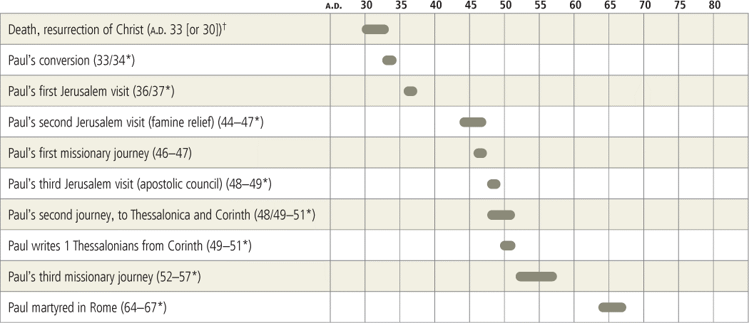

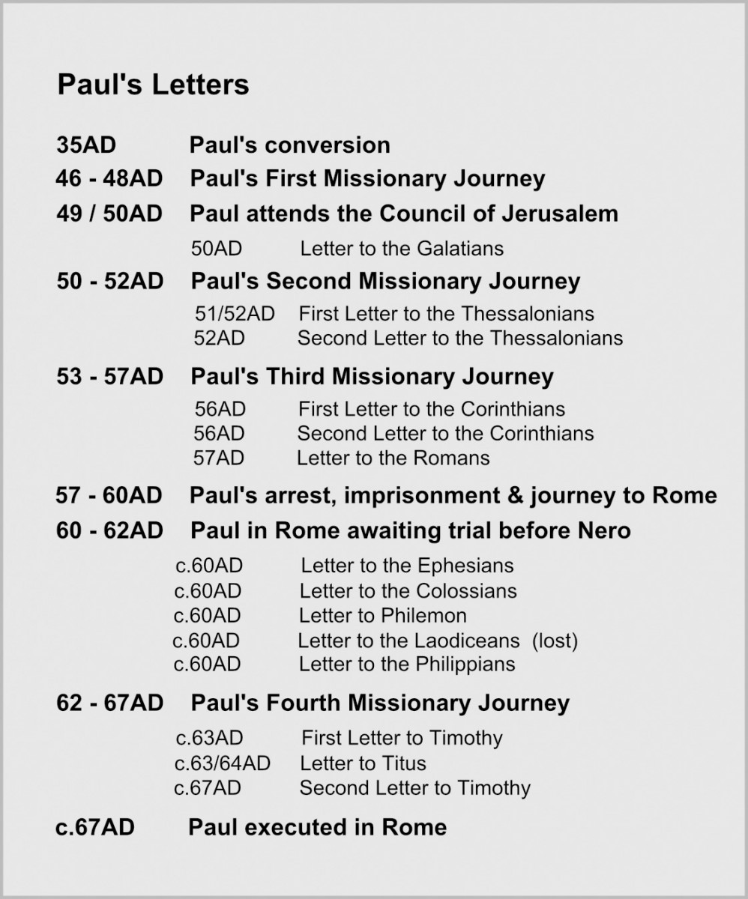

1 Thessalonians 3:6-4:13 (ESV)
Timothy’s Encouraging Report
⁶ But now that Timothy has come to us from you, and has brought us the good news of your faith and love and reported that you always remember us kindly and long to see us, as we long to see you— ⁷ for this reason, brothers, in all our distress and affliction we have been comforted about you through your faith. ⁸ For now we live, if you are standing fast in the Lord. ⁹ For what thanksgiving can we return to God for you, for all the joy that we feel for your sake before our God, ¹⁰ as we pray most earnestly night and day that we may see you face to face and supply what is lacking in your faith?
¹¹ Now may our God and Father himself, and our Lord Jesus, direct our way to you, ¹² and may the Lord make you increase and abound in love for one another and for all, as we do for you, ¹³ so that he may establish your hearts blameless in holiness before our God and Father, at the coming of our Lord Jesus with all his saints.
A Life Pleasing to God
4 Finally, then, brothers, we ask and urge you in the Lord Jesus, that as you received from us how you ought to walk and to please God, just as you are doing, that you do so more and more. ² For you know what instructions we gave you through the Lord Jesus. ³ For this is the will of God, your sanctification: that you abstain from sexual immorality; ⁴ that each one of you know how to control his own body in holiness and honor, ⁵ not in the passion of lust like the Gentiles who do not know God; ⁶ that no one transgress and wrong his brother in this matter, because the Lord is an avenger in all these things, as we told you beforehand and solemnly warned you. ⁷ For God has not called us for impurity, but in holiness. ⁸ Therefore whoever disregards this, disregards not man but God, who gives his Holy Spirit to you.
⁹ Now concerning brotherly love you have no need for anyone to write to you, for you yourselves have been taught by God to love one another, ¹⁰ for that indeed is what you are doing to all the brothers throughout Macedonia. But we urge you, brothers, to do this more and more, ¹¹ and to aspire to live quietly, and to mind your own affairs, and to work with your hands, as we instructed you, ¹² so that you may walk properly before outsiders and be dependent on no one.

Renewing Strength

by C. H. Spurgeon
at https://www.monergism.com/renewing-strength
Sermon No. 1758 - Metropolitan Tabernacle Pulpit
Sermon Suitable For First of The Year, Delivered By C. H. Spurgeon, At Newington.
“Now we live, if you stand fast in the Lord.” - 1 Thessalonians 3:8.
MINISTERS who are really sent of God greatly rejoice in the spiritual prosperity of their people. If they see God’s Word prosper, they prosper. If the Church of God is blessed, they are blessed. Their life is wrapped up in the spiritual life of their people. Never is the servant of God so full of delight as when he sees that the Holy Spirit is visiting his hearers, making them to know the Lord, and confirming them in that heavenly knowledge. On the other hand, if God does not bless the word of His servants, it is like death to them! To be preaching and to have no blessing makes them heavy of heart—the chariot wheels are taken off and they drag heavily along—they seem to have no power nor liberty. They get depressed and they go back to their Master with this complaint, “Who has believed our report? And to whom has the arm of the Lord been revealed?”
He revives and cheers them—and they come back to their service—but if they do not see a manifest blessing resting upon the people, they cry and sigh and are like dying men. If the Lord willed to do so, He might have made robots to preach and these would only need to be wound up and allowed to run down again! They would have known no feelings of joy or of sorrow and would have been invulnerable to the arrows of grief. We have heard of the Iron Duke. Iron preachers would have been enduring instruments and would never have been laid aside by mental depression. But the sympathy of the preacher is God’s great instrument for blessing the hearer! If you read a sermon in a book it is good, but if you hear it preached fresh from the man’s heart, it is far more effective. There is a living fellow-feeling about it, and that is the power which God has, in all ages, been pleased to use—the power of a spirit which He has made sensitive with affection— so sensitive that it rises to joy when its affectionate purpose is accomplished and sinks to depths of grief when that purpose fails.
This, I take it, is what the Apostle means when he says, “Now we live, if you stand fast in the Lord.” The people can make the pastor happy beyond expression by their being rich in Grace and happy in Christ! But they can make him miserable beyond all description if they are either unstable or insincere. Dearly Beloved, I have often rejoiced in God as I have seen the work of the Spirit among you. It is no small joy that for many years we have never been without an increase to the Church. With few exceptions we have never gathered at our monthly communions without receiving a considerable number into our membership.
During these years some have turned back, to our great sorrow, and some have flagged, to our solemn grief. But others have persistently carried on the work of God and have developed gifts and graces which have made them qualified for larger spheres. At this day those at home come behind in no gifts and those abroad do not forget the hallowed training of Zion. In every part of the earth some are engaged in holy service who have gone out from this Church. For all this, our heart must be grateful. But these are evil times. These are times, the like of which I have not seen before, in which the foundations are removed and “what shall the righteous do?” The winds are out. The tacklings are loosed. The mariners reel to and fro! Everything seems to be drifting. Men know not where they are!
Half the professing Christians of the present day do not know their heads from their heels and the half that do know seem inclined to take to their heels and run rather than stand steadfast in the faith and wait till evil days are over! It is time that we spoke to you concerning steadfastness—that you be not like idle boys that leap hedges and ditches after every nest that silly birds may choose to make—but that you keep to the King’s Highway of holiness and truth and hold fast to the doctrines and the practices which are taught us in the Word of God. I say to you by this discourse, “Now we live, if you stand fast in the Lord.”
It is a matter of life and death to us that you should be rooted, grounded, and settled. Notice first, that some are not in the Lord. Secondly, some appear to be in the Lord, but they are not standing fast. And thirdly, that some in the Lord stand fast in the Lord and these are our life—“Now we live, if you stand fast in the Lord.”
I. First, SOME ARE NOT IN THE LORD AT ALL. A solid mass of infidelity and godlessness hems us in. Our heart is heavy because this great city is determined to shut its eyes to the Light of God . There are streets upon streets in which none attend the House of God and we have it on credible information that in certain districts if one man in a street is seen to go regularly to a place of worship, his neighbors mark him as a singular being. The home-born Londoner of the working classes, as a rule, has no care for a place of worship. If I were living in the country, I think I would be content with but half a wage sooner than to come and dwell in this ungodly place!
Our members try to bring up their children in God’s fear, but they are often compelled to quit their homes because of the filthy conduct of those who defile our streets. Yet this is not my present theme. Our greater sorrow is that there are many who hear the Gospel and are not in the Lord! We are not sorry that they should come to hear the Word of God— would to God that all Christless souls would hear of Christ! But we are sorry that they have come month after month, year after year, and have received no saving benefit. I still meet, here and there, with those who tell me, “I used to hear you in Park Street and Exeter Hall,” and yet I gather from them that they are undecided. I have small hope for them if 30 years of ministry have not brought them to Christ!
At any rate, these many years add to the dreadful probability that they will continue to make the Word of God to be unto themselves a savor of death unto death. If I could pick out of this audience, tonight, by Infallible guidance, one man or one woman and could point to that person and say, “Such a one will certainly go down to Hell to endure the everlasting wrath of God”—and if you knew that I was speaking like a Prophet from God and that it was certainly so—you would turn round and look with deepest grief upon that doomed soul! You would shudder to be sitting in the same pew! And yet though, thank God, we may not speak with that certainty, the probability grows so great as almost to amount to a certainty concerning those upon whom entreaties have been wasted, upon whom expostulations have been wasted, by whom invitations have been refused, that they will continue to harden their hearts until at last they sink into the place where mercy never enters!
Ah, Lord, these are heavy tidings and Your saints feel them! I know I am speaking to many who deeply sympathize with me when I say that the thought of this is a worm that makes our joys decay. I mean the thought that some of you contribute to God’s work and are, in many points, excellent—and yet you lack the one thing necessary—and after having joined with God’s people in outward acts of devotion you will be driven from His Presence forever! O Infinite Mercy, grant that it may not be so, but may these men and women, even now, be led to believe in Jesus and be saved! We die when we think of those who are not in the Lord at all! How it would revive us if we could see them saved!
If there is a deadening influence about the thought that some few among us are not converted, think of what the effect must be upon a minister’s mind if he shall have labored long and seen no fruit. There may be instances in which a man has been faithful, but not successful—places where, for a time, the dew falls not and the softening influences of the Spirit are not given. Then the soil breaks the plowshare and the weary ox is ready to faint. I began to preach while yet a youth, scarcely 16 years of age, but before I had preached half a dozen times I saw persons affected by those sermons. I pined to find some heart that had looked to Jesus while I had preached Him—and I have photographed upon my memory, at this very moment, a very humble clay-walled cottage which seemed to me to be a sacred spot, for I was told by a venerable deacon that it was the house of a poor woman who had sought and found the Savior through my ministry.
I did not let the week conclude till I had seen her, for I hungered for the joy of meeting with one whom I had brought to Christ! If I found one soul converted, I took heart and looked for more. Brothers, are you working for Jesus? Then you know what it is to feel the shadow of death when you do not win a soul! Does it not seem hard to be knocking for Christ against a door that never opens, but has fresh bolts put on it to keep it closed? Be not ashamed of yourself because you feel distressed—it proves your capacity for being used. By-and-by God will bless you and then you will understand the text, “Now we live.” You will find that your pulse is quickened, your heart’s blood warmed—you will be filled with a more Divine life as you rise nearer to the dignity of a savior of men and taste the unspeakable joys for which Christ laid down His life!
II. We notice, secondly, that THERE ARE SOME WHO PROFESS TO BE IN CHRIST, BUT THEY CERTAINLY ARE NOT STANDING FAST. This is a Marah—a bitter well. This is a source of heartbreak and of sore tribulation to the servant of God in whom the Spirit of God dwells, namely, that, first, there are many over whom we rejoice who, nevertheless, altogether apostatize. Use the best judgment that you can, there will be some added to a Church who are not really the Lord’s people. They run well—“What hinders them that they should not obey the truth?” They appear to begin in the Spirit, yet, by-and-by, they attempt to be made perfect in the flesh.
Oh, foolish ones, “Who has bewitched you?” They seem to be all that we want them to be, for a time, but soon they are nothing that they should be. And this does not happen merely during the first six months or so, otherwise we might set them on probation, but, alas, it has happened to men that have grown gray in the Church—esteemed and honored— and yet they have fallen till their names cannot be mentioned without sorrow! We can never feel sufficiently grateful to our Lord for allowing a Judas to be among the 12, for thus, He, Himself, bore what has been to His servants the most crushing of grief! The man that went to the House of God in company with us has betrayed, not only us, but our Master, and the Truth of God. This has often happened in the history of the Church and, therefore, we may expect it. But whenever it comes, it is a stab to the very soul! Paul, I think, if he were here, would say, “Now we die, because these men do not stand fast in the Lord.”
Happy am I to have been so largely spared this heart-wounding calamity! Oh, my Brothers and Sisters, we live, if you stand fast in the Lord! But it is as death to us if you turn aside! But there are other forms of instability. Many do not behave in such a way that we could remove their names from the Church roll, but they decline in Grace. Far too many grow worldly and it is especially the case when they grow wealthy. Well did one say to me the other day who has risen to riches, “I almost regret that I have ever changed my position, for I find my difficulties wonderfully increased—my difficulties especially with my family. They ask for things, now, in the form of amusements which they never would have thought of if I had not become wealthy.”
When a man toils and moves to heap riches together, he is laboriously endeavoring to make it difficult for himself to be saved. Yet some think that the main objective of life is to load themselves so that they cannot easily follow after Christ. It is poor progress to grow rich in gold but poor in Grace. We see others whom we look upon as likely to be leaders and helpers, who, if not from this cause, yet from some other, are diverted from the work of God. We do not, now, expect to see them at Prayer Meeting—it would be rather astonishing if they came! We do not dare expect them to conduct a tract society, or a lay-preaching association, or a Sunday school class, for they are careless as to the salvation of souls.
We know some who were once full of zeal, but now they are neither cold nor hot. These may seem trifles to the thoughtless, but they are not trifles to those who watch after their souls and will have to give an account! Whenever I have seen it, I have said to myself, “How much of this is due to me? How much must I blame myself for this?” And one cannot answer that question immediately. Many thoughts and searching considerations are needed, but, believe me, there is nothing which eats more like a sharp acid into a man’s inmost soul to cause him a daily grief than when he sees those that profess to be servants of Christ not answering to the processes of Grace, but acting like worldly men!
There are some of whom I must speak even weeping because they vex our spirit by their neglect of their Master’s business. In these days there are other forms of this lack of steadfastness and they come up in this way. Some are always shifting their doctrinal opinions. Within the last 10 years we have had the most remarkable selection of abominations in the way of new doctrines that ever cursed our human race! If all the heresies that have been put forth were true, I do not know whether there would remain either Heaven, or Hell, or earth, or God, or man—for all these have been removed by the foul finger of doubt! Some go in not so much for disbeliefs as for fanaticisms and, believing nothing one day, the world is to believe everything the next!
We have already miracles restored to us and a daring person has arisen who assumes the name of Christ! A bottomless pit of fanaticism is yawning. Hell from beneath is vomiting all manner of absurdities to vex the Church of God. Now is the time for steadfastness! It is a blessed thing for a man to know what he believes and to hold to it—to have no ear for novelty-mongers, but to say—“If it is new, it is not true. I have my colors nailed to the mast and I cannot take them down.” We know some who are not steadfast in their service of Christ. When a man claims to be perfect, he is wholly useless to us—he is sure to leave his work. He needs all his time to admire his own perfections! It is not possible for him to be of any further service among such poor sinners as we are—and off he goes to stand by himself and say, “God, I thank you, that I am not as other men are.” I would a great deal sooner remain imperfect and be of some use to God, than brag of my excellence and do nothing!
Brothers, stick to your work for God! If you preach, preach on! If called to teach in the Sunday school, at your peril leave your class! If God has bid you go from door to door with tracts, stick to it, and when the Lord Himself shall come, you cannot be found in a better position than in that of discharging the offices to which He has called you! He would not have us stand with our mouths wide open gazing into the air! The best position for a servant, when his Master comes, is to be found doing his Master’s will. We live, if you stand fast in the Lord as to doctrine and as to holy service, and especially we live if the Lord keeps you, dear Brothers and Sisters, true in the matter of holy conversation. I call that holiness which minds its work at home. I call that holiness which makes a kind father, a true brother, an obedient child and makes me mind my daily calling and see that I make others happy and so commend the Gospel to them. See to it that your personal characters in secret before God, at home before your friends and outside in the world where eagle eyes watch to perceive your infirmities, are spotless and unblameable! For then we live! But when men can turn round and fling in our teeth, “These are your Christians, and they deal as others deal and talk as others talk,” then down goes our spirit and we wish we could die! It is life to lead a band of earnest steadfast men who know the Truth of God and live the Truth of God and are ready to die for the Truth of God! This is an honor of which we feel we are unworthy, though we aspire to it. But to lead inconsistent, dubious, half-hearted, idle people onward to some imaginary goal is a doom compared with which death, itself, is delight.
Now, dear Brothers and Sisters, the reason why every true minister sinks in heart when those who seem to be in Christ do not stand fast is this—unless men are steadfast, the Church is weakened. The strength of any Church must be the aggregate of the strength of all the members put together. Therefore if you have a set of weak Brethren, you multiply the weakness of each one by the number of the membership. What a hospital is the result! If each Believer is strong, then the whole Church is strong. And that is our desire—we pine to see the Church of God vigorous in her holy calling! If Believers are steadfast, then God is glorified. Transient piety brings no glory to God! God is not honored by that religion which is taken up today and laid down tomorrow. It is only by perseverance—yes, and perseverance to the end, that glory is brought to God.
The minister is disappointed of his reasonable expectations when men do not stand fast. He is like a farmer who sees the seed grow and just when it is about to yield him a crop, he spies out black smut and his wheat is blighted. He may well weep over the fact that it went so far and yet so utterly failed! Judge, you mothers, what it is to nurse your children till they are near to manhood and then to see them sink into the grave. You have wished, perhaps, that you had been childless sooner than see your dear offspring taken from you. Very similar is the sorrow of the true pastor—when he expects that God will be glorified by his converts, they turn aside and his work is lost. Or if they do not turn aside unto perdition, yet if they are unstable, their joy is lessened and their usefulness is marred. And this is no small thing.
We live in your joy and if you miss it, we grieve for your incalculable loss, for believe me, there is no joy like the highest form of Christianity—and to lose this is a catastrophe! The beginnings of piety are often bitter—and difficult advances are often made through the sea and through the terrible wilderness—but the higher stage of piety is the Beulah land from which you look into the Paradise of God, yourself living on the borders of it! If any child of God should miss this highest joy, it is a most heavy grief to those who watch for their souls. Be you steadfast, for so we live.
III. Then THERE ARE SOME WHO ARE IN THE LORD AND WHO STAND FAST IN THE LORD—and these are our life! They are our life because their holy conduct fills us with living confidence. I tell you, Brothers and Sisters, when I have seen the holy generosity of members of this Church making sacrifices to serve the Lord. When I have seen the holy courage of Brothers and Sisters standing up for Jesus and bearing reproach for the sake of principle—and speaking out the Truth of God in defiance of ridicule. When, in fact, I have seen many things that I will not mention now—I have said to myself, “These are fruits that could not have been produced except by the Truth and by the Spirit of God!”
Then have I felt very confident in the Gospel which has been so adorned by your actions. Certain of our Beloved elders and deacons passed away, to our deep sorrow, not very long ago, and when I came down from their death chambers, I did not require any further argument to prove the religion of the Lord Jesus—the Holy Spirit set His seal upon the Truth by their joyful departures. If infidels had met me as I left those choice deathbeds, I would not have argued with them for a single moment—I would have simply laughed them to scorn—for I would have felt like a man that has looked at the sun till he cannot bear the blaze of it any longer—and then hears a blind man swear that there is no sun! With what confidence we speak when holy lives and joyful deaths prove the Gospel!
Again, how often have I seen fears which have crept into my soul driven away by my dear people! This is a time of fear, when all Solomon’s men that keep watch about his bed had need, each one, to carry his sword drawn because of fear in the night. Yet, when I have seen God’s people steadfast, my fears have fled! Yes, I have said the Lord keeps the feet of His saints. He is as a wall of fire round about His own. If it were possible, the powers of evil would deceive the very elect—but it is not possible! The saints are steadfast and each steadfast one cheers his minister and helps him to lay aside his anxieties and to rejoice in the certainty that the Gospel will triumph!
The steadfast become our life by stimulating us to greater exertion. I believe that the steadfast help the minister to a high degree of usefulness. When the man of God sees his people living to God at a high rate of piety, he speaks many things which otherwise he never would have spoken. He glories in the work of God and with no bated breath or trace of hesitation, he points to his people and cries, “See what God has done!” He exults over his converts with a holy joy. He cries, “See what they used to be and what they are now! See how life has been made to spring up in the midst of death and how the Light of God shines, where before, darkness reigned.”
Take away the living evidences of Divine power from the Church and you lower the preacher’s spirit at once—and deprive him of power to demonstrate his commission by the signs that follow it. I am sure, dear Friends, you would have a deadening influence on me if you were not steadfast in holiness. How can I preach up holiness if someone sitting in the gallery looks down and says, “Yonder is one of his members and a worse thief I do not know!” Can I preach up the glory of Grace when someone cries, “Fine talk, but I saw one of the members of his Church half drunk the other night! Is that what is meant by the free spirit?” If behind me there is a regiment of deceivers and hypocrites, my position is horrible. Surely I had better give over the preaching of the Gospel when you give over the living of the Gospel! My task, in itself difficult, is rendered absolutely impossible if while I preach one thing, you live another!
Happily it has not been so among you and you will not permit it to be so in the future. May God of Infinite Mercy grant to me that I may live because Christ lives in you! That I may be strong because I can fall back upon you as my “living Epistles, known and read of all men!” Of godly established Christians, I may quote the words of David, “Happy is the man that has his quiver full of them: he shall speak with the enemies in the gate.” The best answer to all the opponents of the old-fashioned Gospel is the godly zeal of an earnest Church. “Now we live, if you stand fast in the Lord.” I had many things to say to you, but my time has gone. Only may God the Holy Spirit dwell with the preacher that he may preach the Lord Jesus and not himself. And may the Spirit of God dwell with you, dear members of this Church, that you may live under His influence and may bear His fruit unto the Glory of God!
As for you that are members of other Churches, may the Lord make you to be to your own pastors, their joy and crown! It will be ill for you if, in the Day of Judgment, they have to give an ill account of you. We do not think enough about that trial which each man will have to undergo, or of that account which all under shepherds will have to render in the Last Great Day. It is written, “If the watchman warns them not, they shall perish, but their blood will I require at the watchman’s hands.” Oh, my Master, when You search my garments for the blood of souls, grant that I may be found clear of the blood of all men! What a Heaven this will be! Remember that other Word of God, “If the watchman warns them, and they take no heed of the warning, they shall perish; but he has delivered his soul.”
May every one of us take care to deliver his soul! It is my highest prayer to be able to make full proof of my ministry, that in all of you I may have an unquestioned testimony to my lifelong fidelity to my Lord and to your souls. Pray for me daily and for yourselves, also, that by our steadfastness this favored Church may be made to live and flourish till our Lord Himself shall come!

The Holy Bible: English Standard Version. (2016). (1 Th 3:6–4:12). Wheaton, IL: Crossway Bibles.

