He Saw Everything Clearly
Lent 2023 #1, Mark 8 February 26, 2023

Then his eyes were opened, his sight was restored,
and he saw everything clearly.
Mark 8:25
When the “gloom and darkness” end
²² They came to Bethsaida, and some people brought a blind man and begged Jesus to touch him. ²³ He took the blind man by the hand and led him outside the village. When he had spit on the man’s eyes and put his hands on him, Jesus asked, “Do you see anything?”
²⁴ He looked up and said, “I see people; they look like trees walking around.”
²⁵ Once more Jesus put his hands on the man’s eyes. Then his eyes were opened, his sight was restored, and he saw everything clearly. ²⁶ Jesus sent him home, saying, “Don’t go into the village.”
Mark 8 (see Mark 10:46-52; Isaiah 29:17-19, 35:5-6)

1. Mark “bookends” Jesus’ pilgrimage with healing blind men – people who need to see clearly

2. Jesus gets his hands dirty – goes back to Genesis 2 and the human work of God – this time in private

Two important questions: Why the “two part” healing? And why does Jesus ask for the man’s silence?

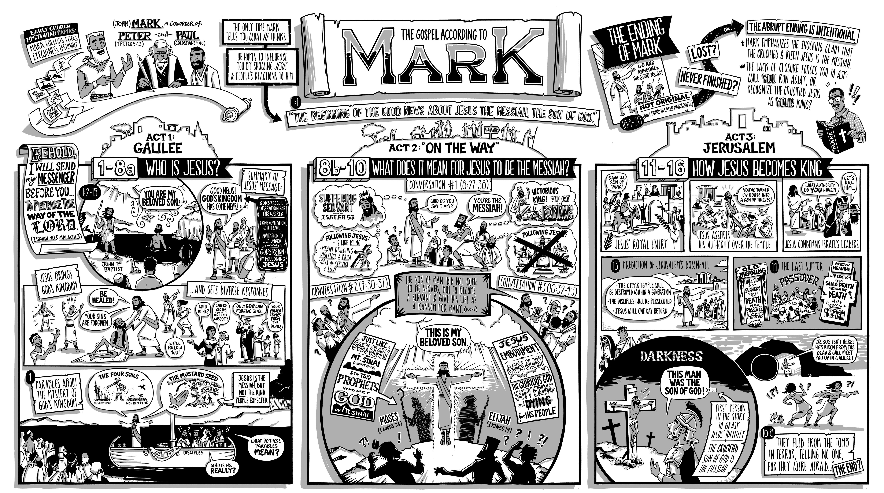
Discerning “the yeast of Pharisees and that of Herod”
¹⁴ The disciples had forgotten to bring bread, except for one loaf they had with them in the boat. ¹⁵ “Be careful,” Jesus warned them. “Watch out for the yeast of the Pharisees and that of Herod.”
¹⁶ They discussed this with one another and said, “It is because we have no bread.”
¹⁷ Aware of their discussion, Jesus asked them: “Why are you talking about having no bread? Do you still not see or understand? Are your hearts hardened? ¹⁸ Do you have eyes but fail to see, and ears but fail to hear? And don’t you remember? ¹⁹ When I broke the five loaves for the five thousand, how many basketfuls of pieces did you pick up?”
“Twelve,” they replied.
²⁰ “And when I broke the seven loaves for the four thousand, how many basketfuls of pieces did you pick up?”
They answered, “Seven.”
²¹ He said to them, “Do you still not understand?”
Mark 8

1. It was never about the physical provision – it was always about Jesus

2. They wouldn’t fully understand until after ______________________________________

The end of the beginning (or the beginning of the end) of the gospel story
²⁷ Jesus and his disciples went on to the villages around Caesarea Philippi. On the way he asked them, “Who do people say I am?”
²⁸ They replied, “Some say John the Baptist; others say Elijah; and still others, one of the prophets.”
²⁹ “But what about you?” he asked. “Who do you say I am?”
Peter answered, “You are the Christ.”
³⁰ Jesus warned them not to tell anyone about him.
³¹ He then began to teach them that the Son of Man must suffer many things and be rejected by the elders, chief priests and teachers of the law, and that he must be killed and after three days rise again. ³² He spoke plainly about this, and Peter took him aside and began to rebuke him.
³³ But when Jesus turned and looked at his disciples, he rebuked Peter. “Get behind me, Satan!” he said. “You do not have in mind the things of God, but the things of men . . . .”
Mark 9

1. Peter’s response reveals that the disciples have only started to see clearly

2. This is the second Mark 8 warning about timing (see Mark 9:9 for the third time). What the disciples still needed to see more clearly is work of Messiah – suffering before glory

The main point: I need to see clearly whether I’m the blind man or a disciple

Forty days “on the way” with Jesus to the cross
⁵¹ As the time approached for him to be taken up to heaven, Jesus resolutely set out for Jerusalem.
Luke 9

Doug’s question: What do I want to see more clearly during this Lent season?

1. The first sign of the kingdom is that I clearly see Messiah
¹⁸ In that day the deaf will hear the words of the scroll,
and out of gloom and darkness the eyes of the blind will see.
¹⁹ Once more the humble will rejoice in the Lord;
the needy will rejoice in the Holy One of Israel.
Isaiah 29

2. Satan’s plan (and that of the nasty yeast) is still to skip the cross
³¹ He then began to teach them that the Son of Man must suffer many things and be rejected by the elders, chief priests and teachers of the law, and that he must be killed and after three days rise again. ³² He spoke plainly about this, and Peter took him aside and began to rebuke him.
³³ But when Jesus turned and looked at his disciples, he rebuked Peter. “Get behind me, Satan!” he said. “You do not have in mind the things of God, but the things of men.”
³⁴ Then he called the crowd to him along with his disciples and said: “If anyone would come after me, he must deny himself and take up his cross and follow me . . . .”
Mark 8

3. My blindness is healed and the resurrection happened – so we are free to tell everyone!
⁹ As they were coming down the mountain, Jesus gave them orders not to tell anyone what they had seen until the Son of Man had risen from the dead. ¹⁰ They kept the matter to themselves, discussing what “rising from the dead” meant.
Mark 9

Resources for studying Mark
The poster for Mark can be found at bibleproject.com
Redeemer Presbyterian’s Lent devotions are online at https://gospelinlife.com/lent-devotional/
There is a wonderful series of sermons by Kim Riddlebarger (though I think he gets the “don’t go into the village” part at least partly wrong) at http://kimriddlebarger.squarespace.com/downloadable-sermons-on-mark/
J. C. Ryles has an interesting commentary on Mark’s gospel at https://www.gracegems.org/Ryle/mark08.htm
Spurgeon has wonderful sermon on salvation themes of the Mark 8 text at spurgeongems.org/vols10-12/chs701.pdf
The

