The Kingdom and the Lord
Summer 2022, Acts 28:11-31 September 18, 2022
Boldly and without hindrance he preached the kingdom of God
and taught about the Lord Jesus Christ.
Acts 28:31

The final miles to Rome
¹¹ After three months we put out to sea in a ship that had wintered in the island. It was an Alexandrian ship with the figurehead of the twin gods Castor and Pollux. ¹² We put in at Syracuse and stayed there three days. ¹³ From there we set sail and arrived at Rhegium. The next day the south wind came up, and on the following day we reached Puteoli. ¹⁴ There we found some brothers who invited us to spend a week with them. And so we came to Rome. ¹⁵ The brothers there had heard that we were coming, and they traveled as far as the Forum of Appius and the Three Taverns to meet us. At the sight of these men Paul thanked God and was encouraged. ¹⁶ When we got to Rome, Paul was allowed to live by himself, with a soldier to guard him.
Acts 28:11-16

1. Now the wind is literally at Paul’s back

2. Paul is encouraged – maybe because his letter to the Romans (see Romans 1:8-12) had been read!

Paul’s first task in Rome: meet with the Jewish leaders
¹⁷ Three days later he called together the leaders of the Jews. When they had assembled, Paul said to them: “My brothers, although I have done nothing against our people or against the customs of our ancestors, I was arrested in Jerusalem and handed over to the Romans. ¹⁸ They examined me and wanted to release me, because I was not guilty of any crime deserving death. ¹⁹ But when the Jews objected, I was compelled to appeal to Caesar—not that I had any charge to bring against my own people. ²⁰ For this reason I have asked to see you and talk with you. It is because of the hope of Israel that I am bound with this chain.”
²¹ They replied, “We have not received any letters from Judea concerning you, and none of the brothers who have come from there has reported or said anything bad about you. ²² But we want to hear what your views are, for we know that people everywhere are talking against this sect.”
Acts 28:17-22

1. The “hope of Israel” (God himself in Jeremiah 14:8; 17:13) is that Messiah would establish God’s kingdom (see Daniel 2)

2. Doug is skeptical that the Jewish leaders didn’t know more about Paul, but they are concerned
about any conflict with Paul in light of Claudius’ edict of 49 AD
Sh
²³ They arranged to meet Paul on a certain day, and came in even larger numbers to the place where he was staying. From morning till evening he explained and declared to them the kingdom of God and tried to convince them about Jesus from the Law of Moses and from the Prophets. ²⁴ Some were convinced by what he said, but others would not believe. ²⁵ They disagreed among themselves and began to leave after Paul had made this final statement: “The Holy Spirit spoke the truth to your forefathers when he said through Isaiah the prophet:
²⁶ “ ‘Go to this people and say,
“You will be ever hearing but never understanding;
you will be ever seeing but never perceiving.”
²⁷ For this people’s heart has become calloused;
they hardly hear with their ears, and they have closed their eyes.
Otherwise they might see with their eyes, hear with their ears,
understand with their hearts and turn, and I would heal them.’
²⁸ “Therefore I want you to know that God’s salvation has been sent to the Gentiles, and they will listen!”
Acts 28, Paul quotes from Isaiah 6:9-10

1. By “explained and declared the kingdom of God” Luke is pointing to the fulfillment of the Old Testament promises AND to the ethics of the kingdom (summarized in the Sermon on the Mount)

2. Paul’s “convincing them about Jesus” sounds like Luke 24:27 and would include all the faith in Jesus elements of the gospel: cross and resurrection, promise of the Holy Spirit, faith repentance

3. God faithfully preserved the Jewish people to bring the gospel to us Gentiles whose rejection of Messiah was foretold in Isaiah (thanks to Bob Deffinbaugh, see also Romans 11:1-10)

The last word in Luke’s continuing story
³⁰ For two whole years Paul stayed there in his own rented house and welcomed all who came to see him. ³¹ Boldly and without hindrance he preached the kingdom of God and taught about the Lord Jesus Christ.
Acts 28:30-32

1. The abrupt ending is Luke’s way of telling us that the gospel is more important than Paul (see Philippians 1:12-14), but there might be an even more important reason for this ending

2. “Declaring the kingdom” and “preaching about Jesus” summarize Luke’s message in Luke/Acts
(see Luke 4:43, 9:2, 18:24-29, 22:16-30; Acts 1:3, 8:12, 13:32-33, 19:8)

3. The more Paul is chained, the less he (and more importantly, the gospel) is hindered
Acts 29: Preaching the kingdom and teaching about the Lord

1. Preaching the kingdom announces the advent of the “crusher” kingdom of which we are a part!

⁴⁴ “In the time of those kings, the God of heaven will set up a kingdom that will never be destroyed, nor will it be left to another people. It will crush all those kingdoms and bring them to an end, but it will itself endure forever. ⁴⁵ This is the meaning of the vision of the rock cut out of a mountain, but not by human hands—a rock that broke the iron, the bronze, the clay, the silver and the gold to pieces.
Daniel 2

2. The kingdom always includes repentance and faith: my response and the Jesus story

¹⁴ After John was put in prison, Jesus went into Galilee, proclaiming the good news of God. ¹⁵ “The time has come,” he said. “The kingdom of God is near. Repent and believe the good news!”
Mark 1 (see Luke 4:43)

3. Participation in this kingdom requires a new ethic: what I should love and what I should hate

“Blessed are you who are poor,
for yours is the kingdom of God.”
Luke 6:20 (the “ethic” for this kingdom is summarized in 6:20-49)

4. Luke’s most important reason for this abrupt ending? The Great Commission is not complete and
the Holy Spirit is still at work!

In my former book, Theophilus, I wrote about all that Jesus began to do and to teach ² until the day he was taken up to heaven, after giving instructions through the Holy Spirit to the apostles he had chosen. ³ After his suffering, he showed himself to these men and gave many convincing proofs that he was alive. He appeared to them over a period of forty days and spoke about the kingdom of God. ⁴ On one occasion, while he was eating with them, he gave them this command: “Do not leave Jerusalem, but wait for the gift my Father promised, which you have heard me speak about. ⁵ For John baptized with water, but in a few days you will be baptized with the Holy Spirit.”
⁶ So when they met together, they asked him, “Lord, are you at this time going to restore the kingdom to Israel?”
⁷ He said to them: “It is not for you to know the times or dates the Father has set by his own authority. ⁸ But you will receive power when the Holy Spirit comes on you; and you will be my witnesses in Jerusalem, and in all Judea and Samaria, and to the ends of the earth.”
Acts 1

Resources for further studies in Acts
The Bible Project team has great stuff on Acts at https://open.life.church/items/179224-poster-jpg
Spurgeon has several sermons on texts in Acts which are available at https://www.biblebb.com/brefindex/act.htm
Tim Keller has a wonderful article at Christianity Today (April, 2021) on hope and resurrection at https://www.christianitytoday.com/ct/2021/april-web-only/timothy-keller-hope-times-fear-resurrection-better-world.html Keller also addresses the impact of the resurrection on his own diagnosis of pancreatic cancer in The Atlantic at https://www.theatlantic.com/ideas/archive/2021/03/tim-keller-growing-my-faith-face-death/618219/
This Gospel Coalition “Why the Resurrection Changes Everything” article includes a survey of many of the key resurrection texts: https://www.thegospelcoalition.org/article/why-the-resurrection-changes-everything/
Peter Krol offers an interesting take on the structure of Acts 27 at https://www.knowableword.com/2021/09/03/what-should-we-make-of-pauls-shipwreck-narrative/
D. A. Carson has a wonderful essay from Acts 17 on “Worldview Evangelism” at https://www.monergism.com/athens-revisited-exegetical-study-acts-17-da-carson
Deffinbaugh’s Acts messages are at https://bible.org/series/studies-book-acts His sermon on Acts 28 is at https://bible.org/seriespage/35-paul-rome-acts-281-31
Allistair Begg has a sermon in this text which focuses on the how God works through the circumstances of Paul’s life at https://www.truthforlife.org/resources/sermon/all-things-god-works/
For those who want to dig deeper into the worldview clash at Mars Hill, I recommend Andrew Klavan’s challenging “Speaking Truth into Modern Culture” at https://youtu.be/Cckiti7as44
John Stott’s The Spirit, The Church and the World: The Message of Acts (IVP, 1990) and F. F. Bruce’s work: New Testament History (Doubleday, 1980) and The Book of the Acts (Eerdmans, 1984). For this passage, I also like Kistemaker’s commentary (Baker Book House, 1990).
Harry Boer, That My House May Be Filled (Eerdmans, 1957)

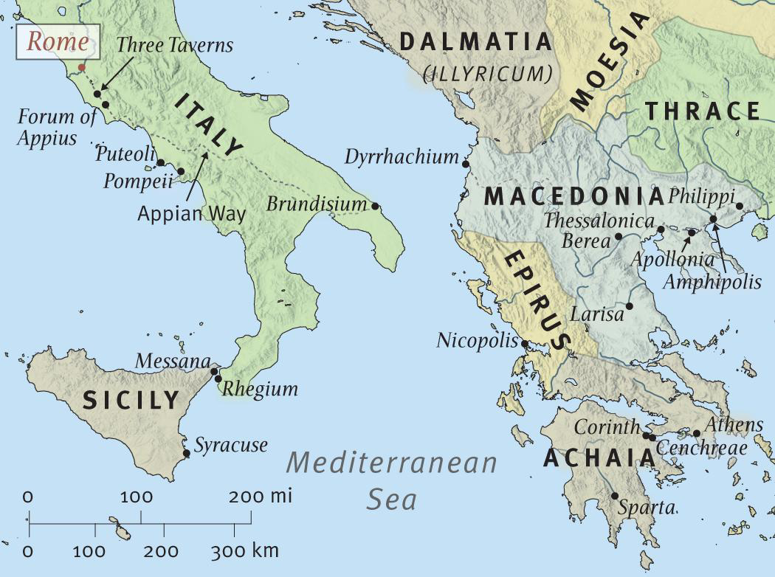

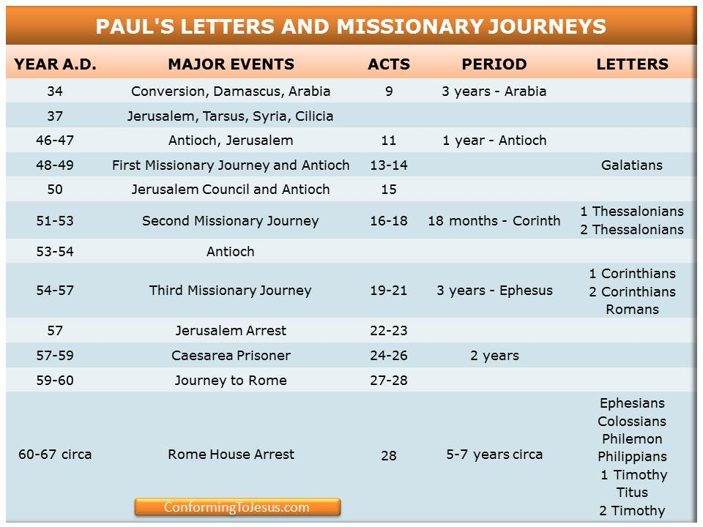

Acts Timeline (ESV Study Bible)

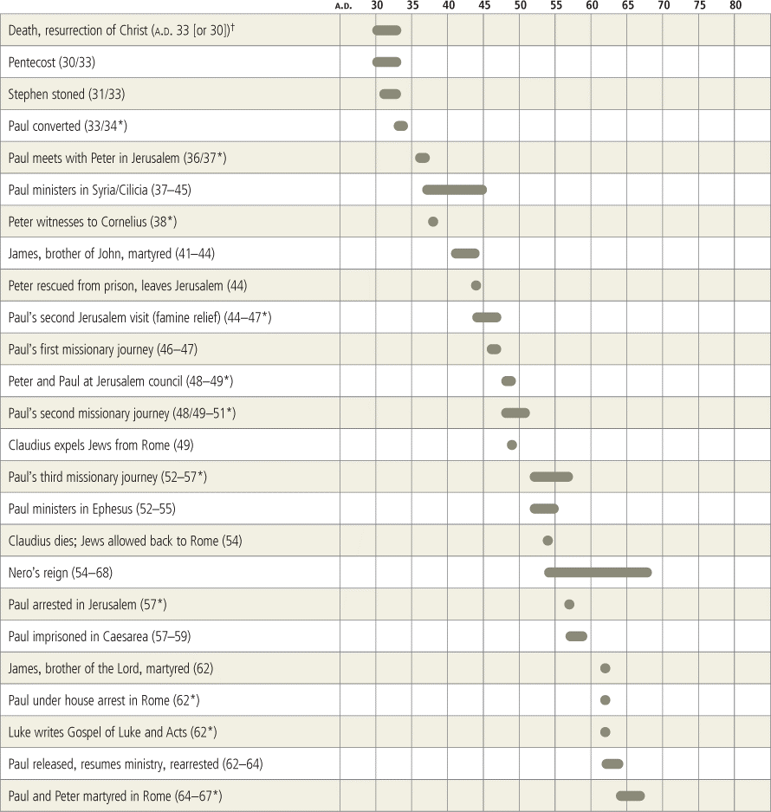

Paul in Rome (Acts 28:1-31)
Bob Deffinbaugh at https://bible.org/seriespage/35-paul-rome-acts-281-31
1 After we had safely reached shore, we learned that the island was called Malta. 2 The local inhabitants showed us extraordinary kindness, for they built a fire and welcomed us all because it had started to rain and was cold. 3 When Paul had gathered a bundle of brushwood and was putting it on the fire, a viper came out because of the heat and fastened itself on his hand. 4 When the local people saw the creature hanging from Paul’s hand, they said to one another, “No doubt this man is a murderer! Although he has escaped from the sea, Justice herself has not allowed him to live!” 5 However, Paul shook the creature off into the fire and suffered no harm. 6 But they were expecting that he was going to swell up or suddenly drop dead. So after they had waited a long time and had seen nothing unusual happen to him, they changed their minds and said he was a god.
7 Now in the region around that place were fields belonging to the chief official of the island, named Publius, who welcomed us and entertained us hospitably as guests for three days. 8 The father of Publius lay sick in bed, suffering from fever and dysentery. Paul went in to see him and after praying, placed his hands on him and healed him. 9 After this had happened, many of the people on the island who were sick also came and were healed. 10 They also bestowed many honors, and when we were preparing to sail, they gave us all the supplies we needed.
11 After three months we put out to sea in an Alexandrian ship that had wintered at the island and had the “Heavenly Twins” as its figurehead. 12 We put in at Syracuse and stayed there three days. 13 From there we cast off and arrived at Rhegium, and after one day a south wind sprang up and on the second day we came to Puteoli. 14 There we found some brothers and were invited to stay with them seven days. And in this way we came to Rome. 15 The brothers from there, when they heard about us, came as far as the Forum of Appius and Three Taverns to meet us. When he saw them, Paul thanked God and took courage. 16 When we entered Rome, Paul was allowed to live by himself, with the soldier who was guarding him.
17 After three days Paul called the local Jewish leaders together. When they had assembled, he said to them, “Brothers, although I had done nothing against our people or the customs of our ancestors, from Jerusalem I was handed over as a prisoner to the Romans. 18 When they had heard my case, they wanted to release me, because there was no basis for a death sentence against me. 19 But when the Jews objected, I was forced to appeal to Caesar – not that I had some charge to bring against my own people. 20 So for this reason I have asked to see you and speak with you, for I am bound with this chain because of the hope of Israel.” 21 They replied, “We have received no letters from Judea about you, nor have any of the brothers come from there and reported or said anything bad about you. 22 But we would like to hear from you what you think, for regarding this sect we know that people everywhere speak against it.” 23 They set a day to meet with him, and they came to him where he was staying in even greater numbers. From morning until evening he explained things to them, testifying about the kingdom of God and trying to convince them about Jesus from both the law of Moses and the prophets. 24 Some were convinced by what he said, but others refused to believe.
25 So they began to leave, unable to agree among themselves, after Paul made one last statement: “The Holy Spirit spoke rightly to your ancestors through the prophet Isaiah 26 when he said, ‘Go to this people and say, “You will keep on hearing, but will never understand, and you will keep on looking, but will never perceive. 27 For the heart of this people has become dull, and their ears are hard of hearing, and they have closed their eyes, so that they would not see with their eyes and hear with their ears and understand with their heart and turn, and I would heal them.”’ 28 “Therefore be advised that this salvation from God has been sent to the Gentiles; they will listen!”
30 Paul lived there two whole years in his own rented quarters and welcomed all who came to him, 31 proclaiming the kingdom of God and teaching about the Lord Jesus Christ with complete boldness and without restriction.¹

Introduction²
The books of the Bible end in interesting ways. The Book of Jonah has what I call an “Alfred Hitchcock ending.” It is just not what we would have expected. How can you be comfortable about a prophet wanting to watch innocent children die and talking back to God when he is rebuked for it? Then there are the “feel good endings,” such as we find in the last chapter of the Book of Ruth. There is also the disputed ending of the Gospel of Mark and the postscript ending of the Gospel of John.
The conclusion to the Book of Acts is unique in a different way – it does not answer some questions which are in our minds:
1. Why is there no account of Paul standing before Caesar?
2. Why are there accounts of one rescue after another which enable Paul to get to Rome, and then in the final chapter of the book, we are not given any account of his trial, and particularly its outcome?
There would appear to be one easy answer to these questions – Luke completed Acts before these things happened. You can’t write about what hasn’t yet happened. In this case, we must acknowledge that God did not consider an account of these events to be essential for Christians; otherwise, other (later) writings containing these accounts would have been included in the New Testament canon. Setting these time-related questions aside, other questions remain:
1. Why is there no great emphasis on Paul’s Gentile ministry (or ministry in general) in Rome?
2. Why is there so much more emphasis on the shipwreck in chapter 27 and the beginning of chapter 28 than on Paul’s time in Rome in chapter 28?
3. Why is there so much emphasis on Publius and his family, and yet none on Caesar?
4. Why was it so important for Paul to reach Rome when there was already a church there?
5. What did Paul’s visit to Rome accomplish?
6. Why did Paul use such strong words (citing from Isaiah 6) in responding to the Jewish leaders in Rome when their rejection of the gospel was neither unanimous nor violent?
As Luke draws the Book of Acts to a conclusion, he leaves a lot of our questions unanswered. In days gone by, I would have attempted to explain this by saying that Luke intended to write yet another volume or, he assumed that a “third volume” is even now in the process of being “written.” I no longer think this is true. I now believe that Luke concluded the Book of Acts just as he very carefully crafted it to be. The problem is not that Luke has left important things out of his account; the problem is that we are looking for the wrong things, rather than paying attention to what Luke is trying to tell us. What is the message to Luke’s early readers, and what is the message for us? That is what we shall seek to discover in our consideration of this final chapter of Acts.

Ministry at Malta Acts 28:1-10
1 After we had safely reached shore, we learned that the island was called Malta. 2 The local inhabitants showed us extraordinary kindness, for they built a fire and welcomed us all because it had started to rain and was cold. 3 When Paul had gathered a bundle of brushwood and was putting it on the fire, a viper came out because of the heat and fastened itself on his hand. 4 When the local people saw the creature hanging from Paul’s hand, they said to one another, “No doubt this man is a murderer! Although he has escaped from the sea, Justice herself has not allowed him to live!” 5 However, Paul shook the creature off into the fire and suffered no harm. 6 But they were expecting that he was going to swell up or suddenly drop dead. So after they had waited a long time and had seen nothing unusual happen to him, they changed their minds and said he was a god.
7 Now in the region around that place were fields belonging to the chief official of the island, named Publius, who welcomed us and entertained us hospitably as guests for three days. 8 The father of Publius lay sick in bed, suffering from fever and dysentery. Paul went in to see him and after praying, placed his hands on him and healed him. 9 After this had happened, many of the people on the island who were sick also came and were healed. 10 They also bestowed many honors, and when we were preparing to sail, they gave us all the supplies we needed (Acts 28:1-10).
Chapter 27 ended with all 276 passengers safely on shore. The passengers would not have kept any heavy clothing, because they had to swim (or paddle on some piece of wreckage) to shore. We know that the storm was still raging, and thus there would have been high seas and strong winds. On top of this, it was raining (heavily, I would assume). Can you imagine how cold folks were as they gathered on shore? The local people saw what was happening and came to help. They quickly built a fire, so that the shivering passengers could warm up.
Some scoffers have objected that there are now no trees on Malta (or so I have read). How, then, could they be gathering firewood? Easily. First, the fact that there are no trees now does not prove that there were no trees then. But beyond this, we should simply point out that no trees were necessary. I have been around the water in my younger days. Unless the Mediterranean Sea is different from the other seas, there is always a good deal of driftwood around, especially when there is a storm. And if one does not find this sufficient, then let me remind you that a large wooden ship had just broken up into small pieces. Many of these pieces reached shore because the non-swimmers clung to them as they worked their way to shore.
Okay, so there really was firewood to gather. The thing to which Luke calls our attention is that Paul was gathering firewood when he was bitten by a viper.³ In the traveling I have done in the Third World, wood gathering was the work of women or children. I don’t know that I can ever recall seeing a man gathering or carrying firewood. The point is that Paul is doing very menial work here when he gathers firewood. That fire may very well have saved some lives. It certainly warmed those who were chilled to the bone. Gathering firewood made a very important contribution to the well-being of the passengers. We don’t know whether others gathered wood or not, but we do know that Paul did.
The viper was probably in somewhat of a dormant state when it was gathered up with the firewood. The warmth of the fire (the heat of the flames) awakened the viper, and it struck the hand which held it, fastening its teeth in his skin. Today we would probably call this viper a “two-stepper” – in two steps the one bitten could be expected to drop dead. The natives knew their snakes, and when they saw the viper fasten itself to Paul’s hand, they were certain that he would be dead in moments. They reasoned that while Paul had escaped death at sea, the goddess of justice⁴ had chosen to bring the appropriate retribution by killing him this way. Surely, they reasoned, Paul must have done something very bad, and now he was going to pay for it.
Paul merely shook the viper into the fire, as the natives looked on with great interest. As time passed, they realized that the snake’s bite had no adverse affect on Paul, and so they changed their minds. This man was not being punished by the gods; he was a god. Unlike the natives in Lystra,⁵ these folks apparently did not attempt to worship Paul. The point here seems to be that the incident with the serpent gave Paul a much more attentive audience and gave the gospel credibility.⁶ One cannot imagine Paul being with these folks for three months and not sharing the gospel with them.
But this is not the only miracle that took place on that island during Paul’s stay. The ship happened to run aground near the fields owned by the governor of the island. This man, whose name was Publius, was Rome’s representative on Malta. What an incredibly large group to “drop in,” uninvited for dinner – for three days! Providentially, Publius was probably the only man on the island wealthy enough to handle such a crowd. Paul learned that the father of Publius was ill and went in to see him. After praying, Paul put his hands on this fellow and healed him. It didn’t take long for the news of this to spread, and soon the sick came from all over the island and were healed.
These healings (in addition to the viper incident) would have given Paul a credibility that would likely have opened doors for evangelism among these people, but Luke does not choose to discuss this. Instead, he writes that when they were preparing to leave Malta for Rome, the people generously provided them with all the supplies that they needed.
What is the connection between the serpent, the sick, and the supplies? I would suggest that here, as earlier (on board the ship), Paul’s presence proved to be a blessing to all. All on board the ship were saved, on account of Paul.⁷ Because of Paul’s ministry of healing the sick on Malta, everyone enjoyed the generous provisions supplied by the grateful people of the island. Paul’s presence was the basis for the blessings all the others enjoyed.

Paul and the Abrahamic Covenant
In this connection, it occurred to me that Paul was “the perfect Jew.” In particular, Paul’s life demonstrated how the Abrahamic Covenant was meant to work in the world:
1 Now the Lord said to Abram, “Go forth from your country, And from your relatives And from your father’s house, To the land which I will show you; 2 And I will make you a great nation, And I will bless you, And make your name great; And so you shall be a blessing; 3 And I will bless those who bless you, And the one who curses you I will curse. And in you all the families of the earth will be blessed” (Genesis 12:1-3, NASB 95, emphasis mine).
The Jews rightly understood God’s covenant with Abraham to mean that God would bless him and his descendants. He promised to bless Abraham and Sarah by giving them a son (Isaac). God promised that He would bless Abraham’s descendants. He would give Abraham’s seed the land of Canaan, and He would bless them there. The problem was that the Jews came to look upon God’s blessings as their sole possession, rather than as a stewardship. They did not understand (or they chose to forget) that the Abrahamic Covenant also meant that the Jews would be a source of blessing to “all the families of the earth” (Genesis 12:3). And so it was that Jonah typified Israel’s resistance to this aspect of the Abrahamic Covenant. He illustrated Israel’s hatred of the Gentiles and of the Jews’ refusal to be a “light to the Gentiles,” as they were meant to be. Sadly, Jonah was not the exception; he was the rule.
Paul was the opposite of Jonah (as we noted in our last lesson). Paul, a true and fulfilled Jew (a Jew who trusted in Jesus as the Messiah), was a blessing to the Gentiles. Earlier, we saw how Paul blessed the Gentiles by bringing the gospel to them. But Paul was a blessing in other ways as well. Paul blessed those on board his ship by encouraging them, and by becoming the means of their deliverance. Paul blessed these shivering passengers by helping to keep the fire going. Paul was a blessing to Publius, his father, and to the natives of Malta by healing the sick. And because of the gratitude of these natives for Paul’s ministry to them, Paul was a blessing to the passengers, who enjoyed the provisions the people of Malta gladly provided.
This is the right way for a Jew to understand and apply the Abrahamic Covenant. It was not an excuse to look down upon Gentiles,⁸ but an incentive to serve the Gentiles and to be a blessing to them. And what greater blessing can a “child of Abraham”⁹ be to unsaved Gentiles than to tell them of the salvation that God has provided through the Jews,¹⁰ that is to say through Jesus?¹¹
Lest you think the Abrahamic Covenant is not instructive to Christians (which it surely is!) in this regard of being a blessing to others (particularly unbelievers), let me remind you of this passage in 1 Corinthians 7:
13 And if a woman has a husband who is not a believer and he is happy to live with her, she should not divorce him. 14 For the unbelieving husband is sanctified because of the wife, and the unbelieving wife because of her husband. Otherwise your children are unclean, but now they are holy (1 Corinthians 7:13-14).
I’m not sure I understand exactly how this works, but I am sure of the fact that God’s presence in His people should prove to be a blessing to those who are around His people. I wonder how much our neighbors and fellow employees delight to have us around, knowing that God’s blessings somehow flows through us to them.
So then, whenever we have an opportunity, let us do good to all people, and especially to those who belong to the family of faith (Galatians 6:10).
Let me underscore the fact that while God uses our spiritual gifts to bless others, this is not the only way that we can be a blessing to others. Paul blessed his shivering shipmates by gathering firewood. This was a lowly task, one that Paul could have left to others. Just as our Lord Jesus served His disciples by the humble task of washing their feet, so we are to serve others by humble service. Sometimes it is as simple as picking up a piece of trash someone has thoughtlessly left behind. Sometimes it may be mowing someone’s yard or washing their dishes. Let us never consider ourselves too good or too important to minister to others in humble ways. Taking a lesson from Paul, it may be high time for some Christians to “get on the stick.”

The Journey to Rome Acts 28:11-16
11 After three months we put out to sea in an Alexandrian ship that had wintered at the island and had the “Heavenly Twins” as its figurehead. 12 We put in at Syracuse and stayed there three days. 13 From there we cast off and arrived at Rhegium, and after one day a south wind sprang up and on the second day we came to Puteoli. 14 There we found some brothers and were invited to stay with them seven days. And in this way we came to Rome. 15 The brothers from there, when they heard about us, came as far as the Forum of Appius and Three Taverns to meet us. When he saw them, Paul thanked God and took courage. 16 When we¹² entered Rome, Paul was allowed to live by himself, with the soldier who was guarding him (Acts 28:11-16).
I am not going to spend much time here. Luke is telling his readers how they made it from Malta to Rome. They found another Alexandrian wheat ship that had wintered nearby on which they could book passage. Why does Luke bother to tell us that this ship had, as it were, a “hood ornament” of twin gods, who were worshipped as sons of Zeus? These were the gods to which the heathen looked for safety when navigating the seas. But why does Luke mention them? Let me suggest some possibilities. First, in combination with what we have already read in relation to the viper incident, we are informed that these Gentiles are truly pagans. They are deeply entrenched in idol worship. Second, it is such folks as these who so desperately need the gospel and are blessed by the unexpected arrival of Paul, Luke, and Aristarchus. Third, these heathen idolaters are far more receptive and gracious toward Paul than the Jewish leaders in Rome.
After wintering on Malta for three months, they once again set sail, making port first at Syracuse, an important city of Sicily. Then they sailed to Rhegium, on the very “toe” of Italy. Making good time, they arrived in Puteoli in only a couple days. This city was apparently the place where the Egyptian wheat ships made port and unloaded their cargo. There were believers in Puteoli, so Paul and his companions were allowed to stay with them for a week. From this point, Paul and the others would travel by land, along the great Appian Way. Believers in Rome had received Paul’s epistle to them (Romans) some time before,¹³ and so when they heard he was arriving, a number went out to meet him, traveling some 30 to 40 miles to do so. Paul was greatly encouraged to see them and thanked God for this.
Luke mentions something in verse 16 which, at first glance, may appear to be insignificant. Paul was allowed to live by himself in Rome, with a soldier guarding him. This was pretty exceptional treatment. Do you think the other prisoners (especially any who may have been condemned to death) would be allowed such freedom? The rest were probably herded into some crowded prison. Paul’s rented accommodations must have been rather spacious to accommodate the large groups that came to hear him.¹⁴ This seemingly insignificant detail is God’s providential provision of a place for Paul to entertain and teach people without hindrance.¹⁵

The Gospel to the Jews in Rome Acts 28:17-24
17 After three days Paul called the local Jewish leaders together. When they had assembled, he said to them, “Brothers, although I had done nothing against our people or the customs of our ancestors, from Jerusalem I was handed over as a prisoner to the Romans. 18 When they had heard my case, they wanted to release me, because there was no basis for a death sentence against me. 19 But when the Jews objected, I was forced to appeal to Caesar – not that I had some charge to bring against my own people. 20 So for this reason I have asked to see you and speak with you, for I am bound with this chain because of the hope of Israel.” 21 They replied, “We have received no letters from Judea about you, nor have any of the brothers come from there and reported or said anything bad about you. 22 But we would like to hear from you what you think, for regarding this sect we know that people everywhere speak against it.” 23 They set a day to meet with him, and they came to him where he was staying in even greater numbers. From morning until evening he explained things to them, testifying about the kingdom of God and trying to convince them about Jesus from both the law of Moses and the prophets. 24 Some were convinced by what he said, but others refused to believe (Acts 28:17-24).
Rome, at last! Rome is not new to us in Acts. Some pilgrims from Rome had been in Jerusalem to witness the miracle at Pentecost (Acts 2:10). It wasn’t so long ago that Luke informed us Jews were not welcome in Rome (Acts 18:2). For some time, Paul had intended to visit the saints in Rome:
Now after all these things had taken place, Paul resolved to go to Jerusalem, passing through Macedonia and Achaia. He said, “After I have been there, I must also see Rome” (Acts 19:21).
Paul’s plan was to collect the contributions of the saints in Macedonia and Achaia, deliver them to the needy brothers and sisters in Jerusalem, and then go directly to Rome. From here, Paul intended to be sent on to Spain:
22 This is the reason I was often hindered from coming to you. 23 But now there is nothing more to keep me in these regions, and I have for many years desired to come to you 24 when I go to Spain. For I hope to visit you when I pass through and that you will help me on my journey there, after I have enjoyed your company for a while. 25 But now I go to Jerusalem to minister to the saints. 26 For Macedonia and Achaia are pleased to make some contribution for the poor among the saints in Jerusalem. 27 For they were pleased to do this, and indeed they are indebted to the Jerusalem saints. For if the Gentiles have shared in their spiritual things, they are obligated also to minister to them in material things. 28 Therefore after I have completed this and have safely delivered this bounty to them, I will set out for Spain by way of you, 29 and I know that when I come to you I will come in the fullness of Christ’s blessing (Romans 15:22-29).
Paul’s plan was a good one, but God often modifies our plans so that His fingerprints are all over what He accomplishes through us. God had even given some indication of these changes when He repeatedly revealed that in Jerusalem Paul would encounter imprisonment and persecutions.¹⁶ He arrived safely in Rome, attached to a Roman guard. But there he would bear witness to the salvation God had provided in the death and resurrection of the Lord Jesus.
The following night the Lord stood near Paul and said, “Have courage, for just as you have testified about me in Jerusalem, so you must also testify in Rome” (Acts 23:11).
And now Paul is in Rome. After three days, Paul contacts the Jewish leaders and invites them to visit him in his rented quarters. When they had gathered, Paul explained his presence in Rome. He assured them that he had not done anything against the Jews or against Jewish customs. He had been handed over as a prisoner to the Romans, and they recognized that he was innocent. They wanted to release him but encountered strong opposition from the Jews, forcing Paul to appeal to Caesar. He made it clear that he did not intend to press charges against the Jews, but only to face the charges they had raised. Paul declared that his chains were due to his faith in what (more accurately, in Whom) was the hope of Israel.
The response of the Jewish leaders is rather amazing. They claim not to have received any letters about Paul, nor had any brethren come from Jerusalem because of Paul. They did claim to have knowledge regarding the “sect” (Christianity) that Paul represented, and they admitted that it was commonly opposed. I think what they are saying is that while they had received no formal charges against Paul, they were aware of the gospel and its impact, and at best they were skeptical. Nevertheless, they were willing to give Paul the opportunity to present his position on these matters. And so a date is set for them to gather and to discuss these things more at length.
That date came, and so did a good number of Jews. I would assume those who gathered represented the Jewish leadership in Rome. If so, the outcome would likely determine whether or not the Jewish leadership in Rome would recommend Paul and his teachings to other Jews. For an entire day, Paul spoke of the kingdom of God, showing how the Lord Jesus fulfilled the Old Testament Scriptures. I would have loved to have heard this survey of the Old Testament and its relationship to Jesus. I imagine that it was very similar to the teaching of our Lord to the two disciples on the road to Emmaus:
Then beginning with Moses and all the prophets, he interpreted to them the things written about himself in all the scriptures (Luke 24:27).
As usual, some were convinced by Paul’s teaching, but others “refused to believe.” This is an interesting choice of words on Luke’s part. He does not say that they were not convinced, as though Paul’s presentation had its weaknesses. What he says strongly implies that Paul’s arguments were compelling, but in spite of the overwhelming evidence in support of Paul’s faith, they refused to believe it. The problem was not with Paul’s presentation; the problem was with the hardened hearts of those who heard.

The End of an Era Acts 28:25-29
25 So they began to leave, unable to agree among themselves, after Paul made one last statement: “The Holy Spirit spoke rightly to your ancestors through the prophet Isaiah 26 when he said, ‘Go to this people and say, “You will keep on hearing, but will never understand, and you will keep on looking, but will never perceive. 27 For the heart of this people has become dull, and their ears are hard of hearing, and they have closed their eyes, so that they would not see with their eyes and hear with their ears and understand with their heart and turn, and I would heal them.”’ 28 “Therefore be advised that this salvation from God has been sent to the Gentiles; they will listen!” [29 When he had said these things, the Jews departed, having a great dispute among themselves.] (Acts 28:25-29)
The outcome of this meeting reminds me of Paul’s trial before the Sanhedrin, when some (Pharisees) sided with Paul, and the rest strongly opposed him.¹⁷ In verse 25, Luke tells us that these Jews disagreed among themselves about what Paul had taught. A number of translations do not regard verse 29 as a part of the original text because it is missing in some key manuscripts. This verse simply reiterates Luke’s statement in verse 25, even more emphatically.
As they are beginning to leave, Paul cites Isaiah 6:9-10 as a fitting explanation of their response to the gospel. This quotation is even more meaningful because our Lord cited this same text in every one of the four Gospels. In Matthew (13:14-15), Mark (4:12), and Luke (8:10), Jesus cited this same text from Isaiah 6 to explain why He had begun to teach the people in parables. In effect, Jesus responded, “I am speaking to them in parables so that they won’t understand Me, won’t repent, and thus won’t be saved.”
This seems like a horrible thing to say, until you consider the context, and understand why Jesus said this. Jesus had been performing many miracles to underscore the authenticity of His teaching. Initially, the Jewish leaders who opposed Jesus sought to discredit these miracles as being something less than miraculous (see John 9:13-34). But when the authenticity of these miracles became undeniable, the scribes from Jerusalem took a different approach: they claimed that our Lord’s miraculous power was actually that of the devil. Thus they attributed the work of the Holy Spirit in Jesus to the work of Satan in Jesus: to them, Jesus was demon possessed.
The experts in the law who came down from Jerusalem said, “He is possessed by Beelzebul,” and, “By the ruler of demons he casts out demons” (Mark 3:22).
Jesus responded that while every blasphemy against Him might be forgiven, they had blasphemed against the Holy Spirit, and this sin would never be forgiven. This blasphemy (attributing the work of the Holy Spirit in Jesus to the devil) was the unpardonable sin. This sin was unforgivable, and thus Jesus spoke in parables to keep them from understanding the gospel and repenting. They had passed the point of no return.
In John’s Gospel, the circumstances surrounding our Lord’s citation from Isaiah 6 are different. Jesus has just made His triumphal entry into Jerusalem.¹⁸ The Father spoke from heaven to the Son. Some thought it was merely the sound of thunder; others thought that an angel had spoken to Jesus.¹⁹ Even though Jesus had performed many signs among them, the Jews as a nation still refused to believe. John interpreted their unbelief as the fulfillment of Isaiah’s words in Isaiah 6:10. They did not believe because they could not believe. Their eyes were judicially blinded, and their hearts were hardened. They had seen and heard more than enough evidence to prove that Jesus was the promised Messiah, but they refused to believe in Him. The time for their national repentance had ended. Soon, they would cry for Pilate to crucify Jesus, and He would die, bearing our sin and our punishment. Not long after this, Jerusalem would be destroyed by the Romans.
Paul did not come to Rome to preach the gospel to Gentiles for the first time. There was already a church there, a church to which Paul had already written the Book of Romans several years earlier. It would seem that Paul was divinely sent to Rome in order to proclaim the gospel to Caesar and his household.²⁰ But in addition to this, I believe Paul was sent to Rome to preach the gospel to the Jews in clarity and power, so that they would be without excuse for rejecting it. Now they have heard, and they have reacted to the gospel. They have responded just like those in Jerusalem and elsewhere: a few have believed, but most have rejected the offer of salvation in Jesus, the promised Messiah. Because the nation has not turned, the sentence of judicial blindness has been imposed on the Jews.
9 You will be shocked and amazed! You are totally blind! They are drunk, but not because of wine; they stagger, but not because of beer. 10 For the Lord has poured out on you a strong urge to sleep deeply. He has shut your eyes (the prophets), and covered your heads (the seers). 11 To you this entire prophetic revelation is like words in a sealed scroll. When they hand it to one who can read and say, “Read this,” he responds, “I can’t, because it is sealed” (Isaiah 29:9-11).
16 I will lead the blind along an unfamiliar way; I will guide them down paths they have never traveled. I will turn the darkness in front of them into light, and level out the rough ground. This is what I will do for them. I will not abandon them. 17 Those who trust in idols will turn back and be utterly humiliated, those who say to metal images, ‘You are our gods.’” 18 “Listen, you deaf ones! Take notice, you blind ones! 19 My servant is truly blind, my messenger is truly deaf. My covenant partner, the servant of the Lord, is truly blind (Isaiah 42:16-19).
Paul spoke of this blindness in 2 Corinthians, chapters 3 and 4:
12 Therefore, since we have such a hope, we behave with great boldness, 13 and not like Moses who used to put a veil over his face to keep the Israelites from staring at the result of the glory that was made ineffective. 14 But their minds were closed. For to this very day, the same veil remains when they hear the old covenant read. It has not been removed because only in Christ is it taken away. 15 But until this very day whenever Moses is read, a veil lies over their minds, 16 but when one turns to the Lord, the veil is removed. 17 Now the Lord is the Spirit, and where the Spirit of the Lord is present, there is freedom. 18 And we all, with unveiled faces reflecting the glory of the Lord, are being transformed into the same image from one degree of glory to another, which is from the Lord, who is the Spirit (2 Corinthians 3:12-18).
3 But even if our gospel is veiled, it is veiled only to those who are perishing, 4 among whom the god of this age has blinded the minds of those who do not believe so they would not see the light of the glorious gospel of Christ, who is the image of God. 5 For we do not proclaim ourselves, but Jesus Christ as Lord, and ourselves as your slaves for Jesus’ sake. 6 For God, who said “Let light shine out of darkness,” is the one who shined in our hearts to give us the light of the glorious knowledge of God in the face of Christ (2 Corinthians 4:3-6).
The blindness of the Jews could only be removed through faith in Jesus. Jesus has now been powerfully proclaimed to the Jewish leaders, and by and large they did not believe. The blindness remains, and it will only be removed through faith in Jesus as the promised Messiah. It is interesting, is it not, that Paul’s Epistle to the Romans focused on the relationship of the gospel to both Jews and Gentiles. Jewish unbelief is explained in a two-fold way: (a) they were not chosen (Romans 9:6-29); and (b) they did not believe in Jesus, but sought to merit God’s favor by law-keeping (Romans 9:30—10:4). Because the Jews would not bring Gentiles to faith by being a “light to the Gentiles,” they were blinded, and the light of the gospel was taken to the Jews. I believe that Paul’s citation from Isaiah 6 in Acts 28 formally announced the commencement of the “times of the Gentiles.” Paul makes it clear that a day is yet to come when “the full number of the Gentiles has come in,” and then God will turn again to His people, opening their blind eyes so that “all Israel will be saved:”
25 For I do not want you to be ignorant of this mystery, brothers and sisters, so that you may not be conceited: A partial hardening has happened to Israel until the full number of the Gentiles has come in. 26 And so all Israel will be saved, as it is written: “The Deliverer will come out of Zion; he will remove ungodliness from Jacob. 27 And this is my covenant with them, when I take away their sins.” 28 In regard to the gospel they are enemies for your sake, but in regard to election they are dearly loved for the sake of the fathers. 29 For the gifts and the call of God are irrevocable. 30 Just as you were formerly disobedient to God, but have now received mercy due to their disobedience, 31 so they too have now been disobedient in order that, by the mercy shown to you, they too may now receive mercy. 32 For God has consigned all people to disobedience so that he may show mercy to them all (Romans 11:25-32).

Two More Years Acts 28:30-31
30 Paul lived there two whole years in his own rented quarters and welcomed all who came to him, 31 proclaiming the kingdom of God and teaching about the Lord Jesus Christ with complete boldness and without restriction (Acts 28:30-31).
How gracious and longsuffering our God is. Paul pronounced the sentence of judicial blindness on Israel (the Jews), and yet he continued to preach the gospel to any and all who came to him for two full years. This Paul did with complete boldness, something for which he asked the Ephesian saints to pray:
18 With every prayer and petition, pray at all times in the Spirit, and to this end be alert, with all perseverance and requests for all the saints. 19 Pray for me also, that I may be given the message when I begin to speak – that I may confidently make known the mystery of the gospel, 20 for which I am an ambassador in chains. Pray that I may be able to speak boldly as I ought to speak (Ephesians 6:18-20, emphasis mine).
God had provided Paul with rented facilities that would accommodate all who came to hear the gospel. God provided Paul with the message and with the boldness to proclaim it. God even provided Paul with the protection of Rome to do so.
Think of it. How would Paul ever have been able to gain an audience with Caesar in Rome? How “free” would Paul have been to preach to the Jews if he had simply been declared innocent and then was released? My sense is that the Jewish opposition would have at least harassed Paul, and most likely would have killed him if they could do so. That soldier to whom Paul was chained did not restrict him from preaching the gospel. Those soldiers to whom Paul was chained heard the gospel over and over. They stood by as Paul dictated his “Prison Epistles” (Galatians, Ephesians, Philippians). And, far from hindering Paul, they greatly helped by serving as his personal bodyguards. Isn’t it amazing the way God works to accomplish His purposes and promises?

Conclusion
Having studied this final chapter of Acts, let us seek to identify what Paul did and did not emphasize in his conclusion. In this way, we should be able to discern what Luke (and thus the Holy Spirit, who inspired the writing of this great work) intended for us to gain from the Book of Acts.
(1) Luke is not interested in merely reporting about disasters. For example, God did not choose to include an account of the fall of Jerusalem in 70 A.D. here, or in any other New Testament Book. If there was ever a New Testament Book where mention of the fall of Jerusalem might be expected, Acts would be that book.
One could certainly argue that if Acts was written around or before 62 A.D., Luke could hardly have written about the destruction of Jerusalem because it had not yet happened. But if God believed that we needed to know about the fall of Jerusalem, He could have delayed the writing of Acts until after this monumental event. Or, God could have provided some other work in the canon of the New Testament which described this tragic event.
I suspect that some may be disappointed that an account of the fall of Jerusalem is not to be found in Acts or elsewhere in the New Testament. Why are we so interested in this horrible event, but yet God passes over it in inspired Scripture? Perhaps we have been conditioned by the press and media to focus on the horrific and the sensational. Thus, some may find the conclusion of Acts anti-climactic because no such account is to be found here.
Tomorrow we will remember the fifth anniversary of 9/11 and the death of nearly 2,800 people. This was a terrible tragedy, but more Jews died in the fall of Jerusalem in 70 A.D. than this, many more. As a good friend has reminded me, many more people have been (and currently are being) tortured and murdered around the world, and yet we don’t even hear of it in the news, nor do we think about it. Indeed, 9/11 was a terrible tragedy, but why are we so focused on it, and not on other tragedies of even greater proportions? I think it is because we focus on those things which affect us, and we tend not to give thought to the tragedies that affect others. Luke has something more important to describe than the fall of Jerusalem.
To put it differently, Luke is not nearly as interested in reporting about the disasters and dark side of life as he is in proclaiming the good news of the gospel. The fall of Jerusalem was a terrible tragedy, but it does not affect us directly today, not nearly as much as the judicial hardening of the Jews and the commencement of the times of the Gentiles.
(2) Neither is Luke interested in reporting about the “rich and famous.” As a friend reminded me, Luke has more to say about Publius, his family, and his neighbors²¹ than he does about Caesar, who is mentioned only once in Acts 28. No wonder Paul writes,
26 Think about the circumstances of your call, brothers and sisters. Not many were wise by human standards, not many were powerful, not many were born to a privileged position. 27 But God chose what the world thinks foolish to shame the wise, and God chose what the world thinks weak to shame the strong. 28 God chose what is low and despised in the world, what is regarded as nothing, to set aside what is regarded as something, 29 so that no one can boast in his presence. 30 He is the reason you have a relationship with Christ Jesus, who became for us wisdom from God, and righteousness and sanctification and redemption, 31 so that, as it is written, “Let the one who boasts, boast in the Lord” (1 Corinthians 1:26-31).
I would hasten to add that those in Caesar’s household were also privileged to hear the gospel, although many of these folks could have been servants in the household of Caesar:
All the saints greet you, especially those who belong to Caesar’s household (Philippians 4:22).
(3) Luke does not even focus our attention on Paul in this concluding chapter. Now this is a surprise, to me at least. Haven’t we read that Paul would stand before kings, and suffer greatly for the gospel?²² Do we not expect to at least see this promise fulfilled by reading an account similar to what we have read in chapters 24–26? Do we not wish to know the outcome of Paul’s trial, and whether he was set free or condemned to death? Surely it is not wrong to care about what happened to Paul.
No, it is not wrong to care about Paul’s well being; but that is not what the Book of Acts is about. Paul understood this. He knew that it was not about him, but about the gospel, and we hear this from him on several occasions. For example, we find this in Acts 20, after Paul has just informed the Ephesian elders that he is going to Jerusalem, where imprisonment and suffering await him.²³ What is Paul’s response to this revelation?
“But I do not consider my life worth anything to myself, so that I may finish my task and the ministry that I received from the Lord Jesus, to testify to the good news of God’s grace” (Acts 20:24).
Paul is not concerned about the well being of these Ephesian elders, or the flock in Ephesus, because they have the Word of God:
“And now I entrust you to God and to the message of his grace. This message is able to build you up and give you an inheritance among all those who are sanctified” (Acts 20:32).
When Paul wrote to the Philippian saints (who alone sent a contribution to him while he was in confinement in Rome),²⁴ he knew that he might never see these folks again. Was he concerned because he would not be there for them? Not at all! Paul knew that it was not about him, but about God:
For I am sure of this very thing, that the one who began a good work in you will perfect it until the day of Christ Jesus (Philippians 1:6).
It is God who began the good work in these saints, and He finishes what He starts. The saints are not dependent upon Paul’s presence, but upon God, who is present through His Word and through His Spirit.
A few verses later in the first chapter of Philippians, Paul told how Christians had responded to his imprisonment:
12 I want you to know, brothers and sisters, that my situation has actually turned out to advance the gospel: 13 The whole imperial guard and everyone else knows that I am in prison for the sake of Christ, 14 and most of the brothers and sisters, having confidence in the Lord because of my imprisonment, now more than ever dare to speak the word fearlessly. 15 Some, to be sure, are preaching Christ from envy and rivalry, but others from goodwill. 16 The latter do so from love because they know that I am placed here for the defense of the gospel. 17 The former proclaim Christ from selfish ambition, not sincerely, because they think they can cause trouble for me in my imprisonment. 18 What is the result? Only that in every way, whether in pretense or in truth, Christ is being proclaimed, and in this I rejoice. Yes, and I will continue to rejoice (Philippians 1:12-18).
Some of the saints had been encouraged by Paul’s imprisonment, encouraged by his example to be even more bold in proclaiming the gospel. Thus, the gospel was being advanced through Paul’s imprisonment. Others were not so noble in their response to Paul’s incarceration. They seized on this occasion to proclaim the gospel at Paul’s expense (at least in their minds). They did so out of selfish motives. Did Paul agonize about this? Not at all! He reported that the gospel was being preached and folks were coming to faith. Paul did not concern himself about these personal insults; rather, he rejoiced in the fact that lost sinners were being brought to faith, though seemingly at his expense. It was a price he was more than willing to pay. To repeat myself, it is not about Paul; it is about the gospel.
In the following verses (Philippians 1:19-26), Paul speaks about his uncertain future. He could be granted his freedom, or he could be executed. How did Paul feel about this?
19 For I know that this will turn out for my deliverance through your prayers and the help of the Spirit of Jesus Christ. 20 My confident hope is that I will in no way be ashamed but that with complete boldness, even now as always, Christ will be exalted in my body, whether I live or die. 21 For to me, living is Christ and dying is gain. 22 Now if I am to go on living in the body, this will mean productive work for me, yet I don’t know which I prefer: 23 I feel torn between the two, because I have a desire to depart and be with Christ, which is better by far, 24 but it is more vital for your sake that I remain in the body. 25 And since I am sure of this, I know that I will remain and continue with all of you for the sake of your progress and joy in the faith, 26 so that what you can be proud of may increase because of me in Christ Jesus, when I come back to you (Philippians 1:19-26).
What mattered to Paul was not his life or his death. Death would actually be a promotion! What mattered to Paul was the progress of the gospel and the growth of the saints. If being given more time would edify the saints at Philippi and elsewhere, then so much the better, even if heaven were Paul’s preference.
This chapter is not about Paul standing before Caesar in Rome, or even about Paul being released by Rome. It is about the advance of the gospel. In particular, it is about the advance of the gospel by the commencement of the Times of the Gentiles. This is a monumental moment in history, far more important than the fate of any one man, or of any one city (Jerusalem).
The rejection of Jesus and the gospel by the Jews brought about an open door for the gospel to be proclaimed to the Gentiles. We saw this pattern in Paul’s preaching throughout the Book of Acts. He went to the “Jew first” and then, when the Jews rejected the gospel, Paul went to the Gentiles. When we reach the end of the Book of Acts we see, as it were, the final act of rejection by the Jews, and the “times of the Gentiles” officially begins.
This morning in our worship time, the opener turned our attention to 1 Peter 2:4-10:
4 So as you come to him, a living stone rejected by men but chosen and priceless in God’s sight, 5 you yourselves, as living stones, are built up as a spiritual house to be a holy priesthood and to offer spiritual sacrifices that are acceptable to God through Jesus Christ. 6 For it says in scripture, “Look, I lay in Zion a stone, a chosen and priceless cornerstone, and whoever believes in him will never be put to shame.” 7 So you who believe see his value, but for those who do not believe, the stone that the builders rejected has become the cornerstone, 8 and a stumbling-stone and a rock to trip over. They stumble because they disobey the word, as they were destined to do. 9 But you are a chosen race, a royal priesthood, a holy nation, a people of his own, so that you may proclaim the virtues of the one who called you out of darkness into his marvelous light. 10 You once were not a people, but now you are God’s people. You were shown no mercy, but now you have received mercy (1 Peter 2:4-10).
I want you to notice that Peter takes Old Testament texts which were originally directed to the Jews and applies them to Gentile believers. The same thing happens in Romans 9:25-26 when Paul cites Hosea 2:23 and 1:10 as an explanation for the salvation of Gentiles. These texts in Hosea were likewise addressed to disobedient Israelites. The “Great Reversal” occurs when the blessings God had provided for the Jews are now directed to the Gentile believers. That is what Acts chapter 28 is all about. The times of the Jews have been temporarily suspended; the times of the Gentiles have begun. What could be better news for those of us who are Gentiles?
God has faithfully preserved a remnant of believing Jews, which guarantees a bright future for the nation Israel:
27 And Isaiah cries out on behalf of Israel, “Though the number of the children of Israel are as the sand of the sea, only the remnant will be saved, 28 for the Lord will execute his sentence on the earth completely and quickly.” 29 Just as Isaiah predicted, “If the Lord of armies had not left us descendants, we would have become like Sodom, and we would have resembled Gomorrah” (Romans 9:27-29).
In the meantime, God is using the evangelization of the Gentiles to provoke the Jews to jealousy:
13 Now I am speaking to you Gentiles. Seeing that I am an apostle to the Gentiles, I magnify my ministry, 14 if somehow I could provoke my people to jealousy and save some of them (Romans 11:13-14).
When the times of the Gentiles is complete, and the temporary and partial hardening of the Jews is removed, then Israel will be drawn to faith in the Messiah and “all Israel will be saved” (Romans 11:25-27). God has used Jewish unbelief to open the door for Gentile evangelism, and this has been a great blessing to the Gentiles. Just imagine the blessing to the Gentiles when Israel comes to faith!
Now if their transgression means riches for the world and their defeat means riches for the Gentiles, how much more will their full restoration bring? (Romans 11:12)
Let us end this lesson and this study of the Book of Acts with the words of Paul at the end of Romans 11:
33 Oh, the depth of the riches and wisdom and knowledge of God! How unsearchable are his judgments and how fathomless his ways! 34 For who has known the mind of the Lord, or who has been his counselor? 35 Or who has first given to God, that God needs to repay him? 36 For from him and through him and to him are all things. To him be glory forever! Amen (Romans 11:33-36).

¹ Unless otherwise indicated, all Scripture quotations are from the NET Bible. The NEW ENGLISH TRANSLATION, also known as THE NET BIBLE, is a completely new translation of the Bible, not a revision or an update of a previous English version. It was completed by more than twenty biblical scholars who worked directly from the best currently available Hebrew, Aramaic, and Greek texts. The translation project originally started as an attempt to provide an electronic version of a modern translation for electronic distribution over the Internet and on CD (compact disk). Anyone anywhere in the world with an Internet connection will be able to use and print out the NET Bible without cost for personal study. In addition, anyone who wants to share the Bible with others can print unlimited copies and give them away free to others. It is available on the Internet at: www.netbible.org.
² Copyright © 2006 by Community Bible Chapel, 418 E. Main Street, Richardson, TX 75081. This is the edited manuscript of Lesson 35 in the Studies in the Book of Acts series prepared by Robert L. Deffinbaugh on September 10, 2006. Anyone is at liberty to use this lesson for educational purposes only, with or without credit. The Chapel believes the material presented herein to be true to the teaching of Scripture, and desires to further, not restrict, its potential use as an aid in the study of God’s Word. The publication of this material is a grace ministry of Community Bible Chapel.
³ I cannot believe that some would suggest that Paul was not really bitten here. How do you think the viper was able to hang from Paul’s hand if he hadn’t bitten him? Neither can I believe that some would suggest that these “primitives” were so ignorant they mistook a non-venomous snake for a viper. Let me assure you that such primitives are very skilled at telling the difference between a snake that kills and one that does not. In addition to this, Dr. Luke was with Paul. Surely a doctor would know the difference between a deadly snake bit and one that was not.
⁴ A footnote in the NET Bible reads:
That is, the goddess Justice has not allowed him to live. BDAG 250 s.v. ???? 2 states, “Justice personified as a deity Ac 28:4”; L&N 12.27, “a goddess who personifies justice in seeking out and punishing the guilty – ‘the goddess Justice.’ ? ???? ??? ??? ?????? ‘the goddess Justice would not let him live’ Ac 28:4.” Although a number of modern English translations have rendered ???? (dikh) “justice,” preferring to use an abstraction, in the original setting it is almost certainly a reference to a pagan deity. In the translation, the noun “justice” was capitalized and the reflexive pronoun “herself” was supplied to make the personification clear. This was considered preferable to supplying a word like ‘goddess’ in connection with ????.
⁵ See Acts 14:8-18.
⁶ Think of it. A significant element of the gospel was the resurrection of Jesus from the dead, and thus the resurrection of all men to eternal salvation or eternal condemnation (John 5:28-29; Acts 17:30-31). The truth of the resurrection of Jesus (in the past) and of all men (in the future) is certainly reinforced when spoken by a man who should have died and did not.
⁷ Acts 27:24, 42-43.
⁸ As one might do when their heathen idolatry became evident.
⁹ I use the term “child of Abraham” deliberately, applying it to all Christians, as Paul used it in Romans 4:16; see also Galatians 6:16.
¹⁰ See John 4:22.
¹¹ John 14:6; Acts 4:10-12.
¹² The “we” section (indicating Luke’s presence) ends here.
¹³ See Romans 1:9-13; 15:22-32.
¹⁴ See verses 17, 23.
¹⁵ See verses 30-31.
¹⁶ See Acts 20:23; 21:4, 10-14.
¹⁷ See Acts 23:6-10.
¹⁸ John 12:12-18.
¹⁹ John 12:28-29.
²⁰ See Acts 9:15; Philippians 4:22.
²¹ Acts 28:7-10.
²² Acts 9:15-16.
²³ See Acts 20:22-23.
²⁴ Philippians 4:15.

