Shipwreck and Snakes
Summer 2022, Acts 27:1-28:10 September 11, 2022
“So keep your faith, men, for I have faith in God that it will happen
just as he told me. Nevertheless, we must run aground on some island.”
Acts 27:25-26

Paul and his companions take to the sea
When it was decided that we would sail for Italy, Paul and some other prisoners were handed over to a centurion named Julius, who belonged to the Imperial Regiment. ² We boarded a ship from Adramyttium about to sail for ports along the coast of the province of Asia, and we put out to sea. Aristarchus, a Macedonian from Thessalonica, was with us.
Acts 27:1-2

1. Julius is Luke’s example for what happens when I reject and accept God’s word

2. Luke and Aristarchus seem to have travelled all the way to Rome (Acts 28:16; Colossians 4:10)

Paul’s three “speeches” on the ship (or, WDJD)
⁹ Much time had been lost, and sailing had already become dangerous because by now it was after the Fast. So Paul warned them, ¹⁰ “Men, I can see that our voyage is going to be disastrous and bring great loss to ship and cargo, and to our own lives also.” ¹¹ But the centurion, instead of listening to what Paul said, followed the advice of the pilot and of the owner of the ship. ¹² Since the harbor was unsuitable to winter in, the majority decided that we should sail on, hoping to reach Phoenix and winter there.
Acts 27:9-12

²¹ After the men had gone a long time without food, Paul stood up before them and said: “Men, you should have taken my advice not to sail from Crete; then you would have spared yourselves this damage and loss. ²² But now I urge you to keep up your courage, because not one of you will be lost; only the ship will be destroyed. ²³ Last night an angel of the God whose I am and whom I serve stood beside me ²⁴ and said, ‘Do not be afraid, Paul. You must stand trial before Caesar; and God has graciously given you the lives of all who sail with you.’ ²⁵ So keep up your courage, men, for I have faith in God that it will happen just as he told me. ²⁶ Nevertheless, we must run aground on some island.”
Acts 27:21-26

³³ Just before dawn Paul urged them all to eat. “For the last fourteen days,” he said, “you have been in constant suspense and have gone without food—you haven’t eaten anything. ³⁴ Now I urge you to take some food. You need it to survive. Not one of you will lose a single hair from his head.” ³⁵ After he said this, he took some bread and gave thanks to God in front of them all. Then he broke it and began to eat. ³⁶ They were all encouraged and ate some food themselves. ³⁷ Altogether there were 276 of us on board. ³⁸ When they had eaten as much as they wanted, they lightened the ship by throwing the grain into the sea.
Acts 27
1. How does Julius respond to Paul? (HDJRTP would be too long on a bracelet)

Speech 1: Julius rejects Paul and destruction looms

Speech 2: No one immediately rejects Paul, but only the soldiers trust Paul (27:31-32)

Speech 3: Everyone heeds Paul (they all eat, 27:36), and Julius now trusts Paul (27:42-43)

2. Deliverance comes only after the soldiers leave the lifeboat behind

3. Doug’s question: Why is it so important to trust the God Paul serves?

Shipwreck and safety
⁴² The soldiers planned to kill the prisoners to prevent any of them from swimming away and escaping. ⁴³ But the centurion wanted to spare Paul’s life and kept them from carrying out their plan. He ordered those who could swim to jump overboard first and get to land. ⁴⁴ The rest were to get there on planks or on pieces of the ship. In this way everyone reached land in safety.
Once safely on shore, we found out that the island was called Malta. ² The islanders showed us unusual kindness. They built a fire and welcomed us all because it was raining and cold. ³ Paul gathered a pile of brushwood and, as he put it on the fire, a viper, driven out by the heat, fastened itself on his hand. ⁴ When the islanders saw the snake hanging from his hand, they said to each other, “This man must be a murderer; for though he escaped from the sea, Justice has not allowed him to live.” ⁵ But Paul shook the snake off into the fire and suffered no ill effects. ⁶ The people expected him to swell up or suddenly fall dead, but after waiting a long time and seeing nothing unusual happen to him, they changed their minds and said he was a god.
⁷ There was an estate nearby that belonged to Publius, the chief official of the island. He welcomed us to his home and for three days entertained us hospitably. ⁸ His father was sick in bed, suffering from fever and dysentery. Paul went in to see him and, after prayer, placed his hands on him and healed him. ⁹ When this had happened, the rest of the sick on the island came and were cured. ¹⁰ They honored us in many ways and when we were ready to sail, they furnished us with the supplies we needed.
Acts 27:42-28:10

1. Good seamanship and good leadership will always matter

2. This rescue story illustrates the importance of common grace—and the “natural” (part of the image of God?) response to crisis

3. Paul never missed an opportunity for ministry!

Lessons from a shipwreck

1. This powerful story forces us to acknowledge Luke’s theme: NOTHING will stop the gospel!

¹⁰ When the governor motioned for him to speak, Paul replied: “I know that for a number of years you have been a judge over this nation; so I gladly make my defense. ¹¹ You can easily verify that no more than twelve days ago I went up to Jerusalem to worship.
Acts 24:10-16 (see Spurgeon’s sermon and Acts 26:8)

2. God uses human skill for his purposes

²⁹ Do you see a man skilled in his work?
He will serve before kings;
he will not serve before obscure men.
Proverbs 22:29 (see also Exodus 31:1-11; Daniel 1:17-20)

3. There is a blessing to being a blessing

¹⁰ They honored us in many ways and when we were ready to sail, they furnished us with the supplies we needed.
Acts 28:10

4. Prayer can be an “organic” way to share the gospel

³⁵ After he said this, he took some bread and gave thanks to God in front of them all. Then he broke it and began to eat. ³⁶ They were all encouraged and ate some food themselves.
Acts 27:35 (see 28:8-9)

5. Am I going to heed Paul’s witness?

³² “We tell you the good news: What God promised our fathers ³³ he has fulfilled for us, their children, by raising up Jesus.”
Acts 13:32-33

²² “But I have had God’s help to this very day, and so I stand here and testify to small and great alike. I am saying nothing beyond what the prophets and Moses said would happen— ²³ that the Christ would suffer and, as the first to rise from the dead, would proclaim light to his own people and to the Gentiles.”
Acts 26

Resources for further studies in Acts
The Bible Project team has great stuff on Acts at https://open.life.church/items/179224-poster-jpg
Spurgeon has several sermons on texts in Acts which are available at https://www.biblebb.com/brefindex/act.htm
Tim Keller has a wonderful article at Christianity Today (April, 2021) on hope and resurrection at https://www.christianitytoday.com/ct/2021/april-web-only/timothy-keller-hope-times-fear-resurrection-better-world.html Keller also addresses the impact of the resurrection on his own diagnosis of pancreatic cancer in The Atlantic at https://www.theatlantic.com/ideas/archive/2021/03/tim-keller-growing-my-faith-face-death/618219/
This Gospel Coalition “Why the Resurrection Changes Everything” article includes a survey of many of the key resurrection texts: https://www.thegospelcoalition.org/article/why-the-resurrection-changes-everything/
Peter Krol offers an interesting take on the structure of Acts 27 at https://www.knowableword.com/2021/09/03/what-should-we-make-of-pauls-shipwreck-narrative/
D. A. Carson has a wonderful essay from Acts 17 on “Worldview Evangelism” at https://www.monergism.com/athens-revisited-exegetical-study-acts-17-da-carson
Deffinbaugh’s Acts messages are at https://bible.org/series/studies-book-acts His sermon on Acts 27 is at https://bible.org/seriespage/shipwreck-acts-271-44
Allistair Begg has a sermon in this text which focuses on the how God works through the circumstances of Paul’s life at https://www.truthforlife.org/resources/sermon/all-things-god-works/
For those who want to dig deeper into the worldview clash at Mars Hill, I recommend Andrew Klavan’s challenging “Speaking Truth into Modern Culture” at https://youtu.be/Cckiti7as44
John Stott’s The Spirit, The Church and the World: The Message of Acts (IVP, 1990) and F. F. Bruce’s work: New Testament History (Doubleday, 1980) and The Book of the Acts (Eerdmans, 1984). For this passage, I also like Kistemaker’s commentary (Baker Book House, 1990).
Harry Boer, That My House May Be Filled (Eerdmans, 1957)

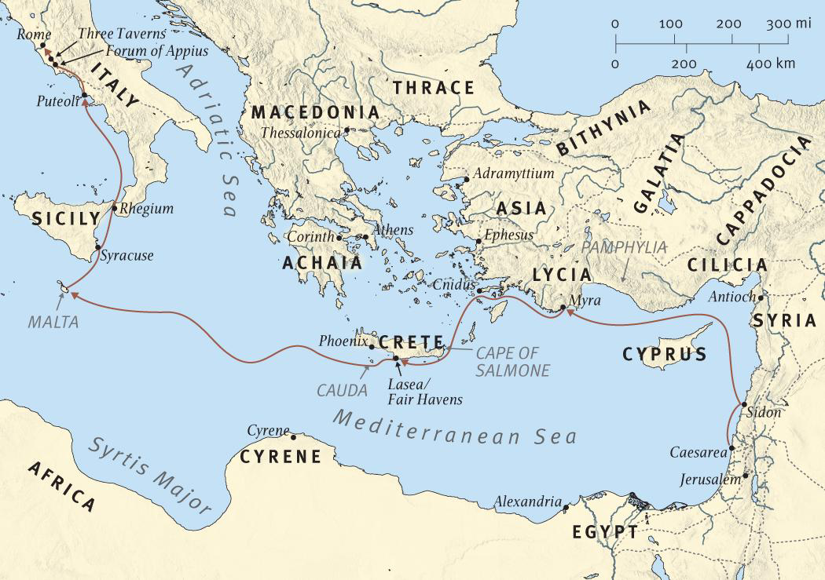

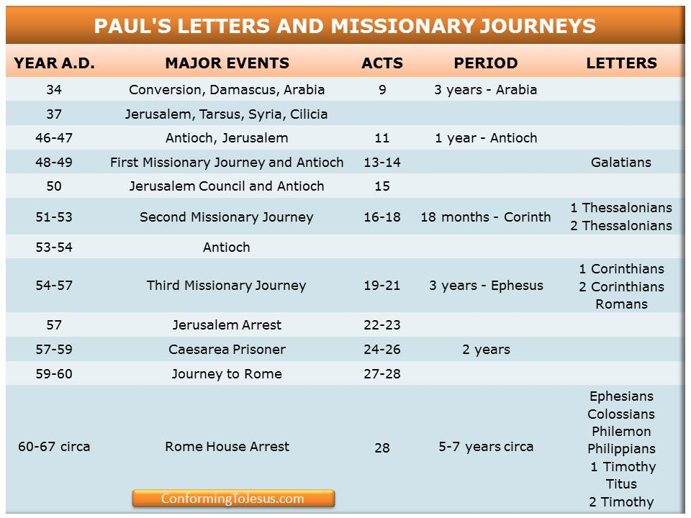

Acts Timeline (ESV Study Bible)

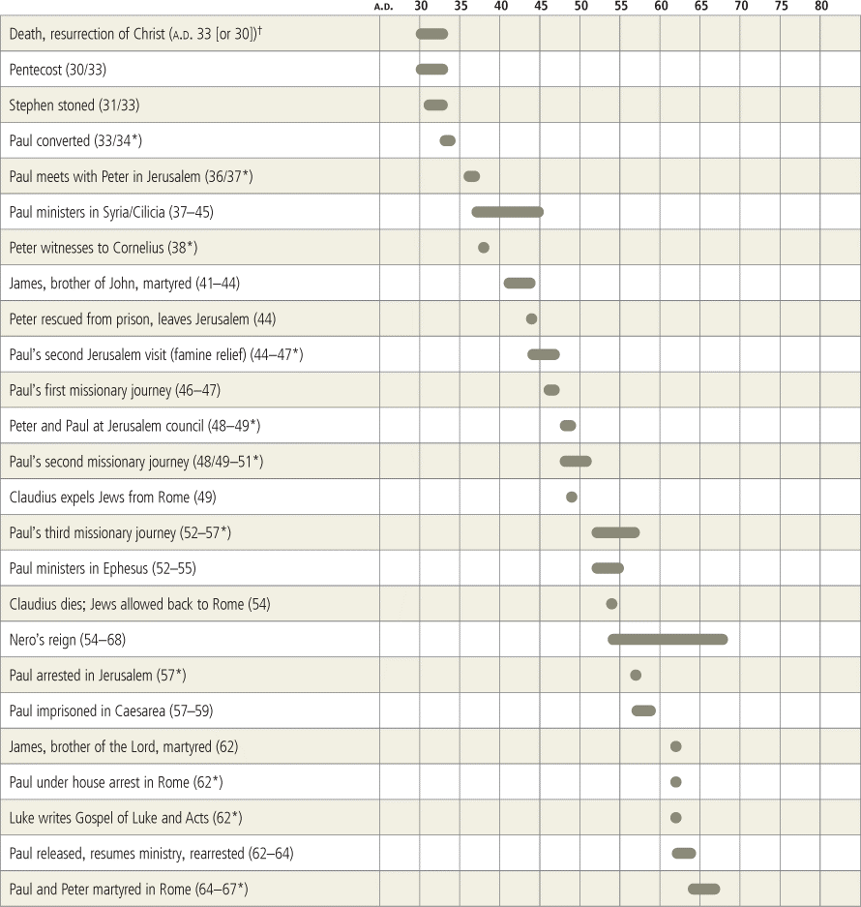

What Should We Make of Paul’s Shipwreck Narrative?
September 3, 2021 By Peter Krol
at https://www.knowableword.com/2021/09/03/what-should-we-make-of-pauls-shipwreck-narrative/
When our church’s team of preachers decided to preach through Acts, I knew chapter 27 would be a doozy (notice how I cleverly ignored this chapter in my interpretive overview of Acts). I have always been confused by this chapter and its role within the book, and though I’m sure compelling sermons have been preached on this text, I have yet to hear one of them. I’m used to hearing otherwise fantastic preachers punt on this chapter, in the name of practicality, to talk about “weathering the storms of our spiritual lives.” So the extraordinarily detailed travelogue of Acts 27 is reduced to a parable and a few minor observations (typically surrounding verses 23-25) seeking to inspire us toward deeper trust in Christ—a wonderful thing to be inspired toward, of course!
Therefore, since I’m in charge of managing our sermon schedule, I made sure to assign Acts 27 to someone else. Pro tip: When you don’t know what to do with a text, require a friend or colleague to deal with it instead. This resulted in one of the most exciting “aha!” moments in my Bible study this year.

A Key Structural Observation
The sucker fortunate fellow to receive the assignment was a good man and marvelous student of the word named Tom Hallman. Tom eagerly set himself to observe the text inside and out, to give him the raw materials for a series of interpretive questions. Our practice is that our team of preachers gives feedback on every sermon before it is preached. We collaborate in two phases: the study of the passage and the delivery of the sermon. So in that first phase, Tom regularly laid before us the fruit of his study for comment and evaluation.
And Tom made a key structural observation that shed tremendous light on the passage for me. In following the narrative’s plot, Tom observed that the main conflict centers on the centurion’s failure to listen to Paul’s counsel in Acts 27:11. This led Tom to recognize a few arcs within the plot:
- Acts 27:9-20: Paul speaks, and the centurion pays more attention to others. The result is that all hope of being saved is abandoned.
- Acts 27:21-44: Paul speaks, and the Romans start listening to him. The result is that all are brought safely to land.
These observations of the primary narrative tension and its accompanying resolution gave us hope that we could sift through the flood of details to discern the author’s main point in this chapter.

Further Dialogue
As we discussed it further and kept staring at the text to observe it more closely, we eventually realized that there were not two arcs but three. Paul actually makes three sizable speeches (Acts 27:10, 21-26, 33-34). He also speaks in Acts 27:31, but that briefer statement does not have the same appearance of introducing a new scene. It is a response to what’s happening in the moment (Acts 27:30).
So we’ve actually got three main speeches from Paul. Do we correspondingly have a clear resolution with each one, to make three complete arcs? This question drove us back into the text.
And sure enough, there it was. So plain and obvious we couldn’t believe we had missed it or ever believed this passage to be opaque to us.
- Acts 27:9-20: Paul speaks, and the centurion pays more attention to others. The result is that all hope of being saved is abandoned.
- Acts 27:21-32: Paul speaks, and no-one immediately rejects him. But eventually the soldiers heed him. (The centurion and soldiers both hear Paul’s words in Acts 27:31, but only the soldiers are mentioned as acting on them in Acts 27:32.) There is no immediate “salvation,” but only a sense of “let’s wait and see; we hope this works.”
- Acts 27:33-44: Paul speaks, and all are encouraged and choose to eat (Acts 27:36). The result is that the centurion has heard enough, and he now wishes to save Paul (Acts 27:43). “And so it was that all were brought safely to land” (Acts 27:44).
These three arcs showed us that the primary tension revolves around whether the Roman centurion (prominent enough to be named in the text—Acts 27:1,3) will listen to Paul or not. And in particular: Will he listen to Paul with respect to salvation? This salvation goes in two directions: Paul wants to save the centurion—along with everyone else on the ship; the centurion, in the end, wishes to save Paul.
In the first arc, Julius will not listen to Paul, and all hope is lost. In the second arc, the soldiers listen to Paul, and it is as though the centurion is watching and deliberating before rendering judgment on this most unusual prisoner. In the third arc, the centurion fully listens to Paul and doesn’t want him to die.

Conclusions About the Text
I’m not weirded out by this chapter any more. It fits cleanly within the book’s main idea that the world’s salvation cannot be stopped. It also masterfully advances Luke’s primary agenda to petition for Paul’s exoneration before Caesar. “Julius was uncertain at first, and unwilling to listen to Paul. But he has been convinced that this Paul is who he says he is, and he refuses to let anyone execute him. Caesar: Why wouldn’t you do the same?”
And not only that, but Acts 27 also serves Luke’s secondary purpose to lead all of Abraham’s children to salvation through the Savior, who is Christ the Lord. “Julius was uncertain at first, and unwilling to listen to Paul. But many have been convinced that this Jesus, whom Paul preaches, is who he says he is. Don’t just stand there watching others listen and find rescue. Noble reader: Why wouldn’t you do the same?”

Conclusions About Our Study Methods
If Luke can have two simultaneous purposes in mind, so can I. While I wanted to help you observe and interpret Acts 27 along with me, I also wanted you to see how I got there. And the events that took place this past week in my dialogues with Tom highlight a few conclusions. First, Bible study needs to be a community project. Second, structure conveys meaning. And third, the most important tool for observing the structure of a narrative episode is plot structure.

Shipwreck (Acts 27:1-44)
Bob Deffinbaugh at https://bible.org/seriespage/shipwreck-acts-271-44
1 When it was decided we would sail to Italy, they handed over Paul and some other prisoners to a centurion of the Augustan Cohort named Julius. 2 We went on board a ship from Adramyttium that was about to sail to various ports along the coast of the province of Asia and put out to sea, accompanied by Aristarchus, a Macedonian from Thessalonica. 3 The next day we put in at Sidon, and Julius, treating Paul kindly, allowed him to go to his friends so they could provide him with what he needed. 4 From there we put out to sea and sailed under the lee of Cyprus because the winds were against us. 5 After we had sailed across the open sea off Cilicia and Pamphylia, we put in at Myra in Lycia. 6 There the centurion found a ship from Alexandria sailing for Italy, and he put us aboard it. 7 We sailed slowly for many days and arrived with difficulty off Cnidus. Because the wind prevented us from going any farther, we sailed under the lee of Crete off Salmone. 8 With difficulty we sailed along the coast of Crete and came to a place called Fair Havens that was near the town of Lasea.
9 Since considerable time had passed and the voyage was now dangerous because the fast was already over, Paul advised them, 10 “Men, I can see the voyage is going to end in disaster and great loss not only of the cargo and the ship, but also of our lives.” 11 But the centurion was more convinced by the captain and the ship’s owner than by what Paul said. 12 Because the harbor was not suitable to spend the winter in, the majority decided to put out to sea from there. They hoped that somehow they could reach Phoenix, a harbor of Crete facing southwest and northwest, and spend the winter there. 13 When a gentle south wind sprang up, they thought they could carry out their purpose, so they weighed anchor and sailed close along the coast of Crete. 14 Not long after this, a hurricane-force wind called the northeaster blew down from the island. 15 When the ship was caught in it and could not head into the wind, we gave way to it and were driven along. 16 As we ran under the lee of a small island called Cauda, we were able with difficulty to get the ship’s boat under control. 17 After the crew had hoisted it aboard, they used supports to undergird the ship. Fearing they would run aground on the Syrtis, they lowered the sea anchor, thus letting themselves be driven along. 18 The next day, because we were violently battered by the storm, they began throwing the cargo overboard, 19 and on the third day they threw the ship’s gear overboard with their own hands. 20 When neither sun nor stars appeared for many days and a violent storm continued to batter us, we finally abandoned all hope of being saved. 21 Since many of them had no desire to eat, Paul stood up among them and said, “Men, you should have listened to me and not put out to sea from Crete, thus avoiding this damage and loss. 22 And now I advise you to keep up your courage, for there will be no loss of life among you, but only the ship will be lost. 23 For last night an angel of the God to whom I belong and whom I serve came to me 24 and said, ‘Do not be afraid, Paul! You must stand before Caesar, and God has graciously granted you the safety of all who are sailing with you.’ 25 Therefore keep up your courage, men, for I have faith in God that it will be just as I have been told. 26 But we must run aground on some island.”
27 When the fourteenth night had come, while we were being driven across the Adriatic Sea, about midnight the sailors suspected they were approaching some land. 28 They took soundings and found the water was twenty fathoms deep; when they had sailed a little farther they took soundings again and found it was fifteen fathoms deep. 29 Because they were afraid that we would run aground on the rocky coast, they threw out four anchors from the stern and wished for day to appear. 30 Then when the sailors tried to escape from the ship and were lowering the ship’s boat into the sea, pretending that they were going to put out anchors from the bow, 31 Paul said to the centurion and the soldiers, “Unless these men stay with the ship, you cannot be saved.” 32 Then the soldiers cut the ropes of the ship’s boat and let it drift away. 33 As day was about to dawn, Paul urged them all to take some food, saying, “Today is the fourteenth day you have been in suspense and have gone without food; you have eaten nothing. 34 Therefore I urge you to take some food, for this is important for your survival. For not one of you will lose a hair from his head.” 35 After he said this, Paul took bread and gave thanks to God in front of them all, broke it, and began to eat. 36 So all of them were encouraged and took food themselves. 37 (We were in all two hundred seventy-six persons on the ship.) 38 When they had eaten enough to be satisfied, they lightened the ship by throwing the wheat into the sea. 39 When day came, they did not recognize the land, but they noticed a bay with a beach, where they decided to run the ship aground if they could. 40 So they slipped the anchors and left them in the sea, at the same time loosening the linkage that bound the steering oars together. Then they hoisted the foresail to the wind and steered toward the beach. 41 But they encountered a patch of crosscurrents and ran the ship aground; the bow stuck fast and could not be moved, but the stern was being broken up by the force of the waves. 42 Now the soldiers’ plan was to kill the prisoners so that none of them would escape by swimming away. 43 But the centurion, wanting to save Paul’s life, prevented them from carrying out their plan. He ordered those who could swim to jump overboard first and get to land, 44 and the rest were to follow, some on planks and some on pieces of the ship. And in this way all were brought safely to land (Acts 27:1-44).¹

Introduction²
In my youth, there was one thing about which I was certain – I would never become a preacher. This was because I thought preachers were a rather useless bunch. The preachers I had known seemed only to be adept at preaching, and some of them were not too good at that. I can remember saying that I would not want to be a pastor because I didn’t want to sit around with little old ladies sipping tea.
Think about some of the preachers you’ve known or seen on television. How many of them would you call if your car broke down on the freeway, or if you needed help putting a new roof on your house? How many of them would you expect to come to your home, roll up their sleeves, take hold of a shovel, and help you dig up your septic system?
It was after I met Alton Williams that I changed my mind about preachers and preaching. Here was a man who grew up on a farm. At the age of 30, he went to Bible school and then became a preacher. I listened to the way Pastor Williams taught the Scriptures with simplicity, and yet with real substance. I watched this man and sometimes worked with him as he and others built a church in Burley, Washington. During his years of ministry with Village Missions, several churches were built by his hands, and several homes as well. Here was a pastor who was not only a good teacher; he was useful in the real world. I continue to admire and appreciate him to this day.
Paul was a great preacher and teacher, as the Book of Acts makes abundantly clear. He was also a man of great character and courage. But beyond this, Paul was skilled and useful in earthly matters. We know from Acts 20 (as well as a number of other texts in the New Testament) that Paul didn’t demand that other Christians take care of him. Rather than live off the labors of others, Paul labored with his own hands, and by this means, he not only provided for his own needs, but also for the needs of others:
33 I have desired no one’s silver or gold or clothing. 34 You yourselves know that these hands of mine provided for my needs and the needs of those who were with me. 35 By all these things, I have shown you that by working in this way we must help the weak, and remember the words of the Lord Jesus that he himself said, ‘It is more blessed to give than to receive’” (Acts 20:33-35).³
Paul was a tent-maker, and I am certain that he was good at it. But in addition to Paul’s skill as a craftsman, he was also useful in other ways, as we are about to see in Acts 27. At a time of great crisis, our spiritual gifts should rise to the occasion. This was certainly the case with Paul when a storm drove his ship off course and eventually battered it to pieces. Let us give careful thought to Paul’s usefulness at sea, and then consider just how this relates to his role as a preacher of the gospel.

Bon Voyage Acts 27:1-8
1 When it was decided we would sail to Italy, they handed over Paul and some other prisoners to a centurion of the Augustan Cohort named Julius. 2 We went on board a ship from Adramyttium that was about to sail to various ports along the coast of the province of Asia and put out to sea, accompanied by Aristarchus, a Macedonian from Thessalonica. 3 The next day we put in at Sidon, and Julius, treating Paul kindly, allowed him to go to his friends so they could provide him with what he needed. 4 From there we put out to sea and sailed under the lee of Cyprus because the winds were against us. 5 After we had sailed across the open sea off Cilicia and Pamphylia, we put in at Myra in Lycia. 6 There the centurion found a ship from Alexandria sailing for Italy, and he put us aboard it (Acts 27:1-6).
It was settled. Paul had appealed to Caesar, and to Caesar he would go. He was one of a number of prisoners who was on his way to Rome. (I would doubt that all of these prisoners had appealed to Caesar. Some of them may have been scheduled for execution there. Public executions were a part of the entertainment in Rome.) Paul was fortunate to have been placed under the care of a centurion named Julius. He, like all the other centurions we have met in the Gospels and Acts, was a man with some admirable qualities.
A ship was found that was leaving Caesarea,⁴ apparently returning to Adramyttium, its home port approximately 75 miles southeast of Troas in Asia Minor. This was apparently a smaller ship that went from port to port, never venturing into the deep, open waters. Accompanying Paul were Aristarchus⁵ from Thessalonica (verse 2) and Luke (note the “we” in these verses). The ship’s first stop was Sidon. Julius kindly allowed Paul the freedom⁶ to visit with his friends there, and they generously provided Paul with items necessary for his journey, the kinds of things Rome would not supply.
From Sidon they sailed north, around the eastern side of Cyprus, then turned west, sailing off the northern coast of Cyprus. This gave them some protection from the winds, which were contrary (verse 4). This meant that the ship had to tack in zigzag fashion, because you cannot sail directly into the wind. This meant that travel was slower, which put them later into the sailing season, closer to the time when the sea would be closed to shipping because of the winter storms. They sailed off the coast of Cilicia and Pamphylia, putting in at Myra, a port city in Lycia.
Myra is almost directly north of Alexandria, a port city in Egypt. Egypt was the bread basket of Rome, and thus a number of large ships carried wheat from Egypt to Rome. Such ships were large and able to handle the open waters of the Mediterranean. The centurion found an Alexandrian cargo ship loaded with wheat from Egypt and leaving for Italy. He then put all the prisoners on board, and they set sail for Rome. The journey to Rome would take considerably longer than expected and would entail the loss of ship and cargo.

The Going Gets Rough Acts 27:7-8
7 We sailed slowly for many days and arrived with difficulty off Cnidus. Because the wind prevented us from going any farther, we sailed under the lee of Crete off Salmone. 8 With difficulty we sailed along the coast of Crete and came to a place called Fair Havens that was near the town of Lasea (Acts 27:7-8).
The winds are still contrary, and sailing is slow. They finally reach Cnidus, at least 100 miles or so south of Ephesus. Luke tells us that “the wind prevented us from going any farther” (verse 7). It could mean that the winds actually prevented them from entering the harbor at Cnidus. Rough seas and high winds can make sailing into port dangerous work. (There were no tug boats in those days. The entrance to the harbor could have been too narrow to allow a sailing vessel to tack its way into port.) The ship pressed on until it reached the eastern side of Crete. It then passed under the island and sailed along its southern coast. Finally, they were able to make port in the city of Fair Havens, near Lasea, which appears to be about mid-island east to west.

Paul’s Advice Is Rejected Acts 27:9-13
9 Since considerable time had passed and the voyage was now dangerous because the fast was already over, Paul advised them, 10 “Men, I can see the voyage is going to end in disaster and great loss not only of the cargo and the ship, but also of our lives.” 11 But the centurion was more convinced by the captain and the ship’s owner than by what Paul said. 12 Because the harbor was not suitable to spend the winter in, the majority decided to put out to sea from there. They hoped that somehow they could reach Phoenix, a harbor of Crete facing southwest and northwest, and spend the winter there. 13 When a gentle south wind sprang up, they thought they could carry out their purpose, so they weighed anchor and sailed close along the coast of Crete (Acts 27:9-13).
It was time to make some decisions. It was now late – very late – in the sailing season. It would appear to be mid-October or so, and sailing stopped from approximately November through January. The ship had not made as much progress as they had hoped, and now they were running out of time. It was obvious that they would have to winter somewhere, but the question was where that should be. They had safely made port in Fair Havens, but some things about this port made it less than desirable for a lengthy stay. Phoenix was a much more desirable harbor, but it was still some distance away. Should they risk heading for Phoenix, or should they remain on at Fair Havens? That was the question.
It was at this point that Paul weighed in. Paul had spent a good deal of time on the sea. He had even spent time in the sea:
23 Are they servants of Christ? (I am talking like I am out of my mind!) I am even more so: with much greater labors, with far more imprisonments, with more severe beatings, facing death many times. 24 Five times I received from the Jews forty lashes less one. 25 Three times I was beaten with a rod. Once I received a stoning. Three times I suffered shipwreck. A night and a day I spent adrift in the open sea. 26 I have been on journeys many times, in dangers from rivers, in dangers from robbers, in dangers from my own countrymen, in dangers from Gentiles, in dangers in the city, in dangers in the wilderness, in dangers at sea, in dangers from false brothers, 27 in hard work and toil, through many sleepless nights, in hunger and thirst, many times without food, in cold and without enough clothing (2 Corinthians 22:23-27, emphasis mine).
Paul had experienced shipwrecks before, and he was not particularly eager to do so again. Perhaps Paul had been shipwrecked in very similar circumstances. He therefore strongly recommends that they wait out the winter months where they are and not attempt to sail farther. He warns that, should they proceed, he fears that there will be a great loss, not only of the ship and its cargo, but also of human life. There is no indication that Paul’s concerns are the result of direct revelation. Indeed, we know that his concerns for the loss of life here were unfounded. Paul seems to speak here from a good deal of experience. And, had God not providentially intervened, all of Paul’s predictions likely would have come true.
The centurion seems to have the final word in this matter. The ship’s owner, as well as the captain, were in favor of pressing on to Phoenix, as were most of the passengers. And so Paul’s counsel is rejected. Perhaps Paul’s advice would have prevailed if unfavorable weather conditions had persisted. When a favorable south wind sprang up, all appearances were that they would be able to make it to Phoenix before the weather changed for the worse. And so they hoisted anchor and set out for Phoenix, staying as close to shore as they could.

All Hope Is Lost Acts 27:14-20
14 Not long after this, a hurricane-force wind called the northeaster blew down from the island. 15 When the ship was caught in it and could not head into the wind, we gave way to it and were driven along. 16 As we ran under the lee of a small island called Cauda, we were able with difficulty to get the ship’s boat under control. 17 After the crew had hoisted it aboard, they used supports to undergird the ship. Fearing they would run aground on the Syrtis, they lowered the sea anchor, thus letting themselves be driven along. 18 The next day, because we were violently battered by the storm, they began throwing the cargo overboard, 19 and on the third day they threw the ship’s gear overboard with their own hands. 20 When neither sun nor stars appeared for many days and a violent storm continued to batter us, we finally abandoned all hope of being saved (Acts 27:14-20).
Without warning, a hurricane-force wind blew down from the island. The winds were so strong, there was no nothing to do but allow the ship to be driven in the opposite direction from their heading. For a short time, they enjoyed some protection from the winds, thanks to a small island named Cauda. It seems to be during this time that the crew took advantage of the situation and were able, with difficulty, to hoist the ship’s boat onto the deck. The irony here is that they took great efforts to save this small boat, which must have doubled as a kind of lifeboat. This boat will not be a means of escape, but will eventually be cut loose and set adrift.⁷
Once the ship’s boat was lashed down on deck, the crew began to secure the ship with cables that would undergird the vessel. It was expected that this storm would put great stress on this heavily laden ship, and extra measures would have to be taken in an effort to keep the ship from breaking apart. Fearing that the ship, now at the mercy of the winds, might run aground, they let out the ship’s anchor to slow its movement. When the storm was just as relentless the next day, they began throwing the ship’s cargo overboard, followed by any of the ship’s gear that was not essential. Lightening the load would reduce the strain on the ship, and it would allow the vessel to sit higher in the water. Besides, the ship would likely take on water from the rough seas. The storm continued to pound the ship and passengers for many days. Finally, all hope of being saved was abandoned.⁸ It was just a matter of time until they all perished at sea, or so it seemed.

There Is Hope! Acts 27:21-26
21 Since many of them had no desire to eat, Paul stood up among them and said, “Men, you should have listened to me and not put out to sea from Crete, thus avoiding this damage and loss. 22 And now I advise you to keep up your courage, for there will be no loss of life among you, but only the ship will be lost. 23 For last night an angel of the God to whom I belong and whom I serve came to me 24 and said, ‘Do not be afraid, Paul! You must stand before Caesar, and God has graciously granted you the safety of all who are sailing with you.’ 25 Therefore keep up your courage, men, for I have faith in God that it will be just as I have been told. 26 But we must run aground on some island” (Acts 27:21-26).
Luke puts the matter so delicately: “. . . Many of them had no desire to eat, . . .” (verse 21). Can you imagine what it would have been like on board that ship? I have not been on the ocean much at all, but even in normal seas, I have watched men hanging over the rail, “feeding the fish.” Who would have thought about eating at a time like this? The whole bunch of them must have been seasick. The thought of eating at that moment would have never occurred to anyone.
The problem is that much energy had been consumed lightening the ship, and no food had been consumed for days. Humanly speaking, all hope of being saved was gone. But an angel of God had appeared to Paul in the night. He instructed Paul not to fear, which strongly implied that Paul too was afraid. It looked as though his warning was going to be literally fulfilled. But the angel assured Paul that he must stand before Caesar. Therefore, God was going to deliver Paul. And, as a gracious gesture, God was going to give Paul the lives of all his shipmates (verse 24).
Therefore, Paul instructed all the passengers not to fear, but to have good courage. Granted, they should have listened to Paul when he first warned them of the danger of leaving the safety of Fair Havens, but they did not. Now, let them listen to the good news Paul had for them. An angel of God had appeared to Paul in the night, assuring him that all the passengers would be saved from the ravages of this storm. This was because God was protecting Paul, who must stand before Caesar. It was because of Paul that his shipmates as well would survive the storm. No life would be lost, but only the ship, which would run aground on some island (as yet unnamed). Paul’s shipmates should be encouraged by Paul’s faith in God, trusting that what God had promised, He would do.

Listening to Paul Acts 27:27-38
27 When the fourteenth night had come, while we were being driven across the Adriatic Sea, about midnight the sailors suspected they were approaching some land. 28 They took soundings and found the water was twenty fathoms deep; when they had sailed a little farther they took soundings again and found it was fifteen fathoms deep. 29 Because they were afraid that we would run aground on the rocky coast, they threw out four anchors from the stern and wished for day to appear. 30 Then when the sailors tried to escape from the ship and were lowering the ship’s boat into the sea, pretending that they were going to put out anchors from the bow, 31 Paul said to the centurion and the soldiers, “Unless these men stay with the ship, you cannot be saved.” 32 Then the soldiers cut the ropes of the ship’s boat and let it drift away. 33 As day was about to dawn, Paul urged them all to take some food, saying, “Today is the fourteenth day you have been in suspense and have gone without food; you have eaten nothing. 34 Therefore I urge you to take some food, for this is important for your survival. For not one of you will lose a hair from his head.” 35 After he said this, Paul took bread and gave thanks to God in front of them all, broke it, and began to eat. 36 So all of them were encouraged and took food themselves. 37 (We were in all two hundred seventy-six persons on the ship.) 38 When they had eaten enough to be satisfied, they lightened the ship by throwing the wheat into the sea (Acts 27:27-38).
Two full weeks had passed, and the storm showed no sign of weakening. No one had seen the sun, the moon, or the stars for many days (verse 20). Since ancient sailors navigated by the heavens, this meant they had no idea where they were. The ship was being driven about at the mercy of the wind. All hope of survival was gone. When all human hope is gone, the stage has been set for our omnipotent God to intervene.
Have you ever noticed how often God brings men to this point before He intervenes? God promised an elderly couple they would have a son, and then waited 25 years to make certain that this would be a miracle. But that child – Isaac – was born, just as God said (Genesis 12-21). God put Israel between the Red Sea and the Egyptian army, so that there appeared to be no way out. Only then did God part the sea, so that the Israelites passed through on dry ground (Exodus 13:17—14:31). God instructed Gideon to reduce his warriors from 32,000 to 300 men, and then ordered him to wage war on the Midianites, who were as numerous as “the sand on the seashore” (Judges 7:12). Needless to say, God gave Gideon the victory. King Hezekiah and the city of Jerusalem were surrounded by the Assyrian army. They were hopelessly outnumbered, but the angel of the Lord struck down 185,000 in one night, and thus the army withdrew and went home (Isaiah 36-37). God loves impossible situations, because when He does the impossible, no man can lay claim to any part of the glory that belongs only to Him.
Conditions are now conducive for the deliverance of Paul and his shipmates. In one sense, they all hoped for land, but not during the night lest they be dashed to pieces on the rocks. Thus, throughout the night, the sailors kept testing the depth of the water. Their soundings revealed that they were approaching land. The depth of the water continued to decrease (from 120 feet to 90 feet). Fearing they would run aground in the darkness, they put out anchors to slow their approach to land until daylight.
The most dangerous moment for a ship in these conditions was making land in this storm, and the sailors knew it. They reasoned that their chances of survival were much greater in the ship’s boat than in the ship. Normally this would have made a lot of sense. The ship’s draft (the depth to which the ship’s lowest point extended below the surface of the water) would be considerably greater than that of the lifeboat. Thus, a small boat could float until it nearly reached shore, while a large boat would strike bottom some distance from shore.
The sailors decided to save themselves by escaping from the ship by means of the lifeboat (“the ship’s boat”). The lifeboat was large enough to hold them, but no more. In effect, this was a death sentence for the people on board ship because they would not have the skill to navigate this crippled vessel safely to land. The ship was still in one piece for the moment, but much of the ship’s gear had been cast overboard. The ship was now down to its bare essentials for navigation. For the past two weeks, they had just tried to stay afloat in one piece, allowing themselves to be driven by the winds. No one knew where they were or what form land would take. Skilled seamen who could carry out their assigned duties appeared to be essential to the ship’s safe arrival.
The sailors knew that the passengers would not allow them to take the lifeboat in order to save themselves, and so they pretended to be putting out anchors from the bow (front) of the ship. Under normal circumstances, these sailors would have saved themselves and condemned the passengers to death. But this time it was different. God was going to spare the passengers (including the ship’s crew) for Paul’s sake. Safety was not to be found by escaping from the ship, but rather by staying on the ship with Paul. Somehow Paul realized what these sailors were up to and put a stop to their “escape.” Was this by divine revelation? If so, we are not told that this was the case. I am inclined to think that when Paul heard them say they were going to lower anchors from the bow, he was knowledgeable enough to recognize their deception. What possible reason would they have to cast anchors attached to the bow of the ship, when anchors had already been put out from the stern? Neither can I imagine how a lifeboat would be used to lower these anchors. Can you see these men taking more than one anchor on board their little craft, and then heaving them over the side without capsizing the boat (especially in very rough waters)?
Paul exposed the sailors’ scheme to the centurion and the soldiers, informing them that if they wished to survive, they must keep the sailors on board. Now the soldiers were listening to what Paul had to say. Paul, the prisoner, was in charge.⁹ The soldiers quickly cut the ropes to the lifeboat, letting it drift away empty. The safety of all on board now rests on one man – Paul. Daylight will soon come and knowing that the passengers will need their strength for what lies ahead, Paul urged them all to eat. He assured them that they needed to eat because they had gone so long without food. He also assured them that they would survive: not a hair on their head would be lost. That was the equivalent of saying, “You will be saved without a scratch.”
You may not think of this as an act of faith, but it was. These people refused to eat because they were seasick. They had learned that there was not reason to eat since this would only repeat another bout of seasickness. They had learned their lesson – better not to eat at all. Now, in order to eat they would have to trust Paul, rather than their instincts and past experience. This time it was different. Their bread would stay down, and it would nourish their bodies for the rigorous effort each would expend in the stormy waters between the ship and the shore. All of the passengers listened to Paul and were encouraged by his words. And so they all ate – all 276 of them (including Paul). Having eaten, they proceeded to lighten the ship by casting the remainder of its cargo (wheat) overboard.

Safe on Land Acts 27:39-44
39 When day came, they did not recognize the land, but they noticed a bay with a beach, where they decided to run the ship aground if they could. 40 So they slipped the anchors and left them in the sea, at the same time loosening the linkage that bound the steering oars together. Then they hoisted the foresail to the wind and steered toward the beach. 41 But they encountered a patch of crosscurrents and ran the ship aground; the bow stuck fast and could not be moved, but the stern was being broken up by the force of the waves. 42 Now the soldiers’ plan was to kill the prisoners so that none of them would escape by swimming away. 43 But the centurion, wanting to save Paul’s life,¹⁰ prevented them from carrying out their plan. He ordered those who could swim to jump overboard first and get to land, 44 and the rest were to follow, some on planks and some on pieces of the ship. And in this way all were brought safely to land (Acts 27:39-44).
Recently a commercial airliner blew out its tires on takeoff. The plane circled the airport for some time consuming most of its fuel. The most critical moment was the touchdown at landing. Paul’s ship has been blown about the Mediterranean for two weeks. Now this crippled craft must make its way to the beach, where they hoped to ground the ship. No one recognized the land, and so they knew nothing about sandbars or hidden dangers. All they could do was make a run for shore. They unfastened the ropes and left the anchors in the sea. They seemed to disable the steering mechanism (the steering oars), which may have given them a bit more speed. Then, hoisting the front sail, they allowed the wind to drive them toward the shore. When they encountered crosscurrents, they stuck fast on a sandbar. The front of the ship held fast while the waves battered the back of the ship so that it began to break up.
It was obvious that it was going to be every man for himself. The soldiers knew full well that they dare not let their prisoner(s) escape. I would imagine that some of these prisoners were under sentence of death and that they would likely attempt an escape. Not knowing where they were, the soldiers did not want to take the risk, and so they determined to kill all the prisoners on the ship and then attempt to make land. Julius was responsible for Paul, who was not under sentence but rather under appeal. In order for Julius to complete his mission, he must deliver Paul alive. Because of this, he issued orders to the soldiers (who were obviously under his command) not to kill their prisoners.¹¹
The centurion ordered those who could swim to jump overboard and swim to shore; those who could not swim were to find something from the ship that would serve as a flotation device and make their way to land. In this manner, every single person on board that ship made it safely to shore, just as Paul had assured them.

Conclusion
As I read Luke’s account of the divine deliverance of Paul and those with him, I could not help but think of several Old Testament texts. First, I thought about Abraham, who appealed to God to spare Sodom and Gomorrah because some who were righteous might be there. There were at least three righteous people on board – Paul, Aristarchus, and Luke. Perhaps there were others. As Luke tells it, God spared the passengers on account of Paul. This is very clear in the text. It is stated twice, first in verses 23 and 24, and again in verse 43.
God promised Abram that He would give him and his wife Sarai a son, and that their descendants would possess the land of Canaan. When Abram fled to Egypt during the famine, he passed Sarai off as his sister. God rescued Abram and Sarai from this situation because of the covenant He had made with Abram. He could not fulfill His covenant with Abram if Sarai became the wife of Pharaoh, nor could He do so if Pharaoh killed Abram for his deception. God spared Abram and Sarai in order to fulfill His promise. So too God spared Paul, his fellow-Christians, and all those aboard ship, and all because God had made a promise to Paul that he would bear witness in Rome.
If you are a Christian, God has a purpose for your life, and I assure you that God will ensure that it will be accomplished. What a comfort the sovereignty of God is to the believer. It assures us that what God starts, God finishes. Some time later Paul will be in Rome, awaiting the outcome of his appeal. He may never see the Philippian saints again. But Paul is not anxious about this because he knows that it is God who saved them, and He will finish what He started:
For I am sure of this very thing, that the one who began a good work in you will perfect it until the day of Christ Jesus (Philippians 1:6).
That is the good news. God will fulfill His purposes and promises to Christians. The bad news is that God will also make good on His warnings to unbelievers:
“The one who believes in the Son has eternal life. The one who rejects the Son will not see life, but God’s wrath remains on him” (John 3:36).
12 And I saw the dead, the great and the small, standing before the throne. Then books were opened, and another book was opened – the book of life. So the dead were judged by what was written in the books, according to their deeds. 13 The sea gave up the dead that were in it, and Death and Hades gave up the dead that were in them, and each one was judged according to his deeds. 14 Then Death and Hades were thrown into the lake of fire. This is the second death – the lake of fire. 15 If anyone’s name was not found written in the book of life, that person was thrown into the lake of fire (Revelation 20:12-15).
The story of the deliverance of Paul and his shipmates is a wonderful illustration of the salvation which God offers to all who will receive it. The majority of those on board ship trusted in themselves, in their captain, and in their ship to get them safely to port in Phoenix. The gentle south winds at Fair Havens proved deceptive. They were not as safe as they supposed nor were they going to reach their desired destination (Phoenix). At first they supposed they would be able to weather the storm, but in time, they lost all hope. They could do nothing to save themselves. There was one man on board ship who promised salvation if they would do as he said – Paul. In so doing, all were saved from disaster and brought safely to shore.
Men and women today think they will somehow reach heaven on their own. Their prosperity or good health may give them confidence that they can make it on their own, and so they reject the warnings of Scripture, just as those on board ship initially rejected Paul’s warnings. Then the storms of life overwhelm us, and we realize that we are hopeless and helpless. There is only one person who can save us, and His name is Jesus. He died for sinners, and God raised Him from the dead. He offers salvation to all those who will trust in Him. Those who seek to abandon Christ for some lifeboat will only perish. Those who trust in Him will be delivered safely through the storms of this life to heaven. As those on board that ship had to entrust themselves to Paul, so we must entrust ourselves to Jesus Christ. He is our only means of deliverance.
Second, I was reminded of Noah and the ark. When God poured out His judgment upon the earth, He provided only one means of deliverance – the ark. Those who believed God and boarded ship were brought safely through the stormy waters. Those who rejected the warnings of Noah perished. This is yet another illustration of God’s salvation in Christ (our “ark” if you would).
Third, I was reminded of the story of Jonah in the Old Testament Book of Jonah. What an amazing contrast Jonah is to Paul. Both Paul and Jonah were Jews, but they were very different Jews. Jonah was commanded to take the gospel to the Gentiles of Nineveh, but he refused and fled in the opposite direction. Paul was commanded to take the gospel to the Gentiles as well, and he obeyed. Jonah fled aboard a ship, and his presence there put all the sailors at risk. His disobedience endangered these Gentile sailors. The sailors are saved by throwing Jonah overboard, off the ship. And thus they are delivered (and apparently converted). Jonah will eventually reach his destination, but only kicking and screaming. It is Paul’s presence on board the ship that saves all. Those who sought to abandon ship (like the sailors) would have put themselves and others at risk. God saved Paul’s shipmates because of Paul. God saved Jonah’s shipmates in spite of Jonah. What a backdrop the Book of Jonah is to Acts 27.
Fourth, I would point out that while Paul was indeed a spiritual man, he was also a very practical man. When all hope was lost and things looked their worst, we might have hoped Paul would call for a prayer meeting, or perhaps hold some kind of evangelistic service. Instead, Paul encouraged those on board to eat so that they would have strength for what was to follow. There are seemingly no foxhole conversions here, and we might wonder why Paul did not preach the gospel here, as he has done so consistently before. I think the reason may be that in handling the crisis as he did, Paul gained great credibility with all those on board the ship. Let us remember that Paul will be with his shipmates for several months yet. He will have much time to share the gospel once they are safely on shore. For the moment, Paul concentrates on saving human life; then he will surely speak of eternal things later on.
My point here is that the spiritual gifts God has given to us have value even in the secular world; their usefulness is not restricted to the church and the saints. And these same gifts may then open doors for spiritual ministry. Think of Joseph, for example, in the Book of Genesis, chapters 37-45. Joseph’s gifts were not only evident in his youth; they were also evident in Potiphar’s estate, in prison, and in the service of Pharaoh. His gifts enabled him to bring his family to Egypt, and thus to save them from the famine. But more than this, Joseph’s abilities were employed to bring his brothers to repentance and his family to reconciliation and harmony.
As I studied this text and thought of how useful Paul was in the “real world,” I was reminded of the words of this proverb:
Do you see a person skilled in his work?
He will take his position before kings;
he will not take his position before obscure people (Proverbs 22:29).
Have you considered your spiritual gifts and how they may be useful in the workplace, in your family, and in your neighborhood, as well as in the church? Spiritual people should be people who have practical value, people who contribute to their community. People should be blessed because of our presence among them.
Disobedient Christians are a danger to themselves and others.
Obedient Christians are a blessing to others.
While it is a pleasure to see Paul’s practical gifts, wisdom, and value to others, let us not end by putting the spotlight on Paul. Let us end by reminding ourselves that the Book of Acts is about God, about His faithfulness, about His sovereignty, about the fact that He sovereignly orchestrates all things so that His purposes and His promises are fulfilled. Paul was spared, along with the entire passenger manifest, not primarily because of Paul’s greatness, but because Paul served a great God. God would not allow Jewish assassins or weak-willed Gentile rulers to keep Paul from the mission for which he had been saved and to which he had been called. In the final analysis, it is not about great men, but about a great God, the one true God, who has purposed to use mere men to proclaim the gospel and thus to bring glory to Himself.

¹ Unless otherwise indicated, all Scripture quotations are from the NET Bible. The NEW ENGLISH TRANSLATION, also known as THE NET BIBLE, is a completely new translation of the Bible, not a revision or an update of a previous English version. It was completed by more than twenty biblical scholars who worked directly from the best currently available Hebrew, Aramaic, and Greek texts. The translation project originally started as an attempt to provide an electronic version of a modern translation for electronic distribution over the Internet and on CD (compact disk). Anyone anywhere in the world with an Internet connection will be able to use and print out the NET Bible without cost for personal study. In addition, anyone who wants to share the Bible with others can print unlimited copies and give them away free to others. It is available on the Internet at: www.netbible.org.
² Copyright © 2006 by Community Bible Chapel, 418 E. Main Street, Richardson, TX 75081. This is the edited manuscript of Lesson 34 in the Studies in the Book of Acts series prepared by Robert L. Deffinbaugh on September 3, 2006. Anyone is at liberty to use this lesson for educational purposes only, with or without credit. The Chapel believes the material presented herein to be true to the teaching of Scripture, and desires to further, not restrict, its potential use as an aid in the study of God’s Word. The publication of this material is a grace ministry of Community Bible Chapel.
³ See also 2 Thessalonians 3:7-9.
⁴ I am assuming that the ship departed from Caesarea. This was a seaport, and it was where Paul had been incarcerated and had stood trial before Felix and Festus. Luke never actually tells the reader that the ship sailed from Caesarea.
⁵ See Colossians 4:10; Philemon 24.
⁶ Although he may very well have been accompanied by a guard.
⁷ See verses 30-32.
⁸ Nearly all the translations convey the sense of the original text here, which is that hope slowly faded away as time passed, until at last it was gone. No one dared to believe they could survive this storm.
⁹ The soldiers could have commandeered the lifeboat for themselves, but instead they did exactly as Paul instructed.
¹⁰ The term translated “save Paul’s life” is diasozo. It is found 5 times in Acts (23:24; 27:43, 44; 28:1, 4). The same term is used a couple of verses later (27:44) of the passengers being brought safely through to land. I think that the sense is more “bring safely through,” which would fit all the other uses in Acts. It was Julius’ duty to deliver Paul safely to Rome and to Caesar, and that is exactly what he intended to do.
¹¹ This too was part of the divine promise to save everyone on board ship. Just as the sailors must not abandon ship, so the soldiers must not kill the prisoners. Everyone must survive this adventure without so much as the loss of one hair (i.e. “without a scratch”).

