Good News and Savage Wolves in Ephesus
Summer 2022, Acts 19:1-10, 20:13-38 August 21, 2022
. . . so that all the Jews and Greeks who lived in the province of Asia
heard the word of the Lord.
Acts 19:10

How the third missionary journey started
²³ After spending some time in Antioch, Paul set out from there and traveled from place to place throughout the region of Galatia and Phrygia, strengthening all the disciples.
²⁴ Meanwhile a Jew named Apollos, a native of Alexandria, came to Ephesus. He was a learned man, with a thorough knowledge of the Scriptures. ²⁵ He had been instructed in the way of the Lord, and he spoke with great fervor and taught about Jesus accurately, though he knew only the baptism of John. ²⁶ He began to speak boldly in the synagogue. When Priscilla and Aquila heard him, they invited him to their home and explained to him the way of God more adequately.
²⁷ When Apollos wanted to go to Achaia, the brothers encouraged him and wrote to the disciples there to welcome him. On arriving, he was a great help to those who by grace had believed. ²⁸ For he vigorously refuted the Jews in public debate, proving from the Scriptures that Jesus was the Christ.
While Apollos was at Corinth, Paul took the road through the interior and arrived at Ephesus.
Acts 18:23-19:1

1. Priscilla and Aquila are already at work to disciple the next generation of teachers

2. Paul expects this to be his final “strengthening” trip to the churches in the west

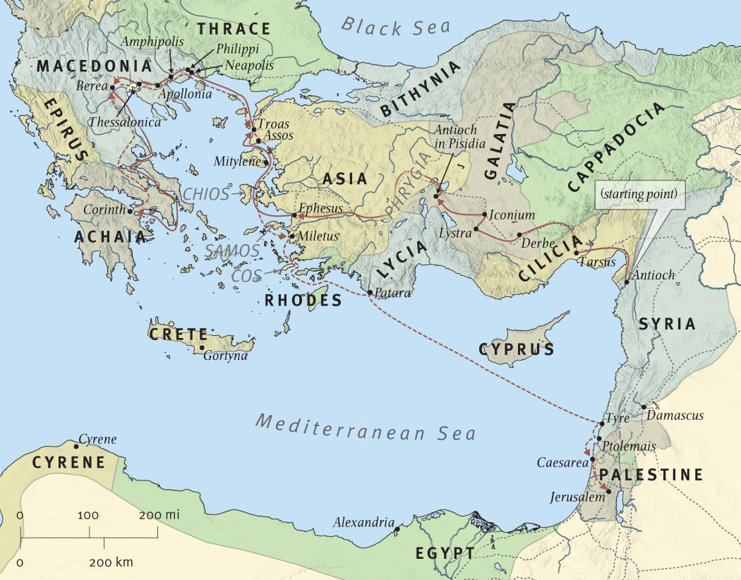
Reaching the whole province of Asia
While Apollos was at Corinth, Paul took the road through the interior and arrived at Ephesus. There he found some disciples ² and asked them, “Did you receive the Holy Spirit when you believed?”
They answered, “No, we have not even heard that there is a Holy Spirit.”
³ So Paul asked, “Then what baptism did you receive?”
“John’s baptism,” they replied.
⁴ Paul said, “John’s baptism was a baptism of repentance. He told the people to believe in the one coming after him, that is, in Jesus.” ⁵ On hearing this, they were baptized into the name of the Lord Jesus. ⁶ When Paul placed his hands on them, the Holy Spirit came on them, and they spoke in tongues and prophesied. ⁷ There were about twelve men in all.
⁸ Paul entered the synagogue and spoke boldly there for three months, arguing persuasively about the kingdom of God. ⁹ But some of them became obstinate; they refused to believe and publicly maligned the Way. So Paul left them. He took the disciples with him and had discussions daily in the lecture hall of Tyrannus. ¹⁰ This went on for two years, so that all the Jews and Greeks who lived in the province of Asia heard the word of the Lord.
Acts 19:1-10

1. The disciples had learned well, just not enough – they needed to grow from repentance to power!

2. This is the fourth “Pentecost” moment in Acts – once again confirming that God is at work

3. Paul’s new missionary strategy of clustering works! (Read Ephesians, Colossians and Revelation for more on these “province of Asia” churches)

Paul’s farewell to the Ephesian elders
²⁵ “Now I know that none of you among whom I have gone about preaching the kingdom will ever see me again. ²⁶ Therefore, I declare to you today that I am innocent of the blood of all men. ²⁷ For I have not hesitated to proclaim to you the whole will of God. ²⁸ Keep watch over yourselves and all the flock of which the Holy Spirit has made you overseers. Be shepherds of the church of God, which he bought with his own blood. ²⁹ I know that after I leave, savage wolves will come in among you and will not spare the flock. ³⁰ Even from your own number men will arise and distort the truth in order to draw away disciples after them. ³¹ So be on your guard! Remember that for three years I never stopped warning each of you night and day with tears.
³² “Now I commit you to God and to the word of his grace, which can build you up and give you an inheritance among all those who are sanctified.
Acts 20 (see Peter’s similar thoughts in 2 Peter 2:1-3, John’s in Revelation 2:1-7)

1. Paul’s final work in the province of Asia is to encourage and equip the “overseers’

2. While these churches will face persecution, the bigger threat will always be internal

Why the Holy Spirit mattered so much in Ephesus

1. The Holy Spirit would introduce them to their glorious salvation (and supply a little wisdom!)

¹¹ In him we were also chosen, having been predestined according to the plan of him who works out everything in conformity with the purpose of his will, ¹² in order that we, who were the first to hope in Christ, might be for the praise of his glory. ¹³ And you also were included in Christ when you heard the word of truth, the gospel of your salvation. Having believed, you were marked in him with a seal, the promised Holy Spirit, ¹⁴ who is a deposit guaranteeing our inheritance until the redemption of those who are God’s possession—to the praise of his glory.
¹⁵ For this reason, ever since I heard about your faith in the Lord Jesus and your love for all the saints, ¹⁶ I have not stopped giving thanks for you, remembering you in my prayers. ¹⁷ I keep asking that the God of our Lord Jesus Christ, the glorious Father, may give you the Spirit of wisdom and revelation, so that you may know him better. ¹⁸ I pray also that the eyes of your heart may be enlightened . . . .
Ephesians 1

2. Being “filled” with the Spirit is how this “life of love” is lived: speaking, singing, giving thanks,
submitting . . . .

Be imitators of God, therefore, as dearly loved children ² and live a life of love, just as Christ loved us and gave himself up for us as a fragrant offering and sacrifice to God . . . . ¹⁵ Be very careful, then, how you live—not as unwise but as wise, ¹⁶ making the most of every opportunity, because the days are evil. ¹⁷ Therefore do not be foolish, but understand what the Lord’s will is. ¹⁸ Do not get drunk on wine, which leads to debauchery. Instead, be filled with the Spirit. ¹⁹ Speak to one another with psalms, hymns and spiritual songs. Sing and make music in your heart to the Lord, ²⁰ always giving thanks to God the Father for everything, in the name of our Lord Jesus Christ.
²¹ Submit to one another out of reverence for Christ.
Ephesians 5

3. The work of the Holy Spirit is how we experience God’s power for spiritual warfare

¹⁰ Finally, be strong in the Lord and in his mighty power. ¹¹ Put on the full armor of God so that you can take your stand against the devil’s schemes. ¹² For our struggle is not against flesh and blood, but against the rulers, against the authorities, against the powers of this dark world and against the spiritual forces of evil in the heavenly realms . . . . ¹⁶ In addition to all this, take up the shield of faith, with which you can extinguish all the flaming arrows of the evil one. ¹⁷ Take the helmet of salvation and the sword of the Spirit, which is the word of God. ¹⁸ And pray in the Spirit on all occasions with all kinds of prayers and requests. With this in mind, be alert and always keep on praying for all the saints.
Ephesians 6

Resources for further studies in Acts
The Bible Project team has great stuff on Acts at https://open.life.church/items/179224-poster-jpg
Spurgeon has several sermons on these texts which are available at https://www.biblebb.com/brefindex/act.htm
Tim Keller has said much on the topic of mission. See “5 Practices” at https://brave.is/5-practices-of-a-missional-church-tim-keller/ and https://www.thegospelcoalition.org/blogs/trevin-wax/gospel-culture-and-mission-an-interview-with-tim-keller/
D. A. Carson has a wonderful essay from Acts 17 on “Worldview Evangelism” at https://www.monergism.com/athens-revisited-exegetical-study-acts-17-da-carson
Deffinbaugh has an audio only message on Acts 17 at https://bible.org/series/studies-book-acts His semon on Acts 20 is at https://bible.org/seriespage/pauls-parting-words-acts-201-38
I borrowed from this John Piper message on missions: https://www.desiringgod.org/messages/the-supremacy-of-god-in-missions
For those who want to dig deeper into the worldview clash at Mars Hill, I recommend Andrew Klavan’s challenging “Speaking Truth into Modern Culture” at https://youtu.be/Cckiti7as44
John Stott’s The Spirit, The Church and the World: The Message of Acts (IVP, 1990) and F. F. Bruce’s work: New Testament History (Doubleday, 1980) and The Book of the Acts (Eerdmans, 1984). For this passage, I also like Kistemaker’s commentary (Baker Book House, 1990).
Harry Boer, That My House May Be Filled (Eerdmans, 1957)

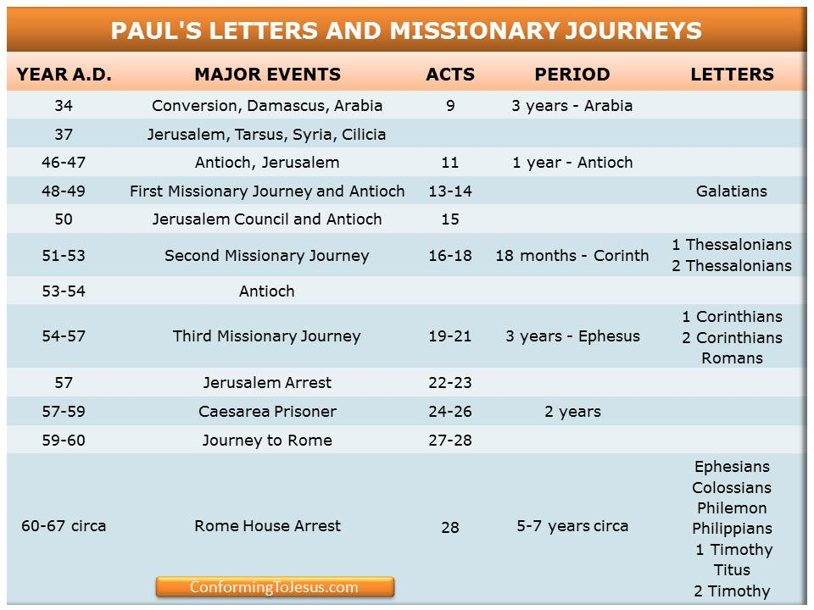

5 Practices of a Missional Church

Tim Keller at https://brave.is/5-practices-of-a-missional-church-tim-keller/
In the West, for nearly a thousand years, the relationship of European Christian churches to the broader culture was a relationship known as Christendom. The institutions of society “Christianized” people and stigmatized non-Christian belief and behavior.
British missionary, Lesslie Newbigin, went to India [in 1936]. When he returned to England, some thirty years later, he discovered that the Western church now found itself in a non-Christian society, but it had not adapted to its new situation. While most traditional evangelical churches can win the temperamentally conventional and conservative to Christ, American author Michael Wolff notes that this market is shrinking. If evangelical churches settle the decline in numbers, with the remaining Christian body not becoming missional, they will decline and die. This has instituted an even greater need for “missional” churches, which adopt the following practices:
1. Speak in the vernacular
In Christendom, technical biblical terms are well known inside and outside of the church. In a missional church, however, these terms must be explained.
The missional church:
- avoids “tribal” language, stylized prayer language, and evangelical jargon that seeks to set a spiritual tone.
- avoids “we-they” language, disdainful jokes that mock people of different politics and beliefs
- avoids sentimental, pompous, “inspirational” talk
- avoids talking as if non-believers were not present
2. Enter and retell the culture’s stories with the Gospel
In Christendom, it is possible to simply exhort Christianized people to do what they know they should. There is little or no real engagement, listening, or persuasion. Often, along with exhortation, there is a heavy reliance on guilt to motivate behavior change.
In a missional church, preaching and communication always assume skeptics are present and consequently engages their stories. To enter the culture’s stories mean showing sympathy towards and deeply acquainting with literature, music, theatre, and other arts expressing the existing hopes, dreams, heroic narratives and fears. To retell the culture’s stories is to show how only in Christ can we have freedom without slavery and embrace-of-the-other without injustice.
3. Theologically train laypeople for public life and vocation
In a missional church, laypeople need theological education to “think Christianly” about everything and work with Christian distinctiveness. They need to know three things: (a) which cultural practices manifest common grace and are to be embraced, (b) which practices are antithetical to the Gospel and must be rejected, and (c) which practices can be adapted/revised.
Christians will have to use the Gospel to demonstrate true, biblical love and tolerance in the public square towards those with whom we deeply differ. This tolerance should equal or exceed that which groups with opposing views show towards Christians. The charge of intolerance is perhaps the main “defeater” of the Gospel in the non-Christian West.
4. Create Christian community that is countercultural and counterintuitive
In Christendom, “fellowship” is basically just a set of nurturing relationships, support, and accountability.
In a missional church, however, Christian community must go beyond that to embody a counterculture, showing the world how radically different a Christian society is with regard to sex, money, and power.
- In sex. We avoid both the secular society’s idolization of sex and traditional society’s fear of sex. We also exhibit love rather than hostility or fear toward those whose sexual life-patterns are different from ours.
- In money. We promote a radically generous commitment of time, money, relationships, and living space to social justice and the needs of the poor, the immigrant, and the economically and physically weak.
- In power. We are committed to power sharing and relationship building among races and classes that are alienated outside of the body of Christ. A missional church must be deeply and practically committed to deeds of compassion and social justice and deeply and practically committed to evangelism and conversion.
5. Practice Christian unity as much as possible on the local level
It is very important that we do not spend time bashing and criticizing other kinds of churches. That criticism simply plays into the common “defeater” that Christians are all intolerant. While we align ourselves in denominations that share many of our distinctives, at the local level we should cooperate with, reach out to, and support the other congregations and churches in our area. This will raise many thorny issues, of course, but our bias should be in the direction of cooperation.

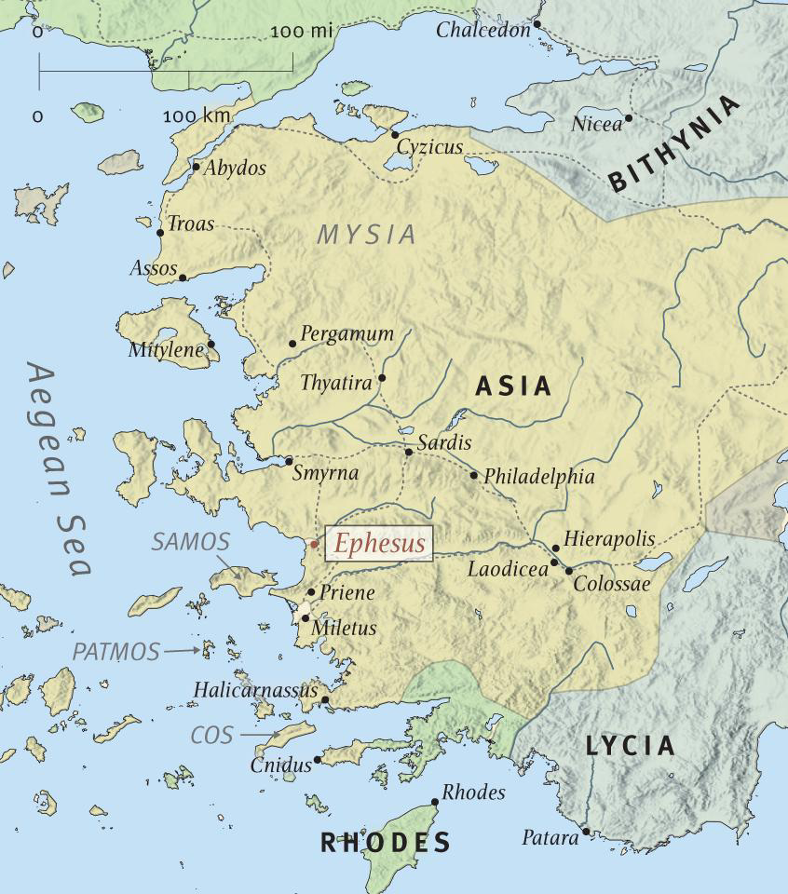

Acts Timeline (ESV Study Bible)

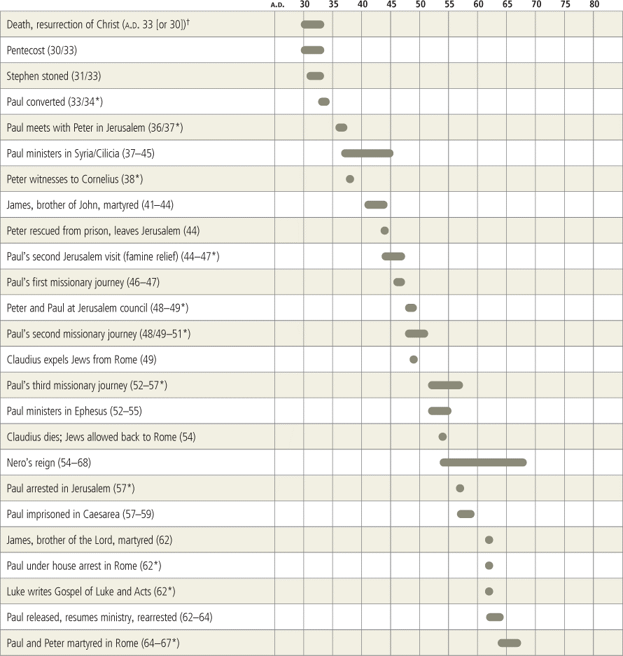

Paul's Parting Words (Acts 20:1-38)
Deffinbaugh at https://bible.org/seriespage/pauls-parting-words-acts-201-38

1 After the disturbance had ended, Paul sent for the disciples, and after encouraging them and saying farewell, he left to go to Macedonia. 2 After he had gone through those regions and spoken many words of encouragement to the believers there, he came to Greece, 3 where he stayed for three months. Because the Jews had made a plot against him as he was intending to sail for Syria, he decided to return through Macedonia. 4 Paul was accompanied by Sopater son of Pyrrhus from Berea, Aristarchus and Secundus from Thessalonica, Gaius from Derbe, and Timothy, as well as Tychicus and Trophimus from the province of Asia. 5 These had gone on ahead and were waiting for us in Troas.
6 We sailed away from Philippi after the days of Unleavened Bread, and within five days we came to the others in Troas, where we stayed for seven days. 7 On the first day of the week, when we met to break bread, Paul began to speak to the people, and because he intended to leave the next day, he extended his message until midnight. 8 (Now there were many lamps in the upstairs room where we were meeting.) 9 A young man named Eutychus, who was sitting in the window, was sinking into a deep sleep while Paul continued to speak for a long time. Fast asleep, he fell down from the third story and was picked up dead. 10 But Paul went down, threw himself on the young man, put his arms around him, and said, “Do not be distressed, for he is still alive!” 11 Then Paul went back upstairs, and after he had broken bread and eaten, he talked with them a long time, until dawn. Then he left. 12 They took the boy home alive and were greatly comforted.
13 We went on ahead to the ship and put out to sea for Assos, intending to take Paul aboard there, for he had arranged it this way. He himself was intending to go there by land. 14 When he met us in Assos, we took him aboard and went to Mitylene. 15 We set sail from there, and on the following day we arrived off Chios. The next day we approached Samos, and the day after that we arrived at Miletus. 16 For Paul had decided to sail past Ephesus so as not to spend time in the province of Asia, for he was hurrying to arrive in Jerusalem, if possible, by the day of Pentecost.
17 From Miletus he sent a message to Ephesus, telling the elders of the church to come to him. 18 When they arrived, he said to them, “You yourselves know how I lived the whole time I was with you, from the first day I set foot in the province of Asia, 19 serving the Lord with all humility and with tears, and with the trials that happened to me because of the plots of the Jews. 20 You know that I did not hold back from proclaiming to you anything that would be helpful, and from teaching you publicly and from house to house, 21 testifying to both Jews and Greeks about repentance toward God and faith in our Lord Jesus. 22 And now, compelled by the Spirit, I am going to Jerusalem without knowing what will happen to me there, 23 except that the Holy Spirit warns me in town after town that imprisonment and persecutions are waiting for me. 24 But I do not consider my life worth anything to myself, so that I may finish my task and the ministry that I received from the Lord Jesus, to testify to the good news of God’s grace. 25 “And now I know that none of you among whom I went around proclaiming the kingdom will see me again. 26 Therefore I declare to you today that I am innocent of the blood of you all. 27 For I did not hold back from announcing to you the whole purpose of God. 28 Watch out for yourselves and for all the flock of which the Holy Spirit has made you overseers, to shepherd the church of God that he obtained with the blood of his own Son. 29 I know that after I am gone fierce wolves will come in among you, not sparing the flock. 30 Even from among your own group men will arise, teaching perversions of the truth to draw the disciples away after them. 31 Therefore be alert, remembering that night and day for three years I did not stop warning each one of you with tears. 32 And now I entrust you to God and to the message of his grace. This message is able to build you up and give you an inheritance among all those who are sanctified. 33 I have desired no one’s silver or gold or clothing. 34 You yourselves know that these hands of mine provided for my needs and the needs of those who were with me. 35 By all these things, I have shown you that by working in this way we must help the weak, and remember the words of the Lord Jesus that he himself said, ‘It is more blessed to give than to receive.’” 36 When he had said these things, he knelt down with them all and prayed. 37 They all began to weep loudly, and hugged Paul and kissed him, 38 especially saddened by what he had said, that they were not going to see him again. Then they accompanied him to the ship (Acts 20:1-38).¹

Introduction²
After eight years among us, this is Richardson and Christianah Oyediran’s last full day with us before they return to their homeland in Nigeria to serve our Lord there. Just a few minutes ago, we had them come to the front so that we could place our hands on them and pray God’s blessings on them and on their future ministry in Nigeria. While we can celebrate the accomplishments Richardson has achieved in the past eight years (including obtaining his doctorate at Dallas Theological Seminary), there is still the tearful realization that our time together has come to an end. I believe the timing of their departure is providential, because it enables us to identify with Paul’s tearful parting from those he would never see again in this life, as recorded in our text in Acts 20. In general terms, Paul knows what will happen when he returns to Jerusalem: prison and persecutions.³ He also is confident that they will never see his face again.⁴ Paul’s last words to these beloved saints are just as relevant and applicable to Christians today as they were to those who heard them personally. Let us listen well to what the Spirit of God has to say to us through Paul’s parting words.

Observations
We would do well to make several observations before we deal with the text itself.
First, we should note that our passage both begins and ends at Ephesus.⁵ This would suggest that Ephesus is an important city in Luke’s mind, and more significantly, the church at Ephesus must play a key role in the expansion of the gospel. Paul urged Timothy to remain in Ephesus to address some false teaching going on there. Ephesus is the first of the seven churches of Asia addressed in Revelation 2 and 3, which may indicate that it is the most prominent of the seven cities of Asia.
Second, Paul was determined to reach Jerusalem as soon as possible, and from there, he planned to go to Rome.
Now after all these things had taken place, Paul resolved to go to Jerusalem, passing through Macedonia and Achaia. He said, “After I have been there, I must also see Rome” (Acts 19:21, emphasis mine).⁶
Third, although Paul was determined to go to Jerusalem, he knew that doing so would be at great cost to him personally.
15 But the Lord said to him, “Go, because this man is my chosen instrument to carry my name before Gentiles and kings and the people of Israel. 16 For I will show him how much he must suffer for the sake of my name” (Acts 9:15-16, emphasis mine).
3 After we sighted Cyprus and left it behind on our port side, we sailed on to Syria and put in at Tyre, because the ship was to unload its cargo there. 4 After we located the disciples, we stayed there seven days. They repeatedly told Paul through the Spirit not to set foot in Jerusalem. 5 When our time was over, we left and went on our way. All of them, with their wives and children, accompanied us outside of the city. After kneeling down on the beach and praying (Acts 21:3-5, emphasis mine).
8 On the next day we left and came to Caesarea, and entered the house of Philip the evangelist, who was one of the seven, and stayed with him. 9 (He had four unmarried daughters who prophesied.) 10 While we remained there for a number of days, a prophet named Agabus came down from Judea. 11 He came to us, took Paul’s belt, tied his own hands and feet with it, and said, “The Holy Spirit says this: ‘This is the way the Jews in Jerusalem will tie up the man whose belt this is, and will hand him over to the Gentiles.’” 12 When we heard this, both we and the local people begged him not to go up to Jerusalem. 13 Then Paul replied, “What are you doing, weeping and breaking my heart? For I am ready not only to be tied up, but even to die in Jerusalem for the name of the Lord Jesus.” 14 Because he could not be persuaded, we said no more except, “The Lord’s will be done” (Acts 21:8-14, emphasis mine).
Fourth, Paul knows that this is the last time he will see these saints face-to-face.⁷
Fifth, beginning at verse 5, Luke has once again joined Paul in his travels.
Sixth, Luke deliberately omits a great deal of information concerning matters that occur in the time frame of Acts 20.⁸ Luke is very selective in what he records in chapter 20. Acts 20 covers a longer period of time than we might expect. For example, we are told that Paul spent three months in Greece,⁹ but what is not said is that the events of verses 1-3 took at least a year. Some of Paul’s struggles, especially regarding the church at Corinth,¹⁰ are never mentioned, even though they occurred in the time frame of our text. The Book of Romans¹¹ (and possibly Galatians) was written while Paul was in Corinth (Greece).
What is most interesting is that no direct mention is made of the collection which Paul has arranged to take to the needy saints in Judea.¹² This is in spite of the fact that those who were designated to accompany Paul to Jerusalem with these funds were named in Acts 20:4. Perhaps Luke assumes that the reader would know this.
Seventh, although the events of Acts 20 cover a period of at least one year, Luke chooses to focus on two events, each about one week in length. These two events are:
Paul’s final words to the saints at Troas (Acts 20:6-12)
Paul’s final words to the Ephesian elders at Miletus (Acts 20:17/18-38)
Eighth, Paul’s exhortation to the Ephesian elders begins and ends with a reminder of his example while serving among them. As a matter of fact, of the 22 verses which deal with Paul’s exhortation of these elders, 7 verses describe Paul’s conduct among them in the past, and 5 verses deal with the dangers which face him in Jerusalem. Paul’s practice and his preaching are very much interrelated.
16 I encourage you, then, be imitators of me. 17 For this reason, I have sent Timothy to you, who is my dear and faithful son in the Lord. He will remind you of my ways in Christ, as I teach them everywhere in every church (1 Corinthians 4:16-17).
Ninth, this is the only sermon in the Book of Acts addressed exclusively to the saints. We have seen Peter’s evangelistic sermons early in Acts, as we have later studied Paul’s evangelistic sermons.¹³ Paul’s farewell address to the Ephesian elders is an example of the kind of message he might deliver to believers in other locations as well.
Our text covers a lot of ground, geographically and otherwise, but I’ve concluded that this chapter is somewhat like a funnel, with all the earlier events of the chapter serving to focus our attention on Paul’s parting words to the Ephesian elders in verses 18-38. In this lesson, I will seek to preserve the emphasis Luke has prescribed. Therefore, I will focus primarily on the farewell message to the Ephesian elders that Luke records in our text.

From Ephesus to Troas Acts 20:1-6
1 After the disturbance had ended, Paul sent for the disciples, and after encouraging them and saying farewell, he left to go to Macedonia. 2 After he had gone through those regions and spoken many words of encouragement to the believers there, he came to Greece, 3 where he stayed for three months. Because the Jews had made a plot against him as he was intending to sail for Syria, he decided to return through Macedonia. 4 Paul was accompanied by Sopater son of Pyrrhus from Berea, Aristarchus and Secundus from Thessalonica, Gaius from Derbe, and Timothy, as well as Tychicus and Trophimus from the province of Asia. 5 These had gone on ahead and were waiting for us in Troas.
Essentially, these verses serve to explain just how it happened that Paul came to Troas, where he met with the church. Paul’s arrival at Troas did not come about as he had planned. After leaving Ephesus, Paul traveled on to Macedonia. It would seem that Paul visited various churches there (such as the church at Philippi), collecting their offerings for the poor in Judea and encouraging the saints with his teaching. Paul then made his way to Greece, where he seems to have stayed in Corinth for three months. Eager to reach Jerusalem, Paul planned to sail directly from Corinth to Syria.
Paul had a number of men accompanying him (and, I assume, he had the gifts from their home churches to the needy in Judea), but they had gone on ahead to Troas. Paul learned of a conspiracy against him by the Jews, who intended to kill him. It has been conjectured that Paul’s ship may have been crowded with Jews who were making a pilgrimage to Jerusalem. Having learned about Paul, they may have conspired to throw him overboard, to perish almost unnoticed. For whatever reason, Paul felt his chances were better on land,¹⁴ and so he arranged to travel back to Macedonia and then sail from there (Philippi) to Troas, where he would meet up with his associates.

Paul’s Ministry at Troas Acts 20:6-12
6 We sailed away from Philippi after the days of Unleavened Bread, and within five days we came to the others in Troas, where we stayed for seven days. 7 On the first day of the week, when we met to break bread, Paul began to speak to the people, and because he intended to leave the next day, he extended his message until midnight. 8 (Now there were many lamps in the upstairs room where we were meeting.) 9 A young man named Eutychus, who was sitting in the window, was sinking into a deep sleep while Paul continued to speak for a long time. Fast asleep, he fell down from the third story and was picked up dead. 10 But Paul went down, threw himself on the young man, put his arms around him, and said, “Do not be distressed, for he is still alive!” 11 Then Paul went back upstairs, and after he had broken bread and eaten, he talked with them a long time, until dawn. Then he left. 12 They took the boy home alive and were greatly comforted (Acts 20:6-12).
In the Book of Acts, we do not read of Paul doing any evangelistic work at Troas. We know that he received the Macedonian vision while at Troas,¹⁵ but Luke gives us no report concerning Paul’s evangelistic activity in this city. We do read of “an open door” for ministry in Troas in Paul’s Second Epistle to the Corinthians:
12 Now when I arrived in Troas to proclaim the gospel of Christ, even though the Lord had opened a door of opportunity for me, 13 I had no relief in my spirit, because I did not find my brother Titus there. So I said good-bye to them and set out for Macedonia. 14 But thanks be to God who always leads us in triumphal procession in Christ and who makes known through us the fragrance that consists of the knowledge of him in every place (2 Corinthians 2:12-14).
It is obvious that there was a church in Troas when Paul and his associates arrived on board ship. They had seven days to spend with these brethren, one of which was “the first day of the week.” I assume this to be a reference to Sunday, and thus Paul was able to meet with the church when they normally came together for worship. However, this is obviously not a typical day of worship for this congregation. This was a very unusual meeting, prompted by the fact that Paul would be leaving the following morning.¹⁶ Paul extended his message until midnight. In addition to this being a long message, it was late at night, they were on the third floor in an upper room, and there were a number of torches burning to provide light. All this was just too much for young Eutychus, who was sitting in the window. One can almost envision Eutychus slowly succumbing to sleep, until he suddenly drops out of the window, falling to his death three floors below.
There is no question in my mind but what Eutychus was dead. While Paul was only thought to be dead when he was stoned in Lystra,¹⁷ Eutychus was “good and dead” when they found him lying on the ground. “They picked him up dead,” Luke tells us.¹⁸ Nothing can be clearer than these words. Paul’s words, “Do not be distressed, for he is still¹⁹ alive!” The word “still” is unfortunate because it is not found in the Greek text, and it is misleading. The boy fell to his death and was taken up dead. Paul then “threw himself on the young man” and “put his arms around him.” The boy came back to life, and Paul announced this fact by saying (literally), “Do not be alarmed, for his life is in him” (ESV).
I have no doubt that Eutychus died and was resuscitated. What amazes me is the casual and matter of fact way that both Paul and Luke deal with this miracle. What an opportunity for Paul to capitalize on this miracle. Likewise, think of how Luke could have embellished the story. And yet we simply read that after the boy was brought back to life, Paul went back upstairs, broke bread with the saints, and then talked with the saints until dawn.
My sense is that Paul was “winding up” his sermon when Eutychus fell to his death. This brought his preaching to an abrupt end, but who could have a better conclusion to his message than the raising of a young lad from death? After they had broken bread together, Paul and the saints talked until dawn. I do not see this “talking” as a formal message, but as the sweet fellowship of those who will soon part forever. When morning came, Paul left, and the young boy was taken home alive with those who accompanied him (his parents?) greatly comforted.
Here is something interesting about Luke’s account of Paul’s Sunday meeting with the saints in Troas: The miracle of resuscitating Eutychus is described in a matter of fact way. There is absolutely no journalistic sensationalism here. The meal that had been delayed until Paul finished his message was now served, and it provided the occasion for conversation until morning light.
I get the distinct impression that while neither Luke nor Paul wish to glamorize the resuscitation of Eutychus, they do wish to emphasize Paul’s preaching and teaching. It took a fatal accident to end it, and then after the miracle of healing this lad, Paul broke bread and spoke with the saints until morning light.
From Luke’s account, I would infer that the message Paul preached was more important than the miracle performed by his hands. Now we should not sell this miracle short. It accredited Paul as a genuine apostle:
11 I have become a fool. You yourselves forced me to do it, for I should have been commended by you. For I lack nothing in comparison to those “super-apostles,” even though I am nothing. 12 Indeed, the signs of an apostle were performed among you with great perseverance by signs and wonders and powerful deeds (2 Corinthians 12:11-12).
I get the distinct impression that Luke expects us to be more impressed with Paul’s message than with this miracle. The reason for this is simple: Men are not sustained in their faith by non-stop miracles; they are sustained by the Word of God. The miracles performed by the apostles accredited them as our Lord’s genuine apostles. The message was more important than the miracles, or rather the miracles only served to underscore the message.
But notice that while we are impressed with the importance of the message Paul delivered at Troas, we are not told what that message was. Luke does an excellent job of calling our attention to Paul’s message, but then he does not tell us what that message was. I believe the explanation is simple: Luke has given us the substance of Paul’s message in his account of Paul’s exhortation of the Ephesian elders. We know that Paul was warned of the dangers ahead for him in nearly every city. Why, then, would we expect Paul’s message to be anything other than what we read in Acts 20:17-38? And so it is that Acts 20:1-16 serves to get our attention as Luke reveals what Paul’s message was.

From Troas to Miletus Acts 20:13-16
13 We went on ahead to the ship and put out to sea for Assos, intending to take Paul aboard there, for he had arranged it this way. He himself was intending to go there by land. 14 When he met us in Assos, we took him aboard and went to Mitylene. 15 We set sail from there, and on the following day we arrived off Chios. The next day we approached Samos, and the day after that we arrived at Miletus. 16 For Paul had decided to sail past Ephesus so as not to spend time in the province of Asia, for he was hurrying to arrive in Jerusalem, if possible, by the day of Pentecost.
After a very tearful parting in Troas, Paul’s companions boarded a ship headed for Assos, where they would take Paul on. Paul himself intended to go by land to Assos, a trip of approximately 20 miles. We are not told why Paul chose to travel by land. Whatever Paul’s reason, he went by land, and the others (including Luke – note the “we” in verse 13) sailed to Assos. When Paul boarded ship at Assos, they all sailed to Mitylene, a major city on the island of Lesbos. Their next stop was at an unnamed port on the mainland, opposite the Island of Chios. From there, they sailed to Samos, an island almost directly west of the city of Ephesus. They had chosen to sail on a vessel that did not make port in Ephesus because Paul was eager to arrive in Jerusalem by the day of Pentecost. And thus it was that they sailed past Ephesus and landed at Miletus, 30 miles or so south of Ephesus. From here, Paul would send word to the elders of the church in Ephesus, asking them to meet him in Miletus.

Paul’s Message in Miletus Acts 20:17-38

Paul’s Conduct and Lifestyle among the Ephesians Acts 20:17-21
17 From Miletus he sent a message to Ephesus, telling the elders of the church to come to him. 18 When they arrived, he said to them, “You yourselves know how I lived the whole time I was with you, from the first day I set foot in the province of Asia, 19 serving the Lord with all humility and with tears, and with the trials that happened to me because of the plots of the Jews. 20 You know that I did not hold back from proclaiming to you anything that would be helpful, and from teaching you publicly and from house to house, 21 testifying to both Jews and Greeks about repentance toward God and faith in our Lord Jesus (Acts 20:17-21).
It is my belief that the first 16 verses of Acts 20 have served to point us to Paul’s message to the Ephesian elders in verses 17-38. I previously pointed out that this is Paul’s only recorded message to the saints. Also, we noted that Paul’s exhortation to the Ephesian elders begins and ends with Paul’s testimony and example. Verses 18-21 are Paul’s account of his conduct while in their midst.
There was a transparency to Paul’s life and ministry that set him apart from many of the religious “hucksters” of his day (and ours). Later on, Paul will call attention to the financial aspects of his ministry,²⁰ but here Paul focuses on the nature of his ministry. His ministry was “in residence.” He lived with and among them from the time he arrived in Asia. His ministry was characterized both by humility and tears. Humility is a quality that should characterize every Christian:
1 I, therefore, the prisoner for the Lord, urge you to live worthily of the calling with which you have been called, 2 with all humility and gentleness, with patience, bearing with one another in love, 3 making every effort to keep the unity of the Spirit in the bond of peace (Ephesians 4:1-3).
Humility is probably best defined by Paul in the Book of Philippians:
1 Therefore, if there is any encouragement in Christ, any comfort provided by love, any fellowship in the Spirit, any affection or mercy, 2 complete my joy and be of the same mind, by having the same love, being united in spirit, and having one purpose. 3 Instead of being motivated by selfish ambition or vanity, each of you should, in humility, be moved to treat one another as more important than yourself. 4 Each of you should be concerned not only about your own interests, but about the interests of others as well. 5 You should have the same attitude toward one another that Christ Jesus had, 6 who though he existed in the form of God did not regard equality with God as something to be grasped, 7 but emptied himself by taking on the form of a slave, by looking like other men, and by sharing in human nature. 8 He humbled himself, by becoming obedient to the point of death – even death on a cross! (Philippians 2:1-8).
Humility is putting the interests of others above your own, of sacrificing self-interest for the good of others.²¹ This was the mindset of our Lord which led Him to the cross of Calvary. This should be the mindset of every person toward their ministry, as it was with Timothy and Epaphroditus.²²
Paul’s attitude of humility is in stark contrast with the arrogance and high-handed methods of those false teachers whose ministries are self-serving:
12 And what I am doing I will continue to do, so that I may eliminate any opportunity for those who want a chance to be regarded as our equals in the things they boast about. 13 For such people are false apostles, deceitful workers, disguising themselves as apostles of Christ. 14 And no wonder, for even Satan disguises himself as an angel of light. 15 Therefore it is not surprising his servants also disguise themselves as servants of righteousness, whose end will correspond to their actions. 16 I say again, let no one think that I am a fool. But if you do, then at least accept me as a fool, so that I too may boast a little. 17 What I am saying with this boastful confidence I do not say the way the Lord would. Instead it is, as it were, foolishness. 18 Since many are boasting according to human standards, I too will boast. 19 For since you are so wise, you put up with fools gladly. 20 For you put up with it if someone makes slaves of you, if someone exploits you, if someone takes advantage of you, if someone behaves arrogantly toward you, if someone strikes you in the face (2 Corinthians 11:12-20).
No wonder Paul uses his example as a standard by which other leaders should be recognized and followed:
17 Be imitators of me, brothers and sisters, and watch carefully those who are living this way, just as you have us as an example. 18 For many live, about whom I have often told you, and now, with tears, I tell you that they are the enemies of the cross of Christ (Philippians 3:17-18).
Notice that here in Philippians 3, Paul speaks of his instruction and warnings as having been communicated “with tears.” In our text in Acts 20, Paul likewise refers to his tears:
18 When they arrived, he said to them, “You yourselves know how I lived the whole time I was with you, from the first day I set foot in the province of Asia, 19 serving the Lord with all humility and with tears, and with the trials that happened to me because of the plots of the Jews (Acts 20:18-19).
What do Paul’s tears have to do with his ministry? His tears reveal the depth of his love and compassion for those in Ephesus. They tell us that when Paul ministered among the Ephesians, he did so because he cared deeply for them, as he did for the saints elsewhere.
For out of great distress and anguish of heart I wrote to you with many tears, not to make you sad, but to let you know the love that I have especially for you (2 Corinthians 2:4).
So then, my brothers and sisters, dear friends whom I long to see, my joy and crown, stand in the Lord in this way, my dear friends! (Philippians 4:1)
For who is our hope or joy or crown to boast of before our Lord Jesus at his coming? Is it not of course you? (1 Thessalonians 2:19)
I have heard Josh McDowell say, “Rules without relationship result in rebellion.” Paul is most emphatically saying that his teaching was founded on a relationship of love and concern.
Paul also called attention to the fact that his teaching and ministry were strongly opposed by unbelieving Jews. Their plots resulted in many trials which Paul had to endure. Lesser men would have “taken a sabbatical” or restated their teaching, so as to avoid persecution. Not so with Paul! Paul points out that he did not “hold back from proclaiming . . . anything that would be helpful” (Acts 20:20). There are many preachers today who take pride in the fact that they teach selectively. We know they will leave out unpleasant topics like sin, righteousness, and judgment, even though these are the realities to which the Holy Spirit bears witness.²³ Hell is a subject that will never come up in their preaching, but health and wealth will be a constant theme. Paul’s teaching centered around “repentance toward God and faith in our Lord Jesus Christ” (Acts 20:21). In other words, the gospel was the core of Paul’s teaching.
Paul’s teaching had several venues. Paul claims to have taught the Ephesians “publicly and from house to house” (verse 20). Some teaching could be done efficiently and effectively in larger groupings. (I would assume that this kind of teaching occurred at the “school of Tyrannus” (Acts 19:9). But teaching must also be done in a more intimate context, where it is applied to life’s needs and challenges. Thus, Paul also taught from “house to house.” Paul knew that the gospel was not restricted to Jews only, and so his ministry encompassed both Jews and Gentiles. Paul’s ministry was evidence of Paul’s integrity. His teaching should be heard and obeyed as the Word of God conveyed by a genuine apostle of Jesus Christ.

Paul’s Prospects in the Future Acts 20:22-25
22 And now, compelled by the Spirit, I am going to Jerusalem without knowing what will happen to me there, 23 except that the Holy Spirit warns me in town after town that imprisonment and persecutions are waiting for me. 24 But I do not consider my life worth anything to myself, so that I may finish my task and the ministry that I received from the Lord Jesus, to testify to the good news of God’s grace. 25 “And now I know that none of you among whom I went around proclaiming the kingdom will see me again (Acts 20:22-25).
Verses 17-21 have focused on Paul’s conduct and teaching while he was with them in the past. Verses 22-25 look forward to what the future holds for Paul, and how this bears upon his final words to them at Miletus. While Paul has “set his face toward Jerusalem,”²⁴ intent on arriving there before Pentecost,²⁵ he does so knowing, in general terms, what awaits him. In several of the cities he has visited, the Spirit of God has informed Paul and others that “imprisonment and persecutions await him.” In addition, Paul knows that these saints will never see his face again.²⁶ No wonder the saints in Troas were willing for Paul to preach to them till midnight and to talk with them until dawn. No wonder the elders in Ephesus were willing to make the 30-mile trek to Miletus to meet with Paul.
Paul’s courage and perseverance in the face of these trials that awaited him in Jerusalem would have silenced and stopped many, but not Paul. Paul did not consider self-preservation his primary motivation. He was a man of humility, who was willing to put the interests of others ahead of his own. Thus, he was determined to fulfill his calling, which was the proclamation of the good news of the grace of God in the person of Jesus Christ.
Here was a man who should be imitated. Here was a man whose teaching and exhortation should be heard. His words of exhortation now follow, and Luke has prepared us to hear and to heed them.

Paul’s Words of Exhortation Acts 20:26-32
26 Therefore I declare to you today that I am innocent of the blood of you all. 27 For I did not hold back from announcing to you the whole purpose of God. 28 Watch out for yourselves and for all the flock of which the Holy Spirit has made you overseers, to shepherd the church of God that he obtained with the blood of his own Son. 29 I know that after I am gone fierce wolves will come in among you, not sparing the flock. 30 Even from among your own group men will arise, teaching perversions of the truth to draw the disciples away after them. 31 Therefore be alert, remembering that night and day for three years I did not stop warning each one of you with tears. 32 And now I entrust you to God and to the message of his grace. This message is able to build you up and give you an inheritance among all those who are sanctified.
Up to this point, Paul’s ministry and mission have been faithfully fulfilled. In verses 26 and 27, Paul echoes the words of Ezekiel:
16 At the end of seven days the word of the Lord came to me: 17 “Son of man, I have appointed you a watchman for the house of Israel. Whenever you hear a word from my mouth, you must give them a warning from me. 18 When I say to the wicked, “You will certainly die,” and you do not warn him – you do not speak out to warn the wicked to turn from his wicked deed and wicked lifestyle so that he may live – that wicked person will die for his iniquity, but I will hold you accountable for his death. 19 But as for you, if you warn the wicked and he does not turn from his wicked deed and from his wicked lifestyle, he will die for his iniquity but you will have saved your own life. 20 “When a righteous person turns from his righteousness and commits iniquity, and I set an obstacle before him, he will die. If you have not warned him, he will die for his sin. The righteous deeds he performed will not be considered, but I will hold you accountable for his death. 21 However, if you warn the righteous person not to sin, and he does not sin, he will certainly live because he was warned, and you will have saved your own life” (Ezekiel 3:16-21).
1 The word of the Lord came to me: 2 “Son of man, speak to your people, and say to them, ‘Suppose I bring a sword against the land, and the people of the land take one man from their borders and make him their watchman. 3 He sees the sword coming against the land, blows the trumpet, and warns the people, 4 but there is one who hears the sound of the trumpet yet does not heed the warning. Then the sword comes and sweeps him away. He will be responsible for his own death. 5 He heard the sound of the trumpet but did not heed the warning, so he is responsible for himself. If he had heeded the warning, he would have saved his life. 6 But suppose the watchman sees the sword coming and does not blow the trumpet to warn the people. Then the sword comes and takes one of their lives. He is swept away for his iniquity, but I will hold the watchman accountable for that person’s death.’ 7 “As for you, son of man, I have made you a watchman for the house of Israel. Whenever you hear a word from my mouth, you must warn them on my behalf. 8 When I say to the wicked, ‘O wicked man, you must certainly die,’ and you do not warn the wicked about his behavior, the wicked man will die for his iniquity, but I will hold you accountable for his death. 9 But if you warn the wicked man to change his behavior, and he refuses to change, he will die for his iniquity, but you have saved your own life (Ezekiel 33:1-9).
These words in Ezekiel speak of warning sinners of the coming judgment of God and of calling these sinners to repentance so that they might be spared from God’s wrath. This is part of the “whole purpose of God” from which Paul did not hold back. Paul spoke of sin and of judgment, and of salvation for those who repent and place their trust in Jesus as God’s only provision for salvation.
We know that Paul’s resolve to fulfill his mission was rewarded because, at the end of his life, he was able to say:
6 For I am already being poured out as an offering, and the time for me to depart is at hand. 7 I have competed well; I have finished the race; I have kept the faith! 8 Finally the crown of righteousness is reserved for me. The Lord, the righteous Judge, will award it to me in that day – and not to me only, but also to all who have set their affection on his appearing (2 Timothy 4:6-8).

Exhorting the Ephesian Elders Acts 20:26-32
28 Watch out for yourselves and for all the flock of which the Holy Spirit has made you overseers, to shepherd the church of God that he obtained with the blood of his own Son. 29 I know that after I am gone fierce wolves will come in among you, not sparing the flock. 30 Even from among your own group men will arise, teaching perversions of the truth to draw the disciples away after them. 31 Therefore be alert, remembering that night and day for three years I did not stop warning each one of you with tears. 32 And now I entrust you to God and to the message of his grace. This message is able to build you up and give you an inheritance among all those who are sanctified (Acts 20:26-32).
After an introduction like this, who could take Paul’s final words of exhortation lightly? Having spoken of the ominous aspects of his future, Paul now warns of a threat to the well-being of the Ephesian church in verses 29 through 31. Paul is confident that the Ephesian church will face its own dangers. In contrast to his conduct and creed, there are those who will rise up like fierce wolves. They will not care about the flock as Paul has done; they will seek to devour the flock. These will come into the church, not only from outside, but also from among this very group of elders to whom Paul is speaking. These wolves will seek to gain a following, and they will attempt to accomplish this by corrupting the truth in such a way as to appeal to the fleshly appetites of vulnerable saints. Paul had passionately and persistently warned of these dangers the entire time he was among them.²⁷
Paul’s words of warning are remarkably similar to those of Peter:
1 But false prophets arose among the people, just as there will be false teachers among you. These false teachers will infiltrate your midst with destructive heresies, even to the point of denying the Master who bought them. As a result, they will bring swift destruction on themselves. 2 And many will follow their debauched lifestyles. Because of these false teachers, the way of truth will be slandered. 3 And in their greed they will exploit you with deceptive words. Their condemnation pronounced long ago is not sitting idly by; their destruction is not asleep (2 Peter 2:1-3).
17 These men are waterless springs and mists driven by a storm, for whom the utter depths of darkness have been reserved. 18 For by speaking high-sounding but empty words they are able to entice, with fleshly desires and with debauchery, people who have just escaped from those who reside in error (2 Peter 2:17-18).
Paul’s prophetic words of warning may well have been received by way of revelation, but they also were the result of painful experience. It was during this same period of time that Paul was deeply distressed over the state of the church in Corinth.²⁸ Already the church was dividing into splinter groups (factions) that were based upon undue attraction and devotion to a particular leader:
11 For members of Chloe’s household have made it clear to me, my brothers and sisters, that there are quarrels among you. 12 Now I mean this, that each of you is saying, “I am with Paul,” or “I am with Apollos,” or “I am with Cephas,” or “I am with Christ” (1 Corinthians 1:11-12²⁹; see also 3:1-10).
These men who sought to gain a personal following will eventually prove to be false apostles, who are actually messengers of Satan. Their message will turn from a simple gospel focused on Christ and His cross,³⁰ and their methods will be highly polished techniques of human persuasion and appeal. Paul refused the slick gimmicks of persuasion and stressed a simplicity of message and method which was dependent upon the convincing ministry of the Holy Spirit. In this way, men were encouraged to put their trust in God, rather then in mere men:
For we are not like so many others, hucksters who peddle the word of God for profit, but we are speaking in Christ before God as persons of sincerity, as persons sent from God (2 Corinthians 2:17).
1 Therefore, since we have this ministry, just as God has shown us mercy, we do not become discouraged. 2 But we have rejected shameful hidden deeds, not behaving with deceptiveness or distorting the word of God, but by open proclamation of the truth we commend ourselves to everyone’s conscience before God (2 Corinthians 4:1-2).
1 When I came to you, brothers and sisters, I did not come with superior eloquence or wisdom as I proclaimed the testimony of God. 2 For I decided to be concerned about nothing among you except Jesus Christ, and him crucified. 3 And I was with you in weakness and in fear and with much trembling. 4 My conversation and my preaching were not with persuasive words of wisdom, but with a demonstration of the Spirit and of power, 5 so that your faith would not be based on human wisdom but on the power of God (1 Corinthians 2:1-5).
As a result, Paul exhorts these elders to watch out for themselves, as well as for the flock of God.³¹ Because some of them would be enticed to pervert the gospel in order to create a personal following, they must first “watch out for themselves.” Every time you commence a flight on a commercial airline, you are instructed about the use of the oxygen mask. Adults are told to place the oxygen mask on themselves first, and then to put a mask on any small child with them. This is because the person who does not first put the mask on themselves will not be able to help little children who cannot help themselves. In a similar way, these shepherds of the flock must first tend to themselves – to their own relationship with Jesus Christ – and then they will be able to shepherd the flock of God.
Once again, Paul contrasts his ministry with those who will arise in Ephesus as false teachers. These men would seek to develop allegiance to themselves by tailoring their message and their methods to suit the whims of their followers.
3 For there will be a time when people will not tolerate sound teaching. Instead, following their own desires, they will accumulate teachers for themselves, because they have an insatiable curiosity to hear new things. 4 And they will turn away from hearing the truth, but on the other hand they will turn aside to myths (2 Timothy 4:3-4).
Paul knows that God’s will for his life will prevent Paul from seeing the faces of these beloved men and of the sheep under their care. Instead of seeking to create an undue devotion to himself, Paul turns these beloved believers to that which will sustain them – the Word of God. He entrusts these saints to God, and to the gospel, the “message of His grace.” It is God’s Word that Paul preached, resulting in their salvation. It is God’s Word – all of it – that Paul taught them to protect and to sustain them. It is God’s Word that will build them up (bring them to maturity). It is God’s Word that will bring about an eternal inheritance among those who are sanctified.
The sufficiency of the Scriptures is also Peter’s theme as he shares these final words with those to whom he writes:
12 Therefore, I intend to remind you constantly of these things even though you know them and are well established in the truth that you now have. 13 Indeed, as long as I am in this tabernacle, I consider it right to stir you up by way of a reminder, 14 since I know that my tabernacle will soon be removed, because our Lord Jesus Christ revealed this to me. 15 Indeed, I will also make every effort that, after my departure, you have a testimony of these things. 16 For we did not follow cleverly concocted fables when we made known to you the power and return of our Lord Jesus Christ; no, we were eyewitnesses of his grandeur. 17 For he received honor and glory from God the Father, when that voice was conveyed to him by the Majestic Glory: “This is my dear Son, in whom I am delighted.” 18 When this voice was conveyed from heaven, we ourselves heard it, for we were with him on the holy mountain. 19 Moreover, we possess the prophetic word as an altogether reliable thing. You do well if you pay attention to this as you would to a light shining in a murky place, until the day dawns and the morning star rises in your hearts. 20 Above all, you do well if you recognize this: No prophecy of scripture ever comes about by the prophet’s own imagination, 21 for no prophecy was ever borne of human impulse; rather, men carried along by the Holy Spirit spoke from God (2 Peter 1:12-21).
I should point out one more thing before pressing on. Notice the way Paul describes the church at Ephesus. It is “the church of God,” the “flock” which God purchased at the cost of the blood of His Son. Elders need to be reminded that their leadership role is not a matter of their seeking and striving, but a matter of divine appointment. It is the Holy Spirit who has made them overseers. The church does not belong to the elders (plural), and not to any one elder. These are the sheep of God’s flock, whom they have been appointed to serve as shepherds. John R.W. Stott cites these words from Richard Baxter, which applies the fact that the church was purchased by the shed blood of God’s precious Son:
Oh then, let us hear these arguments of Christ, whenever we feel ourselves grow dull and careless: ‘Did I die for them, and wilt not thou look after them? Were they worth my blood and are they not worth thy labour? Did I come down from heaven to earth, to seek and to save that which was lost; and wilt thou not go to the next door or street or village to seek them? How small is thy labour and condescension as to mine? I debased myself to this, but it is thy honour to be so employed. Have I done and suffered so much for their salvation; and was I willing to make thee a co-worker with me, and wilt thou refuse that little that lieth upon thy hands?’³²

Paul’s Example in the Matter of Money Acts 20:33-35
33 I have desired no one’s silver or gold or clothing. 34 You yourselves know that these hands of mine provided for my needs and the needs of those who were with me. 35 By all these things, I have shown you that by working in this way we must help the weak, and remember the words of the Lord Jesus that he himself said, ‘It is more blessed to give than to receive.’”
For some preachers, money is the first thing they talk about; indeed, it might be the only thing some talk about. For Paul, it is different. Money is the last thing he talks about here in our text.
You will remember that I mentioned earlier that Paul begins and ends his exhortation by calling attention to his example. Paul has been distinguishing himself and his ministry from that of the false teachers who will arise in the church at Ephesus. They are arrogant; he is humble. They care not for the flock; Paul loves the flock and tearfully ministers to it. They seek to gain a following; Paul points men to Christ and to the sufficiency of His Word. And now, finally, Paul contrasts his conduct regarding finances with those who will seek to devour the flock.
Turning once again to his conduct while among them, Paul reminds the Ephesian elders of things they knew to be true. Paul’s ministry was not about acquiring money. He did not covet the material possessions of those he came to serve. Indeed, Paul would not even be supported by the Ephesian saints, although it was his right.³³ Paul not only provided for himself by “tent making;” he also provided for those who were with him. Paul used his strength to serve the weak, not to prey upon the weak, just as he taught the Ephesians to do:
The one who steals must steal no longer; rather he must labor, doing good with his own hands, so that he may have something to share with the one who has need (Ephesians 4:28).
While we do not find these exact words in any of the four gospels, we do not doubt that our Lord taught that it is “more blessed to give than to receive” (verse 35). Our Lord Himself set the standard, and Paul delighted to keep it, as he exhorted others to do also.

A Tearful Parting
36 When he had said these things, he knelt down with them all and prayed. 37 They all began to weep loudly, and hugged Paul and kissed him, 38 especially saddened by what he had said, that they were not going to see him again. Then they accompanied him to the ship (Acts 20:1-38).
Here is the way a man like Paul should leave a church – prayerfully and tearfully. I can imagine what Paul’s prayers must have been like. No doubt, he prayed about the very things that he had just said. And no doubt there were prayers offered for Paul as he set out for Jerusalem and the trials which awaited him there. What a tearful parting it was, just as one would hope it would be. What a joyful reunion awaits them when they meet once again in heaven.

Conclusion
I approach our text as an elder, and thus I see many areas of direct application. As an elder, I must not only preach the word; I must practice the word. My example has a great deal to do with the credibility of my message. I must walk the talk. I must manifest humility and compassion for the sheep. As an elder, I must faithfully proclaim God’s Word. I must teach all of it. I must never minimize or compromise the gospel. I am obligated to teach it publicly and privately. I am to wean people from dependence on me and point them to the sufficiency of Christ and His Word. I must not restrict the preaching of the gospel to certain racial groups, but must proclaim the gospel to all, without distinction. I must be on guard against attracting my own following by departing from the truths of God’s Word. I must be on guard against spiritual waywardness in my own life, as well as in others. I must be careful not to covet what belongs to others and not to make the acquisition of material things my goal.
I believe that our text should set the standard for present and future elders in our church body. What Paul has described is what you should expect. This text should also serve as instruction in how you can pray for the elders of this church and others.
There are other areas of application as well. Let me suggest a few. First, I would like to apply Paul’s words to our dear, departing friends, Richardson and Christianah Oyediran (and their children, Timothy, Christian, Mary, and Anna). Today we have laid our hands on this couple, and we have prayed that God will prosper their ministry in their homeland of Nigeria. For eight years, Richardson has been pursuing a doctorate in theology at Dallas Theological Seminary. Tomorrow they will depart for Nigeria, and many of us will never see their faces again. I hope that Paul’s words in Acts 20 will serve as a “charge” to Richardson and Christianah as they return to Africa. May Richardson preach the Word faithfully, and may they practice it in their daily lives, always attentive to the dangers within and without. May he protect the flock of God under his care, along with others, to the glory of God.
This Sunday happens to be Father’s Day. I believe that as the term “shepherd” applies to the church leaders the Spirit of God has appointed, so does the word “father.” In the Old Testament, spiritual leaders were sometimes spoken of as a father.³⁴ We see this in Proverbs as well. Spiritual leadership can often be described in father-son terms:
10 You are witnesses, and so is God, as to how holy and righteous and blameless our conduct was toward you who believe. 11 As you know, we treated each one of you as a father treats his own children (1 Thessalonians 2:10-11, emphasis mine).
14 I am not writing these things to shame you, but to correct you as my dear children. 15 For though you may have ten thousand guardians in Christ, you do not have many fathers, because I became your father in Christ Jesus through the gospel. 16 I encourage you, then, be imitators of me. 17 For this reason, I have sent Timothy to you, who is my dear and faithful son in the Lord. He will remind you of my ways in Christ, as I teach them everywhere in every church (1 Corinthians 4:14-17, emphasis mine).
1 From Paul, an apostle of Christ Jesus by the will of God, to further the promise of life in Christ Jesus, 2 to Timothy, my dear child. Grace, mercy, and peace from God the Father and Christ Jesus our Lord! (2 Timothy 1:1-2)
Fathers have an elder-like role in the family. Indeed, one of the qualifications for an elder is that he has proven himself to be a leader of the family:
4 He [an elder] must manage his own household well and keep his children in control without losing his dignity. 5 But if someone does not know how to manage his own household, how will he care for the church of God? (1 Timothy 3:4-5)
I believe Acts 20 serves as a challenge to every father, to lead the family as an elder is to lead in the church.
Yesterday a friend told me of a conversation with a man who leads a successful prison ministry. He said that when they went into a particular prison on Mother’s Day, they took a good supply of Mother’s Day cards for the inmates so they could send a card to their mothers. Every card was taken. When they went into the prison on Father’s Day, they likewise came with a good supply of Father’s Day cards so the men could send a card to their fathers. Not one card was taken. May God use Paul’s words to the Ephesian elders to make us better leaders, beginning in our homes.

¹ Unless otherwise indicated, all Scripture quotations are from the NET Bible. The NEW ENGLISH TRANSLATION, also known as THE NET BIBLE, is a completely new translation of the Bible, not a revision or an update of a previous English version. It was completed by more than twenty biblical scholars who worked directly from the best currently available Hebrew, Aramaic, and Greek texts. The translation project originally started as an attempt to provide an electronic version of a modern translation for electronic distribution over the Internet and on CD (compact disk). Anyone anywhere in the world with an Internet connection will be able to use and print out the NET Bible without cost for personal study. In addition, anyone who wants to share the Bible with others can print unlimited copies and give them away free to others. It is available on the Internet at: www.netbible.org.
² Copyright © 2006 by Community Bible Chapel, 418 E. Main Street, Richardson, TX 75081. This is the edited manuscript of Lesson 27 in the Studies in the Book of Acts series prepared by Robert L. Deffinbaugh on June 18, 2006. Anyone is at liberty to use this lesson for educational purposes only, with or without credit. The Chapel believes the material presented herein to be true to the teaching of Scripture, and desires to further, not restrict, its potential use as an aid in the study of God’s Word. The publication of this material is a grace ministry of Community Bible Chapel.
³ Acts 20:23.
⁴ Acts 20:38.
⁵ Technically, Paul does not stop at Ephesus on his return to Jerusalem, but he does stop at Miletus (Acts 20:15-16), where he summons the elders of the church in Ephesus.
⁶ See also Acts 20:16, 22.
⁷ See Acts 20:38.
⁸ “We have no way of knowing why Luke did not tell of Paul’s stay in Troas (2Co 2:12f.) nor of meeting Titus in Macedonia (2Co 2:13-7:16) nor of Paul’s visit to Illyricum (Ro 15:19f.) to give time for II Corinthians to do its work (2Co 13), one of the most stirring experiences in Paul’s whole career when he opened his heart to the Corinthians and won final victory in the church by the help of Titus who also helped him round up the great collection in Achaia. He wrote II Corinthians during this period after Titus arrived from Corinth.” A.T. Robertson, Word Pictures in the New Testament (electronic edition), at Acts 20:2.
⁹ See Acts 20:2-3.
¹⁰ See, for example, 2 Corinthians 2.
¹¹ See Romans 15:22-29.
¹² See 1 Corinthians 16:1-9; 2 Corinthians 8-9.
¹³ See Acts 13:16-41; 17:16-31.
¹⁴ It is possible that Paul sailed from Corinth to Macedonia, but we know that at least once he traveled by land when the others sailed (for example, see Acts 20:13-14).
¹⁵ Acts 16:8-9.
¹⁶ Acts 20:7.
¹⁷ Acts 14:19.
¹⁸ Acts 20:9.
¹⁹ Acts 20:10. I don’t like the word “still” here. It is not found in the Greek text, and it is misleading.
²⁰ See Acts 20:33-35.
²¹ As we were discussing this text at breakfast this week, my friend, Bruce Beaty, told me about something he had read recently. It was addressed to salesmen and was seeking to highlight what makes one successful in sales. As I recall, it went something like this: “One’s effectiveness in sales can be determined by one’s credibility (truthfulness), reliability (you will do what you say; you will keep your word), [and something else which I forgot], divided by the degree to which the potential customer believes you are seeking his best interests, rather than your own.” Surely this applies to our effectiveness as witnesses of the gospel.
²² See Philippians 2:19-30.
²³ See John 16:7-11.
²⁴ See Acts 19:21.
²⁵ See Acts 20:16.
²⁶ See Acts 20:25, 38.
²⁷ See Acts 20:31.
²⁸ See 2 Corinthians 2, especially verses 12-13.
²⁹ See 2 Corinthians 11.
³⁰ See 1 Corinthians 1:21-31.
³¹ Acts 20:28.
³² The Reformed Pastor, by Richard Baxter (reprint Epworth Press, 1939), pp. 121-122, cited by John R.W. Stott, The Message of Acts (Downers Grove, Illinois: Inter-Varsity Press, 1990), pp. 329-330.
³³ See 1 Corinthians 9, especially verses 4-14.
³⁴ See 2 Kings 2:12; 6:21; 13:14.

