A Most Important Letter
Summer 2022, Acts 15:1-35 July 10, 20212
“To the Gentile believers . . . .
It seemed good to the Holy Spirit and to us not to burden you
with anything beyond the following requirements:
You are to abstain from food sacrificed to idols, from blood,
from the meat of strangled animals and from sexual immorality.
You will do well to avoid these things. Farewell.”
Acts 15:23-29

What happened after Paul and Barnabas returned
Some men came down from Judea to Antioch and were teaching the brothers: “Unless you are circumcised, according to the custom taught by Moses, you cannot be saved.” ² This brought Paul and Barnabas into sharp dispute and debate with them. So Paul and Barnabas were appointed, along with some other believers, to go up to Jerusalem to see the apostles and elders about this question. ³ The church sent them on their way, and as they traveled through Phoenicia and Samaria, they told how the Gentiles had been converted. This news made all the brothers very glad. ⁴ When they came to Jerusalem, they were welcomed by the church and the apostles and elders, to whom they reported everything God had done through them.
⁵ Then some of the believers who belonged to the party of the Pharisees stood up and said, “The Gentiles must be circumcised and required to obey the law of Moses.”
⁶ The apostles and elders met to consider this question.
Acts 15

1. The “scandal” of grace is immediately challenged by the bad news of legalism

2. The early church handled this dispute the correct way: get help!

3. The new believers’ story should make us all glad

4. Legalism always hides a bigger question: the relationship between law and grace (see Galatians 3, Ephesians 2:1-10)

The first synod
⁶ The apostles and elders met to consider this question. ⁷ After much discussion, Peter got up and addressed them: “Brothers, you know that some time ago God made a choice among you that the Gentiles might hear from my lips the message of the gospel and believe. ⁸ God, who knows the heart, showed that he accepted them by giving the Holy Spirit to them, just as he did to us. ⁹ He made no distinction between us and them, for he purified their hearts by faith. ¹⁰ Now then, why do you try to test God by putting on the necks of the disciples a yoke that neither we nor our fathers have been able to bear? ¹¹ No! We believe it is through the grace of our Lord Jesus that we are saved, just as they are.”
¹² The whole assembly became silent as they listened to Barnabas and Paul telling about the miraculous signs and wonders God had done among the Gentiles through them. ¹³ When they finished, James spoke up: “Brothers, listen to me. ¹⁴ Simon has described to us how God at first showed his concern by taking from the Gentiles a people for himself. ¹⁵ The words of the prophets are in agreement with this, as it is written:
¹⁶ “ ‘After this I will return
and rebuild David’s fallen tent.
Its ruins I will rebuild,
and I will restore it,
¹⁷ that the remnant of men may seek the Lord,
and all the Gentiles who bear my name,
says the Lord, who does these things’
¹⁸ that have been known for ages.
¹⁹ “It is my judgment, therefore, that we should not make it difficult for the Gentiles who are turning to God. ²⁰ Instead we should write to them, telling them to abstain from food polluted by idols, from sexual immorality, from the meat of strangled animals and from blood. ²¹ For Moses has been preached in every city from the earliest times and is read in the synagogues on every Sabbath.”
Acts 15

1. Peter’s argument: God’s grace has been at work, confirmed by the Holy Spirit

2. Amos, “the Burden”, closes his five visions of judgment with one of the great “remnant” promises

3. James’ argument: God’s works and God’s word are consistent, therefore we can’t exclude Gentiles whom God has included in his covenant family

4. James’ advice: Add no burden to these new believers, but remind them that “turning to God” includes a new connection to God’s people and God’s word

The letter
²² Then the apostles and elders, with the whole church, decided to choose some of their own men and send them to Antioch with Paul and Barnabas. They chose Judas (called Barsabbas) and Silas, two men who were leaders among the brothers. ²³ With them they sent the following letter:
The apostles and elders, your brothers,
To the Gentile believers in Antioch, Syria and Cilicia: Greetings.
²⁴ We have heard that some went out from us without our authorization and disturbed you, troubling your minds by what they said. ²⁵ So we all agreed to choose some men and send them to you with our dear friends Barnabas and Paul— ²⁶ men who have risked their lives for the name of our Lord Jesus Christ. ²⁷ Therefore we are sending Judas and Silas to confirm by word of mouth what we are writing. ²⁸ It seemed good to the Holy Spirit and to us not to burden you with anything beyond the following requirements: ²⁹ You are to abstain from food sacrificed to idols, from blood, from the meat of strangled animals and from sexual immorality. You will do well to avoid these things. Farewell.
Acts 15

1. These new Gentile believers had already developed a nose for a false gospel (but see again Paul’s warning in Galatians 1)

2. What “seemed good to the Holy Spirit and to us” was a necessity, not a suggestion

3. Why these requirements? These would encourage fellowship with Jewish believers and identify
an important challenge to new believers who are “putting off” a Roman sexual ethic

What happened when the letter was delivered
³⁰ The men were sent off and went down to Antioch, where they gathered the church together and delivered the letter. ³¹ The people read it and were glad for its encouraging message. ³² Judas and Silas, who themselves were prophets, said much to encourage and strengthen the brothers. ³³ After spending some time there, they were sent off by the brothers with the blessing of peace to return to those who had sent them. ³⁵ But Paul and Barnabas remained in Antioch, where they and many others taught and preached the word of the Lord.
Acts 15

1. Of course they were glad!

2. The teaching (here “preach the good news”) never stops

Two ways to read this letter

1) This is a letter to us: Am I trusting in something other than the cross for my salvation?

You foolish Galatians! Who has bewitched you? Before your very eyes Jesus Christ was clearly portrayed as crucified. ² I would like to learn just one thing from you: Did you receive the Spirit by observing the law, or by believing what you heard? ³ Are you so foolish? After beginning with the Spirit, are you now trying to attain your goal by human effort?
Galatians 3:1-3

2) This is a letter from us: Is there a burden being placed on new believers today?

¹² The whole assembly became silent as they listened to Barnabas and Paul telling about the miraculous signs and wonders God had done among the Gentiles through them. ¹³ When they finished, James spoke up: “Brothers, listen to me. ¹⁴ Simon has described to us how God at first showed his concern by taking from the Gentiles a people for himself . . . . ¹⁹ It is my judgment, therefore, that we should not make it difficult for the Gentiles who are turning to God.”
Acts 15:12-19

Resources for further studies in Acts
The Bible Project team has great stuff on Acts at https://open.life.church/items/179224-poster-jpg
Spurgeon has fewer sermons on Acts available than I would hope at http://www.romans45.org/spurgeon/index/r_ac.htm . His “Gospel Missions” sermon is at http://www.spurgeongems.org/vols1-3/chs76.pdf
Tim Keller has said much on the topic of mission. See “5 Practices” at https://brave.is/5-practices-of-a-missional-church-tim-keller/ and https://www.thegospelcoalition.org/blogs/trevin-wax/gospel-culture-and-mission-an-interview-with-tim-keller/
Kim Riddlebarger has an interesting article on Acts 15 at https://www.kimriddlebarger.com/the-riddleblog/three-take-aways-from-the-jerusalem-council-acts-15
J.C. Ryle has a reflection on self-examination from Acts 15 at https://www.biblebb.com/files/ryle/pract1.txt and an essay on conversion in Acts: https://www.monergism.com/conversion-j-c-rylehttps://www.onergism.com/conversion-j-c-ryle
Deffinbaugh has a helpful introduction at https://bible.org/seriespage/unique-contribution-book-acts
His Acts series is at https://bible.org/series/studies-book-acts His sermon on this text is at https://bible.org/seriespage/21-great-debates-acts-151-41
John Stott’s The Spirit, The Church and the World: The Message of Acts (IVP, 1990) and F. F. Bruce’s work: New Testament History (Doubleday, 1980) and The Book of the Acts (Eerdmans, 1984). For this passage, I also like Kistemaker’s commentary (Baker Book House, 1990).
Harry Boer, That My House May Be Filled (Eerdmans, 1957)

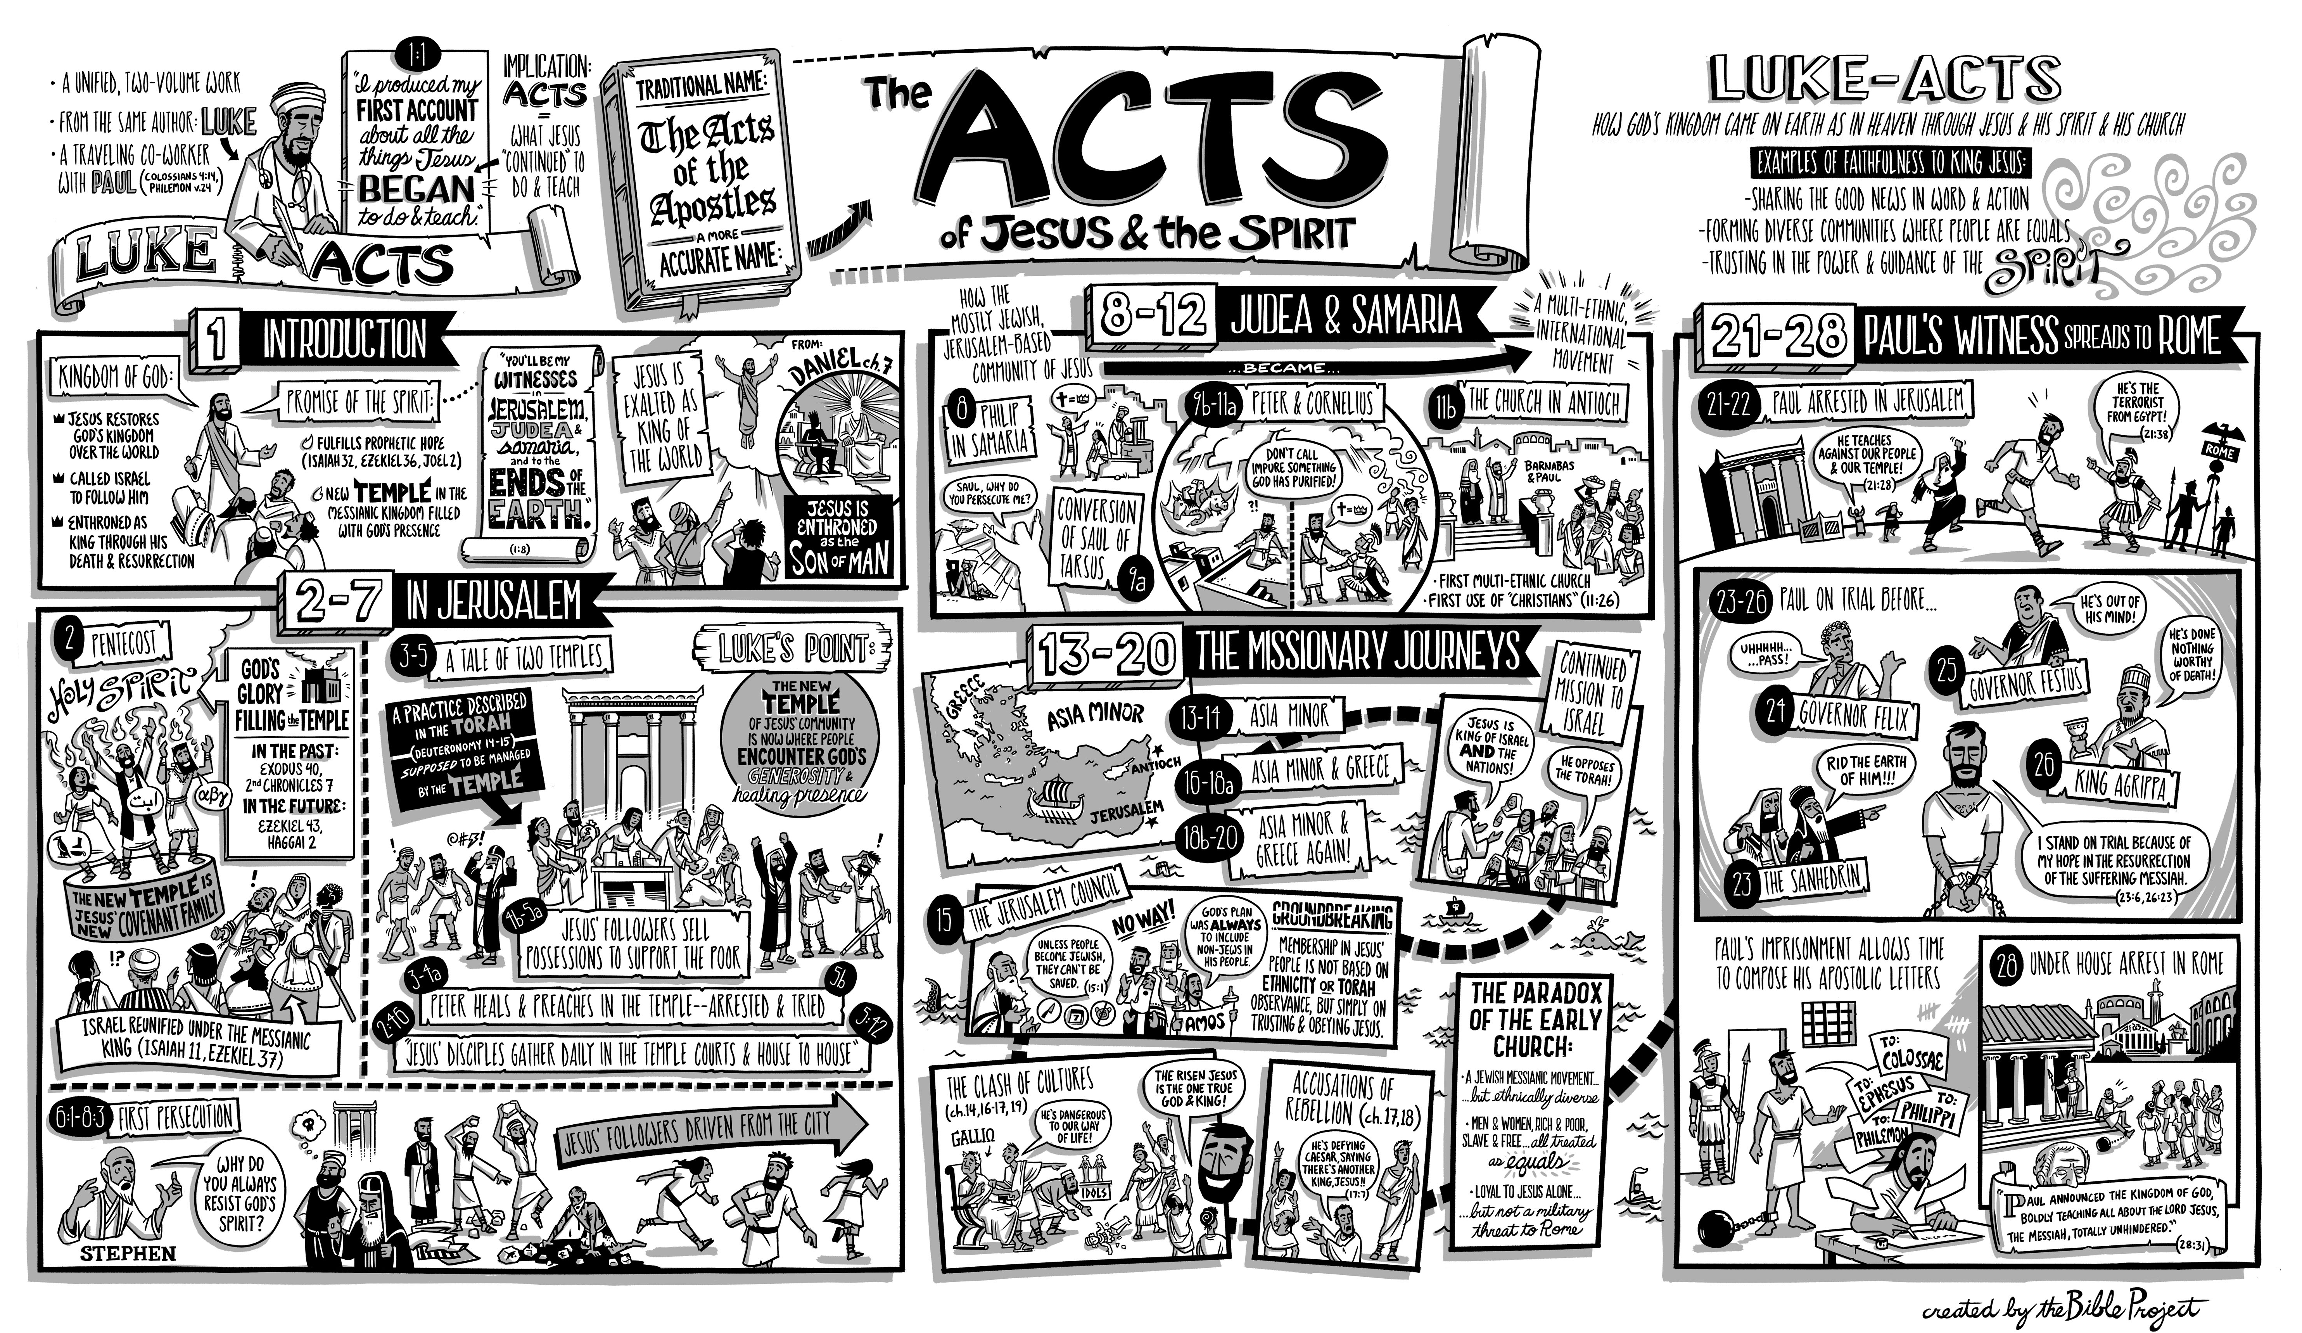

5 Practices of a Missional Church

Tim Keller at https://brave.is/5-practices-of-a-missional-church-tim-keller/
In the West, for nearly a thousand years, the relationship of European Christian churches to the broader culture was a relationship known as Christendom. The institutions of society “Christianized” people and stigmatized non-Christian belief and behavior.
British missionary, Lesslie Newbigin, went to India [in 1936]. When he returned to England, some thirty years later, he discovered that the Western church now found itself in a non-Christian society, but it had not adapted to its new situation. While most traditional evangelical churches can win the temperamentally conventional and conservative to Christ, American author Michael Wolff notes that this market is shrinking. If evangelical churches settle the decline in numbers, with the remaining Christian body not becoming missional, they will decline and die. This has instituted an even greater need for “missional” churches, which adopt the following practices:
1. Speak in the vernacular
In Christendom, technical biblical terms are well known inside and outside of the church. In a missional church, however, these terms must be explained.
The missional church:
- avoids “tribal” language, stylized prayer language, and evangelical jargon that seeks to set a spiritual tone.
- avoids “we-they” language, disdainful jokes that mock people of different politics and beliefs
- avoids sentimental, pompous, “inspirational” talk
- avoids talking as if non-believers were not present
2. Enter and retell the culture’s stories with the Gospel
In Christendom, it is possible to simply exhort Christianized people to do what they know they should. There is little or no real engagement, listening, or persuasion. Often, along with exhortation, there is a heavy reliance on guilt to motivate behavior change.
In a missional church, preaching and communication always assume skeptics are present and consequently engages their stories. To enter the culture’s stories mean showing sympathy towards and deeply acquainting with literature, music, theatre, and other arts expressing the existing hopes, dreams, heroic narratives and fears. To retell the culture’s stories is to show how only in Christ can we have freedom without slavery and embrace-of-the-other without injustice.
3. Theologically train laypeople for public life and vocation
In a missional church, laypeople need theological education to “think Christianly” about everything and work with Christian distinctiveness. They need to know three things: (a) which cultural practices manifest common grace and are to be embraced, (b) which practices are antithetical to the Gospel and must be rejected, and (c) which practices can be adapted/revised.
Christians will have to use the Gospel to demonstrate true, biblical love and tolerance in the public square towards those with whom we deeply differ. This tolerance should equal or exceed that which groups with opposing views show towards Christians. The charge of intolerance is perhaps the main “defeater” of the Gospel in the non-Christian West.
4. Create Christian community that is countercultural and counterintuitive
In Christendom, “fellowship” is basically just a set of nurturing relationships, support, and accountability.
In a missional church, however, Christian community must go beyond that to embody a counterculture, showing the world how radically different a Christian society is with regard to sex, money, and power.
- In sex. We avoid both the secular society’s idolization of sex and traditional society’s fear of sex. We also exhibit love rather than hostility or fear toward those whose sexual life-patterns are different from ours.
- In money. We promote a radically generous commitment of time, money, relationships, and living space to social justice and the needs of the poor, the immigrant, and the economically and physically weak.
- In power. We are committed to power sharing and relationship building among races and classes that are alienated outside of the body of Christ. A missional church must be deeply and practically committed to deeds of compassion and social justice and deeply and practically committed to evangelism and conversion.
5. Practice Christian unity as much as possible on the local level
It is very important that we do not spend time bashing and criticizing other kinds of churches. That criticism simply plays into the common “defeater” that Christians are all intolerant. While we align ourselves in denominations that share many of our distinctives, at the local level we should cooperate with, reach out to, and support the other congregations and churches in our area. This will raise many thorny issues, of course, but our bias should be in the direction of cooperation.

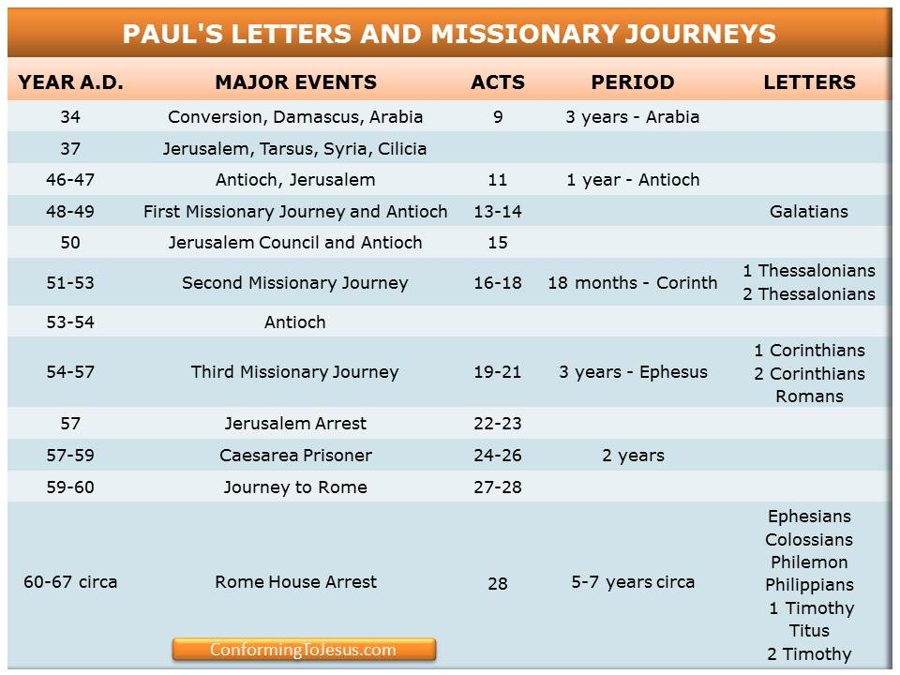

Acts Timeline (ESV Study Bible)

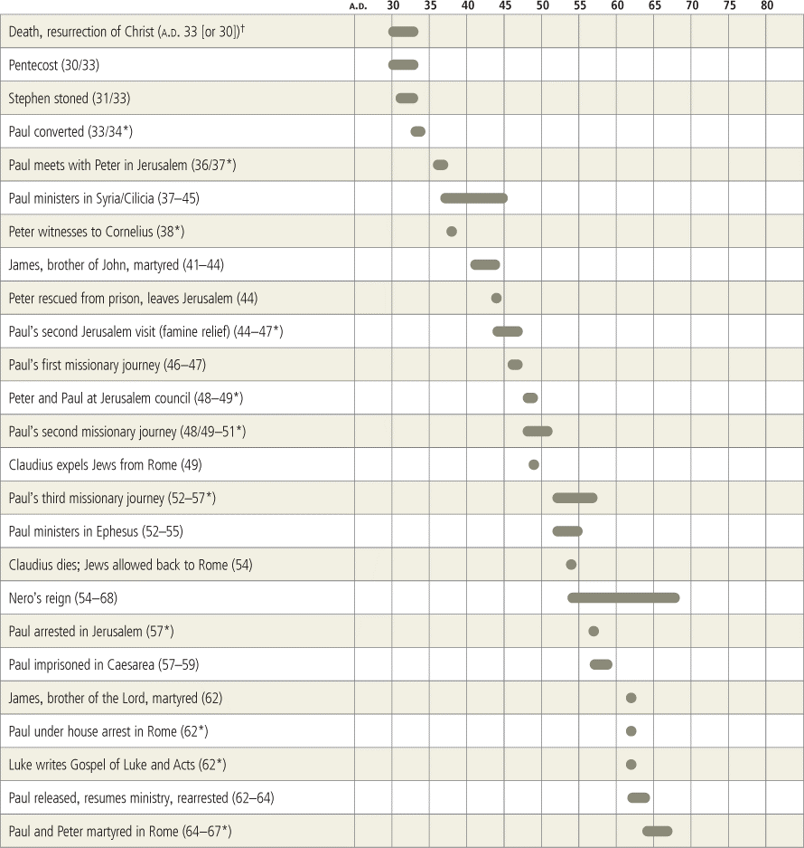

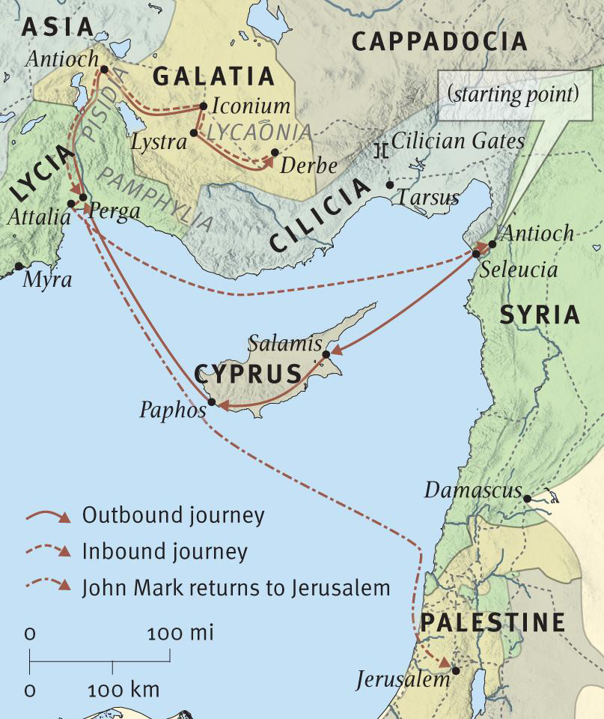

The Great Debates: (Acts 15:1-41)
Bob Deffinbaugh at https://bible.org/seriespage/21-great-debates-acts-151-41

1 Now some men came down from Judea and began to teach the brothers, “Unless you are circumcised according to the custom of Moses, you cannot be saved.” 2 When Paul and Barnabas had a major argument and debate with them, the church [lit. they] appointed Paul and Barnabas and some others from among them to go up to meet with the apostles and elders in Jerusalem about this point of disagreement. 3 So they were sent on their way by the church, and as they passed through both Phoenicia and Samaria, they were relating at length the conversion of the Gentiles and bringing great joy to all the brothers. 4 When they arrived in Jerusalem, they were received by the church and the apostles and the elders, and they reported all the things God had done with them. 5 But some from the religious party of the Pharisees who had believed stood up and said, “It is necessary to circumcise the Gentiles and to order them to observe the law of Moses.”
6 Both the apostles and the elders met together to deliberate about this matter. 7 After there had been much debate, Peter stood up and said to them, “Brothers, you know that some time ago God chose me to preach to the Gentiles so they would hear the message of the gospel and believe. 8 And God, who knows the heart, has testified to them by giving them the Holy Spirit just as he did to us, 9 and he made no distinction between them and us, cleansing their hearts by faith. 10 So now why are you putting God to the test by placing on the neck of the disciples a yoke that neither our ancestors nor we have been able to bear? 11 On the contrary, we believe that we are saved through the grace of the Lord Jesus, in the same way as they are.”
12 The whole group kept quiet and listened to Barnabas and Paul while they explained all the miraculous signs and wonders God had done among the Gentiles through them.
13 After they stopped speaking, James replied, “Brothers, listen to me. 14 Simeon has explained how God first concerned himself to select from among the Gentiles a people for his name. 15 The words of the prophets agree with this, as it is written, 16 ‘After this I will return, and I will rebuild the fallen tent of David; I will rebuild its ruins and restore it, 17 so that the rest of humanity may seek the Lord, namely, all the Gentiles I have called to be my own,’ says the Lord, who makes these things 18 known from long ago. 19 “Therefore I conclude that we should not cause extra difficulty for those among the Gentiles who are turning to God, 20 but that we should write them a letter telling them to abstain from things defiled by idols and from sexual immorality and from what has been strangled and from blood. 21 For Moses has had those who proclaim him in every town from ancient times, because he is read aloud in the synagogues every Sabbath.”
22 Then the apostles and elders, with the whole church, decided to send men chosen from among them, Judas called Barsabbas and Silas, leaders among the brothers, to Antioch with Paul and Barnabas. 23 They sent this letter with them: From the apostles and elders, your brothers, to the Gentile brothers and sisters in Antioch, Syria, and Cilicia, greetings! 24 Since we have heard that some have gone out from among us with no orders from us and have confused you, upsetting your minds by what they said, 25 we have unanimously decided to choose men to send to you along with our dear friends Barnabas and Paul, 26 who have risked their lives for the name of our Lord Jesus Christ. 27 Therefore we are sending Judas and Silas who will tell you these things themselves in person. 28 For it seemed best to the Holy Spirit and to us not to place any greater burden on you than these necessary rules: 29 that you abstain from meat that has been sacrificed to idols and from blood and from what has been strangled and from sexual immorality. If you keep yourselves from doing these things, you will do well. Farewell.
30 So when they were dismissed, they went down to Antioch, and after gathering the entire group together, they delivered the letter. 31 When they read it aloud, the people rejoiced at its encouragement. 32 Both Judas and Silas, who were prophets themselves, encouraged and strengthened the brothers with a long speech. 33 After they had spent some time there, they were sent off in peace by the brothers to those who had sent them. 35 But Paul and Barnabas remained in Antioch, teaching and proclaiming (along with many others) the word of the Lord.¹

Introduction²
As I was preparing this lesson, I was reminded of the healing of Naaman in 2 Kings 5. Naaman was a Gentile,³ but even more than this, he was the commander of the Syrian forces that harassed the people of Israel. Naaman was also a leper. Thanks to an Israelite slave girl, Naaman’s wife learned that there was a prophet in Israel who could heal her husband.
Naaman pursued a course of action that is very understandable – he sought to use all the power and influence he could muster to facilitate his healing. And so he had the king of Syria write a letter to the king of Israel, which virtually demanded that Naaman be cured. He also came with all the material incentives he could carry: ten talents of silver, six thousand shekels of gold, and ten changes of clothing. He then arrived in style at the palace of the king of Israel.
The king of Israel was greatly distressed. How could he possibly heal Naaman? Was this just a cheap trick, another excuse to attack Israel? When the prophet Elisha learned of Naaman’s arrival and “request,” he sent word to the king to let Naaman come to him for healing so that he would know there was a prophet in Israel. Naaman arrived with a retinue of attendants,⁴ along with some false expectations. He assumed that he would be personally greeted by the prophet, who would then heal him in some grand and dramatic fashion. (And of course the prophet would then collect his fee by accepting all the gifts he had brought.)
It didn’t work out that way at all. Naaman received no “red carpet treatment.” Elisha did not even go out to meet Naaman. Instead, he sent out a messenger with instructions for Naaman to dip himself in the river Jordan seven times, with the assurance that he would be completely healed. Naaman was furious. The river Jordan was dirty, while the rivers in his country were clear. He expected to be healed in style, in a dramatic way befitting his position.
Naaman’s servant was wise. Would Naaman not have done some great thing to be healed, if only Elisha had asked? Of course he would. Then why would he not do something as simple as dipping in the river Jordan? And so Naaman complied with the prophet’s instructions, and he was healed. Naaman returned to the home of Elisha. He was ready to pay for the prophet’s services. This time Elisha did come out to speak with Naaman, but he refused to accept any gifts. He granted Naaman’s request for some Israelite soil, upon which this man would, from now on, worship the God of Israel in Syria.
Naaman proceeded toward Syria but Gehazi, Elisha’s servant, could not stand to let all that loot return with him. Notice Gehazi’s thinking:
Gehazi, the prophet Elisha’s servant, thought, “Look, my master did not accept what this Syrian Naaman offered him. As certainly as the Lord lives, I will run after him and accept something from him” (2 Kings 5:20, emphasis mine).
Gehazi could not stand to allow “this Syrian” to return home without somehow paying tribute. Gehazi caught up with Naaman’s chariot and concocted the story that two young prophets had just arrived and that they were in need of some money and clothing. Naaman gladly met this request, and Gehazi made his way back to the house where he hid these gifts. Elisha “saw” it all and confronted his servant, rebuking him for thinking that this was a time to be acquiring material wealth. As a result, Gehazi was stricken with leprosy.
It is easy to see how Gehazi was wrong to lie to Naaman and to take goods for himself under false pretenses. But was there not another reason why Elisha refused the gift that Naaman offered? Is it not for the same reason that Elisha instructed Naaman to dip seven times in the Jordan? God is not for hire. He gives good gifts to men on the basis of grace, not works. Naaman could not purchase what God would only give to men freely. God’s gifts are gifts of grace; they cannot be merited or purchased.
It is easy to see why Naaman was happy to grant Gehazi’s request. He was more than grateful for the healing he had received. And he would probably feel a lot better thinking that he had some part in it, as his contribution to Gehazi would suggest. But it was wrong for Gehazi to receive gifts from Naaman. It was no favor to allow Naaman to think that he had somehow contributed toward God’s gracious gift of healing. Grace cannot be bought or sold.
I see something similar taking place in our text. As a result of the first missionary journey, Gentiles had come to faith in large numbers. While unbelieving Jews resisted the preaching of the gospel to Gentiles, some Jewish believers were insisting that Gentile converts must be circumcised and keep the Old Testament Law of Moses. Gentile converts, much like Naaman, were truly grateful to be included in the salvation God brought about through the Jews. To some, grateful Gentile converts submitting to circumcision and to law keeping might not appear to be such a huge concession. But they did not understand the implications of circumcision. Paul did, and he, along with Barnabas, strongly opposed the teaching of these Judaizers – those who believed that Gentiles must enter into the faith by converting to Judaism. As a result, the first church council was called, and this is described in the text for this message. This decision is a watershed event, not only in the Book of Acts, but in the history of the church. Let us listen well to the words of our text, and let us seek to learn what the Jerusalem Council meant for those in that day, as well as for Christians today.

The Issue at Hand Acts 15:1-5
1 Now some men came down from Judea and began to teach the brothers, “Unless you are circumcised according to the custom of Moses, you cannot be saved.” 2 When Paul and Barnabas had a major argument and debate with them, the church [lit. they] appointed Paul and Barnabas and some others from among them to go up to meet with the apostles and elders in Jerusalem about this point of disagreement. 3 So they were sent on their way by the church, and as they passed through both Phoenicia and Samaria, they were relating at length the conversion of the Gentiles and bringing great joy to all the brothers. 4 When they arrived in Jerusalem, they were received by the church and the apostles and the elders, and they reported all the things God had done with them. 5 But some from the religious party of the Pharisees who had believed stood up and said, “It is necessary to circumcise the Gentiles and to order them to observe the law of Moses” (Acts 15:1-5).
In Old Testament times, there were a few Gentiles who were “grafted into” Israel’s blessings – people like Rahab, Ruth, and Naaman. There weren’t many, and they seemed to pose no threat to the Jews. But with the coming of Jesus, things began to change. A few believing Gentiles are found in the Gospels,⁵ and there are clear indications that many more will follow.⁶ The early chapters of the Book of Acts focus on Jewish evangelism, primarily in Jerusalem. Then, in chapter 8, we find the church being scattered abroad by persecution, and thus the gospel is proclaimed in Samaria, and even beyond (such as to the Gentile Ethiopian eunuch).⁷ In Acts 10, God dramatically directs Peter to the house of Cornelius, a Gentile, where he preaches the gospel. As a result of Peter’s preaching, all those gathered at the home of Cornelius are saved. While they initially objected to Peter’s actions, his Jewish colleagues had to conclude from Peter’s explanation of these events that God had purposed to seek and to save Gentiles as well as Jews.⁸
The birth of the church at Antioch,⁹ followed by the first missionary journey,¹⁰ brought many Gentiles into the household of faith. When Paul and Barnabas returned to Antioch, a very serious theological issue surfaced, because some were insisting that Gentile converts must be circumcised and keep the Law. While Luke describes the setting for the Jerusalem Council, the Book of Galatians provides some additional background information. It is my assumption that our text in Acts 15 must be read in conjunction with the Book of Galatians, and especially these verses in chapter 2:¹¹
11 But when Cephas came to Antioch, I opposed him to his face, because he had clearly done wrong. 12 Until certain people came from James, he had been eating with the Gentiles. But when they arrived, he stopped doing this and separated himself because he was afraid of those who were pro-circumcision. 13 And the rest of the Jews also joined with him in this hypocrisy, so that even Barnabas was led astray with them by their hypocrisy. 14 But when I saw that they were not behaving consistently with the truth of the gospel, I said to Cephas in front of them all, “If you, although you are a Jew, live like a Gentile and not like a Jew, how can you try to force the Gentiles to live like Jews?” 15 We are Jews by birth and not Gentile sinners, 16 yet we know that no one is justified by the works of the law but by the faithfulness of Jesus Christ. And we have come to believe in Christ Jesus, so that we may be justified by the faithfulness of Christ and not by the works of the law, because by the works of the law no one will be justified (Galatians 2:11-16).
The ambivalence (hypocrisy) of apostles like Peter probably encouraged others who were even more radical in their views to press their demands publicly, as we read in Acts 15:
1 Now some men came down from Judea and began to teach the brothers, “Unless you are circumcised according to the custom of Moses, you cannot be saved” (Acts 15:1).
5 But some from the religious party of the Pharisees who had believed stood up and said, “It is necessary to circumcise the Gentiles and to order them to observe the law of Moses” (Acts 15:5).
We should note that these Judaizers who demanded circumcision and law keeping were not evangelists who were preaching their message to Gentile pagans. These were Jewish believers (those of the Pharisee party) who were targeting newly saved Gentiles. It is interesting how some are more than willing to let others do the evangelizing, only to prey upon these new converts with their distorted doctrines.
At first glance, what these Judaizers were demanding may not have seemed that much to ask. They wanted Gentile converts to undergo circumcision. But the rite of circumcision, like baptism, was a symbol, and it implied much more.¹² To the Jews, being circumcised was viewed as a commitment to live under the Law of Moses, as the Old Testament Israelites did. In our text, the implications of circumcision will be spelled out by Peter in just a few verses. But that would be getting ahead of our story.
Paul strongly opposed this added requirement of circumcision as heresy; indeed, it was the introduction of another gospel:
6 I am astonished that you are so quickly deserting the one who called you by the grace of Christ and are following a different gospel – 7 not that there really is another gospel, but there are some who are disturbing you and wanting to distort the gospel of Christ. 8 But even if we (or an angel from heaven) should preach a gospel contrary to the one we preached to you, let him be condemned to hell! 9 As we have said before, and now I say again, if any one is preaching to you a gospel contrary to what you received, let him be condemned to hell! (Galatians 1:6-9)
Because of this, Paul goes on in his Epistle to the Galatians to describe how he rebuked Peter (Cephas) and other Jews (including Barnabas) for their hypocrisy when they separated themselves from Gentile believers at Antioch.¹³ If the events of Galatians 2 took place before the Jerusalem Council (as I am inclined to think), then Paul’s strong opposition to error among the saints (including men like Peter) played a crucial role in helping Peter (and the others who were present at the Jerusalem Council) to see this matter much more clearly.
To get back to our text, the church at Antioch wisely determined that this debate had raised a vitally important theological question, one that the apostles in Jerusalem needed to answer. And so they sent Paul and Barnabas, along with others, to Jerusalem. On their way to Jerusalem, Paul and Barnabas reported the success of their ministry among the Gentiles to the saints in Phoenicia and Samaria, which was met with great rejoicing. (One would assume that those rejoicing were Gentiles.) When they arrived in Jerusalem, they were received by the church, and they gave a similar report concerning the success of their first missionary journey.
Some did not find this an occasion for rejoicing, but instead took this as an opportunity to press their demands that Gentile converts must be required to be circumcised and to keep the Law of Moses:
But some from the religious party of the Pharisees who had believed stood up and said, “It is necessary to circumcise the Gentiles and to order them to observe the law of Moses” (Acts 15:5).

The Jerusalem Council
Acts 15:6-21
6 Both the apostles and the elders met together to deliberate about this matter. 7 After there had been much debate, Peter stood up and said to them, “Brothers, you know that some time ago God chose me to preach to the Gentiles so they would hear the message of the gospel and believe. 8 And God, who knows the heart, has testified to them by giving them the Holy Spirit just as he did to us, 9 and he made no distinction between them and us, cleansing their hearts by faith. 10 So now why are you putting God to the test by placing on the neck of the disciples a yoke that neither our ancestors nor we have been able to bear? 11 On the contrary, we believe that we are saved through the grace of the Lord Jesus, in the same way as they are.”
12 The whole group kept quiet and listened to Barnabas and Paul while they explained all the miraculous signs and wonders God had done among the Gentiles through them.
13 After they stopped speaking, James replied, “Brothers, listen to me. 14 Simeon¹⁴ has explained how God first concerned himself to select from among the Gentiles a people for his name. 15 The words of the prophets agree with this, as it is written, 16 ‘After this I will return, and I will rebuild the fallen tent of David; I will rebuild its ruins and restore it, 17 so that the rest of humanity may seek the Lord, namely, all the Gentiles I have called to be my own,’ says the Lord, who makes these things 18 known from long ago. 19 “Therefore I conclude that we should not cause extra difficulty for those among the Gentiles who are turning to God, 20 but that we should write them a letter telling them to abstain from things defiled by idols and from sexual immorality and from what has been strangled and from blood. 21 For Moses has had those who proclaim him in every town from ancient times, because he is read aloud in the synagogues every Sabbath” (Acts 15:6-21).
It is not just the apostles who gather to decide on the issue of circumcision (verse 6). It is the apostles and the elders of the church at Jerusalem. Those who came to Antioch “from James” were undoubtedly not apostles, but they did give the impression that they spoke with apostolic approval. It is important that the decision reached in Jerusalem embrace all the leaders in the church. That way, anyone who taught differently would be recognized as a rogue, that is, as a false teacher, speaking only for themselves. This is one of the reasons a letter was written to the Gentile churches.
Luke makes it very clear to his readers that he is not reporting every conversation, nor is he elaborating on the viewpoint of those who are demanding circumcision. He gives a summary of the contribution of four individuals: Peter (Acts 15:7-11), Barnabas and Paul¹⁵ (Acts 15:12), and James (Acts 15:13-21). An abridged version of the participation of these four is recorded for us, but only after Luke has told us that there had already been “much debate” (Acts 15:7). I would understand this to mean that Luke purposely spared his readers from hearing a complete re-hash of the Judaisers’ arguments. They were wrong, after all, and their error did not need to be publicized. (If these folks were genuinely convinced by the apostles, and fully endorsed the decision of the Council, they would not want their arguments to be aired publicly.)
Peter’s argument is recorded first, and James seems to bring the closing word. Barnabas and Paul speak between Peter and James. Peter’s argument is five verses long; James’ argument is somewhat longer (nine verses). Luke grants Barnabas and Paul merely one verse in his account. Why would this be? Barnabas and Paul were the ones under attack. They already had their say with these Judaisers. The purpose of the Council was to hear where the Jerusalem leaders stood on this issue.
Peter’s argument is simple and direct. In reality, it is merely a reminder of the events of Acts 10 and 11, and the conclusion which this same group reached. God directed Peter to go to the home of Cornelius, a Gentile, and there to preach the gospel. While Peter was still speaking to them, the Holy Spirit fell upon these Gentiles, indicating that they were saved, having equal standing with the Jewish believers. As Peter put it earlier,
15 Then as I began to speak, the Holy Spirit fell on them just as he did on us at the beginning. 16 And I remembered the word of the Lord, as he used to say, ‘John baptized with water, but you will be baptized with the Holy Spirit.’ 17 Therefore if God gave them the same gift as he also gave us after believing in the Lord Jesus Christ, who was I to hinder God?” (Acts 11:15-17)
Peter’s Jewish brethren could hardly object to what God was doing:
When they heard this, they ceased their objections and praised God, saying, “So then, God has granted the repentance that leads to life even to the Gentiles” (Acts 11:18).
Peter seems to be saying something like this: “Haven’t we already dealt with this issue and made our decision? Didn’t we agree that God is saving Gentiles as well as Jews? Didn’t we agree that these Gentile saints need only be baptized with water, and not circumcised? Can’t we see that God did not distinguish between these Gentiles and us, because in both cases our hearts were cleansed by faith, and not by works? If, then, we are all saved by faith, and not by works, why are we insisting that Gentiles be burdened with law keeping when it did not save us, nor any of our ancestors?
Peter then makes a remarkable statement: “We believe that we are saved through the grace of the Lord Jesus, in the same way as they are.” I am indebted to James Montgomery Boice¹⁶ for pointing out that this is exactly the opposite of how some Jewish Christians were thinking. The Jews were used to thinking that anyone who wanted to be saved must be saved like they were. In fact, some still were. They were insisting that Gentiles can only participate in God’s blessings to the seed of Abraham by doing what Abraham did – be circumcised. But Peter insists that the Law never saved anyone; it only condemned (compare Romans 3:19-20). He then states that Jews must be saved the same way Gentiles are saved, by faith, apart from law keeping.
Paul states this same point in the Book of Romans:
30 What shall we say then? – that the Gentiles who did not pursue righteousness obtained it, that is, a righteousness that is by faith, 31 but Israel even though pursuing a law of righteousness did not attain it. 32 Why not? Because they pursued it not by faith but (as if it were possible) by works. They stumbled over the stumbling stone, 33 just as it is written, “Look, I am laying in Zion a stone that will cause people to stumble and a rock that will make them fall, yet the one who believes in him will not be put to shame.” 1 Brothers and sisters, my heart’s desire and prayer to God on behalf of my fellow Israelites is for their salvation. 2 For I can testify that they are zealous for God, but their zeal is not in line with the truth. 3 For ignoring the righteousness that comes from God, and seeking instead to establish their own righteousness, they did not submit to God’s righteousness. 4 For Christ is the end of the law, with the result that there is righteousness for everyone who believes (Romans 9:30—10:4).
Now that Peter has spoken, Barnabas and Paul speak to a hushed group as they report to them concerning the many miraculous signs and wonders that God performed through them as they proclaimed the gospel to the Gentiles. Jesus punctuated His teaching with signs and wonders and miracles of various kinds (See John 2:11; 4:54; 6:2; 9:16; 11:47; Acts 2:22). So too God produced ¹⁷ many signs and wonders through the apostles in Jerusalem, Judea, and Samaria (see Acts 2:43; 5:12). Now, Barnabas and Paul describe the same miraculous phenomena when they preached the gospel to the Gentiles (see also Acts 14:3). Truly, God did not distinguish between Jews and Gentiles.
In verses 13-21, James steps forward. One does not get the impression that Peter is the dominant leader here; instead, James seems to play that role. James does something that the three before him have not done – he cites Scripture. Thus, the decision that is reached is based both upon Scripture and on experience. James follows up on what Peter has said. God has revealed His purpose to save Gentiles as well as Jews. This is the fulfillment of what the Old Testament prophets had foretold. James turns to the words of Amos 9:11-12 to establish his point:
16 ‘After this I will return,
and I will rebuild the fallen tent of David;
I will rebuild its ruins and restore it,
17 so that the rest of humanity may seek the Lord,
namely, all the Gentiles I have called to be my own,’
says the Lord, who makes these things 18 known from long ago (Acts 15:16-17).
This text emphasizes two different lines of prophecy, which intersect in the person and work of Jesus. First, God promises to restore the dynasty of David so as to fulfill the Davidic Covenant. The Lord Jesus Christ is the “Son of David,” who will sit on the throne of His father.¹⁸ The second promise is that the restoration of the throne to David’s “Son” will fulfill God’s purpose to save those Gentiles God has chosen for Himself. This, the prophet tells us, has been made known “from long ago.”¹⁹
Do these two themes (the restoration of the throne to David’s “son” and the salvation of Gentiles) not converge in the person of our Lord, as seen in the fourth chapter of Luke?
16 Now Jesus came to Nazareth, where he had been brought up, and went into the synagogue on the Sabbath day, as was his custom. He stood up to read, 17 and the scroll of the prophet Isaiah was given to him. He unrolled the scroll and found the place where it was written, 18 “The Spirit of the Lord is upon me, because he has anointed me to proclaim good news to the poor. He has sent me to proclaim release to the captives and the regaining of sight to the blind, to set free those who are oppressed, 19 to proclaim the year of the Lord’s favor.” 20 Then he rolled up the scroll, gave it back to the attendant, and sat down. The eyes of everyone in the synagogue were fixed on him. 21 Then he began to tell them, “Today this scripture has been fulfilled even as you heard it being read.” 22 All were speaking well of him, and were amazed at the gracious words coming out of his mouth. They said, “Isn’t this Joseph’s son?” 23 Jesus said to them, “No doubt you will quote to me the proverb, ‘Physician, heal yourself!’ and say, ‘What we have heard that you did in Capernaum, do here in your hometown too.’” 24 And he added, “I tell you the truth, no prophet is acceptable in his hometown. 25 But in truth I tell you, there were many widows in Israel in Elijah’s days, when the sky was shut up three and a half years, and there was a great famine over all the land. 26 Yet Elijah was sent to none of them, but only to a woman who was a widow at Zarephath in Sidon. 27 And there were many lepers in Israel in the time of the prophet Elisha, yet none of them was cleansed except Naaman the Syrian.” 28 When they heard this, all the people in the synagogue were filled with rage. 29 They got up, forced him out of the town, and brought him to the brow of the hill on which their town was built, so that they could throw him down the cliff. 30 But he passed through the crowd and went on his way (Luke 4:16-30).
James is saying that the salvation of many Gentiles should come as no surprise to his Jewish brethren. This is what God long ago promised to do. This is what God has done, as evidenced by the salvation of Cornelius and his household, and now many more Gentiles in the first missionary journey. The question is no longer, “Has God chosen to save many Gentiles?”; the question is, “How should the Jewish saints deal with these newly-saved Gentile saints?” They should surely not impose upon these Gentiles burdens that God did not lay on them. It is interesting that James never actually uses the word circumcision, but this is clearly what is in his mind. They dare not impose the rite of circumcision on Gentile converts. They dare not insist that Gentile converts place themselves under the Law. Their Jewish brethren had sought to keep the Law for centuries, finding their efforts to be futile.

Four Puzzling Prohibitions
. . . but that we should write them a letter telling them to abstain from things defiled by idols and from sexual immorality and from what has been strangled and from blood (Acts 15:20).
. . . that you abstain from meat that has been sacrificed to idols and from blood and from what has been strangled and from sexual immorality. If you keep yourselves from doing these things, you will do well. Farewell (Acts 15:29).
Students of Scripture have puzzled over these four prohibitions. Why were these given and not others? Are these the only “rules” a Gentile must keep? Are these not issues that were addressed by the Old Testament Law of Moses? Are these merely cultural sensitivities, so that Gentiles act one way when they are with Jews, but another when they are not? Are these sins? Are these the only sins? Are there not other commandments which Christians should keep? Why does one prohibition (fornication/sexual immorality) seem like sin, while the others feel more cultural?
Let me begin by observing that while we may scratch our heads when we seek to understand these prohibitions, their meaning seems to be clear to the saints in that day, both to the Jewish Christians and to the new Gentile believers. They did not require further explanation, and no one seemed to quibble with the fact that these prohibitions were imposed. As Cliff Lopez, one of my colleagues, observed, all four of these prohibited practices were a common part of the heathen rituals in which these new believers once participated.
I must confess at this point that what I am saying here in print is not the same as what I said when I preached this message. In my sermon, I took the position that these prohibitions were primarily prohibitions related to table fellowship between Jewish and Gentile believers. Fortunately, I have the privilege of serving in a church where there are many gifted teachers. After my message, several spoke with me, suggesting some additional points of interpretation or application. I am particularly indebted to David Dean, a friend, missionary, and doctoral student at Dallas Theological Seminary. He graciously shared some insights from his experiences and studies which bear on this subject.
Rather than re-word David’s interpretation of this text, I am simply going to quote it (with very few edits), because it makes a great deal of sense. David’s first statement counters the argument I initially made that these prohibitions were really about “table fellowship.” He then proceeds to show that each prohibition is not a matter of conscience or fellowship, but rather is something forbidden by the Scriptures outside the Law of Moses:²⁰
“The entire point of the Acts 15 letter was that Gentile believers need not be bound by the scruples of Jewish believers who still felt bound by Mosaic law – and table fellowship was the primary place where the issue arose in the first place. To argue (as many have) that the letter insisted that Gentile believers must never eat blood or strangled meat in order to avoid scandalizing Jewish Christians is to surrender the whole issue in the wrong direction.
There is a much simpler and sounder solution. I was driven to study this issue when serving in the Philippines, because many people came to me regarding the matter of eating blood (which is common in their culture). Basically, one must reconcile several teachings of Scripture and one logical necessity in order to come to a coherent understanding of the issues at hand. (1) Jesus declared all foods clean (see Mark 7:19). (2) Acts 15 forbids eating blood “things strangled” simply means meat that has not been intentionally bled. (3) There is teaching on the matter of avoiding scandalizing others with regard to food which must be taken into account (see Romans 14:1 – 15:7 and 1 Corinthians 8). (4) The Acts 15 letter cannot be making concessions for Jewish Christians because that would be backtracking, as noted above. Here’s my solution.
(1) The prohibition against eating blood is NOT from the Mosaic law. It is from Genesis 9:2-4, which obviously predates Mosaic law. This is a universal prohibition for the entire human race and for all time. (If you try to argue that it is not, you must also argue that the prohibition against murder is not.)
(2) According to Genesis 9:3-4, blood is not food. It does not say that blood is a forbidden food; it says that blood is not food (for, just as God defined food in Genesis 1:29 as plant matter, here He defines food as plant matter and animal flesh, excluding blood).
(3) Whenever one bleeds an animal killed for meat, he has fulfilled the command of Genesis 9 not to eat meat with the blood. (By the way, eating a rare steak is not sin, as long as the meat was properly bled when it was slaughtered. A small amount of blood always remains in meat even after bleeding. Further, cooking meat so that it no longer appears red does not remove the tiny bit of blood that remains – it simply changes its color.) To put it more precisely, in Genesis 9 God forbids the INTENTIONAL eating of blood – either by extracting blood and drinking it, or by intentionally leaving it in meat slaughtered for consumption. This is because “the life is in the blood” (Leviticus 17:11). There is something fundamentally wrong with eating what still has the life in it. This is related to the whole concept of sacrifice that is so central to Christ’s redeeming work, for in the spilling of blood there is the taking of life. It is also one of the reasons why many pagan religions advocate the eating of blood. (In fact, there is a whole pagan theology of eating one’s enemies in order to absorb their life-force, but that is a matter for another time. . . .)
(4) Fornication is also something that God universally prohibits, though it is more difficult to find this in Scripture by chapter and verse. I believe that Genesis 2:24 essentially establishes the only context in which sexual relations are approved by God: marriage. This is not a merely Mosaic regulation; it is universally binding on all of mankind. It is clear that God forbids fornication (i.e. sexual immorality – any kind of sex outside of marriage) even among pagans. Again, the prohibition against fornication is not a Mosaic prohibition, but a universal one.
(5) Idolatry is obviously also something that God universally forbids. This hardly needs to be supported (see Romans 1:22-25 for just one example).
(6) The conclusion is clear. The four things prohibited in the Acts 15 letter are all NON-MOSAIC, universal regulations. They are, and always have been, universally binding on all humans. They are, however, also strongly emphasized in Mosaic law. Pagan society in the first century was woefully unaware of these universal regulations – except through the teaching of the Hebrew Scriptures (hence James’ comment in Acts 15:21). When the Jerusalem church agreed that Mosaic regulations should not be imposed on the Gentile believers, they recognized that with the rejection of Mosaic regulations as binding on Gentile Christians, it might be understood that the prohibitions against idolatry, eating blood, eating strangled meat, and fornication should also be thrown out, as they were only generally known through Mosaic law. The church was careful to restate these regulations not because they wanted to avoid scandalizing Jewish believers, but because they were and are and always will be universally binding on all mankind. They did not want to appear to be condoning what God had universally condemned.
A couple of further observations may be helpful.
(A) I am not suggesting that the Jerusalem decree (as I explain it above) indicates that Gentile Christians should not be sensitive to the scruples of spiritually immature (“weak”) Jewish Christians. They should. Paul deals with these matters in Romans 14–15 and 1 Corinthians 8. However, I think that the common interpretation of Acts 15 that argues that the forbidding of eating blood and strangled meat is for the purpose of making table fellowship possible between Jewish and Gentile Christians actually undermines the teachings in those passages. It is important to remember that while mature believers should bear with the scruples of immature believers, the desired goal is always that the immature believers should come to maturity and become free of their unscriptural scruples.
(B) Note, too, that the revelation (and realization) of the non-applicability of Mosiac law to Gentile converts arose out of conflict – (the debate here in Acts 15 as well as the questioning of Peter in chapter 11), and the church only came to the conclusion recorded in the Acts 15 letter after having struggled with the issues for some time. The dismissal of the Mosaic law as a binding rule of life for Christians was a monumental paradigm shift in their thinking, and it seems that God revealed it slowly, and gently, to the church.”²¹
Those of you who are diligent students of Scripture will appreciate the difficulty of our text and the careful thought that David has given to its interpretation. I am privileged to be a member of a church where iron sharpens iron.

Following Through Acts 15:22-33
22 Then the apostles and elders, with the whole church, decided to send men chosen from among them, Judas called Barsabbas and Silas, leaders among the brothers, to Antioch with Paul and Barnabas. 23 They sent this letter with them: From the apostles and elders, your brothers, to the Gentile brothers and sisters in Antioch, Syria, and Cilicia, greetings! 24 Since we have heard that some have gone out from among us with no orders from us and have confused you, upsetting your minds by what they said, 25 we have unanimously decided to choose men to send to you along with our dear friends Barnabas and Paul, 26 who have risked their lives for the name of our Lord Jesus Christ. 27 Therefore we are sending Judas and Silas who will tell you these things themselves in person. 28 For it seemed best to the Holy Spirit and to us not to place any greater burden on you than these necessary rules: 29 that you abstain from meat that has been sacrificed to idols and from blood and from what has been strangled and from sexual immorality. If you keep yourselves from doing these things, you will do well. Farewell.
30 So when they were dismissed, they went down to Antioch, and after gathering the entire group together, they delivered the letter. 31 When they read it aloud, the people rejoiced at its encouragement. 32 Both Judas and Silas, who were prophets themselves, encouraged and strengthened the brothers with a long speech. 33 After they had spent some time there, they were sent off in peace by the brothers to those who had sent them (Acts 15:22-33).
The first (and rather amazing) thing we should notice is that the decision reached by the Jerusalem Council was unanimous. This decision was reached by the apostles, the elders, and the whole church. This doctrine of justification by faith, apart from works, is so fundamental that one cannot differ with it and be considered a Christian.
Since some had gone out teaching “another gospel” (salvation by faith plus works), claiming the approval of the Jerusalem leaders, it was important to distinguish these false teachers from those who were committed to the truth. The letter was the first step in this process. It disavowed those teachers who had gone out, claiming the approval and authority of their teaching by the Jerusalem leaders. They were not authorized to teach what they did, and their teaching only served to create confusion. In general terms, the Jerusalem leaders renounced the teaching of those who had gone out without authorization.
These false teachers are not named, but the Gentile saints would know who they were. Four teachers are designated by the Jerusalem leaders as authorized to speak with their authority: “Judas called Barsabbas and Silas” (two men from Jerusalem), and Barnabas and Paul, who are called their “dear friends.” Paul and Barnabas are identified as men who have risked their lives for the sake of the gospel. These are men who are proven, and who are approved by Jerusalem’s leaders.
The more I have thought about this letter, the less specific it is. Circumcision is not mentioned and neither is the Law. Only the four prohibitions are itemized as being necessary rules. Actually, this makes sense to me. We know that “much debate” occurred before the Council reached its decision. Why would we suppose that one brief letter could adequately clarify all the issues that needed to be addressed? Think of all the Old Testament passages that needed to be cited. Think of all the exposition of Scripture that was required. The purpose of the letter was primarily to identify those who were authorized to speak for the Jerusalem leaders – and, who were not. This is why the four men were sent to these churches. They spent considerable time in these cities:
32 Both Judas and Silas, who were prophets themselves, encouraged and strengthened the brothers with a long speech. 33 After they had spent some time there, they were sent off in peace by the brothers to those who had sent them (Acts 15:32-33, emphasis mine).
Even when Judas and Silas returned to Jerusalem, Paul and Barnabas remained in Antioch for some time, teaching and preaching the Word (verse 35). Justification by faith was such a foundational doctrine it required a thorough treatment, and this is what the letter presupposed.

Conclusion
In many ways, Acts 15 is a watershed chapter. Peter virtually disappears after this chapter, and the church in Jerusalem fades to relative insignificance. But Gentile evangelism virtually explodes. This is because the theological basis for Gentile evangelism has now been established. It is no wonder that from here on, Gentile converts are in the majority.
Think of how things might have gone had God not superintended here. The case of Roe v. Wade opened the floodgates for the slaughter of millions of innocent and helpless human beings (I have chosen my words carefully here). Had the Jerusalem Council ruled in favor of the Judaisers, the Great Commission would have been frustrated, rather than fulfilled.²² Spiritually speaking, the Jerusalem Council is the Gentiles’ Declaration of Independence. Gentile believers are not dependent upon Judaism for their salvation, even in part; they are dependent only upon Jesus Christ and His work at Calvary.
The threat which the Judaisers posed to Christianity in the first century is no isolated danger. We have seen it all through history. When God delivered the Israelites from their bondage in Egypt, there were those who longingly looked back to their time in Egypt. More than once, there were those who sought to convince the Israelites that they should return to Egypt.
3 Why has the Lord brought us into this land only to be killed by the sword, that our wives and our children should become plunder? Wouldn’t it be better for us to return to Egypt?” 4 So they said to one another, “Let’s appoint a leader and return to Egypt” (Numbers 14:3-4).
Imagine that. The Israelites preferred their former slavery in Egypt to the freedom into which their God was leading them. So too there will always be those who seek to turn us from our freedom in Christ to our former slavery to sin.
7 So you are no longer a slave but a son, and if you are a son, then you are also an heir through God. 8 Formerly when you did not know God, you were enslaved to beings that by nature are not gods at all. 9 But now that you have come to know God (or rather to be known by God), how can you turn back again to the weak and worthless basic forces? Do you want to be enslaved to them all over again? (Galatians 4:7-9; see also Romans 6:15-23)
The amazing thing is that those who seek to turn us back to our former slavery do so in the guise that this is the way to be spiritual. In his Epistle to the Galatians, Paul insists that we are sanctified by grace, just as we are saved by grace:
1 You foolish Galatians! Who has cast a spell on you? Before your eyes Jesus Christ was vividly portrayed as crucified! 2 The only thing I want to learn from you is this: Did you receive the Spirit by doing the works of the law or by believing what you heard? 3 Are you so foolish? Although you began with the Spirit, are you now trying to finish by human effort? 4 Have you suffered so many things for nothing? - if indeed it was for nothing. 5 Does God then give you the Spirit and work miracles among you by your doing the works of the law or by your believing what you heard? (Galatians 3:1-5)
My point is simply this: the same danger that threatened to pervert the gospel and to destroy the church is still alive and well today. It may assume slightly different forms, and it may change the vocabulary,²³ but in the end, it insists that salvation and sanctification are the result of faith plus works. This is a deadly and dangerous heresy, and we must constantly be on the alert for its appearance. Paul calls it “another gospel,” and he uses the strongest language to warn Christians of its dangers:
6 I am astonished that you are so quickly deserting the one who called you by the grace of Christ and are following a different gospel - 7 not that there really is another gospel, but there are some who are disturbing you and wanting to distort the gospel of Christ. 8 But even if we (or an angel from heaven) should preach a gospel contrary to the one we preached to you, let him be condemned to hell! 9 As we have said before, and now I say again, if any one is preaching to you a gospel contrary to what you received, let him be condemned to hell! (Galatians 1:6-9)
The decision of the Jerusalem Council is really the key to understanding the Epistles. The theme of justification by faith dominates Paul’s Epistles to the Romans and to the Ephesians. The doctrine of the church expounded in texts like Ephesians 2 and 3 is rooted in the decision of the Jerusalem Council.
It is interesting to contrast circumcision with baptism in the New Testament. Circumcision was a symbolic act imposed upon Gentile believers, so that they would be obligated to keep the Old Testament Law of Moses. The Judaisers could not conceive of Gentile salvation apart from circumcision, and so circumcision was the initiatory rite which made the Gentile convert a “virtual Jew,” and thus obligated to keep the Law. Baptism, on the other hand, is the Christian initiatory rite, for both Jew and Gentile. It is not a meritorious work that contributes toward salvation, but an act of obedience signifying one’s salvation by identification with Jesus in His death, burial and resurrection. (Spirit) baptism into Christ does not make a Gentile into a Jew; it abolishes the difference between Jews and Gentiles in Jesus:
For in one Spirit we were all baptized into one body. Whether Jews or Greeks or slaves or free, we were all made to drink of the one Spirit (1 Corinthians 12:13).
Put differently, circumcision “unifies” Jews and Gentiles by making all into Jews. Baptism into Christ (Spirit baptism, symbolized in water baptism) unifies all believers in Jesus, so that old distinctions do not apply. Remember Peter’s emphasis on the fact that God makes no distinction between Jews and Gentiles (Acts 15:9; see also Romans 10:12).
Adding works to faith as a requirement for salvation actually undermines the gospel in another way. Those who are self-righteous, thinking that their works will bring about their salvation, fail to attain the salvation for which they have labored because they reject God’s offer of righteousness in Jesus.
For ignoring the righteousness that comes from God, and seeking instead to establish their own righteousness, they did not submit to God’s righteousness (Romans 10:3).
And those who are sinners and know it are deceived into thinking they are doomed, because they do not have good works to offer as righteousness.
The gospel of justification by faith alone, apart from good works, is truly good news to sinners who know they fail to meet God’s standard of righteousness, and never will attain it by their own efforts. They do not need to be told to try harder (by the legalists); they simply need to be told to trust in Jesus, who offers them His righteousness, with which God the Father is pleased:
“Blessed are the poor in spirit, for the kingdom of heaven belongs to them” (Matthew 5:3).
28 Come to me, all you who are weary and burdened, and I will give you rest. 29 Take my yoke on you and learn from me, because I am gentle and humble in heart, and you will find rest for your souls. 30 For my yoke is easy to bear, and my load is not hard to carry” (Matthew 11:28-30).
4 But “when the kindness of God our Savior and his love for mankind appeared, 5 he saved us not by works of righteousness that we have done but on the basis of his mercy, through the washing of the new birth and the renewing of the Holy Spirit, 6 whom he poured out on us in full measure through Jesus Christ our Savior. 7 And so, since we have been justified by his grace, we become heirs with the confident expectation of eternal life” (Titus 3:4-7).
My sin-sick friend, you do not have to produce the kind of righteousness which pleases God; in fact, you cannot ever do so. The Law was not given so that you can earn God’s gift of salvation. The Law was given to show you how sinful you are, and how far short of His righteousness you fall. The Law was given to point you to Jesus, for He alone has fulfilled the Law. And by His death on the cross of Calvary, He has borne the penalty for your sins. He rose from the dead, and He offers you His righteousness and the gift of salvation if you will simply give up trying to be good and trust in God’s only provision for salvation – Jesus Christ.
1 And although you were dead in your transgressions and sins, 2 in which you formerly lived according to this world’s present path, according to the ruler of the kingdom of the air, the ruler of the spirit that is now energizing the sons of disobedience, 3 among whom all of us also formerly lived out our lives in the cravings of our flesh, indulging the desires of the flesh and the mind, and were by nature children of wrath even as the rest… 4 But God, being rich in mercy, because of his great love with which he loved us, 5 even though we were dead in transgressions, made us alive together with Christ - by grace you are saved! - 6 and he raised us up with him and seated us with him in the heavenly realms in Christ Jesus, 7 to demonstrate in the coming ages the surpassing wealth of his grace in kindness toward us in Christ Jesus. 8 For by grace you are saved through faith, and this is not from yourselves, it is the gift of God; 9 it is not from works, so that no one can boast (Ephesians 2:1-9).
The decision of the Jerusalem Council confirmed that Law-keeping has not, cannot, and will never save guilty sinners. Only Jesus can do that, and only on the basis of grace. That is because it is by bestowing grace on unworthy sinners that God brings glory to Himself:
5 He did this by predestining us to adoption as his sons through Jesus Christ, according to the pleasure of his will - 6 to the praise of the glory of his grace that he has freely bestowed on us in his dearly loved Son. . . . 13 And when you heard the word of truth (the gospel of your salvation) - when you believed in Christ - you were marked with the seal of the promised Holy Spirit, 14 who is the down payment of our inheritance, until the redemption of God’s own possession, to the praise of his glory (Ephesians 1:5-6, 13-14, emphasis mine).
Grace is a core truth, central and foundational to all that God is doing in the life of His children. To reject grace and embrace works is to seek to rob God of the glory that belongs only to Him, and to usurp His glory for ourselves. Grace is not only the heart of the gospel, it is the basis of sanctification. It is the key to Christian service (spiritual gifts are literally “graces”). It is the key to our relationships, one with the other.
Notice the emphasis Luke has on grace thus far in the Book of Acts:
With great power the apostles were giving testimony to the resurrection of the Lord Jesus, and great grace was on them all (Acts 4:33).
Now Stephen, full of grace and power, was performing great wonders and miraculous signs among the people (Acts 6:8).
When he came and saw the grace of God, he rejoiced and encouraged them all to remain true to the Lord with devoted hearts (Acts 11:23).
When the meeting of the synagogue had broken up, many of the Jews and God-fearing proselytes followed Paul and Barnabas, who were speaking with them and were persuading them to continue in the grace of God (Acts 13:43).
So they stayed there for a considerable time, speaking out courageously for the Lord, who testified to the message of his grace, granting miraculous signs and wonders to be performed through their hands (Acts 14:3).
From there they sailed back to Antioch, where they had been commended to the grace of God for the work they had now completed (Acts 14:26).
On the contrary, we believe that we are saved through the grace of the Lord Jesus, in the same way as they are” (Acts 15:11).
In the books that are indisputably written by Paul, he uses the word “grace” 78 times. Grace is something God gives, but it is also something from which Satan seeks to keep us. Let grace be as important to us as it was to Paul and to the apostles.
To Timothy, my genuine child in the faith. Grace, mercy, and peace from God the Father and Christ Jesus our Lord! (1 Timothy 1:2)
Therefore let us confidently approach the throne of grace to receive mercy and find grace whenever we need help (Hebrews 4:16).
Grace, mercy, and peace will be with us from God the Father and from Jesus Christ the Son of the Father, in truth and love (2 John 3).

¹ Unless otherwise indicated, all Scripture quotations are from the NET Bible. The NEW ENGLISH TRANSLATION, also known as THE NET BIBLE, is a completely new translation of the Bible, not a revision or an update of a previous English version. It was completed by more than twenty biblical scholars who worked directly from the best currently available Hebrew, Aramaic, and Greek texts. The translation project originally started as an attempt to provide an electronic version of a modern translation for electronic distribution over the Internet and on CD (compact disk). Anyone anywhere in the world with an Internet connection will be able to use and print out the NET Bible without cost for personal study. In addition, anyone who wants to share the Bible with others can print unlimited copies and give them away free to others. It is available on the Internet at: www.netbible.org.
² Copyright © 2006 by Community Bible Chapel, 418 E. Main Street, Richardson, TX 75081. This is the edited manuscript of Lesson 21 in the Studies in the Book of Acts series prepared by Robert L. Deffinbaugh on April 23, 2006. Anyone is at liberty to use this lesson for educational purposes only, with or without credit. The Chapel believes the material presented herein to be true to the teaching of Scripture, and desires to further, not restrict, its potential use as an aid in the study of God’s Word. The publication of this material is a grace ministry of Community Bible Chapel.
³ As our Lord was sure to point out (see Luke 4:27).
⁴ 2 Kings 5:9.
⁵ See Matthew 8:5-13.
⁶ Luke 4:16-30; Matthew 28:18-20.
⁷ Acts 8.
⁸ Acts 11:18.
⁹ Acts 11:19-25.
¹⁰ Acts 13-14.
¹¹ I would agree with John R.W. Stott when he writes, “Before going on . . . I need to share with my readers that I hold the so-called ‘South Galatian’ view, namely that Paul’s Letter to the Galatians was written to the South Galatian churches of Pisidian Antioch, Iconium, Lystra, and Derbe, which he and Barnabas had just visited on their first missionary journey; that he dictated it during the height of this theological crisis before the Council settled it (for he does not refer in his letter to the ‘apostolic decree’); that he was writing it probably on his way up to Jerusalem for the Council, which would be his third visit to the city, although he does not mention it in Galatians because it has not yet taken place; and that therefore the situation Luke describes at the beginning of Acts 15 is the same as that to which Paul refers in Galatians 2:11-16.” John R.W. Stott, The Message of Acts: the Spirit, the Church, and the World (Downers Grove, Illinois, U.S.A.: Inter-Varsity Press, 1990), pp. 241-242. This is a very helpful commentary, which has been most useful to me.
¹² We can see that this was the case for baptism in Romans 6, and for circumcision in Galatians, especially in 5:2ff.
¹³ Galatians 2:11-16.
¹⁴ James Boice points out that James makes no reference to Paul and Barnabas, but he does refer to Peter, using the most Jewish name possible (not Simon, but Simeon). He points to a footnote in the NIV which calls attention to this in Acts 15:14. James Montgomery Boice, Acts (Grand Rapids, Michigan: Baker Books, 1997), p. 265.
¹⁵ Notice how Luke reverts to “Barnabas and Paul” here. I believe Barnabas is named first here because he is still regarded as the leader by this group (who initially commissioned Barnabas to go to Antioch in Acts 11:22).
¹⁶ J. M. Boice, op cit., pp. 264-265.
¹⁷ See 2 Samuel 7:12-16.
¹⁸ See Matthew 1:1; 9:27; Luke 1:32-33; 18:38-39.
¹⁹ See Genesis 12:3, for example.
²⁰ You will note that at the end of his argument, David recognizes that these prohibitions are also dealt with within the Law of Moses. His point is that they are universal because they are also taught outside the Law of Moses.
²¹ David Dean is a member of Community Bible Chapel, where he is frequently invited to preach. David is also a full-time doctoral student at Dallas Theological Seminary.
²² I do not mean that the Great Commission was completely and finally fulfilled by the completion of the Book of Acts. I would say that so far as Paul was concerned, his task in fulfilling the Great Commission was completed (2 Timothy 4:7).
²³ For example, it may not be circumcision that is required for salvation, but baptism. But those who require baptism as a necessary act of man in addition to faith also tend to burden believers with various forms of legalism and law-keeping.

