The Church Before Pentecost
Ready for Pentecost #5, Acts 1:15-26 May 22, 2022
Then they returned to Jerusalem . . . .
They all joined together constantly in prayer,
along the women, and Mary the mother of Jesus, and his brothers.
In those days Peter stood up among the believers . . .
and said, “Brothers, the Scripture had to be fulfilled
which the Holy Spirit spoke long ago
through the mouth of David
concerning Judas . . . .”
Acts 1:12-17

A lot happens in that room!
¹² Then they returned to Jerusalem from the hill called the Mount of Olives, a Sabbath day’s walk from the city. ¹³ When they arrived, they went upstairs to the room where they were staying. Those present were Peter, John, James and Andrew; Philip and Thomas, Bartholomew and Matthew; James son of Alphaeus and Simon the Zealot, and Judas son of James. ¹⁴ They all joined together constantly in prayer, along with the women and Mary the mother of Jesus, and with his brothers.
Acts 1 (see “the house” in John 20:26, and Luke’s account in Luke 24:33)

1. Remember: When in doubt, pray together!

2. Jesus’ family is now included in the band of disciples

3. The “joined together constantly” theme describes the heart of the Jerusalem church

Acts 2:42

Acts 2:46

Acts 4:24

Acts 5:12

Acts 15:24

What the Holy Spirit said through David (to the church!)
¹⁵ In those days Peter stood up among the believers (a group numbering about a hundred and twenty) ¹⁶ and said, “Brothers, the Scripture had to be fulfilled which the Holy Spirit spoke long ago through the mouth of David concerning Judas, who served as guide for those who arrested Jesus— ¹⁷ he was one of our number and shared in this ministry.”
¹⁸ (With the reward he got for his wickedness, Judas bought a field; there he fell headlong, his body burst open and all his intestines spilled out. ¹⁹ Everyone in Jerusalem heard about this, so they called that field in their language Akeldama, that is, Field of Blood.)
²⁰ “For,” said Peter, “it is written in the book of Psalms,
“ ‘May his place be deserted; let there be no one to dwell in it,’
and,
“ ‘May another take his place of leadership.’
²¹ Therefore it is necessary to choose one of the men who have been with us the whole time the Lord Jesus went in and out among us, ²² beginning from John’s baptism to the time when Jesus was taken up from us. For one of these must become a witness with us of his resurrection.”
Acts 1 (Peter quotes from Psalm 69 and 109)

1. God was not surprised by Judas’ wickedness (neither was Jesus!)

2. Having a testimony matters

3. Like much in Acts, this process is descriptive not prescriptive (see the James story in Acts 12:1-4)

The Office chooses the Person
²³ So they proposed two men: Joseph called Barsabbas (also known as Justus) and Matthias. ²⁴ Then they prayed, “Lord, you know everyone’s heart. Show us which of these two you have chosen ²⁵ to take over this apostolic ministry, which Judas left to go where he belongs.” ²⁶ Then they cast lots, and the lot fell to Matthias; so he was added to the eleven apostles.
Acts 1

1. Propose and Pray (Acts 6:1-7; Acts 14:21-23)

2. God chooses (Acts 20:28; 1 Timothy 4:14; Titus 1:5)

3. Elders and Deacons are necessary to a healthy church (1 Timothy 3:1-7; 1 Peter 5:1; Romans 16:1)

4. Selecting leaders got everyone involved
Resources for studying Luke’s two part story of Jesus
Bible.org has some wonderful resources at https://bible.org/book/Luke
I. Howard Marshall’s Greek commentary is my go to help (Eerdmans, 1978)
Spurgeon has a sermon that connects the ascension and Second Coming at https://www.biblebb.com/files/spurgeon/1817.htm
J. C. Ryle has an interesting commentary at https://gracegems.org/Ryle/l24.htm I have also included his classic article, “Repentance”, at https://www.monergism.com/repentance
Bob Deffinbaugh has a very interesting sermon series on Luke at https://bible.org/series/luke-gospel-gentiles. His message on the end of Luke is at https://bible.org/seriespage/invisibility-invincibility-luke-2436-53 Deffinbaugh has an good summary of the book of Acts at https://bible.org/seriespage/unique-contribution-book-acts and on the preparation for Pentecost in Acts at https://bible.org/seriespage/2-preparation-pentecost-acts-11-26
Kevin DeYoung has a good Ascension summary at https://www.thegospelcoalition.org/blogs/kevin-deyoung/theological-primer-the-ascension/
F. F. Bruce’s helpful study of the Jerusalem church at http://www.biblicalstudies.org.uk/pdf/cbrfj/church-jerusalem_bruce.pdf
John Calvin’s summary of the benefits of Jesus’ ascension at https://www.monergism.com/3-benefits-imparted-our-faith-christs-ascension
John Murray, Rev. Muir’s favorite professor, has a wonderful but hard to read lecture on Jesus’ intercessory work at https://www.biblicalstudies.org.uk/article_christ_murray.html
Tim Keller has some very interesting comments on the mission of the church at https://redeemercitytocity.com/articles-stories/the-missional-church and a contemporary look at repentance at http://download.redeemer.com/pdf/learn/resources/All_of_Life_Is_Repentance-Keller.pdf
If you want to equip yourself to explain why we believe in resurrection, Michael Horton has a wonderful, if a bit heavy, article at https://whitehorseinn.org/resource-library/articles/risen-indeed-2/

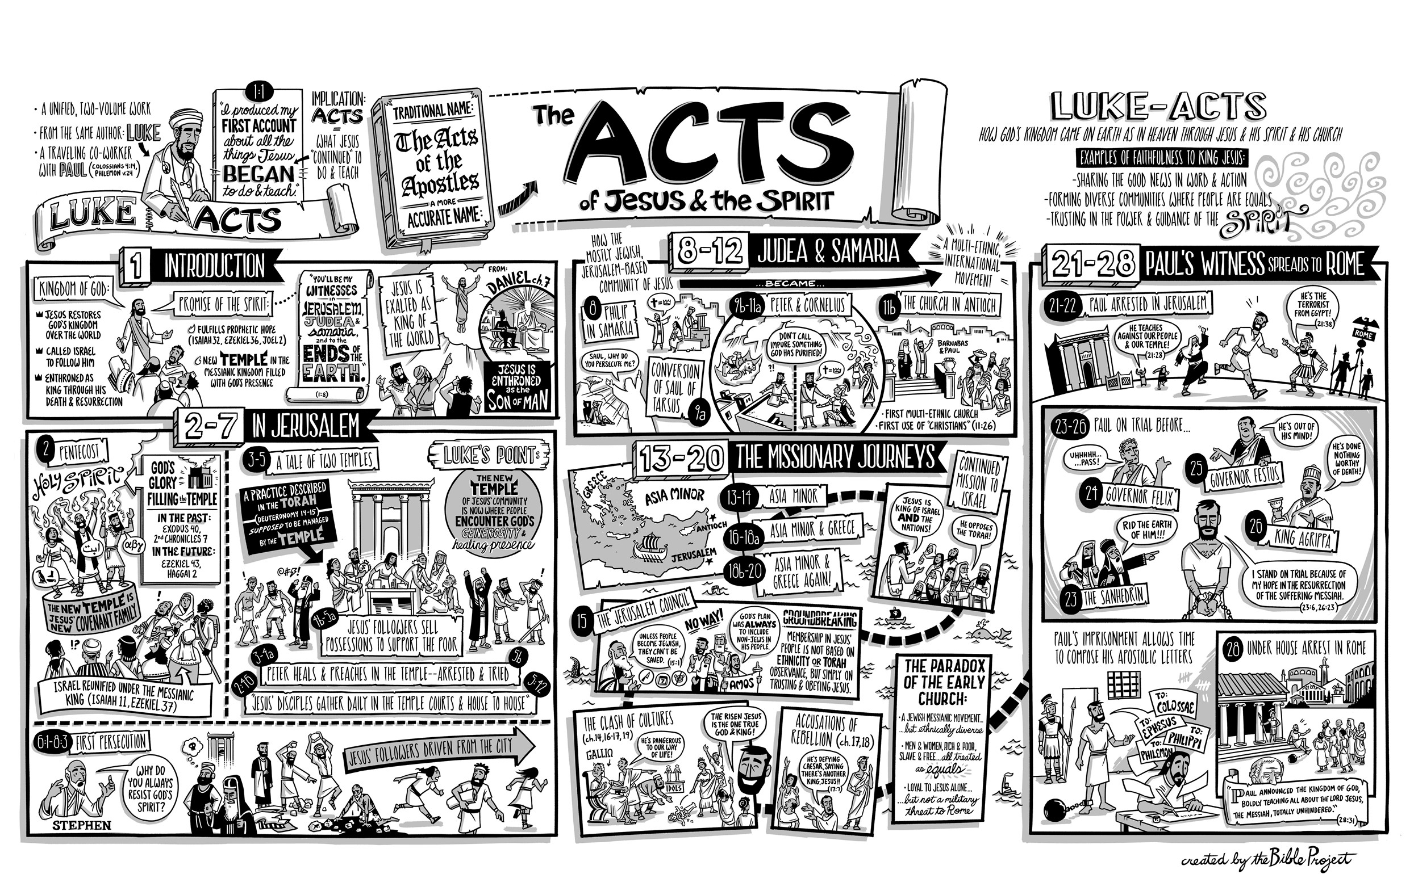
Luke’s chronology
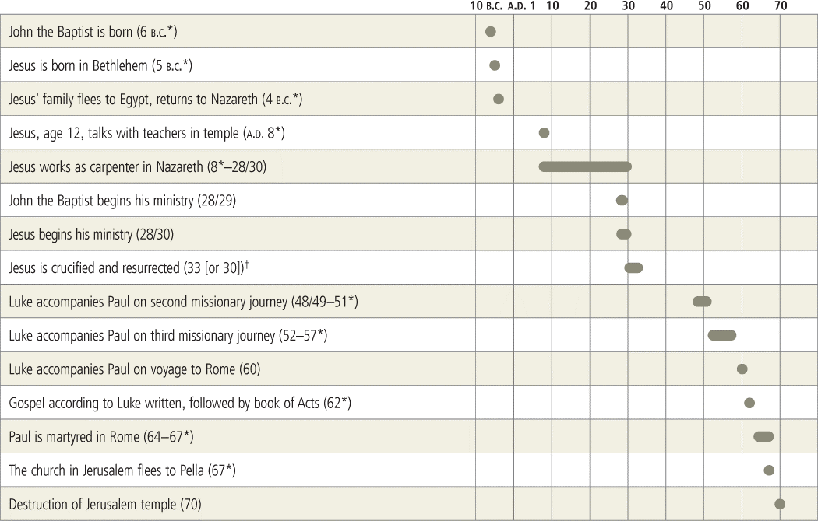

Preparation for Pentecost (Acts 1:1-26)
Deffinbaugh at https://bible.org/seriespage/2-preparation-pentecost-acts-11-26

Introduction¹
Ben Hadad, the king of Syria, was threatening war against Israel and its King, Ahab. He boasted of his victory over Israel, and we read,
The king of Israel replied, “Tell him the one who puts on his battle gear should not boast like one who is taking it off” (1 Kings 20:11).²
The point is that one should not boast before his victory, but should wait until after. There is a great difference between “before” and “after.”
One of the popular themes in contemporary advertising is that of “before” and “after.” There are the weight loss programs, which exhibit the most unflattering photo they can find to present as “before” their program was attempted. Then follows a marvelous “after” photo, which displays a beautiful person, so different from the “before” photo.
In times past, though I have not seen this as much lately, we saw the “before” and “after” of advertising for weight gain. A photo of the proverbial “90-pound weakling” was followed by the “after” of an awesome, muscle-flexing Charles Atlas physique. Who wouldn’t want to look like that?
The “before” and “after” theme is found frequently in the media. “Makeover” programs turn proverbial ugly ducklings into swans. Now it has become popular to carry this theme over to homes, where pitiful or plain houses are transformed into palatial homes.
Long before modern advertising, the Bible had its own versions of “before” and “after.” In Genesis, we have a picture of man “before” the fall and “after.” In the Book of Judges, we have Gideon as a fearful and reticent man (“before”), and then we have Gideon “after” as the brave warrior. In Ephesians 2, Paul contrasts the Gentiles in their unbelief with the Gentiles as saints, now a part of the church.
I believe the first chapter of Acts could be titled “Before,” because it precedes Pentecost in chapter two, and from there on it is definitely “after.” While we may be eager to get to Pentecost, let us pause long enough to consider Luke’s introduction to the Book of Acts and to the transforming power of Pentecost. Let us give thought to the way Luke prepares us for what is yet to come.

The Structure of Our Text
I would like to look at Acts 1 in three segments:
Verses 1-11 From Christ’s Resurrection to His Return
Verses 12-14 Waiting in Jerusalem
Verses 15-26 Filling the Vacancy left by Judas
Verses 1-11 describe what happened during that 40-day period between our Lord’s resurrection and His ascension. In verses 12-14, Luke tells us what the apostles were doing while they waited. Finally, verses 15-26 are the account of the selection of Matthias as the twelfth apostle, a replacement for Judas.
I must tell you that the most problematic passage in Acts 1 is the final paragraph which describes the selection of Matthias as the twelfth apostle. Why does Luke spend as much time (12 verses) describing this one event as he does depicting the 40 days of our Lord’s appearances on the earth (11 verses)? What is so important about the selection of Matthias that deserves this kind of editorial space? That is what we shall seek to discover in our study.

Forty Days of Purpose Acts 1:1-11
1 I wrote the former account, Theophilus, about all that Jesus began to do and teach 2 until the day he was taken up to heaven, after he had given orders by the Holy Spirit to the apostles he had chosen. 3 To the same apostles also, after his suffering, he presented himself alive with many convincing proofs. He was seen by them over a forty-day period and spoke about matters concerning the kingdom of God. 4 While he was with them, he declared, “Do not leave Jerusalem, but wait there for what my Father promised, which you heard about from me. 5 For John baptized with water, but you will be baptized with the Holy Spirit not many days from now.” 6 So when they had gathered together, they began to ask him, “Lord, is this the time when you are restoring the kingdom to Israel?” 7 He told them, “You are not permitted to know the times or periods that the Father has set by his own authority. 8 But you will receive power when the Holy Spirit has come upon you, and you will be my witnesses in Jerusalem, and in all Judea and Samaria, and to the farthest parts of the earth.” 9 After he had said this, while they were watching, he was lifted up and a cloud hid him from their sight. 10 As they were still staring into the sky while he was going, suddenly two men in white clothing stood near them 11 and said, “Men of Galilee, why do you stand here looking up into the sky? This same Jesus who has been taken up from you into heaven will come back in the same way you saw him go into heaven” (Acts 1:1-11).
Luke begins by informing his readers that the Book of Acts is the second volume of his account of the life and ministry of Jesus. Volume 1 – the Gospel of Luke – is the description of “all that Jesus began to do and teach until the day he was taken up to heaven, after he had given orders by the Holy Spirit to the apostles he had chosen”(verse 1b-2a). By inference, this second volume is the account of all that Jesus continued to do and to teach, through His apostles. As the first volume ends with the Great Commission, the second volume begins with it (verse 8). What I would like to underscore is the role of the Holy Spirit in our Lord’s giving of the Great Commission. We are told in verse 2 that Jesus gave orders by the Holy Spirit. We are further told that the Great Commission was an order given to the apostles who Jesus Himself had chosen.
I believe that among the many things we see in these early verses, we find that the Holy Spirit’s ministry in Acts – a dominant theme in this book – is linked to His ministry through the person of our Lord. Put another way, the same Holy Spirit who empowered Jesus as He gave the Great Commission is the One who will empower the apostles (and the church) to carry out this command. The ministry of the Holy Spirit does not commence in Acts, it continues in Acts. Its commencement is found in the Gospels. My point here is that Luke links the ministry of the Holy Spirit in the life of our Lord in the Gospels to the ministry of the Holy Spirit in the life of the church in Acts.
As I read the early verses of chapter one, I am also impressed with the realization that Luke provides us with some powerful evidences of the resurrection of our Lord from the dead:
To the same apostles also, after his suffering, he presented himself alive with many convincing proofs. He was seen by them over a forty-day period and spoke about matters concerning the kingdom of God (Acts 1:3).
Think of it! Jesus waited 40 days from the time of His resurrection till the day of His ascension into heaven. During those 40 days, He provided them with “many convincing proofs” that He had indeed risen from the dead. Only Paul matches Luke in the proofs he supplies for the resurrection:
3 For I passed on to you as of first importance what I also received—that Christ died for our sins according to the scriptures, 4 and that he was buried, and that he was raised on the third day according to the scriptures, 5 and that he appeared to Cephas, then to the twelve. 6 Then he appeared to more than five hundred of the brothers and sisters at one time, most of whom are still alive, though some have fallen asleep. 7 Then he appeared to James, then to all the apostles. 8 Last of all, as though to one born at the wrong time, he appeared to me also. 9 For I am the least of the apostles, unworthy to be called an apostle, because I persecuted the church of God (1 Corinthians 15:3-9).
The apostles were witnesses of our Lord’s resurrection (1:8, 22; 2:32; 3:15; 5:32; 10:39-41; 13:30-31). Our Lord saw to it that these witnesses had more than enough evidence of His resurrection, and added to this was the witness of the Spirit to the resurrection:
7 But I tell you the truth, it is to your advantage that I am going away. For if I do not go away, the Advocate will not come to you, but if I go, I will send him to you. 8 And when he comes, he will prove the world wrong concerning sin and righteousness and judgment— 9 concerning sin, because they do not believe in me; 10 concerning righteousness, because I am going to the Father and you will see me no longer; 11 and concerning judgment, because the ruler of this world has been condemned” (John 16:7-11, emphasis mine).
The Holy Spirit would internally indict sinners regarding the righteousness of Christ because He cannot be seen any longer. The empty tomb and the absence of a body is further evidence of our Lord’s resurrection, and to this the Holy Spirit will bear witness.
A further matter of interest is that during this 40-day period, our Lord spoke with the apostles concerning the things pertaining to the kingdom of God (1:3). We are not, however, given any indication as to just what things Jesus taught them. Based upon Paul’s words in Ephesians 3, I am inclined to assume what a portion of this conversation may have been:
4 When reading this, you will be able to understand my insight into this secret of Christ. 5 Now this secret was not disclosed to people in former generations as it has now been revealed to his holy apostles and prophets by the Spirit, 6 namely, that through the gospel the Gentiles are fellow heirs, fellow members of the body, and fellow partakers of the promise in Christ Jesus (Ephesians 3:4-6, emphasis mine).
Somewhere along the line, the apostles were enlightened by our Lord concerning the mystery of the church. I would suspect that it may have been during that 40-day interval between our Lord’s resurrection and His ascension. What is of particular interest is that this revelation came about “through the Spirit.”
There is additional evidence that our Lord spoke to the apostles about the mystery of the church during these 40 days. When the apostles asked Jesus regarding the timing of the coming of the kingdom of God, they appear to indicate that they know the kingdom will be set aside for a time:
So when they had gathered together, they began to ask him, “Lord, is this the time when you are restoring the kingdom to Israel?” (Acts 1:6)
Why did the apostles speak of the coming of the kingdom of God as its being “restored”? I think it was because Jesus had revealed the mystery of the church to them.
There is a theme which dominates the 40-day period between the resurrection and ascension of our Lord. If I were to summarize it, it would probably be like this:
“Your mission until I return is to preach the gospel to all nations. The Holy Spirit will come upon you shortly to empower you to carry out this task, so wait in Jerusalem until you receive this power.”
The coming of the Spirit is described as: (1) “the promise of the Father (verse 4); (2) that which the apostles heard from Jesus (verse 4); and, (3) that which John the Baptist foretold (verse 5). The apostles sought greater knowledge. Jesus informed them that they had (or would have) all the knowledge they needed. What they needed was power, power to proclaim the gospel so that men would believe and be saved. Pentecost was the occasion which God chose to bestow this power on His apostles.
When the apostles³press Jesus to tell them the time when the kingdom of God will be established, Jesus graciously refuses by informing them that this information is outside their authority – there is no “need to know” so far as they are concerned. This information, this timing, is something that falls entirely within the Father’s own authority. To seek this knowledge is to go outside the boundaries of their authority.⁴
But isn’t Pentecost and the coming of the Holy Spirit really a matter of authority, a legitimate matter of authority? In the Great Commission of Matthew 28, Jesus claimed all authority, and He based His command to proclaim the gospel to all nations on this authority:
18 Then Jesus came up and said to them, “All authority in heaven and on earth has been given to me. 19 Therefore go and make disciples of all nations, baptizing them in the name of the Father and the Son and the Holy Spirit, 20 teaching them to obey everything I have commanded you. And remember, I am with you always, to the end of the age” (Matthew 28:18-20, emphasis mine).
I believe that when the Spirit came upon the apostles, they received the authority they needed to carry out the Great Commission. They sought authority that was outside the boundaries God had established. Jesus promised authority within the boundaries of what God purposed, because the coming of the Spirit was “the promise of the Father” (verse 4).
Luke’s account of our Lord’s ascension is brief, but informative:
9 After he had said this, while they were watching, he was lifted up and a cloud hid him from their sight. 10 As they were still staring into the sky while he was going, suddenly two men in white clothing stood near them 11 and said, “Men of Galilee, why do you stand here looking up into the sky? This same Jesus who has been taken up from you into heaven will come back in the same way you saw him go into heaven” (Acts 1:9-11).
Luke’s Great Commission (unlike those in the Gospel of Matthew, Mark, and John) was given just prior to His ascension. Our Lord’s last words sum up the focus of the first 11 verses of Acts: They are to be His witnesses, beginning in Jerusalem and ending in the remotest part(s) of the earth. They will receive power through the Holy Spirit to be witnesses. Having said this, our Lord ascended into heaven. They watched Him rise until a cloud obscured their vision. They stood there, transfixed. (I wonder if they were waiting for that cloud to move out of their line of sight.)
Two angels suddenly appear near them. It was a gentle rebuke, if a rebuke at all. What were they standing there for, looking into the sky? Jesus was coming back, just as they saw Him depart. The inference is, “Don’t just stand here; get going!”⁵
In the midst of all of the “gnats,” let us not miss the “camel” of this text, namely that the Holy Spirit was soon (“not many days from now,” verse 5) to come upon them, empowering them to carry out the Great Commission. They must not attempt to carry out the Great Commission without Pentecostal power.

What to Do while You Wait Acts 1:12-14
12 Then they returned to Jerusalem from the mountain called the Mount of Olives (which is near Jerusalem, a Sabbath day’s journey away). 13 When they had entered Jerusalem, they went to the upstairs room where they were staying. Peter and John, and James, and Andrew, Philip and Thomas, Bartholomew and Matthew, James son of Alphaeus and Simon the Zealot, and Judas son of James were there. 14 All these continued together in prayer with one mind, together with the women, along with Mary the mother of Jesus, and his brothers (Acts 1:12-14).
The apostles did as the angels implied; they returned to Jerusalem to wait. I do not think that verses 12-14 describe only the activity of the believers during the 10-day gap between our Lord’s ascension and Pentecost, however. I am inclined to think that verses 12-14 are an apt description of the apostles’ activity during the entire 50-day period preceding Pentecost. Let me explain why I have reached this conclusion.
First, I note the wording of the first part of verse 13:
When they had entered Jerusalem, they went to the upstairs roomwhere they were staying(Acts 1:13a, emphasis mine).
It appears to me that this upper room may well be a place well known to the apostles, perhaps a room owned by someone close to Jesus. It would further seem that this is the room where the apostles had been staying the previous 40 days.
Not only the wording of verse 13, but also what we know of these 40 days, suggests that this is where the apostles had been staying since our Lord’s death. Prior to His death, the disciples were constantly with Jesus. Some of the women mentioned in Acts 1:14 may well have been those who accompanied Jesus and His disciples, and who also contributed to His support (Luke 8:1-3). When Jesus arose from the dead, He did not remain with them continually, as He once did. Instead, He would come and go. This is implied in Acts 1:3, but it is clear in particular instances, such as when Jesus appeared to the disciples who went fishing with Peter in John 21. The apostles were all Galileans (see Acts 1:11; 2:7; see also Matthew 26:73), so they could not stay in their own homes. I believe that this upper room became headquarters for them during the entire 50-day period after our Lord’s resurrection.
What we have in verses 12-14, then, is a description of where the apostles stayed and what they did from the time of our Lord’s death till Pentecost. The apostles stayed in Jerusalem, as instructed, and they devoted themselves to prayer, along with those who were closely associated with Jesus in His earthly ministry. We should also observe that among this group were the brothers of our Lord (Acts 1:14). From this, we can infer that Jesus’ unbelieving brothers (John 7:5) had come to believe in Jesus, no doubt largely due to His resurrection.
It seems to me that these loyal followers of Jesus are at their finest in verses 12-14. While it is not plainly stated, it would seem that from a human point of view the events at Pentecost were partially a response to the prayers of these saints.

A Replacement for Judas Acts 1:15-26
15 In those days Peter stood up among the believers (a gathering of about one hundred and twenty people) and said, 16 “Brothers, the scripture had to be fulfilled that the Holy Spirit foretold through David concerning Judas—who became the guide for those who arrested Jesus— 17 for he was counted as one of us and received a share in this ministry.” 18 (Now this man Judas acquired a field with the reward of his unjust deed, and falling headfirst he burst open in the middle and all his intestines gushed out. 19 This became known to all who lived in Jerusalem, so that in their own language they called that field Hakeldama, that is, “Field of Blood.”) 20 “For it is written in the book of Psalms, ‘Let his house become deserted, and let there be no one to live in it,’ and ‘Let another take his position of responsibility.’ 21 Thus one of the men who have accompanied us during all the time the Lord Jesus associated with us, 22 beginning from his baptism by John until the day he was taken up from us—one of these must become a witness of his resurrection together with us.” 23 So they proposed two candidates: Joseph called Barsabbas (also called Justus) and Matthias. 24 Then they prayed, “Lord, you know the hearts of all. Show us which one of these two you have chosen 25 to assume the task of this service and apostleship from which Judas turned aside to go to his own place.” 26 Then they cast lots for them, and the one chosen was Matthias; so he was counted with the eleven apostles (Acts 1:15-26).
This united prayer lasted for another ten days after our Lord’s ascension.⁶It was during this ten-day period that a replacement was chosen for Judas. The mystery of this paragraph is to explain why Luke went to so much effort (and space) to describe an event which appears to have little impact on the events that follow Pentecost. Verses 15-26 immediately precede Pentecost, but do not appear to have any profound impact on the apostles or on the community of believers. Why, then, does Luke include these verses?
Let us seek to answer this question by observing what happened. We know that unified prayer preceded this process (1:14); indeed prayer was a part of the process (see 1:24-25). We learn that it was Peter who provided the leadership (1:15). The search for Judas’ replacement was prompted, at least in part, by the consideration of some Old Testament Scriptures (Psalm 69:25; 109:8). From Psalm 69, they recognized that Judas’ betrayal was part of the divine plan. The betrayal of our Lord was no accident, and it did not catch God off guard. In particular, Judas’ death was seen to be a part of the divine plan. The events surrounding Judas’ death⁷were interpreted as the fulfillment of the prophecy of Psalm 69:25. The decision to proceed with the process of replacing Judas was seen as obedience to Psalm 109:8, thus leading to its fulfillment.
In days gone by, I have sided with those who found the selection of Matthias as an example of fleshly action hastily taken. Like others, I have pointed to Paul as the most likely candidate for Judas’ replacement. Like others, I have called attention to the fact that after this account, the name of Matthias is never found again in the New Testament.⁸I also called attention to the fact that Jesus told His apostles to wait until the coming of the Spirit.⁹
Others have sought to justify this action on the part of the apostles. They remind us that most of the twelve apostles disappear in Acts and the Epistles, and not just Matthias. They call attention to references to“the twelve”after this (Acts 6:2; 1 Corinthians 15:5). They also point out that Luke’s account depicts this selection in a favorable light, and that nothing negative is said about the action taken here.
In the end, I think we must acknowledge that we must “read between the lines” a great deal to conclude that the replacement of Judas was wrong. I think there are two things that are clear, and that should dominate our thinking. First, the replacement of Judas occurs prior to Pentecost. And second, the replacement of Judas is carried out in a way that is very “Old Testament.”
After Pentecost, the selection of leadership (as well as the seeking of divine guidance) is heavily dependent upon the presence and power of the Holy Spirit:
But carefully select from among you, brothers, seven men who are well-attested,full of the Spiritand of wisdom, whom we may put in charge of this necessary task (Acts 6:3, emphasis mine).
Here,“the twelve”addressed a problem of inequity in the care and feeding of their widows. They determined that others needed to be appointed to oversee this ministry. They left the selection of these leaders to the people, but they did set the qualifications. One of these qualifications was that each man manifested evidence of the Spirit’s presence in his life.
1 Now there were these prophets and teachers in the church at Antioch: Barnabas, Simeon called Niger, Lucius the Cyrenian, Manaen (a close friend of Herod the tetrarch from childhood) and Saul. 2 While they were serving the Lord and fasting,the Holy Spirit said, “Set apart for me Barnabas and Saul for the work to which I have called them.” 3 Then, after they had fasted and prayed and placed their hands on them, they sent them off. 4 So Barnabas and Saul,sent out by the Holy Spirit, went down to Seleucia, and from there they sailed to Cyprus (Acts 13:1-4, emphasis mine).
In Acts 13 while those at the church in Antioch were fasting, the Holy Spirit indicated that Barnabas and Saul should be set apart and sent out as missionaries. The church acknowledged the leading of the Spirit and laid their hands on these men, and then sent them off. Luke then tells his readers that these two men were sent out by the Holy Spirit. The Holy Spirit designated Barnabas and Saul. No lots were cast here, nor did they need to be.
9 But Saul (also known as Paul),filled with the Holy Spirit, stared straight at him 10 and said, “You who are full of all deceit and all wrongdoing, you son of the devil, you enemy of all righteousness—will you not stop making crooked the straight paths of the Lord? 11 Now look, the hand of the Lord is against you, and you will be blind, unable to see the sun for a time!” Immediately mistiness and darkness came over him, and he went around seeking people to lead him by the hand. 12 Then when the proconsul saw what had happened, he believed, because he was greatly astounded at the teaching about the Lord. 13 ThenPaul and his companionsput out to sea from Paphos and came to Perga in Pamphylia, but John left them and returned to Jerusalem (Acts 13:9-13, emphasis mine).
Barnabas and Saul arrived at the island of Cyprus and had traveled as far as Paphos. There they encountered the proconsul, Sergius Paulus. He was interested in the gospel, but a Jewish false prophet named Bar-Jesus (or Elymas) opposed them, seeking to turn the proconsul away from the truth. Up until this point, Paul (known as Saul until now) was clearly Barnabas’ assistant. But the Holy Spirit enabled Paul to see what this false prophet was doing and prompted him to pronounce a curse on Bar-Jesus. From this point on, with very few exceptions (Acts 14:14; 15:12, 25), it was always Paul and Barnabas, or Paul and Silas, or“Paul and his companions.”It was evidence of the Spirit’s working through Paul that seems to have triggered this exchange in roles of Paul and Barnabas.
28For it seemed best to the Holy Spirit and to usnot to place any greater burden on you than these necessary rules: 29 that you abstain from meat that has been sacrificed to idols and from blood and from what has been strangled and from sexual immorality. If you keep yourselves from doing these things, you will do well. Farewell (Acts 15:28-29, emphasis mine).
When the Jerusalem Council met to determine what should be required of Gentile converts, they determined that Gentiles must not be placed under the law, and that they observe only a few restrictions. And when they reached their decision, they made it clear that their decision was guided by the Holy Spirit.
28 Watch out for yourselves and for all the flockof which the Holy Spirit has made you overseers, to shepherd the church of God that he obtained with the blood of his own Son (Acts 20:28, emphasis mine).
In his last face-to-face meeting with the Ephesian elders, Paul spoke to them about their responsibilities as shepherds. He made it clear that the Holy Spirit played a key role in their appointment. Thus, whether it was the selection of leaders or making important doctrinal distinctions, the Holy Spirit played a key role from Pentecost on.

Conclusion: Lessons to be Learned
Our text has much to teach us, which is why Luke designed this chapter as his introduction to the Book of Acts. Let us consider what some of these lessons might be.
I began this lesson by suggesting that it is an example of a “before and after” presentation. The selection of Matthias as the twelfth apostle is clearly a “before,” clearly an Old Testament method of seeking God’s will. This process will never be seen again in the rest of the New Testament. After seeing how God works through His Spirit in Acts 2 and beyond, who would ever want to go back to the old? As the writer to the Hebrews constantly emphasized, the New Covenant is vastly superior to the Old. In 2 Corinthians 3 and 4, Paul makes the same point, showing how much more glorious the New Covenant is to the Old and that New Testament ministry is to the old, because of the Holy Spirit.
4 Now we have such confidence in God through Christ. 5 Not that we are adequate in ourselves to consider anything as if it were coming from ourselves, but our adequacy is from God, 6 who made us adequate to be servants of a new covenant not based on the letter but on the Spirit, for the letter kills, but the Spirit gives life. 7 But if the ministry that produced death—carved in letters on stone tablets—came with glory, so that the Israelites could not keep their eyes fixed on the face of Moses because of the glory of his face (a glory which was made ineffective), 8 how much more glorious will the ministry of the Spirit be? 9 For if there was glory in the ministry that produced condemnation, how much more does the ministry that produces righteousness excel in glory! 10 For indeed, what had been glorious now has no glory because of the tremendously greater glory of what replaced it. 11 For if what was made ineffective came with glory, how much more has what remains come in glory! (2 Corinthians 3:4-11)
Let us never consider going back to the old.
Our text also reminds us that whenever God commands us to do something, He will provide all that we need to carry out His command. Our Lord gave His apostles the Great Commission, appointing them as witnesses of His resurrection, and as His ambassadors, to proclaim the gospel to all the world. Not only did Jesus give them 40 days of continual confirmation of His resurrection; He also gave them His Spirit, who likewise bears witness to the resurrection through them.
The Great Commission was not only given to the apostles; it was given to the church. We can be certain that He will provide us with everything we need to carry out His command. In the context of Acts (and the Epistles), we should see that the Holy Spirit is a significant part of the enablement we need.
Acts 1, consistent with the rest of the Book of Acts, reminds us that it is not about us; it is about God. Acts is not the account of God choosing the best and most talented and godly people on the face of the earth, so that He can accomplish the Great Commission. Acts is the record of how our Lord is fulfilling the Great Commission by using weak and fallible men. The religious leaders were quick to take note of the limitations of the apostles, and yet had to reluctantly acknowledge something powerful about their ministry:
13 When they saw the boldness of Peter and John, and discovered that they were uneducated and ordinary men, they were amazed and recognized these men had been with Jesus. 14 And because they saw the man who had been healed standing with them, they had nothing to say against this (Acts 4:13-14).
It isn’t about us, my friend; it is about God. It is the Spirit of God working through weak and even foolish (in the eyes of the world) men that reveals the power of God, and brings glory to Him, not us:
26 Think about the circumstances of your call, brothers and sisters. Not many were wise by human standards, not many were powerful, not many were born to a privileged position. 27 But God chose what the world thinks foolish to shame the wise, and God chose what the world thinks weak to shame the strong. 28 God chose what is low and despised in the world, what is regarded as nothing, to set aside what is regarded as something, 29 so that no one can boast in his presence. 30 He is the reason you have a relationship with Christ Jesus, who became for us wisdom from God, and righteousness and sanctification and redemption, 31 so that, as it is written, “Let the one who boasts, boast in the Lord” (1 Corinthians 1:26-31).
Let me last observe that Acts 1 is the beginning of the doctrine of the Holy Spirit in Acts. Consider these elements:
First we find the doctrine of the Trinityin the first chapter, which speaks of the Father (1:4), the Son (1:4, etc.), and the Holy Spirit (1:2, 5, 8, 16). Before long (Acts 5:3-4), the Holy Spirit will be identified as God. This should come as no surprise because the Great Commission of Matthew also referred to all three members of the Godhead:
18 Then Jesus came up and said to them, “All authority in heaven and on earth has been given to me. 19 Therefore go and make disciples of all nations,baptizing them in the name of the Father and the Son and the Holy Spirit, 20 teaching them to obey everything I have commanded you. And remember, I am with you always, to the end of the age” (Matthew 28:18-20, emphasis mine).
Second, we learn that the Great Commission, which our Lord commanded His apostles, was given through the Holy Spirit (1:2).
Third, Luke makes it emphatically clear that the power to carry out the Great Commission is the power that the Holy Spirit will bestow (1:4-5, 8). The Holy Spirit confirms the apostles’ testimony, especially their claim that they have seen Jesus Christ risen from the dead. We see this confirmed in Acts 5:
“And we are witnesses of these events, and so is the Holy Spirit whom God has given to those who obey him” (Acts 5:32).
Fourth, the Holy Spirit is portrayed as the Author of the Old Testament Scriptures.He is the One who inspired the words of David in the psalms:
16 “Brothers, the scripture had to be fulfilled that the Holy Spirit foretold through David concerning Judas—who became the guide for those who arrested Jesus— (Acts 1:16).
This truth is buttressed by John 14-16, 2 Timothy 3:16-17, and 2 Peter 1:20-21.
Acts 1 is the “before” section of this great book. Things will only get better from here. Let us eagerly look forward to the changes Pentecost will bring for the “better.”

¹Copyright © 2005 by Community Bible Chapel, 418 E. Main Street, Richardson, TX 75081. This is the edited manuscript of Lesson 2 in theStudies in the Book of Actsseries prepared by Robert L. Deffinbaugh on September 25, 2005. Anyone is at liberty to use this lesson for educational purposes only, with or without credit. The Chapel believes the material presented herein to be true to the teaching of Scripture, and desires to further, not restrict, its potential use as an aid in the study of God’s Word. The publication of this material is a grace ministry of Community Bible Chapel.
²Unless otherwise indicated, all Scripture quotations are from the NET Bible. The NEW ENGLISH TRANSLATION, also known as THE NET BIBLE, is a completely new translation of the Bible, not a revision or an update of a previous English version. It was completed by more than twenty biblical scholars who worked directly from the best currently available Hebrew, Aramaic, and Greek texts. The translation project originally started as an attempt to provide an electronic version of a modern translation for electronic distribution over the Internet and on CD (compact disk). Anyone anywhere in the world with an Internet connection will be able to use and print out the NET Bible without cost for personal study. In addition, anyone who wants to share the Bible with others can print unlimited copies and give them away free to others. It is available on the Internet at:www.netbible.org.
³You will note that I do not use the term“disciples”to refer to the eleven here, or the twelve elsewhere in Acts. The reason is that Luke ceases to use the term“disciples”to refer to the eleven or twelve in the Book of Acts. He now consistently refers to them as“apostles.”The term“disciple”is now employed when reference is made to new believers in Acts.
⁴This is much like Adam and Eve, who sought knowledge outside of the boundaries of their authority.
⁵In this regard, it is similar to the words of the two angels to the women at the tomb, as seen in Luke 24:4-7.
⁶We can easily deduce this since Pentecost was 50 days after Passover. Jesus was appearing to the apostles for 40 days until His ascension, and so there had to be 10 days left until Pentecost.
⁷The apparent contradictions between this account and that of Matthew 27:3-10 are not insurmountable. If all the facts were known, I believe that these two accounts would perfectly compliment each other. It is not my purpose here to allow these matters to sidetrack our consideration of the argument of this text. Other scholars have tackled this problem and have proposed solutions.
⁸We do, however, find a reference to“the twelve”in both Acts 6:2 and 1 Corinthians 15:5.
⁹He does not forbid taking any action until Pentecost; He merely forbids the apostles to leave Jerusalem (in carrying out the Great Commission) until after Pentecost.

