How to Find God At Work in My Life
Beginning in Beginnings: Genesis January 16, 2022
Now Joseph had been taken down to Egypt . . . .The Lord was with Joseph, and he prospered in the home of his Egyptian master . . . .
Genesis 39:1-2
But while he was there in the prison, the Lord was with him . . . .
Genesis 39:20-21

The final “account” in Genesis
Jacob stayed in the land where his father has stayed, the land of Canaan.
This is the account of Jacob. Joseph, a young man of seventeen was tending the flocks . . . .
Genesis 37:1-2
“You intended to harm me, but God intended it for good to accomplish what is now being done, the saving of many lives. So then, don’t be afraid. I will provide for you and your children.”
Genesis 50:20

1. How has God revealed himself in his creation and redemption?

2. What is most important about myself and my fellow “adams”?

3. What is my place in this creation and God’s redemption plan?

Key question: Where in the opening chapters of Joseph’s story does he experience God’s presence?

The new chapter in God’s story begins
Joseph, a young man of seventeen, was tending the flocks with the brothers, the sons of Bilah and the sons of Zilphah, his father’s wives. and he brought their father a bad report about them. Now Israel loved Joseph more than any of his other sons, because he had been born to him in his old age, and he made a richly ornamented robe for him . . . .
Genesis 37:2-3

1. Families have been struggling since Cain and Abel – and God still works!

2. Joseph is part of a long line of shepherds who faced rejection – which brings us to Jesus

Finding Jesus in the story

1. Genesis has already pointed to Jesus in the pictures of light, Son, and sacrifice

2. Watch the sonship theme (but there will always be a surprise – God is in charge!)

Jacob had twelve sons:
²³ The sons of Leah:
Reuben the firstborn of Jacob, Simeon, Levi, Judah, Issachar and Zebulun.
²⁴ The sons of Rachel:
Joseph and Benjamin.
²⁵ The sons of Rachel’s maidservant Bilhah:
Dan and Naphtali.
²⁶ The sons of Leah’s maidservant Zilpah:
Gad and Asher.
These were the sons of Jacob, who were born to him in Paddan Aram.
Genesis 37:17-20

3. In God’s economy, deliverance ultimately comes from rejection and suffering

So Joseph went after his brothers and found them near Dothan. ¹⁸ But they saw him in the distance, and before he reached them, they plotted to kill him.
¹⁹ “Here comes that dreamer!” they said to each other. ²⁰ “Come now, let’s kill him and throw him into one of these cisterns and say that a ferocious animal devoured him. Then we’ll see what comes of his dreams.”
Genesis 37:17-20

Lessons from Genesis

1. Remember God’s promises

The Lord had said to Abram, “Leave your country, your people and your father’s household and go to the land I will show you.
² “I will make you into a great nation
and I will bless you;
I will make your name great,
and you will be a blessing.
³ I will bless those who bless you,
and whoever curses you I will curse;
and all peoples on earth
will be blessed through you.”
Genesis 12:1-3 (see also Genesis 50:22-25; Hebrews 11:22)

2. Obedience

Potiphar put him in charge of his household, and he entrusted to his care everything he owned. ⁵ From the time he put him in charge of his household and of all that he owned, the Lord blessed the household of the Egyptian because of Joseph. The blessing of the Lord was on everything Potiphar had, both in the house and in the field. ⁶ So he left in Joseph’s care everything he had; with Joseph in charge, he did not concern himself with anything except the food he ate.
Genesis 39:4-6 (see also Genesis 22:3 for Abraham’s obedience)

3. Where is God’s provision

⁶ Abraham took the wood for the burnt offering and placed it on his son Isaac, and he himself carried the fire and the knife. As the two of them went on together, ⁷ Isaac spoke up and said to his father Abraham, “Father?”
“Yes, my son?” Abraham replied.
“The fire and wood are here,” Isaac said, “but where is the lamb for the burnt offering?”
⁸ Abraham answered, “God himself will provide the lamb for the burnt offering, my son.” And the two of them went on together.
Genesis 22

But while Joseph was there in the prison, ²¹ the Lord was with him; he showed him kindness and granted him favor in the eyes of the prison warden. ²² So the warden put Joseph in charge of all those held in the prison, and he was made responsible for all that was done there. ²³ The warden paid no attention to anything under Joseph’s care, because the Lord was with Joseph and gave him success in whatever he did.
Genesis 39 (also check Maclaren’s commentary on this text)

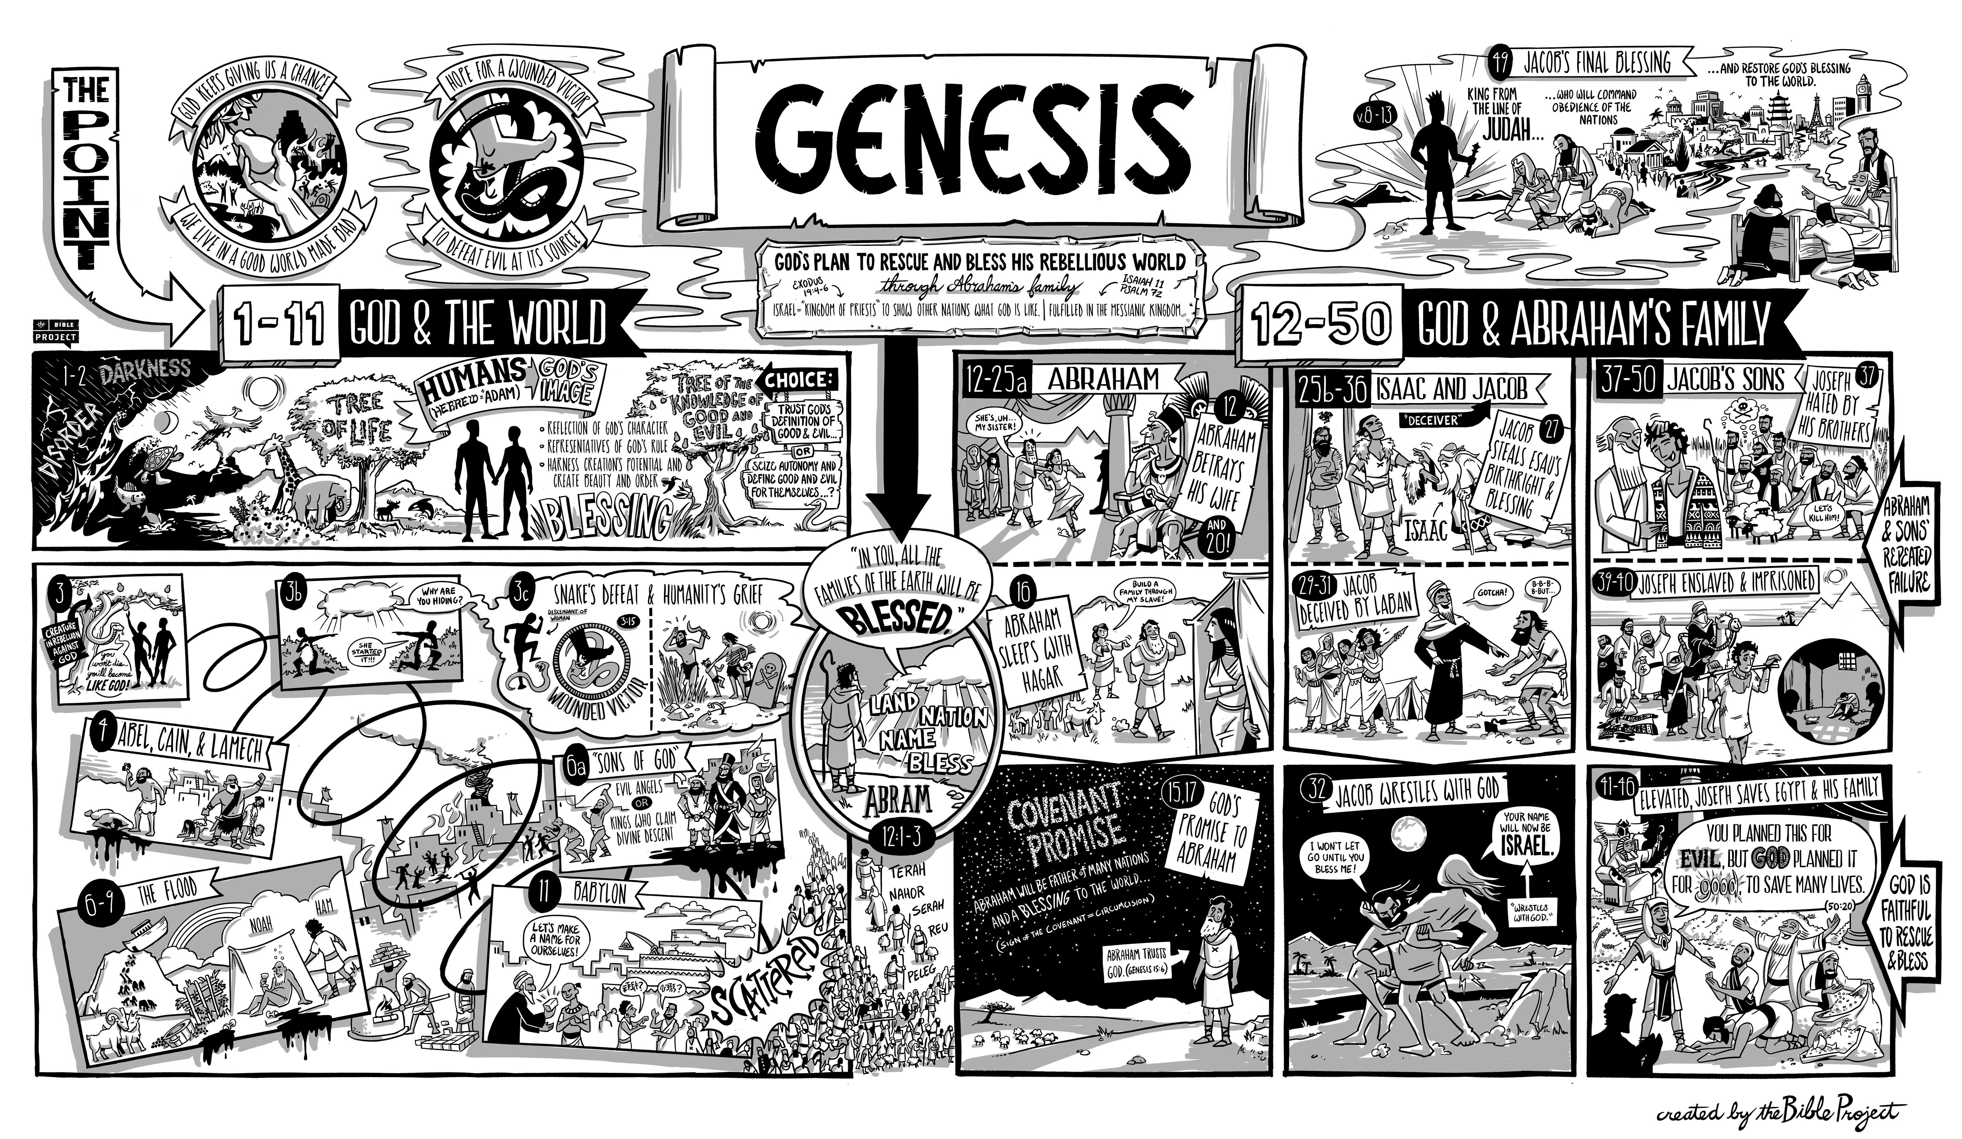
Resources for the Genesis
Be sure to check the Bible Project’s poster on Genesis.
Bible.org has some wonderful sermons on Genesis, especially those by Deffinbaugh and Stedman.
John Piper has a classis Christological message on the Joseph story at https://www.desiringgod.org/messages/the-sale-of-joseph-and-the-son-of-god
Riddlebarger’s blog has a wonderful take on the Joseph story at https://www.kimriddlebarger.com/the-riddleblog/josephs-faith-in-death
Jonathan Edwards has a reflection on the Joseph story at https://www.biblebb.com/files/edwards/temptation.htm
Maclaren has a helpful commentary at on many of these passages at https://www.monergism.com/thethreshold/articles/onsite/bible_book/genesis_maclaren.html
Many of Spurgeon’s sermons on Genesis are collected at https://www.spurgeon.org/resource-library/scripture-index/genesis/
Very Poythress has some very interesting thoughts on hermeneutics in Genesis at www.frame-poythress.org/wp-content/uploads/2013/09/2013ChristianInterpretationsOfGenesis1.pdf and
http://faculty.wts.edu/wp-content/uploads/2016/06/PoythressVernCorrelationsWithProvidenceInGenesis2.pdf
Tim Keller has a wonderful sermon on the “male and female” dynamic at https://www.monergism.com/first-wedding-day-%E2%80%93-genesis-218-25

Joseph's Faith in the Face of Death
Riddlebarger’s blog at https://www.kimriddlebarger.com/the-riddleblog/josephs-faith-in-death
A key figure in the closing chapters of the Book of Genesis, Joseph is known for several things: his “coat of many colors,” being sold into slavery by his jealous brothers, and for his remarkable ability to interpret the dreams of the Egyptian Pharaoh. But when the author of Hebrews looks back on the life of Joseph in Hebrews 11 (the so-called “hall of faith”), Joseph is remembered for something often overlooked. “By faith Joseph, at the end of his life, made mention of the exodus of the Israelites and gave directions concerning his bones” (Hebrews 11:22).
Joseph was the eleventh son of Jacob. Rachel was his mother. Joseph became the apple of his father’s eye and the recipient of the famous multi-colored coat–a gift from his doting father, provoking great jealousy on the part of his brothers. Joseph even had the nerve to claim that he had a dream in which his older brothers bowed down to him. When Jacob sent the seventeen year-old upstart Joseph to find his brothers, they plotted to kill him. One of his brothers, Reuben, talked the others into throwing Joseph down a well, knowing that he (Reuben) would return later and rescue him. But in the mysterious providence of God, Joseph was sold to traders, who took Joseph into Egypt as a slave, where he was sold again to Potiphar. While in Potiphar’s care, God was with Joseph, and the young Israelite thrived. Through a series of remarkable events, including interpreting Pharaoh’s dream (as recounted in Genesis 41), Joseph eventually became viceroy over all of Egypt.
When famine struck the land of Palestine, Jacob sent his sons to Egypt to purchase grain–Egypt possessed a great surplus of grain, thanks in part, to the skills of Joseph. In one of the greatest of biblical ironies, Joseph recognized his brothers, who were forced to bow down before him–in fulfillment of Joseph’s earlier dream. Joseph even quizzed them for information about his family and father. He arranged for his brothers to return to Egypt to retrieve a missing brother (Benjamin).
When his brothers appeared before him a second time (this time with Benjamin), Joseph revealed himself and arranged to meet his father Jacob in the land of Goshen. It was here that the Israelites would dwell until the Passover and Exodus, when God led his people back to the land of promise. When Joseph learned that Jacob was ill, he traveled to see his dying father. In Genesis 49:22-26, Jacob gave Joseph this remarkable blessing.
Joseph is a fruitful bough, a fruitful bough by a spring; his branches run over the wall. The archers bitterly attacked him, shot at him, and harassed him severely, yet his bow remained unmoved; his arms were made agile by the hands of the Mighty One of Jacob (from there is the Shepherd, the Stone of Israel), by the God of your father who will help you, by the Almighty who will bless you with blessings of heaven above, blessings of the deep that crouches beneath, blessings of the breasts and of the womb. The blessings of your father are mighty beyond the blessings of my parents, up to the bounties of the everlasting hills. May they be on the head of Joseph, and on the brow of him who was set apart from his brothers.
While Joseph received the greatest blessing of all the sons of Jacob, Jacob did bless all of his sons as heads of the twelve tribes of Israel. Joseph knew that Israel’s future was not in the land of Goshen (in Egypt), but in that land flowing with milk and honey which God had promised to give to his great-grandfather Abraham, his grandfather Isaac, and his father Jacob.
As we learn in the closing verses of the Book of Genesis, “Joseph remained in Egypt, he and his father's house. Joseph lived 110 years” (Genesis 50:22). When it came time for Joseph to die, “Joseph said to his brothers, `I am about to die, but God will visit you and bring you up out of this land to the land that he swore to Abraham, to Isaac, and to Jacob’” (Genesis 50:24). Even though Egypt was now his home of many years, and the place where he rose to great prominence, Joseph did not forget God’s promise to give the descendants of Abraham the land promised to them.
Before he breathed his last, “Joseph made the sons of Israel swear, saying, `God will surely visit you, and you shall carry up my bones from here’” (v. 25). Joseph would be buried in the land of promise, not Egypt. Genesis ends with these remarkable words: “So Joseph died, being 110 years old. They embalmed him,” according to Egyptian custom “and he was put in a coffin in Egypt.” When God led his people from Israel in the Exodus, Moses took Joseph’s remains with them. Joseph was eventually buried in Shechem, in the heart of the land God promised to give his people (Exodus 13:19; Joshua 24:32).
When the author of Hebrews looks back on the life of Joseph, he does not mention Joseph’s wisdom or managerial skills, Joseph’s rise to power, or his brush with death. He does not mention Joseph’s ability to interpret dreams. But the author of Hebrews does mention Joseph’s desire to be buried in the land of promise. This is the sure sign that Joseph believed God’s promise to give his people the land of Canaan. And this makes Joseph a man of faith. About to die, Joseph reminds us all that God keeps his covenant promises!

