A Short History of God’s History
Beginning in Beginnings: Genesis 1-3 January 9, 2022
In the beginning God created the heavens and the earth.
Now the earth was formless and empty,
darkness was over the face of the deep,
and the Spirit of God was hovering over the waters.
And God said, “Let there be light,” and there was light . . . .
Genesis 1:1-4

Three areas of investigation for careful readers

1. How has God revealed himself in his creation?

2. What is most important about myself and my fellow humanity?

3. What is my place in this creation and God’s redemption plan?

Two important questions

1. What does the genre of the creation story tell me?
Doug’s thought: This creation hymn is a celebration of God’s sovereignty and provision

2. How does God’s creation narrative instruct the science of origins?
Doug’s thought: This is first of all a “Who?” text and not a “When?” or “How?” text

Following the story

Preface: The haretz God created for his people (God introduced as Elohim)

 | Separated |  | Filled
Day 1 |  | Day 4
Day 2 |  | Day 5
Day 3 |  | Day 6, Good
 |  | Day 6, Very Good
Day 7

Account 1, Chapters 2-4: What happened in the haretz (God introduced as Yahweh)

Account 2, Chapter 5: The story of Adam (“them” in 5:2) and their line

Account 3, Chapters 6-9: The story of Noah and God’s judgment and deliverance

Account 4, Chapters 10-11: The story of Noah’s sons, especially Shem, and the dispersion at Babel

Account 5, Chapters 11:27-25:18: The story of Terah and his son Abraham (Ishmael included)

Account 6, Chapters 25:19-37:1: The story of Isaac (Esau included)

Account 7, Chapters 37-50: The story of Jacob, mostly about Joseph

Doug’s thought: What ties these “accounts” together is family!
What we learn about our Creator
¹ The heavens declare the glory of God;
the skies proclaim the work of his hands . . . .
⁷ The law of the Lord is perfect,
reviving the soul.
Galatians 3:26-4:7

1. God really does reveal himself through his work in creation, but we need his book to understand it

2. God didn’t just break into history, he created history

3. Diversity inside unity is one way we reflect the imago Dei

What I learn about myself
When the Lord God made the earth and the heavens— ⁵ and no shrub of the field had yet appeared on the earth and no plant of the field had yet sprung up, for the Lord God had not sent rain on the earth and there was no man to work the ground, ⁶ but streams came up from the earth and watered the whole surface of the ground— ⁷ the Lord God formed the man from the dust of the ground and breathed into his nostrils the breath of life, and the man became a living being.
⁸ Now the Lord God had planted a garden in the east, in Eden; and there he put the man he had formed. ⁹ And the Lord God made all kinds of trees grow out of the ground—trees that were pleasing to the eye and good for food. In the middle of the garden were the tree of life and the tree of the knowledge of good and evil . . . . . The Lord God took the man and put him in the Garden of Eden to work it and take care of it. ¹⁶ And the Lord God commanded the man, “You are free to eat from any tree in the garden; ¹⁷ but you must not eat from the tree of the knowledge of good and evil, for when you eat of it you will surely die.”
¹⁸ The Lord God said, “It is not good for the man to be alone. I will make a helper suitable for him.”
Genesis 2:4-18

1. I am a “hands on” project of God, the combination of dirt and the breath of God

2. To enjoy creation, I need a relationship with the Creator rather than autonomy

3. History’s first lo tov shows that I am built for community

What we learn about our way in this world (leveraging common grace)

1. God’s orders of creation are a blessing

²⁷ So . . . male and female he created them.
Genesis 1:27
¹⁵ The Lord God took the man and put him in the Garden of Eden to work it and take care of it. ¹⁶ And the Lord God commanded the man, “You are free to eat from any tree in the garden; ¹⁷ but you must not eat from the tree of the knowledge of good and evil, for when you eat of it you will surely die.”
Genesis 2:15-16
²⁴ For this reason a man will leave his father and mother and be united to his wife, and they will become one flesh.
Genesis 2:24

2. The work of caring for creation is more than honorable, it is worship

²⁶ Then God said, “Let us make man in our image, in our likeness, and let them rule over the fish of the sea and the birds of the air, over the livestock, over all the earth, and over all the creatures that move along the ground.”
Genesis 1:26
²⁸ He who has been stealing must steal no longer, but must work, doing something useful with his own hands, that he may have something to share with those in need.
Ephesians 4

3. We are born into a spiritual battle against the curse

¹⁵ And I will put enmity between you and the woman,
and between your offspring and hers;
he will crush your head,
and you will strike his heel.”
Genesis 3:15 (God speaking to the serpent in the presence of the man and woman)

¹⁰ Finally, be strong in the Lord and in his mighty power. ¹¹ Put on the full armor of God so that you can take your stand against the devil’s schemes. ¹² For our struggle is not against flesh and blood, but against the rulers, against the authorities, against the powers of this dark world and against the spiritual forces of evil in the heavenly realms. ¹³ Therefore put on the full armor of God, so that when the day of evil comes, you may be able to stand your ground, and after you have done everything, to stand.
Ephesians 6

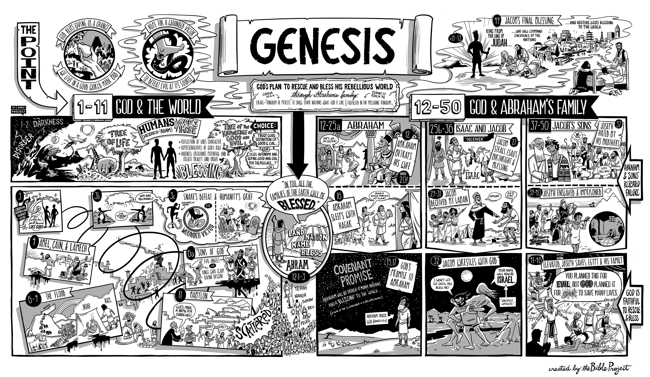
Resources for the Genesis
Be sure to check the Bible Project’s poster on Galatians.
Bible.org has some wonderful sermons on Genesis, especially those by Deffinbaugh and Stedman.
Maclaren has a helpful commentary at on many of these passages at https://www.monergism.com/thethreshold/articles/onsite/bible_book/genesis_maclaren.html
Many of Spurgeon’s sermons on Genesis are collected at https://www.spurgeon.org/resource-library/scripture-index/genesis/
Very Poythress has some very interesting thoughts on hermeneutics in Genesis at www.frame-poythress.org/wp-content/uploads/2013/09/2013ChristianInterpretationsOfGenesis1.pdf and
http://faculty.wts.edu/wp-content/uploads/2016/06/PoythressVernCorrelationsWithProvidenceInGenesis2.pdf
The “scale of the universe” program that Doug references can be found at https://htwins.net/scale2/
Tim Keller has a wonderful sermon on the “male and female” dynamic at https://www.monergism.com/first-wedding-day-%E2%80%93-genesis-218-25

