In The Valley of Decision
Pentecost #7, Acts 2:1-21 May 23, 2021
“ ‘In the last days,’ God says,
‘I will pour out my Spirit on all people.’ “
Acts 2:17 (Peter quoting Joel 2:28)

Celebration of Pentecost
¹ When the day of Pentecost came, they were all together in one place. ² Suddenly a sound like the blowing of a violent wind came from heaven and filled the whole house where they were sitting. ³ They saw what seemed to be tongues of fire that separated and came to rest on each of them. ⁴ All of them were filled with the Holy Spirit and began to speak in other tongues as the Spirit enabled them.
Acts 2:1-4

1) Shavuot is the second harvest festival, one of three pilgrimages which celebrates receiving Torah

2) At Pentecost God gives his people a new identifying mark, not Torah but the Spirit

3) The signs (two out of the three signs from 1 Kings 19) are there to get our attention

4) The Spirit’s arrival means the wait is over (yes to Acts 1:8, but better Jer. 31 and Hebrews 10:15)

First lessons from Jerusalem
¹⁵ Now there were staying in Jerusalem God-fearing Jews from every nation under heaven. ⁶ When they heard this sound, a crowd came together in bewilderment, because each one heard them speaking in his own language. ⁷ Utterly amazed, they asked: “Are not all these men who are speaking Galileans? ⁸ Then how is it that each of us hears them in his own native language? ⁹ Parthians, Medes and Elamites; residents of Mesopotamia, Judea and Cappadocia, Pontus and Asia, ¹⁰ Phrygia and Pamphylia, Egypt and the parts of Libya near Cyrene; visitors from Rome ¹¹ (both Jews and converts to Judaism); Cretans and Arabs—we hear them declaring the wonders of God in our own tongues!”
Acts 2

1) God brings the world to Jerusalem (Babel in reverse, see Genesis 10-11)

2) Being in Jerusalem doesn’t mean I’ll be in control

The beginning of Peter’s first sermon
¹⁴ Then Peter stood up with the Eleven, raised his voice and addressed the crowd: “Fellow Jews and all of you who live in Jerusalem, let me explain this to you; listen carefully to what I say. ¹⁵ These men are not drunk, as you suppose. It’s only nine in the morning! ¹⁶ No, this is what was spoken by the prophet Joel:
¹⁷ “ ‘In the last days, God says,
I will pour out my Spirit on all people.
Your sons and daughters will prophesy,
your young men will see visions,
your old men will dream dreams.
¹⁸ Even on my servants, both men and women,
I will pour out my Spirit in those days,
and they will prophesy.
¹⁹ I will show wonders in the heaven above
and signs on the earth below,
blood and fire and billows of smoke.
²⁰ The sun will be turned to darkness
and the moon to blood
before the coming of the great and glorious day of the Lord.
²¹ And everyone who calls
on the name of the Lord will be saved.”
Acts 2

1) “This is that” – God is doing a new work

2) The GATDOTL is not one future kairos but the present messianic age

3) Peter knows what comes “before” (see Joel 2:28)

-- repentance (Joel 2:12-14)

-- restoration (Joel 2:21-25)

-- the assurance of God’s presence (Joel 2:27)

4) Joel and Peter both end in the Valley of Decision

The Day of the Lord
²⁸ “And afterward, I will pour out my Spirit on all people.
Your sons and daughters will prophesy,
your old men will dream dreams, your young men will see visions.
²⁹ Even on my servants, both men and women,
I will pour out my Spirit in those days.
³⁰ I will show wonders in the heavens and on the earth,
blood and fire and billows of smoke.
³¹ The sun will be turned to darkness and the moon to blood
before the coming of the great and dreadful day of the Lord.
³² And everyone who calls on the name of the Lord will be saved;
for on Mount Zion and in Jerusalem there will be deliverance, as the Lord has said,
among the survivors whom the Lord calls.
3 “In those days and at that time, when I restore the fortunes of Judah and Jerusalem,
² I will gather all nations and bring them down to the Valley of Jehoshaphat.
There I will enter into judgment against them
concerning my inheritance, my people Israel,
for they scattered my people among the nations and divided up my land.
³ They cast lots for my people and traded boys for prostitutes;
they sold girls for wine that they might drink.
⁴ “Now what have you against me, O Tyre and Sidon and all you regions of Philistia? Are you repaying me for something I have done? If you are paying me back, I will swiftly and speedily return on your own heads what you have done. ⁵ For you took my silver and my gold and carried off my finest treasures to your temples. ⁶ You sold the people of Judah and Jerusalem to the Greeks, that you might send them far from their homeland.
⁷ “See, I am going to rouse them out of the places to which you sold them, and I will return on your own heads what you have done. ⁸ I will sell your sons and daughters to the people of Judah, and they will sell them to the Sabeans, a nation far away.” The Lord has spoken.
⁹ Proclaim this among the nations: Prepare for war! Rouse the warriors!
Let all the fighting men draw near and attack.
¹⁰ Beat your plowshares into swords and your pruning hooks into spears.
Let the weakling say, “I am strong!”
¹¹ Come quickly, all you nations from every side, and assemble there.
Bring down your warriors, O Lord!
¹² “Let the nations be roused; let them advance into the Valley of Jehoshaphat,
for there I will sit to judge all the nations on every side.
¹³ Swing the sickle, for the harvest is ripe.
Come, trample the grapes, for the winepress is full and the vats overflow—
so great is their wickedness!”
¹⁴ Multitudes, multitudes in the valley of decision!
For the day of the Lord is near in the valley of decision.
¹⁵ The sun and moon will be darkened, and the stars no longer shine.
¹⁶ The Lord will roar from Zion and thunder from Jerusalem;
the earth and the sky will tremble.
But the Lord will be a refuge for his people,
a stronghold for the people of Israel.

The “Last Days” in Anacortes

1) We are identified by the Holy Spirit
Peter replied, “Repent and be baptized, every one of you, in the name of Jesus Christ for the forgiveness of sins. And you will receive the gift of the Holy Spirit. The promise if for you and your children and for all who are far off – for all whom the Lord our God will call.
Acts 2:38-39

2) Watch for God’s restoring work to come before
“ I will repay you for the years the locusts have eaten . . . .
Then you will know that I am in Israel, that I am the Lord your God, and that there is no other;
never again will my people be shamed.
“And afterward, I will pour out my Spirit on all people . . . .
Joel 2:25-28

3) How is God getting our attention?
¹⁴ Multitudes, multitudes in the valley of decision! For the day of the Lord is near in the valley of decision. The sun and the moon will be darkened, and the stars no longer shine. The Lord will roar from Zion and thunder from Jerusalem; the earth and the sky will tremble. But the Lord will be a refuge for his people, a stronghold for the people of Israel.
Joel 3:14-16

God send us a season of glorious disorder. Oh for a sweep of wind that will set the seas in motion
and make our ironclad brethren now lying so quietly at anchor to roll from stem to stern . . . .
O Spirit of God, You are ready to work with us today even as You did then! Stay not, we beseech
You, but work at once. Break down every barrier that hinders the incomings of Your might. Overturn,
overturn, O sacred wind! Consume all obstacles, O heavenly fire, and give us now both hearts of flame and tongues of fire to preach Your reconciling word for Jesus’ sake. Amen.
Spurgeon’s closing prayer in “The Pentecostal Wind and Fire”

4) There is a whole lot of calling going on
³² And everyone who calls on the name of the Lord will be saved; for on Mount Zion and in Jerusalem there will be deliverance, as the Lord has said, among the survivors whom the Lord calls.
Joel 2:32 (see Acts 2:39)

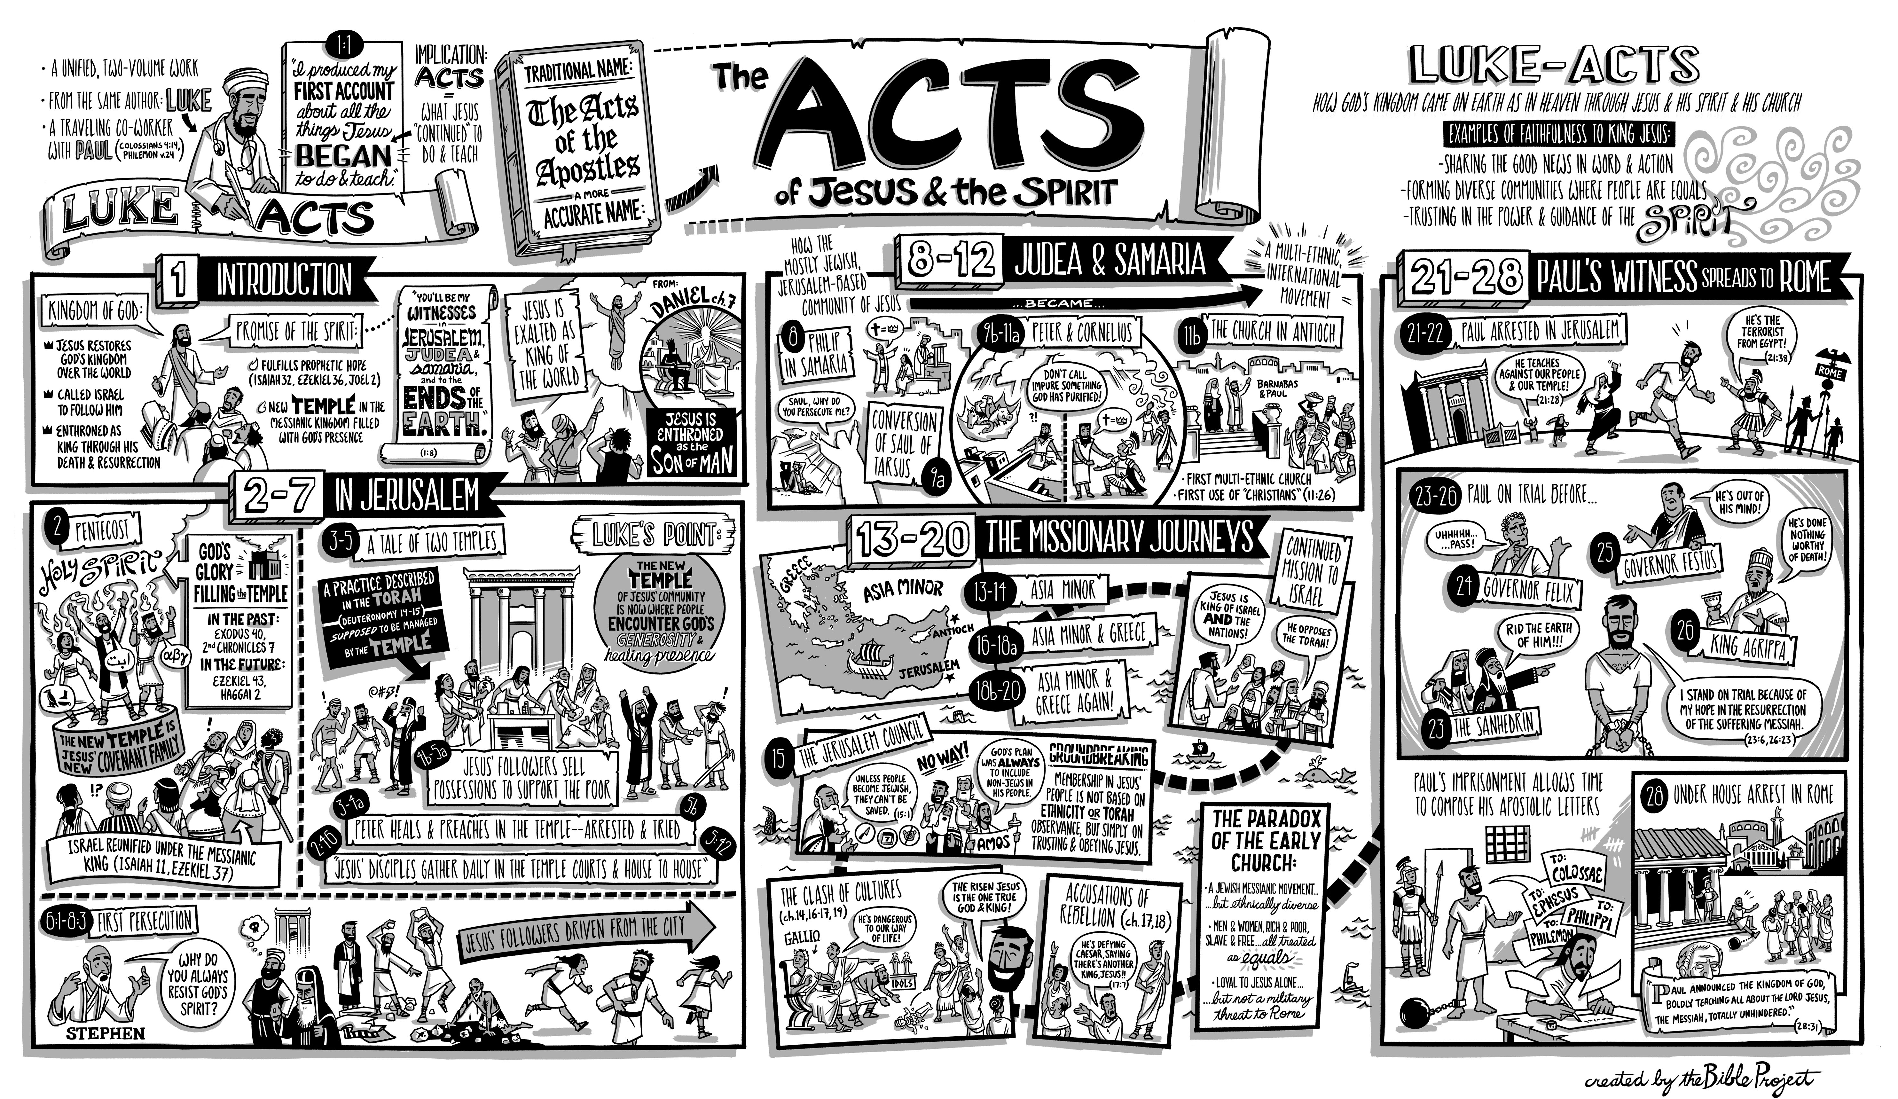

Resources for further studies in Acts
The Bible Project team has great stuff on Acts at https://open.life.church/items/179224-poster-jpg
Spurgeon has sermons on this text at https://www.spurgeon.org/resource-library/sermons/pentecost-2/#flipbook/ and http://www.spurgeongems.org/vols25-27/chs1619.pdf
Deffinbaugh’s introduction at https://bible.org/seriespage/unique-contribution-book-acts
and Acts series at https://bible.org/series/studies-book-acts
I have really appreciated John Stott’s The Spirit, The Church and the World: The Message of Acts (IVP, 1990) and F. F. Bruce’s work: New Testament History (Doubleday, 1980) and The Book of the Acts (Eerdmans, 1984).

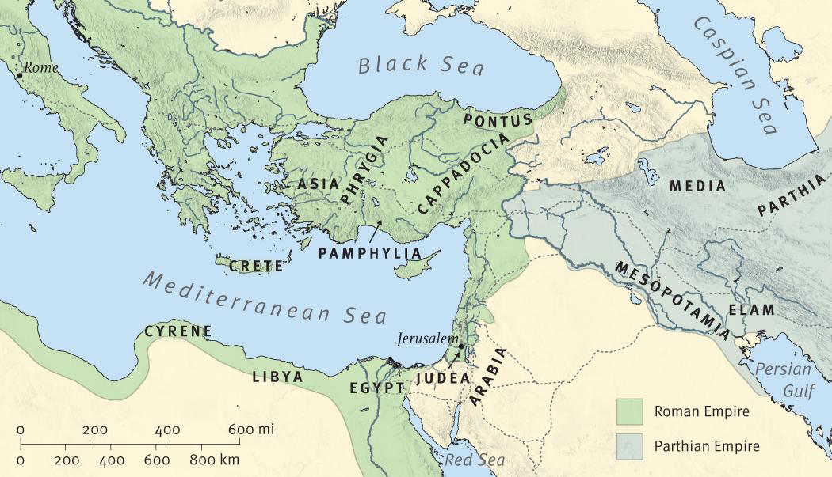

Acts Timeline (ESV Study Bible)

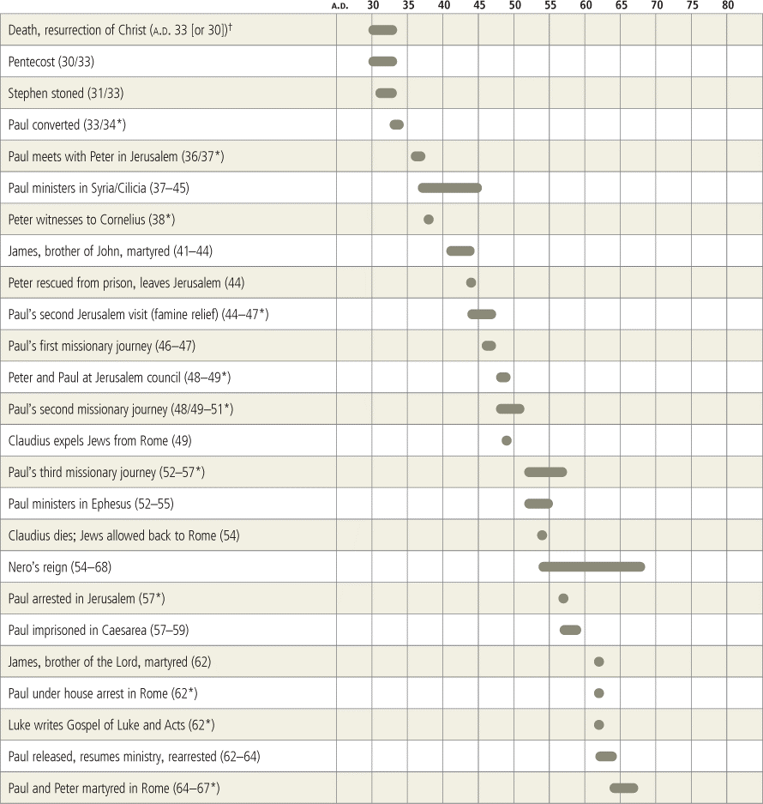

THE PENTECOSTAL WIND AND FIRE NO. 1619
BY C. H. SPURGEON, at http://www.spurgeongems.org/vols25-27/chs1619.pdf

“And suddenly there came a sound from heaven as of a rushing mighty wind,
and it filled all the house where they were sitting.
And there appeared unto them cloven tongues like as of fire, and it sat upon each of them.
And they were all filled with the Holy Ghost, and began to speak with other tongues,
as the Spirit gave them utterance.”
Acts 2:2-4.
FROM the descent of the Holy Ghost at the beginning we may learn something concerning His
operations at the present time. Remember at the outset that whatever the Holy Spirit was at the first that
He is that now, for as God He remains forever the same—whatsoever He then did He is able to do still,
for His power is by no means diminished. As says the prophet Micah, “O you that are named the house
of Jacob, is the Spirit of the LORD straitened?” We would greatly grieve the Holy Spirit if we supposed
that His might was less today than in the beginning. Although we may not expect and need not desire the
miracles which came with the gift of the Holy Spirit, so far as they were physical, yet we may both
desire and expect that which was intended and symbolized by them, and we may reckon to see the same
spiritual wonders performed among us at this day.
Pentecost, according to the belief of the Jews, was the time of the giving of the law, and if when the
law was given there was a marvelous display of power on Sinai, it was to be expected that when the
Gospel was given, whose ministration is far more glorious, there should be some special unveiling of the
divine presence. If at the commencement of the Gospel we behold the Holy Spirit working great signs
and wonders, may we not expect a continuance—nay, if anything, an increased display of His power as
the ages roll on? The law vanished away, but the Gospel will never vanish. It shines more and more to
the perfect millennial day and therefore I reckon that, with the sole exception of physical miracles,
whatever was wrought by the Holy Ghost at the first we may look to be wrought continually while the
dispensation lasts.
It ought not to be forgotten that Pentecost was the feast of first fruits—it was the time when the first
ears of ripe corn were offered unto God. If, then, at the commencement of the Gospel harvest we see so
plainly the power of the Holy Spirit, may we not most properly expect infinitely more as the harvest
advances, and most of all when the most numerous sheaves shall be ingathered? May we not conclude
that if the Pentecost was thus marvelous, the actual harvest will be more wonderful still?
This morning my object is not to talk of the descent of the Holy Spirit as a piece of history, but to
view it as a fact bearing upon us at this hour, even upon us who are called in these latter days to bear our
testimony for the truth. The Father has sent us the Comforter that He may dwell in us till the coming of
the Lord. The Holy Ghost has never returned, for He came in accordance with the Savior’s prayer to
abide with us forever. The gift of the Comforter was not temporary and the display of His power was not
to be once seen and no more. The Holy Ghost is here and we ought to expect His divine working among
us. And if He does not so work, we should search ourselves to see what it is that hinders, and whether
there may not be something in ourselves which vexes Him, so that He restrains His sacred energy and
does not work among us as He did aforetime.
May God grant that the meditation of this morning will increase our faith in the Holy Ghost and
inflame our desires towards Him so that we may look to see Him fulfilling His mission among men as at
the beginning.

I. First, I shall call your attention to THE INSTRUCTIVE SYMBOLS of the Holy Spirit, which
were made prominent at Pentecost. They were two. There was a sound as of a rushing mighty wind and
there were cloven tongues, as it were, of fire.
Take the symbols separately. The first is wind—an emblem of deity and therefore a proper symbol
of the Holy Spirit. Often, under the Old Testament, God revealed Himself under the emblem of breath or
wind. Indeed, as most of you know, the Hebrew word for “wind” and “spirit” is the same. So, with the
Greek word, when Christ talked to Nicodemus, it is not very easy for translators to tell us when He said,
“spirit,” and when He said, “wind.” Indeed, some most correctly render the original all the way through
by the word, “wind,” while others with much reason have also used the word “spirit” in their translation.
The original word signified either the one or the other, or both. Wind is, of all material things, one of
the most spiritual in appearance. It is invisible, ethereal, mysterious, hence men have fixed upon it as
being nearest akin to spirit. In Ezekiel’s famous vision, when he saw the valley full of dry bones, we all
know that the Spirit of God was intended by that vivifying wind which came when the prophet
prophesied and blew upon the withered relics till they were quickened into life. “The LORD has his way
in the whirlwind,” thus He displays Himself when He works. “The Lord answered Job out of the
whirlwind,” thus He reveals Himself when He teaches His servants.
Observe that this wind on the day of Pentecost was accompanied with a sound—a sound as of a
mighty rushing wind, for albeit the Spirit of God can work in silence, yet in saving operations He
frequently uses sound. I would be the last to depreciate meetings in which there is nothing but holy
silence, for I could wish that we had more reverence for silence, and it is in stillness that the inner life is
nourished. Yet the Holy Ghost does not work for the advancement of the kingdom of God by silence
alone, for faith comes by hearing. There is a sound as of a mighty rushing wind when the Word is
sounded forth throughout whole nations by the publishing of the Gospel. If the Lord had not given men
ears or tongues, silent worship would have been not only appropriate but necessary—but inasmuch as
we have ears the Lord must have intended us to hear something—and as we have tongues, He must have
meant us to speak.
Some of us would be glad to be quiet, but where the Gospel has free course, there is sure to be a
measure of noise and stir. The sound came on this occasion, no doubt, to call the attention of the
assembly to what was about to occur, to arouse them, and to fill them with awe! There is something
indescribably solemn about the rush of a rising tempest. It bows the soul before the sublime mystery of
divine power. What more fitting as an attendant upon divine working than the deeply solemn rush of a
mighty wind?
With this awe-inspiring sound as of a mighty wind, there was clear indication of its coming from
heaven. Ordinary winds blow from this or that quarter of the skies, but this descended from heaven
itself—it was distinctly like a down-draught from above. This sets forth the fact that the true Spirit, the
Spirit of God, neither comes from this place nor that—neither can His power be controlled or directed
by human authority, but His working is always from above, from God Himself. The work of the Holy
Spirit is, so to speak, the breath of God and His power is evermore in a special sense the immediate
power of God.
Coming downward, therefore, this mysterious wind passed into the chamber where the disciples
were assembled and filled the room. An ordinary rushing mighty wind would have been felt outside the
room, and would probably have destroyed the house or injured the inmates, if it had been aimed at any
one building—but this heavenly gust filled but did not destroy the room—it blessed, but did not
overthrow the waiting company.
The meaning of the symbol is that as breath, air, wind, is the very life of man, so is the Spirit of God
the life of the spiritual man. By Him are we quickened at the first. By Him are we kept alive afterwards.
By Him is the inner life nurtured, and increased, and perfected. The breath of the nostrils of the man of
God is the Spirit of God.
This holy breath was not only intended to quicken them, but to invigorate them. What a blessing
would a breeze be just now to us who sit in this heavy atmosphere. How gladly would we hail a gust
from the breezy down, or a gale from the open sea! If the winds of earth are so refreshing, what must a
wind from heaven be!
That rushing mighty wind soon cleared away all earth-engendered damps and vapors—it aroused the
disciples and left them braced up for the further work of the Lord. They took in great draughts of
heavenly life. They felt animated, aroused, and bestirred. A sacred enthusiasm came upon them, because
they were filled with the Holy Ghost. And girt with that strength, they rose into a nobler form of life
than they had known before.
No doubt this wind was intended to show the irresistible power of the Holy Ghost, for simple as the
air is, and mobile and apparently feeble, yet set it in motion and you feel that a thing of life is among
you. Make that motion more rapid and who knows the power of the restless giant who has been
awakened. See, it becomes a storm, a tempest, a hurricane, a tornado, a cyclone. Nothing can be more
potent than the wind when it is thoroughly roused and so, though the Spirit of God be despised among
men, so much so that they do not even believe in His existence, yet let Him work with the fullness of
His power and you will see what He can do.
He comes softly, breathing like a gentle zephyr which fans the flowers, but does not dislodge the
insect of most gauzy wing, and our hearts are comforted. He comes like a stirring breeze and we are
quickened to a livelier diligence—our sails are hoisted and we fly before the gale. He comes with yet
greater strength and we prostrate ourselves in the dust as we hear the thunder of His power bringing
down with a crash false confidences and refuges of lies! How the firm reliances of carnal men, which
seemed to stand like rocks, are utterly cast down! How men’s hopes, which appeared to be rooted like
oaks, are torn up by the roots before the breath of the convincing Spirit! What can stand against Him?
Oh! that we did but see in these latter days something of that mighty rushing wind which breaks the
cedars of Lebanon and sweeps before it all things that would resist its power.
The second Pentecostal symbol was fire. Fire, again, is a frequent symbol of deity. Abraham saw a
burning lamp and Moses beheld a burning bush. When Solomon had built his holy and beautiful house,
its consecration lay in the fire of God descending upon the sacrifice to mark that the Lord was there, for
when the Lord had dwelt aforetime in the tabernacle, which was superseded by the temple, He revealed
Himself in a pillar of cloud by day and a pillar of fire by night. “Our God is a consuming fire.” Hence
the symbol of fire is a fit emblem of God the Holy Spirit. Let us adore and worship Him. Tongues of
flame sitting on each man’s head betokened a personal visitation to the mind and heart of each one of
the chosen company.
Not to consume them came the fires, for no one was injured by the flaming tongue—to men whom
the Lord has prepared for His approach, there is no danger in His visitations. They see God and their
lives are preserved. They feel His fires and are not consumed. This is the privilege of those alone who
have been prepared and purified for such fellowship with God.
The intention of the symbol was to show them that the Holy Spirit would illuminate them, as fire
gives light. “He shall lead you into all truth.” Henceforth they were not to be untrained children, but to
be teachers in Israel, instructors of the nations whom they were to disciple unto Christ—hence the Spirit
of the light was upon them.
But fire does more than give light—it inflames—and the flames which sat upon each showed them
that they were to be ablaze with love, intense with zeal, burning with self-sacrifice, and that they were to
go forth among men to speak not with the chill tongue of deliberate logic, but with burning tongues of
passionate pleading, persuading and entreating men to come unto Christ that they might live. The fire
signified inspiration. God was about to make them speak under a divine influence, to speak as the Spirit
of God should give them utterance. Oh! blessed symbol, would God that all of us experienced its
meaning to the full and that the tongue of fire sat upon every servant of the Lord. May a fire burn
steadily within to destroy our sin, a holy sacrificial flame to make us whole burnt offerings unto God, a
never-dying flame of zeal for God and devotion to the cross.
Note that the emblem was not only fire, but a tongue of fire, for God meant to have a speaking
church. Not a church that would fight with the sword—with that weapon we have nought to do—but a
church that should have a sword proceeding out of its mouth, whose one weapon should be the
proclamation of the Gospel of Jesus Christ. I should think from what I know of some preachers that
when they had their Pentecost, the influence put upon them was in the form of tongues of flowers. But
the apostolic Pentecost knew not flowers, but flames. What fine preaching we have nowadays! What
new thoughts and poetical turns! This is not the style of the Holy Ghost.
Soft and gentle is the flow of smooth speech which tells of the dignity of man, the grandeur of the
century, the toning down of all punishment for sin, and the probable restoration of all lost spirits,
including the arch-fiend himself. This is the Satanic ministry, subtle as the serpent, bland as his seducing
words to Eve.
The Holy Ghost calls us not to this mode of speech. Fire, intensity, zeal, passion as much as you
will—but as for aiming at effect by polished phrases and brilliant periods—these are fitter for those who
would deceive men than for those who would tell them the message of the Most High. The style of the
Holy Ghost is one which conveys the truth to the mind in the most forcible manner—it is plain but
flaming, simple but consuming. The Holy Spirit has never written a cold period throughout the whole
Bible and never did He speak by a man a lifeless word, but evermore He gives and blesses the tongue of
fire.
These, then, are the two symbols, and I should like you to carefully observe how the Holy Spirit
teaches us by them. When He came from the Father to His Son Jesus it was as a dove. Let peace rest on
that dear sufferer’s soul through all His days of labor and through the passion which would close them.
His anointing is that of peace—He needed no tongue of flame, for He was already all on fire with love.
When the Holy Spirit was bestowed, by the Son of God, upon His disciples it was as breath—“He
breathed on them and said, Receive the Holy Ghost.” To have life more abundantly is a chief necessity
of servants of the Lord Jesus and therefore the Holy Spirit visits us.
Now that we have the Holy Spirit from Christ as our inner life and quickening, He also comes upon
us with the intent to use us in blessing others and this is the manner of His visitation—He comes as the
wind, which wafts the words we speak, and as fire which burns a way for the truth we utter. Our words
are now full of life and flame. They are borne by the breath of the Spirit, and they fall like fire-flakes,
and set the souls of men blazing with desire after God. If the Holy Spirit shall rest upon me or upon you,
or upon any of us, to qualify us for service, it shall be after this fashion—not merely of life for
ourselves, but of fiery energy in dealing with others.

Come on us even now, O rushing mighty wind and tongue of fire, for the world has great need. It
lies stagnant in the malaria of sin and needs a healing wind. It is shrouded in dreadful night and needs
the flaming torch of truth. There is neither health nor light for it but from You, O blessed Spirit. Come,
then, upon it through Your people.

Now put these two symbols together, only mind what you are at. Wind and fire together! I have kept
them separate in my discourse hitherto and you have seen power in each one—what are they together?
Rushing mighty wind alone—how terrible! Who shall stand against it? See how the gallant ships dash
together and the monarchs of the forest bow their heads. And fire alone! Who shall stand against it when
it devours its prey? But set wind and fire to work in hearty union! Remember the old city of London?
When first the flames began, it was utterly impossible to quench them because the wind fanned the
flame and the buildings gave way before the flame-torrent. Set the prairie on fire. If a rain shower falls
and the air is still, the grass may perhaps cease to burn, but let the wind encourage the flame and see
how the devourer sweeps along while the tall grass is licked up by tongues of fire.
We have lately read of forests on fire. What a sight! Hear how the mighty trees are crashing in the
flame! What can stand against it! The fire sets the mountains on a blaze. What a smoke blackens the
skies—it grows dark at noon. As hill after hill offers up its sacrifice, the timid imagine that the great day
of the Lord has come. If we could see a spiritual conflagration of equal grandeur it were a
consummation devoutly to be wished. O God, send us Your Holy Ghost in this fashion—give us both
the breath of spiritual life and the fire of unconquerable zeal, till nation after nation shall yield to the
sway of Jesus.

O You who art our God, answer us by fire, we pray You. Answer us both by wind and fire, and then
shall we see You to be God indeed. The kingdom comes not and the work is flagging. O that You would
send the wind and the fire! You will do this when we are all of one accord, all believing, all expecting,
all prepared by prayer. Lord, bring us to this waiting state.

II. Secondly, my brethren, follow me while I call your attention to THE IMMEDIATE EFFECTS of
this descent of the Holy Spirit, for these symbols were not sent in vain.
There were two immediate effects—the first was filling and the second was the gift of utterance. I
call special attention to the first, namely, filling—“It filled all the house where they were sitting.” And it
did not merely fill the house, but the men—“They were all filled with the Holy Ghost.” When they stood
up to speak, even the ribald mockers in the crowd noticed this, for they said, “These men are full,” and
though they added, “with new wine,” yet they evidently detected a singular fullness about them.
We are poor, empty things by nature, and useless while we remain so—we need to be filled with the
Holy Ghost. Some people seem to believe in the Spirit of God giving utterance only, and they look upon
instruction in divine things as of secondary importance. Dear, dear me. What trouble comes when we act
upon that theory! How the empty vessels clatter, and rattle, and sound! Men in such case utter a
wonderful amount of nothing and even when that nothing is set on fire it does not come to much.
I dread a revival of that sort, where the first thing and the last thing is everlasting talk. Those who set
up for teachers ought to be themselves taught of the Lord—how can they communicate that which they
have not received? Where the Spirit of God is truly at work, He first fills and then gives utterance—that
is His way. Oh that you and I were at this moment filled with the Holy Ghost.
“Full!” Then they were not cold, and dead, and empty of life as we sometimes are. “Full.” Then
there was no room for anything else in any one of them! They were too completely occupied by the
heavenly power to have room for the desires of the flesh. Fear was banished, every minor motive was
expelled. The Spirit of God, as it flooded their very being, drove out of them everything that was
extraneous. They had many faults and many infirmities before, but that day, when they were filled with
the Spirit of God, faults and infirmities were no more perceptible. They became different men from what
they had ever been before—men full of God are the reverse of men full of self.
The difference between an empty man and a full man is something very wonderful. Let a thirsty
person have an empty vessel handed to him. There may be much noise in the handing, but what a
mockery it is as it touches his lips. But fill it with refreshing water and perhaps, there may be all the
more silence in the passing of it, for a full cup needs careful handling, but oh, what a blessing when it
reaches the man’s lips! Out of a full vessel he may drink his full. Out of a full church the world shall
receive salvation, but never out of an empty one. The first thing we want as a church is to be filled with
the Holy Ghost. The gift of utterance will then come as a matter of course.
They ask me, “May the sisters speak anywhere? If not in the assembly, may they not speak in
smaller meetings?” I answer, yes, if they are full of the Holy Ghost. Shall this brother or that be allowed
to speak? Certainly, if he be filled, he may flow. May a layman preach? I know nothing about laymen
except that I am no cleric myself—but let all speak who are full of the Holy Ghost.
“Spring up, O well.” If it be a fountain of living water, who would restrain it, who could restrain it?
Let him overflow who is full, but mind he does not set up to pour out when there is nothing in him—for
if he counts it his official duty to go pouring out, pouring out, pouring out, at unreasonable length, and
yet nothing comes of it, I am sure he acts, not by the Holy Spirit, but according to his own vanity.
The next Pentecostal symbol was utterance. As soon as the Spirit of God filled them, they began to
speak at once. It seems to me that they began to speak before the people had come together. They could
not help it—the inner forces demanded expression and they must speak. So when the Spirit of God
really comes upon a man, he does not wait till he has gathered an audience of the size which he desires,
but he seizes the next opportunity. He speaks to one person, he speaks to two, he speaks to three, to
anybody—he must speak, for he is full and must have vent.
When the Spirit of God fills a man, he speaks so as to be understood. The crowd spoke different
languages and these Spirit-taught men spoke to them in the language of the country in which they were
born. This is one of the signs of the Spirit’s utterance.
If my friend over yonder talks in a Latinized style to a company of fruit sellers, I will guarantee you
the Holy Ghost has nothing to do with him. If a learned brother fires over the heads of his congregation
with a grand oration, he may trace his elocution, if he likes, to Cicero and Demosthenes, but do not let
him ascribe it to the Holy Spirit, for that is not after His manner. The Spirit of God speaks so that His
words may be understood, and if there is any obscurity, it lies in the language used by the Lord Himself.
The crowd not only understood, but they felt. There were lancets in this Pentecostal preaching and
the hearers “were pricked in the heart.” The truth wounded men and the slain of the Lord were many, for
the wounds were in the most vital part. They could not make it out—they had heard speakers before, but
this was quite a different thing. The men spoke fire-flakes and one hearer cried to his fellow, “What is
this?” The preachers were speaking flame and the fire dropped into the hearts of men till they were
amazed and confused.
Those are the two effects of the Holy Spirit—a fullness of the Spirit in the ministry and the church—
and next, a fire ministry and a church on fire, speaking so as to be felt and understood by those around.
Causes produce effects like themselves, and this wind and fire ministry soon did its work. We read that
this “was noised abroad.” Of course it was, because there had been a noise as of a rushing mighty wind.
Next to that we read that all the people came together and were confounded. There was naturally a
stir, for a great wind from heaven was rushing. All were amazed and astonished, and while some
inquired believingly, others began to mock. Of course they did—there was a fire burning and fire is a
dividing thing—and this fire began to separate between the precious and the vile, as it always will when
it comes into operation.
We may expect at the beginning of a true revival to observe a movement among the people—a noise
and a stir. These things are not done in a corner. Cities will know of the presence of God and crowds
will be attracted by the event.
This was the immediate effect of the Pentecostal marvel and I shall now ask you to follow me to my
third point, which is this—

III. The Holy Spirit being thus at work, what was THE MOST PROMINENT SUBJECT which
these full men began to preach about with words of fire?
Suppose that the Holy Spirit should work mightily in the church—what would our ministers preach
about? We should have a revival, should we not, of the old discussions about predestination and free
agency? I do not think so. These are happily ended, for they tended towards bitterness, and for the most
part the disputants are not equal to their task. We should hear a great deal about the pre-millennial and
the post-millennial advent, should we not? I do not think so. I never saw much of the Spirit of God in
discussions or dreams upon times and seasons which are not clearly revealed. Should we not hear
learned essays upon advanced theology? No, sir—when the devil inspires the church, we have modern
theology—but when the Spirit of God is among us, that rubbish is shot out with loathing.
What did these men preach about? Their hearers said, “We hear them speak in our own tongues the
wonderful works of God.” Their subject was the wonderful works of God. Oh, that this might be to my
dying day my sole and only topic—“The wonderful works of God.” For, first, they spoke of redemption,
that wonderful work of God. Peter’s sermon was a specimen of how they spoke of it. He told the people
that Jesus was the Son of God, that they had crucified and slain Him, but that He had come to redeem
men, and that there was salvation through His precious blood. He preached redemption. Oh, how this
land will echo again and again with, “Redemption, redemption, redemption, redemption by the precious
blood,” when the Holy Ghost is with us. This is fit fuel for the tongue of flame—this is something
worthy to be wafted by the divine wind.
“God was in Christ, reconciling the world unto himself, not imputing their trespasses unto them.”
“The blood of Jesus Christ his Son cleanses us from all sin.” This is one of the wonderful works of God
of which we can never make too frequently mention.
They certainly spoke of the next wonderful work of God, namely, regeneration. There was no
concealing of the work of the Holy Spirit in that primitive ministry. It was brought to the front. Peter
said, “You shall receive the Holy Ghost.” The preachers of Pentecost told of the Spirit’s work by the
Spirit’s power—conversion, repentance, renewal, faith, holiness, and such things were freely spoken of
and ascribed to their real author, the divine Spirit. If the Spirit of God shall give us once again a full and
fiery ministry, we shall hear it clearly proclaimed, “You must be born again,” and we shall see a people
forthcoming which are born, not of blood, nor of the will of the flesh, but of the will of God, and by the
energy which comes from heaven. A Holy Ghost ministry cannot be silent about the Holy Ghost and His
sacred operations upon the heart.
And very plainly they spoke on a third wonderful work of God, namely, remission of sin. This was
the point that Peter pushed home to them, that on repentance they should receive remission of sins. What
a blessed message is this—pardon for crimes of deepest dye, a pardon bought with Jesus’ blood, free
pardon, full pardon, irreversible pardon given to the vilest of the vile when they ground their weapons of
rebellion, and bow at the feet that once were nailed to the tree. If we would prove ourselves to be under
divine influence, we must keep to the divine message of fatherly forgiveness to returning prodigals.
What happier word can we deliver?
These are the doctrines which the Holy Ghost will revive in the midst of the land when He works
mightily—redemption, regeneration, remission. If you would have the Spirit of God resting on your
labors, dear brothers and sisters, keep these three things always to the front and make all men hear in
their own tongue the wonderful works of God.

IV. I shall close by noticing, in the fourth place, what were the GLORIOUS RESULTS of all this.
Have patience with me if you find the details somewhat long. The result of the Spirit coming as wind
and fire, filling and giving utterance, was, first, in the hearers’ deep feeling. There was never, perhaps,
in the world such a feeling excited by the language of mortal man as that which was awakened in the
crowds in Jerusalem on that day. You might have seen a group here, and a group there, all listening to
the same story of the wondrous works of God, and all stirred and affected, for the heavenly wind and
fire went with the preaching and they could not help feeling its power.
We are told that they were pricked in the heart. They had painful emotions, they felt wounds which
killed their enmity. The Word struck at the center of their being—it pierced the vital point. Alas, people
come into our places of worship nowadays to hear the preacher and their friends ask them on their
return, “How did you like him?” Was that your errand, to see how you liked him? What practical benefit
is there in such a mode of using the servants of God? Are we sent among you to give opportunities for
criticism? Yet the mass of men seem to think that we are nothing better than fiddlers or play-actors who
come upon the stage to help you while away an hour.
O my hearers, if we are true to our God and true to you, ours is a more solemn business than most
men dream. The object of all true preaching is the heart—we aim at divorcing the heart from sin and
wedding it to Christ. Our ministry has failed and has not the divine seal set upon it unless it makes men
tremble, makes them sad, and then soon brings them to Christ and causes them to rejoice.
Sermons are to be heard by the thousands and yet how little comes of them all, because the heart is
not aimed at, or else the archers miss the mark. Alas, our hearers do not present their hearts as our target,
but leave them at home and bring us only their ears, or their heads. Here we need divine aid. Pray
mightily that the Spirit of God may rest upon all who speak in God’s name, for then they will create
deep feeling in their hearers!
Then followed an earnest inquiry. “They were pricked in their heart, and they said to Peter and the
rest of the apostles, ‘Men and brethren, what shall we do?’” Emotion is of itself but a poor result unless
it leads to practical action. To make men feel is well enough, but it must be a feeling which impels them
to immediate movement, or at least to earnest inquiry as to what they shall do. O Spirit of God, if You
will rest on me, even me, men shall not hear and go their way and forget what they have heard! They
will arise and seek the Father and taste His love. If You would rest on all the brotherhood that publish
Your Word, men would not merely weep while they hear, and be affected while the discourse lasts, but
they would go their way to ask, “What must we do to be saved?”
This is what we need. We do not require new preachers, but we need a new anointing of the Spirit.
We do not require novel forms of service, but we want the fire Spirit, the wind Spirit to work by us till
everywhere men cry, “What must we do to be saved?”
Then came a grand reception of the Word. We are told that they gladly received the Word and they
received it in two senses—first, Peter bade them repent and so they did. They were pricked to the heart
from compunction on account of what they had done to Jesus, and they sorrowed after a godly sort and
quit their sins. They also believed in Him whom they had slain and accepted Him as their Savior, there
and then, without longer hesitancy. They trusted in Him whom God had set forth to be a propitiation and
thus they fully received the Word. Repentance and faith make up a complete reception of Christ and
they had both of these. Why should we not see this divine result today? We shall see it in proportion to
our faith.
But what next? Why, they were baptized directly. Having repented and believed, the next step was to
make confession of their faith—and they did not postpone that act for a single day—why should they?
Willing hands were there, the whole company of the faithful were all glad to engage in the holy service,
and that same day they were baptized in the name of the Father, and of the Son, and of the Holy Spirit. If
the Holy Ghost were fully with us, we should never have to complain that many believers never confess
their faith, for they would be eager to confess the Savior’s name in His own appointed way.
Backwardness to be baptized comes too often of fear of persecution, indecision, love of ease, pride, or
disobedience—but all these vanish when the heavenly wind and fire are doing their sacred work. Sinful
diffidence soon disappears, sinful shame of Jesus is no more seen, and hesitancy and delay are banished
forever when the Holy Spirit works with power.
Furthermore, there was not merely this immediate confession, but as a result of the Spirit of God,
there was great steadfastness. “They continued steadfastly in the apostles’ doctrine.” We have had
plenty of revivals of the human sort and their results have been sadly disappointing. Under excitement,
nominal converts have been multiplied—but where are they after a little testing? I am sadly compelled
to own that, so far as I can observe, there has been much sown and very little reaped that was worth
reaping, from much of that which has been called revival. Our hopes were flattering as a dream, but the
apparent result has vanished like a vision of the night. But where the Spirit of God is really at work the
converts stand—they are well-rooted and grounded, and hence they are not carried about by every wind
of doctrine, but they continue steadfast in the apostolic truth.
We see next that there was abundant worship of God, for they were steadfast not only in the
doctrine, but in breaking of bread, and in prayer and in fellowship. There was no difficulty in getting a
prayer meeting then, no difficulty in maintaining daily communion then, no want of holy fellowship
then, for the Spirit of God was among them and the ordinances were precious in their eyes. “Oh,” say
some, “if we could get this minister or that evangelist, we should do well.” Brothers, if you had the Holy
Spirit you would have everything else growing out of His presence, for all good things are summed up
in Him.
Next to this there came striking generosity. Funds were not hard to raise—liberality overflowed its
banks, for believers poured all that they had into the common fund. Then was it indeed seen to be true
that the silver and the gold are the Lord’s. When the Spirit of God operates powerfully, there is little
need to issue telling appeals for widows and orphans, or to go down on your knees and plead for
missionary fields which cannot be occupied for want of money.
At this moment our village churches can scarcely support their pastors at a starvation rate—but I
believe that if the Spirit of God will visit all the churches, means will be forthcoming to keep all going
right vigorously. If this does not happen, I tremble for our Nonconformist churches, for the means of
their existence will be absent—both as to spiritual and temporal supplies they will utterly fail.
There will be no lack of money when there is no lack of grace. When the Spirit of God comes, those
who have substance yield it to their Lord. And those who have but little grow rich by giving of that little,
and those who are already rich become happy by consecrating what they have. There is no need to rattle
the box when the rushing mighty wind is heard and the fire is dissolving all hearts in love.
Then came continual gladness. “They did eat their meat with gladness.” They were not merely glad
at prayer meetings and sermons, but glad at breakfast and at supper. Whatever they had to eat, they were
for singing over it. Jerusalem was the happiest city that ever was when the Spirit of God was there. The
disciples were singing from morning to night, and I have no doubt the outsiders asked, “What is it all
about?” The temple was never so frequented as then—there was never such singing before—the very
streets of Jerusalem and the Hill of Zion rang with the songs of the once despised Galileans.
They were fall of gladness and that gladness showed itself in praising God. I have no doubt they
broke out now and then in the services with shouts of, “Glory! Hallelujah!” I should not wonder but
what all propriety was scattered to the winds. They were so glad, so exhilarated that they were ready to
leap for joy. Of course we never say, “Amen,” or “Glory!” now. We have grown to be so frozenly
proper that we never interrupt a service in any way, because to tell the truth, we are not so particularly
glad, we are not so specially full of praise that we want to do anything of the sort. Alas, we have lost
very much of the Spirit of God and much of the joy and gladness which attend His presence, and so we
have settled into a decorous apathy! We gather the links of propriety instead of the palm branches of
praise.

God send us a season of glorious disorder. Oh for a sweep of wind that will set the seas in motion
and make our ironclad brethren now lying so quietly at anchor to roll from stem to stern. As for us, who
are as the little ships, we will fly before the gale if it will but speed us to our desired haven. Oh for fire
to fall again—fire which shall affect the most stolid! This is a sure remedy for indifference. When a
flake of fire falls into a man’s bosom, he knows it, and when the Word of God comes home to a man’s
soul, he knows it, too. Oh that such fire might first sit upon the disciples and then fall on all around!
For to close, there was then a daily increase of the church—“The Lord added to the church daily
such as should be saved.” Conversion was going on perpetually. Additions to the church were not events
which happened once a year, but they were everyday matters, “so mightily grew the word of God and
prevailed.”

O Spirit of God, You are ready to work with us today even as You did then! Stay not, we beseech
You, but work at once. Break down every barrier that hinders the incomings of Your might. Overturn,
overturn, O sacred wind! Consume all obstacles, O heavenly fire, and give us now both hearts of flame and tongues of fire to preach Your reconciling word for Jesus’ sake. Amen.

