The Sign of the Covenant
Abraham in 2021: Genesis 17 January 17, 2021
When Abraham was ninety-nine years old, the Lord appeared to him and said,
“I am God Almighty; walk before me and be blameless.
I will confirm my covenant between me and you . . . .”
Genesis 17:1-2

Joining Abraham in the high school of faith
¹¹ By faith Abraham, even though he was past age—and Sarah herself was barren—was enabled to become a father because he considered him faithful who had made the promise. ¹² And so from this one man, and he as good as dead, came descendants as numerous as the stars in the sky and as countless as the sand on the seashore.
¹³ All these people were still living by faith when they died. They did not receive the things promised; they only saw them and welcomed them from a distance. And they admitted that they were aliens and strangers on earth. ¹⁴ People who say such things show that they are looking for a country of their own. ¹⁵ If they had been thinking of the country they had left, they would have had opportunity to return. ¹⁶ Instead, they were longing for a better country—a heavenly one. Therefore God is not ashamed to be called their God, for he has prepared a city for them.
Hebrews 11:11

1) Walking is the life of sure reliance (see Spurgeon’s “Walk of Faith”, Genesis 3:8, 5:22, 6:9, Ex. 16:4)

2) Presence and promise now experience of the “heavenly” country later (God’s Holy Spirit presence)

“As for me”
³ Abram fell facedown, and God said to him, ⁴ “As for me, this is my covenant with you: You will be the father of many nations. ⁵ No longer will you be called Abram; your name will be Abraham, for I have made you a father of many nations . . . . ⁸ The whole land of Canaan, where you are now an alien, I will give as an everlasting possession to you and your descendants after you; and I will be their God.”
Genesis 17:3-8

1) God changes Abraham’s name, so God changes Abraham’s future

2) The heart of covenant is God’s presence (in the land?) with Abraham’s children

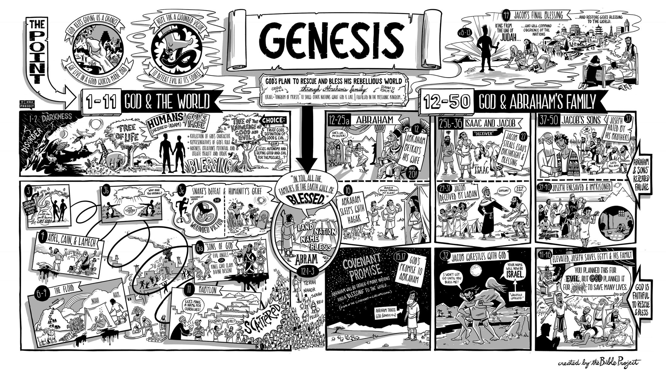
“As for you”
⁹ Then God said to Abraham, “As for you, you must keep my covenant, you and your descendants after you for the generations to come. ¹⁰ This is my covenant with you and your descendants after you, the covenant you are to keep: Every male among you shall be circumcised. ¹¹ You are to undergo circumcision, and it will be the sign of the covenant between me and you. ¹² For the generations to come every male among you who is eight days old must be circumcised, including those born in your household or bought with money from a foreigner—those who are not your offspring. ¹³ Whether born in your household or bought with your money, they must be circumcised. My covenant in your flesh is to be an everlasting covenant. ¹⁴ Any uncircumcised male, who has not been circumcised in the flesh, will be cut off from his people; he has broken my covenant.”
¹⁵ God also said to Abraham, “As for Sarai your wife, you are no longer to call her Sarai; her name will be Sarah. ¹⁶ I will bless her and will surely give you a son by her. I will bless her so that she will be the mother of nations; kings of peoples will come from her.”
Genesis 17:9-16

1) Abraham’s “obligation” is summarized: walk blameless in God’s presence, expanded in the Ten Words

2) Abraham’s laughter gets us ready for Isaac and illustrates the limits of faith (Sailhammer, 139-140)

3) Circumcision reminds Abraham of blood, of separation, and of the way sin is transmitted

4) Covennt principle #3: The “sign” identifies me with the promises of covenant (see baptism!)

More lessons with Abraham

1) Abraham remembered kindergarten – he obeyed “that very day”

²³ On that very day Abraham took his son Ishmael and all those born in his household or bought with his money, every male in his household, and circumcised them, as God told him. ²⁴ Abraham was ninety-nine years old when he was circumcised, ²⁵ and his son Ishmael was thirteen; ²⁶ Abraham and his son Ishmael were both circumcised on that same day. ²⁷ And every male in Abraham’s household, including those born in his household or bought from a foreigner, was circumcised with him.
Genesis 17

2) We identify outwardly with God’s covenant through baptism
⁹ For in Christ all the fullness of the Deity lives in bodily form, ¹⁰ and you have been given fullness in Christ, who is the head over every power and authority. ¹¹ In him you were also circumcised, in the putting off of the sinful nature, not with a circumcision done by the hands of men but with the circumcision done by Christ, ¹² having been buried with him in baptism and raised with him through your faith in the power of God, who raised him from the dead.
Colossians 2

3) It really does matter that Abraham believed first, then was circumcised

⁹ Is this blessedness only for the circumcised, or also for the uncircumcised? We have been saying that Abraham’s faith was credited to him as righteousness. ¹⁰ Under what circumstances was it credited? Was it after he was circumcised, or before? It was not after, but before! ¹¹ And he received the sign of circumcision, a seal of the righteousness that he had by faith while he was still uncircumcised. So then, he is the father of all who believe but have not been circumcised, in order that righteousness might be credited to them. ¹² And he is also the father of the circumcised who not only are circumcised but who also walk in the footsteps of the faith that our father Abraham had before he was circumcised.
Romans 4:9-12 (Paul has just quoted the “blessed are they” passage in Psalm 32)

4) It’s not election that gets you blessed it’s living in covenant!

¹⁹ Then God said, “Yes, but your wife Sarah will bear you a son, and you will call him Isaac. I will establish my covenant with him as an everlasting covenant for his descendants after him. ²⁰ And as for Ishmael, I have heard you: I will surely bless him; I will make him fruitful . . . .”
Genesis 17:19-20

Resources for further studies of Genesis 12-25
The Bible Project team has a great video, https://www.youtube.com/watch?v=F4isSyennFo, and poster and study for Genesis at https://bibleproject.com/learn/genesis-12-50/
Spurgeon has several good sermons for Genesis 17; I like Spurgeon’s “Triumph of Faith” at http://www.spurgeongems.org/vols16-18/chs1082.pdf
I like Sailhammer’s commentary in the Expositor’s Bible Commentary (Zondervan, 1990); Bruce Waltke’s newer commentary Genesis (Zondervan, 2001); and Leupold’s commentary on Genesis available online at https://www.ccel.org/ccel/leupold/genesis.xiv.html
monergism.com has a series of articles on Paul’s thoughts on Abraham in Galatians 3 and Romans:
John Davis at http://www.etsjets.org/files/JETS-PDFs/19/19-3/19-3-pp201-208_JETS.pdf
Moise Silve at http://files1.wts.edu/uploads/pdf/publications/wtj/silva-fall-01.pdf
Bob Deffinbaugh has a good series on Abraham. This week at https://bible.org/seriespage/grasping-great-truth-god-genesis-171-27
Third Mill has good stuff:
Ligon Duncan’s excellent intro to covenants at https://thirdmill.org/magazine/article.
asp/link/jl_duncan%5Ejl_duncan.CT001.html/at/Covenant%20Theology
three videos on Abraham at https://thirdmill.org/seminary/course.asp/vs/FA
Alexander Maclaren has a good series on Abraham at https://www.ccel.org/ccel/maclaren/gen_num.ii.i.xi.html
Charles Biggs I “Reformed Perspectives” at http://reformedperspectives.org/newfiles/cr_biggs/OT.Biggs.Genesis.15.ourcovenantgod_10.27.03.html
Good article on Galatians 3 and our connection to Abraham
John Davis at http://www.etsjets.org/files/JETS-PDFs/19/19-3/19-3-pp201-208_JETS.pdf
Kim Riddlebarger at https://kimriddlebarger.squarespace.com/an-exposition-of-galatians/Does%20the%20Promise%20Come%20by%20Faith%20or%20Works%204.pdf
and Third Mill at
http://www.thirdmill.org/files/english/lay_people_speak/16331~3_9_99_5-22-34_PM~McL.gal3.ps.pdf

The Abraham Cycle (Waltke, p. 20)

A Genealogy of Terah, 11:27-32
B Promise of a son and start of Abraham’s spiritual odyssey, 12:1-9
C Abram lies about Sarai; the Lord protects her in a foreign palace, 12:10-20
D Lot settles in Sodom, 13:1-18
E Abraham intercedes for Sodom and Lot militarily, 14:1-24
F Covenant with Abraham; annunciation of Ishmael, 15:1-16:16
F` Covenant with Abraham; annunciation of Isaak, 17:1-18:15
E` Abraham intercedes for Sodom and Lot in prayer, 18:16-33
D` Lot flees doomed Sodom and settles in Moab, 19:1-38
C` Abraham lies about Sarah; God protects her in a foreign palace, 20:1-18
B` Birth of son and climax of Abraham’s spiritual odyssey, 21:1-22:19
A` Genealogy of Nahor, 22:20-24
Sailhammer (Expositor’s Bible Commentary) on Abraham’s laughter
17–18 Abraham’s response to God’s promise is not what the reader would expect: “Abraham fell facedown” and “laughed” (wayyishāq v.17a). In light of the author’s portrayal of Abraham thus far in Genesis (e.g., 15:6), it does not seem likely that his laughter is intended to point to a lack of faith—although one must admit that the text itself leaves that impression. However, without commenting directly on Abraham’s surprising reaction to God’s promise, the author allows Abraham’s own words in v.17b to uncover the motivation behind his laughter—“Will a son be born to a man a hundred years old? Will Sarah bear a child at the age of ninety?”—leaving a final verdict on the nature of his laughter somewhat in the lurch.
In 18:12, when Sarah also responded to God’s promise with laughter, the author shows that her laughter was met with divine disapproval: “Then the Lord said, “Why did Sarah laugh?’ ” The absence of such a rebuke of Abraham’s laughter here in chapter 17 suggests that his laughter does not so much reflect a total lack of faith as it does a limitation of his faith in what God must do to fulfill his promise. Abraham is not depicted here as one whose faith in God has reached full maturity; rather he is one whose faith must still be pushed beyond its present limits. His faith must grow if he is to continue to put his trust in God’s promise. In any event, one clear purpose of the author in including the note about Abraham’s laughter can be seen in the fact that the Hebrew expression “he laughed” (wayyiṣḥāq v.17) foreshadows the name “Isaac” (yiṣḥāq).
The irony of Abraham’s response is evident. Even in his surprising response of laughter in the face of God’s promise, Abraham’s laughter became a verbal sign marking the ultimate fulfillment of the promise in Isaac. Throughout the remainder of the narratives surrounding the birth of Isaac (yiṣhāq), a key word within each major section is “laughter” (ṣāḥaq). Sarah “laughed” (wattiṣḥaq, 18:12); Lot’s sons-in-law laughed (ḵimṣaḥēq, 19:14; NIV, “[thought he was] joking”); all who heard of Sarah’s birth to Isaac would “laugh” (yiṣḥāq, 21:6); the son of Hagar laughed (m^{e}ṣaḥēq, 21:9b; NIV, “was mocking”) at Isaac. Finally, Isaac’s own failure to trust in God (26:7) was uncovered when the Philistine king saw him “laughing” (m^{e}ṣahēq, 26:8b; NIV, “caressing”) with Rebekah. Thus, for the author of the book, both the power of God and the limitations of human faith are embodied in that most ambiguous of human acts, laughter.
For the first time the name “Abraham,” rather than “Abram,” is used as the subject of a verb: “Abraham fell facedown; he laughed” (v.17; cf. v.3). The author’s irony can be seen in the fact that Abraham was laughing at the very thing that his new name was intended to mark: “You will be the father of many nations” (v.4b).

Sailhamer, J. H. (1990). Genesis. In F. E. Gaebelein (Ed.), The Expositor’s Bible Commentary: Genesis, Exodus, Leviticus, Numbers (Vol. 2, pp. 139–140). Grand Rapids, MI: Zondervan Publishing House.

