Signs of the Covenant
Abraham in 2021: Genesis 15 January 10, 2021
Abraham believed the Lord, and he credited it to him as righteousness.
Genesis 15:6

Joining Abraham in First Grade
What then shall we say that Abraham, our forefather, discovered in this matter? ² If, in fact, Abraham was justified by works, he had something to boast about—but not before God. ³ What does the Scripture say? “Abraham believed God, and it was credited to him as righteousness.”
Romans 4:1 (see also Hebrews 11:11-12, and Romans 1:16-17 quoting from Habakkuk 2:4)

1) Paul begins his study of faith where the Old Testament begins the story of faith, with Abraham

2) In the Old Testament, righteousness is more ethical – Deuteronomy 6:25; Job 27:6; but see Job 33:26

3) In the New Testament, righteousness is more relational – Matthew 1:19; Galatians 3:11; 1 Peter 3:18

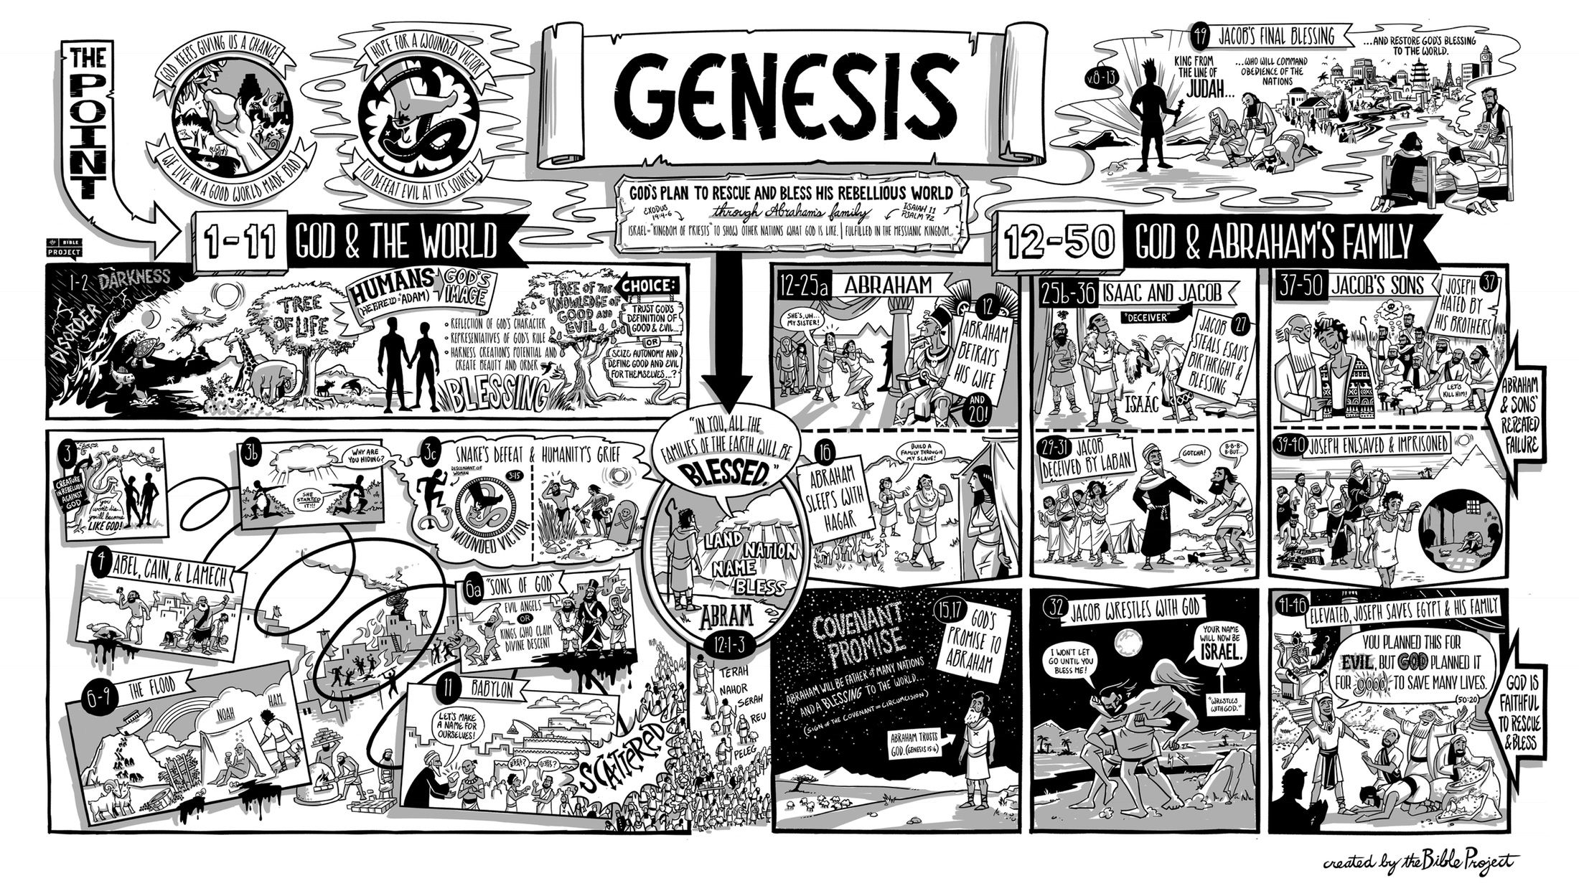
The promise of Sonship
² But Abram said, “O Sovereign Lord, what can you give me since I remain childless and the one who will inherit my estate is Eliezer of Damascus?” ³ And Abram said, “You have given me no children; so a servant in my household will be my heir.”
⁴ Then the word of the Lord came to him: “This man will not be your heir, but a son coming from your own body will be your heir.” ⁵ He took him outside and said, “Look up at the heavens and count the stars—if indeed you can count them.” Then he said to him, “So shall your offspring be.”
⁶ Abram believed the Lord, and he credited it to him as righteousness.
Genesis 15:1

1) Watch for how Abram’s solutions are not going to be God’s solutions

2) God’s promise is about one Son and about many children

The core of the Covenant: A promise in blood
⁷ He also said to him, “I am the Lord, who brought you out of Ur of the Chaldeans to give you this land to take possession of it.”
⁸ But Abram said, “O Sovereign Lord, how can I know that I will gain possession of it?”
⁹ So the Lord said to him, “Bring me a heifer, a goat and a ram, each three years old, along with a dove and a young pigeon.”
¹⁰ Abram brought all these to him, cut them in two and arranged the halves opposite each other; the birds, however, he did not cut in half. ¹¹ Then birds of prey came down on the carcasses, but Abram drove them away.
¹² As the sun was setting, Abram fell into a deep sleep, and a thick and dreadful darkness came over him. ¹³ Then the Lord said to him, “Know for certain that your descendants will be strangers in a country not their own, and they will be enslaved and mistreated four hundred years. ¹⁴ But I will punish the nation they serve as slaves, and afterward they will come out with great possessions. ¹⁵ You, however, will go to your fathers in peace and be buried at a good old age. ¹⁶ In the fourth generation your descendants will come back here, for the sin of the Amorites has not yet reached its full measure.”
¹⁷ When the sun had set and darkness had fallen, a smoking firepot with a blazing torch appeared and passed between the pieces. ¹⁸ On that day the Lord made a covenant with Abram . . . .
Genesis 15:7-17

1) Covenant principle #2: A covenant is a promise in _____________________________________

2) The logic taught in God’s story of redemption is substitution – who is taking my place?

3) Abraham participates by bringing an offering, then going to sleep

4) The unexpected ending of this covenant renewal: God takes the curse on himself!

Second lessons from Abraham

1) Adiaphora: a short look at chronology and geography

^{16 “}In the fourth generation your descendents will come back here, for the sin of the Amorites has not yet reached its full measure.”
^{18 “}To your descendants I give this land, from the river of Egypt to the great river, the Euphrates . . . .”
Genesis 15

2) Abraham’s very bad day (or, “the people that you meet”)
After this, the word of the Lord came to Abram in a vision: “Do not be afraid Abram. I am your shield, your very great reward.”
Genesis 15:1

3) Assurance: For Abraham, it was the land for us, the Holy Spirit (remember Acts 2:38-39; Galatians 3)

¹⁶ Therefore, the promise comes by faith, so that it may be by grace and may be guaranteed to all Abraham’s offspring—not only to those who are of the law but also to those who are of the faith of Abraham. He is the father of us all. ¹⁷ As it is written: “I have made you a father of many nations.” He is our father in the sight of God, in whom he believed—the God who gives life to the dead and calls things that are not as though they were . . . .

Romans 4:16-17

4) Righteousness means justification: “God has the power to do what he had promised”

¹⁸ Against all hope, Abraham in hope believed and so became the father of many nations, just as it had been said to him, “So shall your offspring be.” ¹⁹ Without weakening in his faith, he faced the fact that his body was as good as dead—since he was about a hundred years old—and that Sarah’s womb was also dead. ²⁰ Yet he did not waver through unbelief regarding the promise of God, but was strengthened in his faith and gave glory to God, ²¹ being fully persuaded that God had power to do what he had promised. ²² This is why “it was credited to him as righteousness.” ²³ The words “it was credited to him” were written not for him alone, ²⁴ but also for us, to whom God will credit righteousness—for us who believe in him who raised Jesus our Lord from the dead. ²⁵ He was delivered over to death for our sins and was raised to life for our justification.
Romans 4:18-25

Resources for further studies of Genesis 12-25
The Bible Project team has a great video, https://www.youtube.com/watch?v=F4isSyennFo, and poster and study for Genesis at https://bibleproject.com/learn/genesis-12-50/
Spurgeon has several good sermons:
-- for Genesis 15, I like Spurgeon’s “Justification by Faith” at http://www.spurgeongems.org/vols13-15/chs844.pdf
-- for Genesis 12, I likw “Abraham as an Example for Believers” at http://www.spurgeongems.org/vols37-39/chs2292.pdf and a wonderful theological introduction to Abram’s call (with intriguing references to Bunyan) at www.spurgeongems.org/vols13-15/chs843.pdf
I like Sailhammer’s commentary in the Expositor’s Bible Commentary (Zondervan, 1990); Bruce Waltke’s newer commentary Genesis (Zondervan, 2001); and Leupold’s commentary on Genesis available online at https://www.ccel.org/ccel/leupold/genesis.xiv.html
monergism.com has a series of articles on Paul’s thoughts on Abraham in Galatians 3 and Romans:
John Davis at http://www.etsjets.org/files/JETS-PDFs/19/19-3/19-3-pp201-208_JETS.pdf
Moise Silve at http://files1.wts.edu/uploads/pdf/publications/wtj/silva-fall-01.pdf
Third Mill has good stuff:
Ligon Duncan’s excellent intro to covenants at https://thirdmill.org/magazine/article.
asp/link/jl_duncan%5Ejl_duncan.CT001.html/at/Covenant%20Theology
three videos on Abraham at https://thirdmill.org/seminary/course.asp/vs/FA
Alexander Maclaren has a good series on Abraham at https://www.ccel.org/ccel/maclaren/gen_num.ii.i.xi.html
Charles Biggs I “Reformed Perspectives” at http://reformedperspectives.org/newfiles/cr_biggs/OT.Biggs.Genesis.15.ourcovenantgod_10.27.03.html
Good article on Galatians 3 and our connection to Abraham
John Davis at http://www.etsjets.org/files/JETS-PDFs/19/19-3/19-3-pp201-208_JETS.pdf
Kim Riddlebarger at https://kimriddlebarger.squarespace.com/an-exposition-of-galatians/Does%20the%20Promise%20Come%20by%20Faith%20or%20Works%204.pdf
and Third Mill at
http://www.thirdmill.org/files/english/lay_people_speak/16331~3_9_99_5-22-34_PM~McL.gal3.ps.pdf

The Abraham Cycle (Waltke, p. 20)

A Genealogy of Terah, 11:27-32
B Promise of a son and start of Abraham’s spiritual odyssey, 12:1-9
C Abram lies about Sarai; the Lord protects her in a foreign palace, 12:10-20
D Lot settles in Sodom, 13:1-18
E Abraham intercedes for Sodom and Lot militarily, 14:1-24
F Covenant with Abraham; annunciation of Ishmael, 15:1-16:16
F` Covenant with Abraham; annunciation of Isaak, 17:1-18:15
E` Abraham intercedes for Sodom and Lot in prayer, 18:16-33
D` Lot flees doomed Sodom and settles in Moab, 19:1-38
C` Abraham lies about Sarah; God protects her in a foreign palace, 20:1-18
B` Birth of son and climax of Abraham’s spiritual odyssey, 21:1-22:19
A` Genealogy of Nahor, 22:20-24

