Leaving and Believing
Abraham in 2021: Genesis 12:1-9 January 3, 2021
The Lord had said to Abram, “Leave your country, your people, and your father’s
household and go to the land that I will show you.”
Genesis 12:1

Terah’s place in the Line of the Promise
This is the account of Terah. Terah became the father of Abram, Nahor and Haran . . . . Now Sarai was barren; she had no children.
Terah took his sons Abram, his grandson Lot son of Haran, and his daughter-in-law Sarai . . . and together they set out from Ur of the Chaldeans to go to Canaan. But when they came to Haran, they settled there. Terah lived 205 years, and he died in Canaan.
Genesis 11:27-32 (see also Joshua 24)

1) The is the final “new start” before ___________________________________ !

2) This is the “hinge” account (Terah both ends and begins), but note: the “son of the promise” is missing

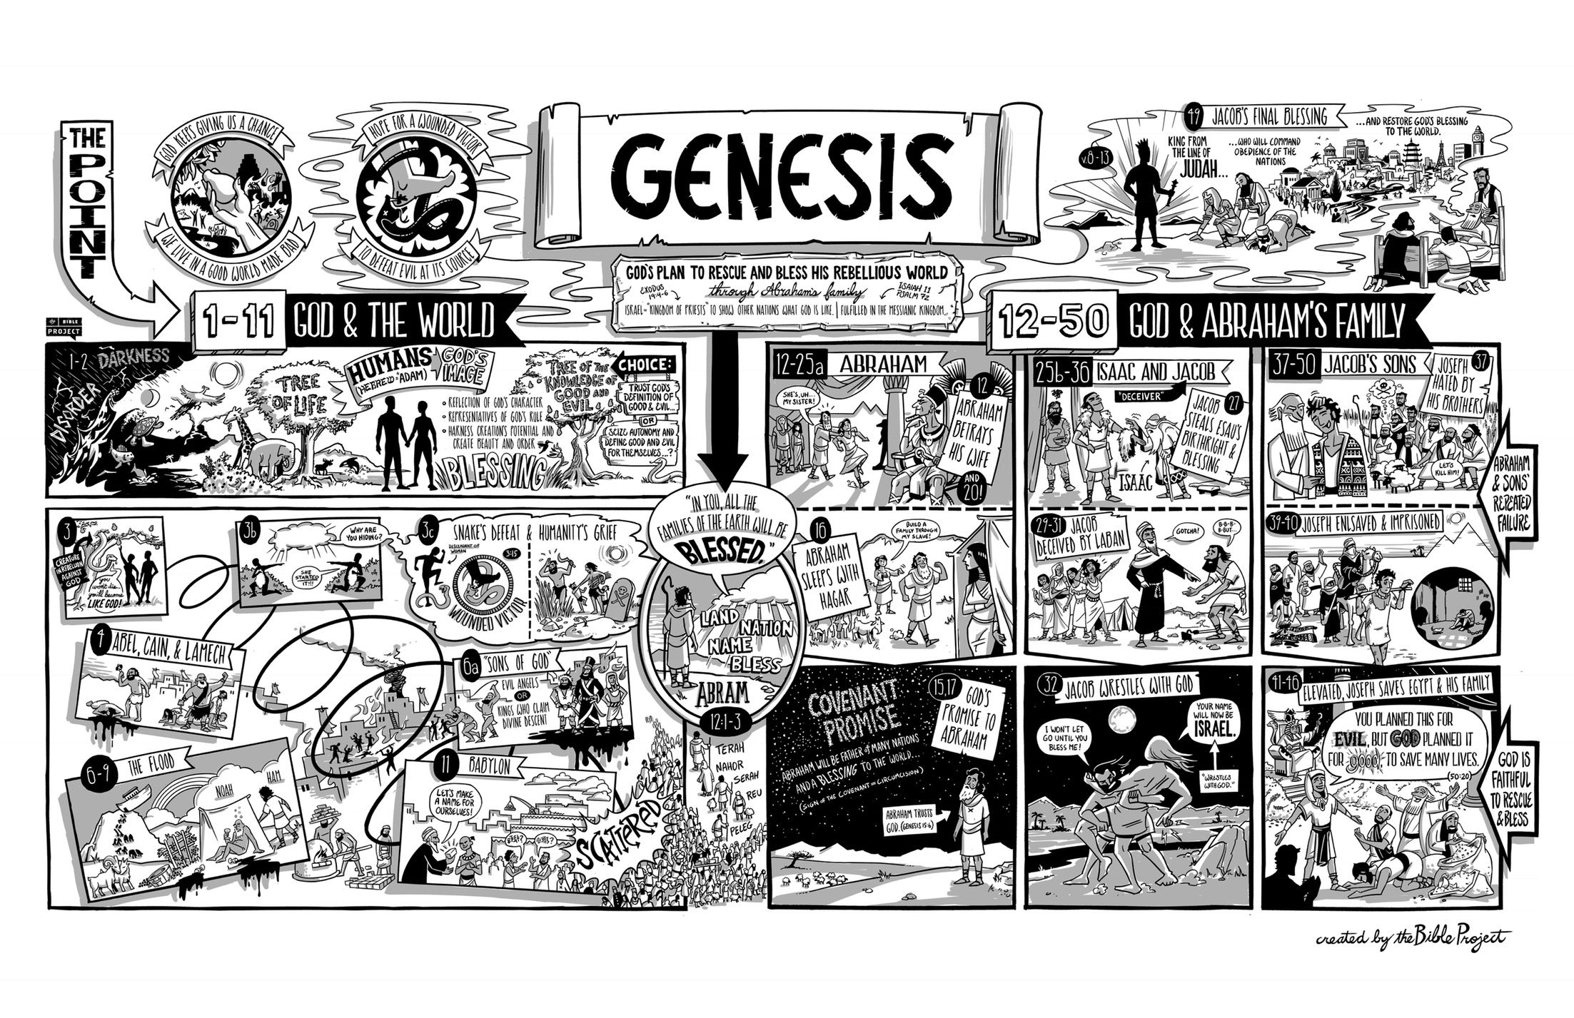
The
The Lord had said to Abram, “Leave your country, your people and your father’s household and go
to the land I will show you.
1 וַיֹּ֤אמֶר יְהוָה֙ אֶל־אַבְרָ֔ם לֶךְ־לְךָ֛ מֵאַרְצְךָ֥ וּמִמּֽוֹלַדְתְּךָ֖ וּמִבֵּ֣ית אָבִ֑יךָ אֶל־הָאָ֖רֶץ אֲשֶׁ֥ר אַרְאֶֽךָּ׃
Genesis 12:1

1) Abram had to leave “his” to enter God’s promise

2) “The land” (ha ‘aretz) reflects Abram’s past and God’s future

3) God takes the initiative in Abram’s call (see the title of Spurgeon’s sermon #843!)

It’s all about covenant
² “I will make you into a great nation
and I will bless you;
I will make your name great,
and you will be a blessing.
³ I will bless those who bless you,
and whoever curses you I will curse;
and all peoples on earth
will be blessed through you.”
Abram traveled through the land . . . . At that time the Canaanites were in the land. The Lord appeared to Abram and said, “To your offspring I will give this land.” So he [Abram] built an altar there to the Lord, who had appeared to him.
Genesis 12:2-7

1) These are the words of promise: nation, blessing, name

2) “Nation” and “name” require offspring (or, Paul will note in Galatians 3:16, “the” offspring!)

3) Note the priority of blessing (even over “land”)

4) Covenant Principle #1: Even unconditional covenants require a response

First lessons from Abraham

1) God’s work can start in strange places

² Joshua said to all the people, “This is what the Lord, the God of Israel, says: ‘Long ago your forefathers, including Terah the father of Abraham and Nahor, lived beyond the River and worshiped other gods. ³ But I took your father Abraham from the land beyond the River and led him throughout Canaan and gave him many descendants . . . .
Joshua 24

2) Abraham is also the father of those who respond in obedience
⁴ So Abram left, as the Lord had told him; and Lot went with him. Abram was seventy-five years old when he set out from Haran.
Genesis 12:4 (see also Genesis 22:3; Hebrews 11:8; James 2:14-26)

3) Looking forward to the Good News!

You foolish Galatians! Who has bewitched you? Before your very eyes Jesus Christ was clearly portrayed as crucified. ² I would like to learn just one thing from you: Did you receive the Spirit by observing the law, or by believing what you heard? ³ Are you so foolish? After beginning with the Spirit, are you now trying to attain your goal by human effort? ⁴ Have you suffered so much for nothing—if it really was for nothing? ⁵ Does God give you his Spirit and work miracles among you because you observe the law, or because you believe what you heard?
⁶ Consider Abraham: “He believed God, and it was credited to him as righteousness.” ⁷ Understand, then, that those who believe are children of Abraham. ⁸ The Scripture foresaw that God would justify the Gentiles by faith, and announced the gospel in advance to Abraham: “All nations will be blessed through you.” ⁹ So those who have faith are blessed along with Abraham, the man of faith.

Galatians 3 (see Romans 4:13-25)

4) Welcome to the family

²⁶ You are all sons of God through faith in Christ Jesus, ²⁷ for all of you who were baptized into Christ have clothed yourselves with Christ. ²⁸ There is neither Jew nor Greek, slave nor free, male nor female, for you are all one in Christ Jesus. ²⁹ If you belong to Christ, then you are Abraham’s seed, and heirs according to the promise.
Galatians 3:26-29

Resources for further studies of Genesis 12-25
The Bible Project team has a great video, https://www.youtube.com/watch?v=F4isSyennFo, and poster and study for Genesis at https://bibleproject.com/learn/genesis-12-50/
Spurgeon has several good sermons:
“Abraham as an Example for Believers” at http://www.spurgeongems.org/vols37-39/chs2292.pdf
and a wonderful theological introduction to Abram’s call (with intriguing references to Bunyan)
at www.spurgeongems.org/vols13-15/chs843.pdf
I like Sailhammer’s commentary in the Expositor’s Bible Commentary (Zondervan, 1990); Bruce Waltke’s newer commentary Genesis (Zondervan, 2001); and Leupold’s commentary on Genesis available online at https://www.ccel.org/ccel/leupold/genesis.xiv.html
monergism.com has a series of articles on Paul’s thoughts on Abraham in Galatians 3 and Romans:
John Davis at http://www.etsjets.org/files/JETS-PDFs/19/19-3/19-3-pp201-208_JETS.pdf
Moise Silve at http://files1.wts.edu/uploads/pdf/publications/wtj/silva-fall-01.pdf
Third Mill has good stuff:
Ligon Duncan’s excellent intro to covenants at https://thirdmill.org/magazine/article.
asp/link/jl_duncan%5Ejl_duncan.CT001.html/at/Covenant%20Theology
three videos on Abraham at https://thirdmill.org/seminary/course.asp/vs/FA
Alexander Maclaren has a good series on Abraham at https://www.ccel.org/ccel/maclaren/gen_num.ii.i.xi.html
Good article on Galatians 3 and our connection to Abraham
John Davis at http://www.etsjets.org/files/JETS-PDFs/19/19-3/19-3-pp201-208_JETS.pdf
Kim Riddlebarger at https://kimriddlebarger.squarespace.com/an-exposition-of-galatians/Does%20the%20Promise%20Come%20by%20Faith%20or%20Works%204.pdf
and Third Mill at
http://www.thirdmill.org/files/english/lay_people_speak/16331~3_9_99_5-22-34_PM~McL.gal3.ps.pdf

