Bethlehem: A Tale of Two Kings
Advent 2020, Third Sunday: Micah 5 December 13, 2020
When [Herod] had called together all the people’s chief priests and teachers
of the law, he asked them where the Christ was to be born.
“In Bethlehem in Judea,” they replied, “for this is what the prophet has written:
“’But you, Bethlehem, in the land of Judah, are by no means least among the rulers
of Judah; for out of you will come a ruler who will be the shepherd of my people Israel.’”
Matthew 2:3-6, quoting from Micah 5:2

Walking between two Testaments
² “But you, Bethlehem Ephrathah,
though you are small among the clans of Judah,
out of you will come for me one who will be ruler over Israel,
whose origins are from of old, from ancient times.
Micah 5:2 (in the tradition of Genesis 48:1-7; 1 Samuel 16:1; Ruth 1:1. 4:11)

After Jesus was born in Bethlehem in Judea, during the time of King Herod, Magi from the east came to Jerusalem ² and asked, “Where is the one who has been born king of the Jews? We saw his star in the east and have come to worship him.”
³ When King Herod heard this he was disturbed, and all Jerusalem with him. ⁴ When he had called together all the people’s chief priests and teachers of the law, he asked them where the Christ was to be born. ⁵ “In Bethlehem in Judea,” they replied, “for this is what the prophet has written:
⁶ “ ‘But you, Bethlehem, in the land of Judah, are by no means least among the rulers of Judah;
for out of you will come a ruler who will be the shepherd of my people Israel.’”
⁷ Then Herod called the Magi secretly and found out from them the exact time the star had appeared. ⁸ He sent them to Bethlehem and said, “Go and make a careful search for the child. As soon as you find him, report to me, so that I too may go and worship him.”
⁹ After they had heard the king, they went on their way, and the star they had seen in the east went ahead of them until it stopped over the place where the child was. ¹⁰ When they saw the star, they were overjoyed. ¹¹ On coming to the house, they saw the child with his mother Mary, and they bowed down and worshiped him. Then they opened their treasures and presented him with gifts of gold and of incense and of myrrh. ¹² And having been warned in a dream not to go back to Herod, they returned to their country by another route.
Matthew 2 (see also the opening verses of Luke 2)

1) Bethlehem has been a “destination” since Genesis 35:16

2) The enemies may change, but the search continues for a king to deliver us

3) Both Matthew and Micah set up a battle between two kingdoms (back to Daniel 2 and 7)

Doing biblical theology
Marshal your troops, O city of troops, for a siege is laid against us.
They will strike Israel’s ruler on the cheek with a rod.
² “But you, Bethlehem Ephrathah,
though you are small among the clans of Judah,
out of you will come for me one who will be ruler over Israel,
whose origins are from of old, from ancient times.”
³ Therefore Israel will be abandoned
until the time when she who is in labor gives birth
and the rest of his brothers return to join the Israelites.
⁴ He will stand and shepherd his flock
in the strength of the Lord,
in the majesty of the name of the Lord his God.
And they will live securely,
for then his greatness will reach to the ends of the earth.
⁵ And he will be their peace.
When the Assyrian invades our land . . . .
Micah 5:1-5

1) Micah tells the story of God’s judgement and deliverance (this is the second cycle)

2) God’s voice distinguishes the first ruler of Israel with the future Ruler whose origin is divine

3) There will be a King whose reign will end in true peace (see Isaiah 9; Luke 2; Romans 5)

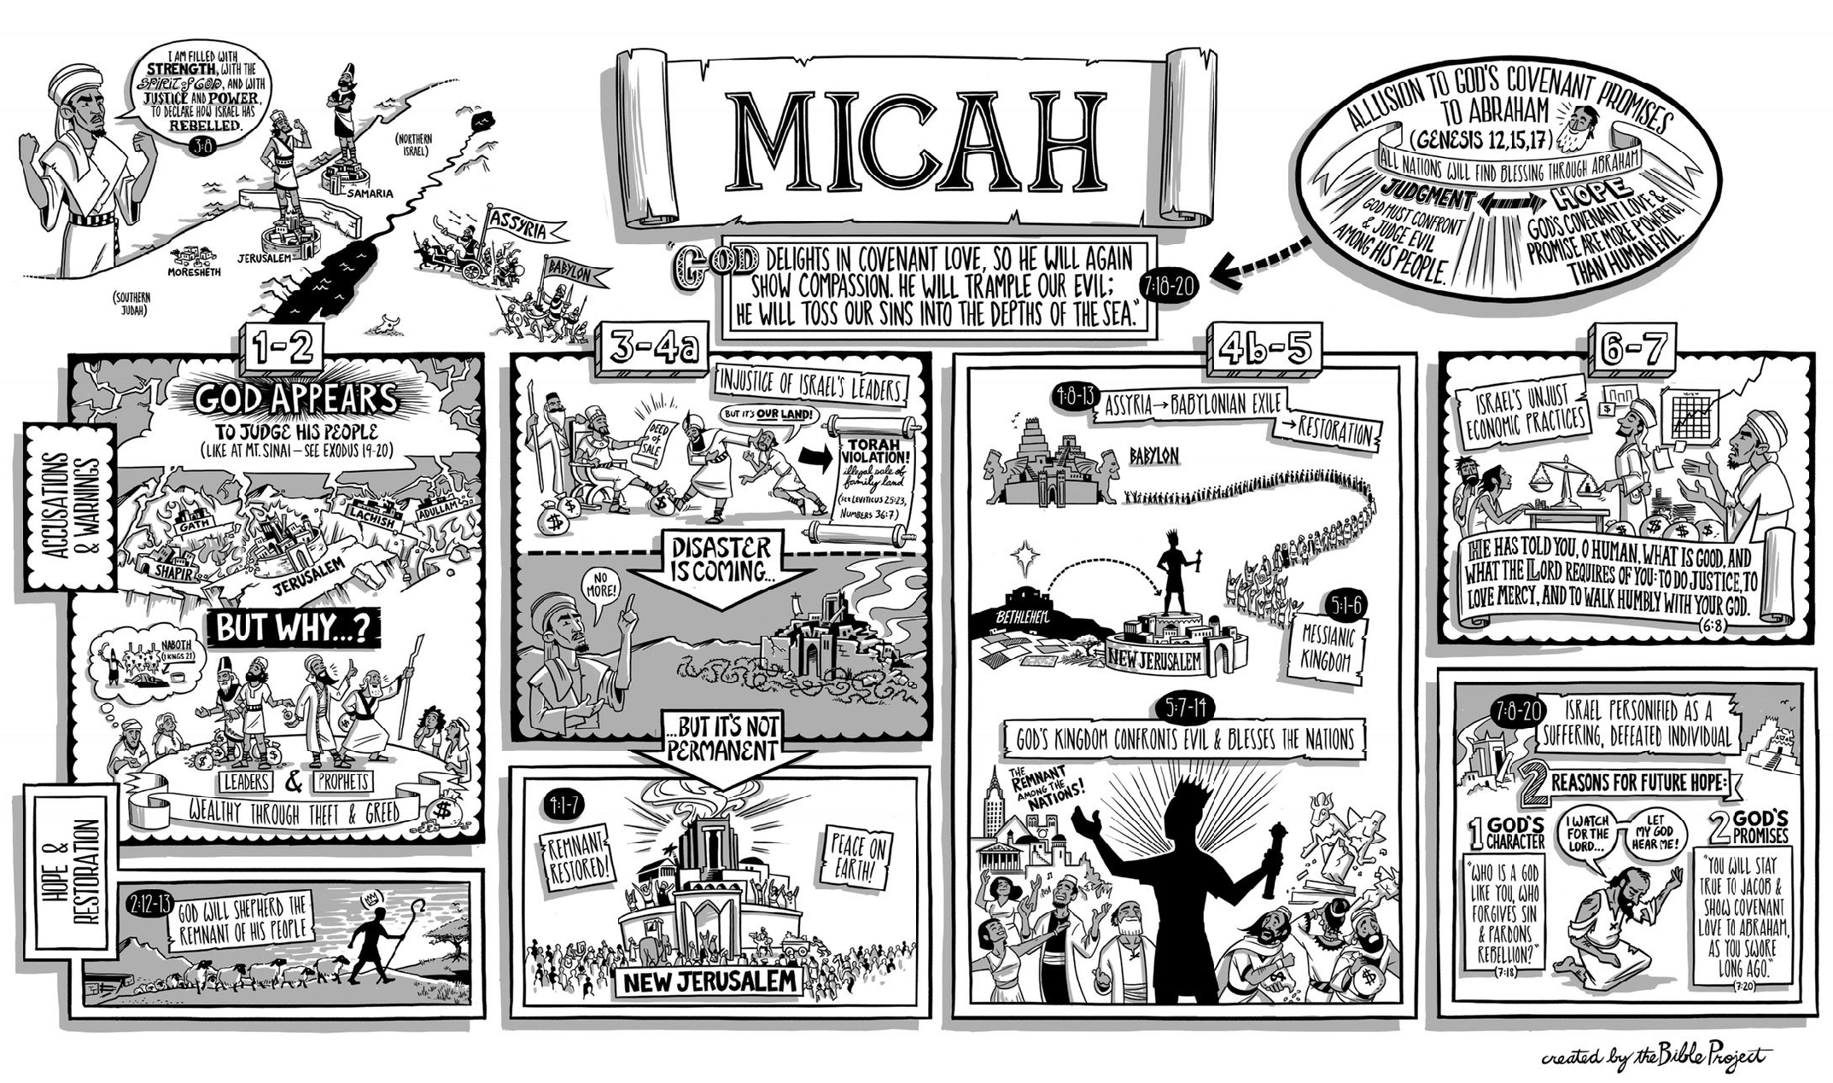
Learning from Bethlehem

1) Don’t watch Jerusalem for the arrival of the King

¹¹ Then the elders and all those at the gate said, “We are witnesses. May the Lord make the woman who is coming into your home like Rachel and Leah, who together built up the house of Israel. May you have standing in Ephrathah and be famous in Bethlehem. ¹² Through the offspring the Lord gives you by this young woman, may your family be like that of Perez, whom Tamar bore to Judah.” ¹³ So Boaz took Ruth and she became his wife.
Ruth 4, “the woman” is Ruth!

2) Bethlehem still matters (because we still have Assyrians at the gates)

We are a community of evangelical Christians who believe that following Jesus with integrity means that our lives are formed by our love for God, the teaching of the Bible and a fearless life of discipleship in the complexities of the Israeli-Palestinian conflict. We believe that one of the first hallmarks of discipleship is love for both our own community and for our enemies. We wish to find Jesus at the center of everything we do and to make his life our life. Which means finding courageous love for Palestinian Arabs and Israeli Jews alike.
Bethlehem Bible College mission statement for their Christ at the Checkpoint conference

3) History doesn’t have all the answers

In those days Caesar Augustus issued a decree that a census should be taken of the entire Roman world. ² (This was the first census that took place while Quirinius was governor of Syria.) ³ And everyone went to his own town to register.
⁴ So Joseph also went up from the town of Nazareth in Galilee to Judea, to Bethlehem the town of David, because he belonged to the house and line of David.
Luke 2

4 ) Final peace won’t be achieved until the final King arrives

⁶ For to us a child is born, to us a son is given;
and the government shall be upon his shoulder,
and his name shall be called
Wonderful Counselor, Mighty God,
Everlasting Father, Prince of Peace.
Isaiah 9:6

Resources for further studies of Micah 5 and Bethlehem
The Bible Project team has a video and poster at https://www.youtube.com/watch?v=MFEUEcylwLc
Spurgeon has two sermons on this passage at https://www.biblebb.com/brefindex/mic.htm
Jonty Rhodes writes on the Micah 5 prophecy (attached below) at https://tabletalkmagazine.com/article/2018/12/a-ruler-from-bethlehem/
John Piper has a good Micah 5 sermon at https://www.desiringgod.org/messages/from-little-bethlehem-will-come-a-ruler-in-israel
D. K. Innes has a good study of Micah 5 at http://www.biblicalstudies.org.uk/pdf/eq/1969-3_169.pdf
For the “historical Jesus” study, I recommend Geza Vermes’ Jesus the Jew: A Historian’s Reading of the Gospels (Fortress Press, 1973) and the work of John Dominic Crossan, The First Christmas: What the Gospels Really Teach About Jesus’ Birth (Harper One, 2007) and Jesus: A Revolutionary Biography (Harper One, 1994).

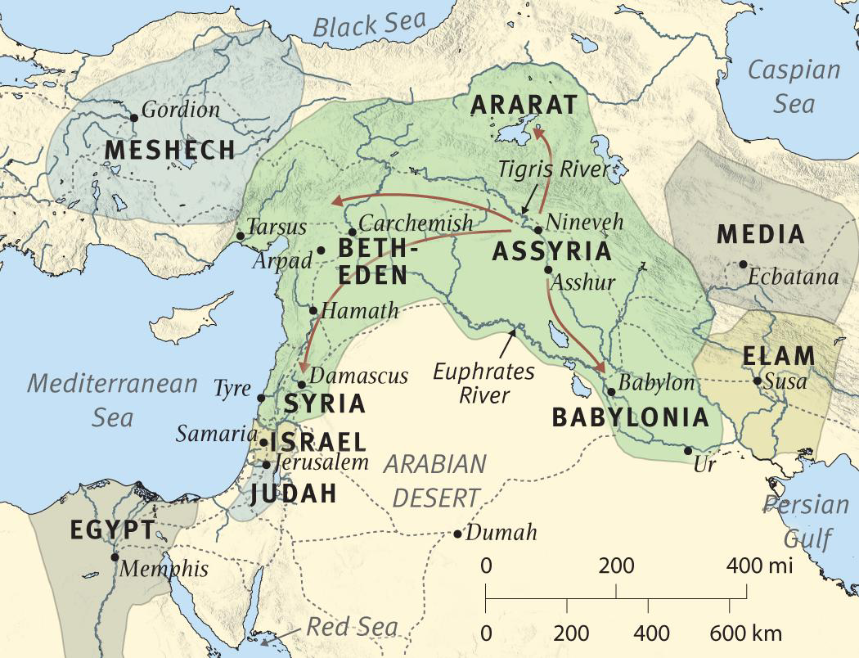

The world during the time of Micah, sometime between 750 and 686 BC

A Ruler from Bethlehem
by Jonty Rhodes at https://tabletalkmagazine.com/article/2018/12/a-ruler-from-bethlehem/
According to legend, King Arthur lies on the mystical island of Avalon, waiting to return to rescue Britain at her hour of greatest need. One day, the darkest of days, Britain’s “Once and Future King” will appear. Arthur is, of course, mythological. But the prophet Micah knew of a true king whose origins were “from of old” and who would come unexpectedly to rescue his people.
Micah, a contemporary of Isaiah, spoke God’s word to Israel at a time of great danger. Due to the sin of both Samaria (the northern kingdom of Israel) and Judah (the southern kingdom), the Israelites would suffer a devastating attack. The mighty Assyrian empire would sweep in and conquer God’s people—Samaria would be left as “a heap in the open country” (Micah 1:6) and disaster would even come “to the gate of Jerusalem” (v. 12). Much of the blame rested on the leaders of Israel.
These rulers, far from protecting and providing for their people, had become cannibal-like, killing and devouring. They “eat the flesh of my people, and flay their skin from off them, and break their bones in pieces and chop them up like meat in a pot, like flesh in a cauldron” (3:3). No wonder that years later the prophet Jeremiah would summarize Micah’s message by quoting one of his most foreboding predictions:
Micah of Moresheth prophesied . . .
“Zion shall be plowed as a field; Jerusalem shall become a heap of ruins, and the mountain of the house a wooded height.” (Jer. 26:18, quoting Micah 3:12)
Into this dark, dangerous world Micah spoke not only words of judgment but of hope. In our verse, this hope centers on a humble place and a heavenly ruler.
Micah is hinting that Jesus’ origins are not just Davidic but divine.
Share

A Humble Place
“But you . . .” begins Micah’s good news. Samaria is rubble, Jerusalem in ruins, but for someone there’s hope. Strangely, that “someone” is not a person but a place: Bethlehem Ephrathah. “From you shall come forth for me one who is to be ruler in Israel.”
Rather than from mighty Jerusalem, the capital of Judah, with its royal palace, the Rescuer-King would come from humble Bethlehem. Bethlehem was nowhere: a small town just to the southwest of Jerusalem. Yet sometime during 700–730 BC, Micah prophesied that this backwater village would be the birthplace of the Messiah.
And so it came to pass. In Matthew’s gospel, we read that “Jesus was born in Bethlehem of Judea in the days of Herod the king” (2:1). In the providence of God, the Roman emperor had issued an order that every citizen was to return to his hometown. And so Mary and Joseph left Nazareth to travel to Bethlehem. The emperor may have been planning a head count, but God was ensuring that His word through Micah would be fulfilled.
Just as in the days of Micah, Israel had a greedy, vicious ruler. Herod the Great would reveal himself to be another “cannibal king” when he commanded the slaughter of all the male children in Bethlehem, and he would father Herod Antipas, who later served up the head of John the Baptist on a platter. But amid the darkness, the king had come. In fact, Micah’s prophecy is quoted when Herod asks the chief priests and scribes where the Christ was supposed to be born. “In Bethlehem of Judea,” they answer, “for so it is written by the prophet” (Matt. 2:5).

A Heavenly Ruler
But Micah tells us more than just the birthplace of this ruler. We also learn of his family origins. This ruler will be one “whose coming forth is from of old, from ancient days.” What is Micah telling us about Christ?
Given that the prophecy is addressed to Bethlehem, it’s likely in the first place that this is an allusion to that town’s most famous son. King David, the founding father of Israel’s kingly line, was born in Bethlehem, many years before Micah’s prophecy. The future ruler would be from this root: Jesus is a descendant of David, the king from of old. He has ancient, royal blood.
But I think Micah is telling us more. Christ’s origins are far older than David, Abraham, or even creation itself. Psalm 74:12 tells us that “God my king is from of old,” using the same expression that Micah uses to describe Christ. Micah is hinting that Jesus’ origins are not just Davidic but divine. He is God the Son, and as God, He has no beginning. He has always existed.
So, far from the corridors of power, Jesus Christ, descended from David through His adoptive father, Joseph, was born in Bethlehem. God Himself came to rule and rescue. He looked unimpressive. His birthplace was inauspicious. But this is always God’s way: through the weak and foolish message of the cross comes rescue from sin—a far greater threat than Micah’s Assyrians. And how fitting that Bethlehem means “house of bread.” An appropriate birthplace for the One who, in stark contrast to Herod and the cannibal kings of Micah’s day, came to feed His people. The Bread of Life, lying in a manger, a feeding trough, in the House of Bread.
Rev. Jonty Rhodes is minister of Christ Church Central Leeds in Leeds, England. He is author of Covenants Made Simple: Understanding God’s Unfolding Promises to His People.

