Walk Worthy
Message #6, Ephesians 4:1-5:14 October 11, 2020

As a prisoner for the Lord, then, I urge you to love a life worthy
of the calling you have received. Be completely humble and gentle;
be patient, bearing with one another in love. Make every effort
to keep the unity of the Spirit through the bond of peace . . . .
Ephesians 4:1-3

Drama for the “New Humanity” (we’ll cover the seventh scene next week)

Scene 1) Ephesians 4:1-6, Walking in unity
As a prisoner for the Lord, then, I urge you to live a life worthy of the calling you have received. ² Be completely humble and gentle; be patient, bearing with one another in love. ³ Make every effort to keep the unity of the Spirit through the bond of peace . . . .

Scene 2) Ephesians 4:17-24, Walking in laying aside and putting on
¹⁷ So I tell you this, and insist on it in the Lord, that you must no longer live as the Gentiles do, in the futility of their thinking. ¹⁸ They are darkened in their understanding and separated from the life of God because of the ignorance that is in them due to the hardening of their hearts. ¹⁹ Having lost all sensitivity, they have given themselves over to sensuality so as to indulge in every kind of impurity, and they are full of greed. ²⁰ That, however, is not the way of life you learned . . ..

Scene 3) Ephesians 4:25-32, Walking in step with the Spirit
²⁵ Therefore each of you must put off falsehood and speak truthfully to your neighbor, for we are all members of one body. ²⁶ “In your anger do not sin”: Do not let the sun go down while you are still angry, ²⁷ and do not give the devil a foothold. ²⁸ Anyone who has been stealing must steal no longer, but must work, doing something useful with their own hands, that they may have something to share with those in need.
²⁹ Do not let any unwholesome talk come out of your mouths, but only what is helpful for building others up according to their needs, that it may benefit those who listen . . . .

Scene 4) Ephesians 5:1-5, Walking in love
Follow God’s example, therefore, as dearly loved children ² and walk in the way of love, just as Christ loved us and gave himself up for us as a fragrant offering and sacrifice to God.
³ But among you there must not be even a hint of sexual immorality, or of any kind of impurity, or of greed, because these are improper for God’s holy people . . . .

Scene 5) Ephesians 5:6-14, Walking in light
⁸ For you were once darkness, but now you are light in the Lord. Live as children of light ⁹ (for the fruit of the light consists in all goodness, righteousness and truth) ¹⁰ and find out what pleases the Lord. ¹¹ Have nothing to do with the fruitless deeds of darkness, but rather expose them . . . .

Scene 6) Ephesians 5:15-21, Walking being filled with the Spirit
¹⁵ Be very careful, then, how you live—not as unwise but as wise, ¹⁶ making the most of every opportunity, because the days are evil. ¹⁷ Therefore do not be foolish, but understand what the Lord’s will is. ¹⁸ Do not get drunk on wine, which leads to debauchery. Instead, be filled with the Spirit . . . .

Elements of a great drama
And God raised us up in Christ and seated us with him in the heavenly realms in Christ Jesus, in order that in the coming ages he might show the incomparable riches of his grace expressed to us in Christ Jesus.
Ephesians 3:2-13

1) Characters: ____________________________________________________

2) Setting: __________________________________________________

3) Plot: _________________________________________________________________________

4) Theme: _______________________________________________________________________

5) Style, Point of View: ______________________________________________________________

Four “reconstruction” questions

1) What does the Author want to teach us about the characters in this drama?

2) What does the Author of this drama want to reveal about the setting of the drama

3) What does the Author teach us about the plot, about our journey as the New Humanity?

4) What does the Author reveal about himself?

Scene 1: Walking in unity
I urge you, therefore,
even I, the bondsman on behalf of the Lord,
to walk in a manner fitting of the calling [or “vocation”] by which you have been called.
with all humility and gentleness
with patience
holding up one another in love
being diligent to preserve the “oneness” of spiritual reality in the shared-bonds of peace
one body and one Spirit
just as also you were called by means of a one hope calling
one Lord, one faith, one baptism,
one God and Father of all,
who is over all, and through all, and in all.
But . . . . [the nature of God is also reflected in our diversity, especially in the gifts given to the church]
Ephesians 4:1-5 (Doug’s expanded translation based on the NASV)

1) We are a people called out of the world and into a journey with “one another”

2) Our shared life reflects “spiritual reality” breaking into the material realms

3) With our attention turned to the “heavenly realms” we cannot neglect our fellow travelers

4) God’s “oneness” (going back ot the shma’ in Deuteronomy 6:4) is reflected in

-- our shared “one another” life and calling (John 17:20-22)

-- the unique position he holds as Father “over, through, in” all creation

Working outline of Ephesians

Overall Theme:

Chapters 1-3 |  | The Glory of God in the Church
 | Chapter 1 |  | The glory of God in redemption
 | Chapter 2 |  | The glory of God in reconciliation
 | Chapter 3 |  | The glory of God in the revelation of the mystery of the church
Chapters 4-6 |  | The Glory and Pleasure of God through the Church
 | Chapter 4 |  | The glory of God in the unity and growth of the church
 | Chapter 5 |  | The glory of God in the imitation of Christ by the saints
 | Chapter 6 |  | The glory of God in victory of Christ

Resources for further studies of Ephesians
For studying Ephesians 4
Horatio Bonar’s short study at https://www.monergism.com/without-god
Riddlebarger’s sermon is a good transition at http://kimriddlebarger.squarespace.com/sermons-on-ephesians/One%20Lord%208.edited%20%20wpd.pdfhttp://kimriddlebarger.squarespace.com/sermons-on-ephesians/One%20Lord%208.edited%20%20wpd.pdf
Bob Deffinbaugh at https://bible.org/seriespage/11-calling-and-conduct-christian-ephesians-41-16
Wayne’s World “We’re Not Worthy” scene at https://www.youtube.com/watch?v=jjaqrPpdQYc
This is a wonderful Bible Project introduction on youtube: https://www.youtube.com/watch?time_continue=12&v=Y71r-T98E2Q&feature=emb_logo
Bob Deffinbaugh’s Ephesians series is at https://bible.org/series/ephesians-glory-god-church
Spurgeon’s series of messages on Ephesians are at http://www.romans45.org/spurgeon/index/r_eph.htm
Kim Riddlebarger’s sermons on Ephesians are at http://kimriddlebarger.squarespace.com/sermons-on-ephesians/;jsessionid=3799445CA50CA06F2F395D4FBE89D586.v5-web017
ThirdMill has produced “Paul and the Ephesians” at https://thirdmill.org/seminary/lesson.asp/vid/19/version/
Desiring God, John Piper’s media ministry, has some wonderful resources at https://www.desiringgod.org/scripture/ephesians/1/messages
Mark Johnston’s “Preaching Ephesians” at https://www.reformation21.org/articles/preaching-ephesians.php
Doug’s favorite commentaries are John R. W. Stott’s The Message of Ephesians (IVP, 1979), William Hendriksen, Exposition of Ephesians (Baker Book House, 1967); Ephesians in the Expositor’s Bible Commentary (Zondervan, 1981) by A. Skevington Wood; and, much shorter, F. F. Bruce’s The Epistle to the Ephesians (Revell, 1961).
Martyn Lloyd-Jones has a wonderful seven volume series on Ephesians (Baker Books, 1978).
The text we spent the most time on in Darrell Johnson’s class was Timothy Gombis’ The Drama of Ephesians (IVP Academic, 2010)
The Gospel Coalition has resources on Ephesians at https://www.thegospelcoalition.org/course/ephesians/
Alexander Maclaren’s commentary on Ephesians 1 is at https://www.studylight.org/commentaries/mac/ephesians-1.html
F.F. Bruce’s paraphrase is available at https://www.biblicalstudies.org.uk/pdf/eq/1962-3_163.pdf

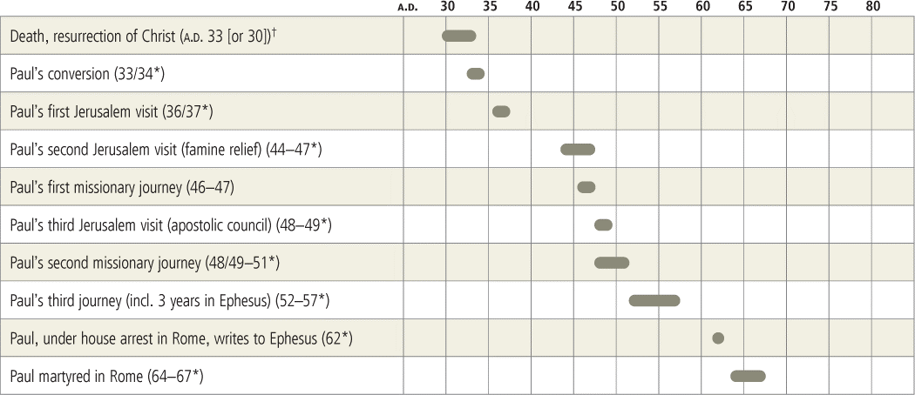

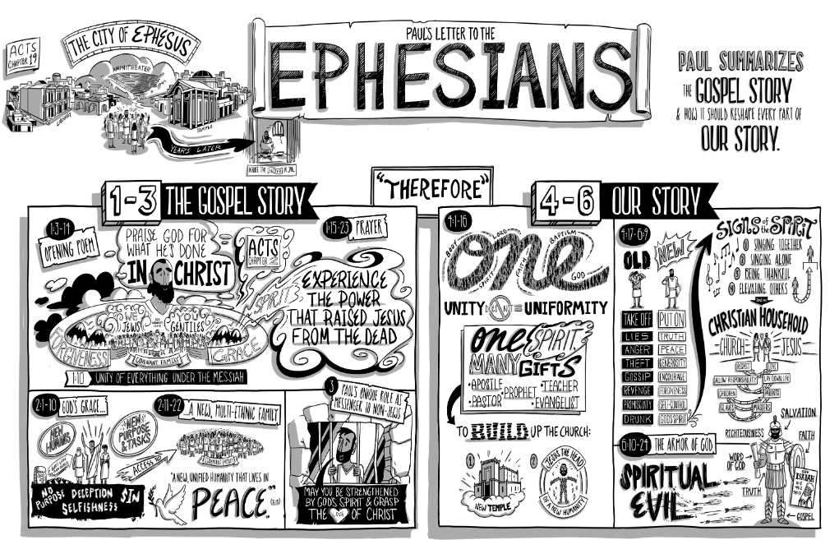
Reading for this week
Monday: Ephesians 4:17-24, Walking in laying aside and putting on
¹⁷ So I tell you this, and insist on it in the Lord, that you must no longer live as the Gentiles do, in the futility of their thinking. ¹⁸ They are darkened in their understanding and separated from the life of God because of the ignorance that is in them due to the hardening of their hearts. ¹⁹ Having lost all sensitivity, they have given themselves over to sensuality so as to indulge in every kind of impurity, and they are full of greed. ²⁰ That, however, is not the way of life you learned when you heard about Christ and were taught in him in accordance with the truth that is in Jesus. ²² You were taught, with regard to your former way of life, to put off your old self, which is being corrupted by its deceitful desires; ²³ to be made new in the attitude of your minds; ²⁴ and to put on the new self, created to be like God in true righteousness and holiness.

1) What does the Author want to teach us about the characters in this drama?

2) What does the Author of this drama want to reveal about the setting of the drama

3) What does the Author teach us about the plot, about our journey as the New Humanity?

4) What does the Author reveal about himself?

Tuesday: Ephesians 4:25-32, Walking in step with the Spirit
²⁵ Therefore each of you must put off falsehood and speak truthfully to your neighbor, for we are all members of one body. ²⁶ “In your anger do not sin”: Do not let the sun go down while you are still angry, ²⁷ and do not give the devil a foothold. ²⁸ Anyone who has been stealing must steal no longer, but must work, doing something useful with their own hands, that they may have something to share with those in need.
²⁹ Do not let any unwholesome talk come out of your mouths, but only what is helpful for building others up according to their needs, that it may benefit those who listen ³⁰ And do not grieve the Holy Spirit of God, with whom you were sealed for the day of redemption. ³¹ Get rid of all bitterness, rage and anger, brawling and slander, along with every form of malice. ³² Be kind and compassionate to one another, forgiving each other, just as in Christ God forgave you.

1) What does the Author want to teach us about the characters in this drama?

2) What does the Author of this drama want to reveal about the setting of the drama

3) What does the Author teach us about the plot, about our journey as the New Humanity?

4) What does the Author reveal about himself?
Wednesday: Ephesians 5:1-5, Walking in love (we will be covering this passage in our Wednesday study)
Follow God’s example, therefore, as dearly loved children ² and walk in the way of love, just as Christ loved us and gave himself up for us as a fragrant offering and sacrifice to God.
³ But among you there must not be even a hint of sexual immorality, or of any kind of impurity, or of greed, because these are improper for God’s holy people ⁴ Nor should there be obscenity, foolish talk or coarse joking, which are out of place, but rather thanksgiving. ⁵ For of this you can be sure: No immoral, impure or greedy person—such a person is an idolater—has any inheritance in the kingdom of Christ and of God. ^{v} ⁶ Let no one deceive you with empty words, for because of such things God’s wrath comes on those who are disobedient. ⁷ Therefore do not be partners with them.

1) What does the Author want to teach us about the characters in this drama?

2) What does the Author of this drama want to reveal about the setting of the drama

3) What does the Author teach us about the plot, about our journey as the New Humanity?

4) What does the Author reveal about himself?

Thursday: Ephesians 5:6-14, Walking in light
⁸ For you were once darkness, but now you are light in the Lord. Live as children of light ⁹ (for the fruit of the light consists in all goodness, righteousness and truth) ¹⁰ and find out what pleases the Lord. ¹¹ Have nothing to do with the fruitless deeds of darkness, but rather expose them. ¹² It is shameful even to mention what the disobedient do in secret. ¹³ But everything exposed by the light becomes visible—and everything that is illuminated becomes a light. ¹⁴ This is why it is said: “Wake up, sleeper, rise from the dead, and Christ will shine on you.”

1) What does the Author want to teach us about the characters in this drama?

2) What does the Author of this drama want to reveal about the setting of the drama

3) What does the Author teach us about the plot, about our journey as the New Humanity?

4) What does the Author reveal about himself?

Friday: Ephesians 5:15-21, Walking being filled with the Spirit (this will be our beginning point on 10/18)
¹⁵ Be very careful, then, how you live—not as unwise but as wise, ¹⁶ making the most of every opportunity, because the days are evil. ¹⁷ Therefore do not be foolish, but understand what the Lord’s will is. ¹⁸ Do not get drunk on wine, which leads to debauchery. Instead, be filled with the Spirit ¹⁹ speaking to one another with psalms, hymns, and songs from the Spirit. Sing and make music from your heart to the Lord, ²⁰ always giving thanks to God the Father for everything, in the name of our Lord Jesus Christ. ²¹ Submit to one another out of reverence for Christ.

1) What does the Author want to teach us about the characters in this drama?

2) What does the Author of this drama want to reveal about the setting of the drama

3) What does the Author teach us about the plot, about our journey as the New Humanity?

4) What does the Author reveal about himself?

