Every Spiritual Blessing
Message #2, Ephesians 1:4-13 September 13, 2020
Praise be to the God and Father of our Lord Jesus Christ,
who has blessed us in the heavenly realms
with every spiritual blessing in Christ.
Ephesians 1:1-3

Seven blessings (the list is complete, but not exhaustive, just like spiritual gifts!)
⁴ For he chose us in him before the creation of the world to be holy and blameless in his sight. In love ⁵ he predestined us for adoption to sonship through Jesus Christ, in accordance with his pleasure and will—⁶ to the praise of his glorious grace, which he has freely given us in the One he loves. ⁷ In him we have redemption through his blood, the forgiveness of sins, in accordance with the riches of God’s grace ⁸ that he lavished on us. With all wisdom and understanding, ⁹ he made known to us the mystery of his will according to his good pleasure, which he purposed in Christ, ¹⁰ to be put into effect when the times reach their fulfillment—to bring unity to all things in heaven and on earth under Christ. ¹¹ In him we were also chosen, having been predestined according to the plan of him who works out everything in conformity with the purpose of his will, ¹² in order that we, who were the first to put our hope in Christ, might be for the praise of his glory. ¹³ And you also were included in Christ when you heard the message of truth, the gospel of your salvation. When you believed, you were marked in him with a seal, the promised Holy Spirit, ¹⁴ who is a deposit guaranteeing our inheritance until the redemption of those who are God’s possession—to the praise of his glory.
Ephesians 1:4-14

1) When we read this passage all together, we see

1. The purpose and will of God worked out in the Church

2. The glory of God revealed in the Church

2) This is about God’s sovereign grace in our salvation

3) Prepositions matter: in, through, under and because of Christ

4) Note the tension between the purpose for these blessings and the conditionality of these blessings

Doug’s exegetical translation
Note: This section is one long sentence pouring from the mind of Paul, so it is very difficult to translate.
Blessing #1 For he chose [ = select for oneself, ex + logeō in middle voice] us in him before the foundation of the world to be [emphasis on “we would be,” PAN verb] holy and blameless in his sight [ = “before him”]

Blessing #2 In love [could be placed with Blessing #1] he predestined [ = ordained beforehand, pro + oridzō ] us to be adopted as sons [from a root which means “to place a son,” where we get the word “thesis”] through Jesus Christ to himself, in accordance to the pleasure [this word can mean “purpose” or “kindness”] of his will.
– to the praise [in the Philippians 4:8 sense, each time] of his glory kind of grace, which he has freely given us in the One having been loved [or, “the graciously given to us in the One he loves kind of grace”, the verb come from the root form of “grace” as well!]. [doxology #1]

Blessing #3 In him we have redemption [ = apolutrōsis, to purchase someone out of slavery or pay a ransom] through his blood . . . .

Blessing #4 . . . the forgiveness of sins [imagery of losing one’s footing, a moral fall] in accordance with the riches [emphasis on the vast wealth] of God’s grace that he lavished [better, “causes to increase abundantly”] on us with all wisdom and understanding [“wisdom and understanding” could connect to Blessing #5]

Blessing #5 And he made known to us the mystery of his will according to his good pleasure, which he purposed in Christ to be put into effect [better, “into a new administration or economy”] when the times [ = kairos ] have reached their fulfillment – to bring all things in heaven and on earth together under one head [literally, “to put the head back on” or even “summarize”], even Christ.

Blessing #6 In him we were also chosen have obtained an inheritance [from ek + klēroō, an aorist passive plural verb], having been predestined [ back to Blessing #2] according to the plan of him who works out [ = energeō ] everything in conformity with the purpose of his will, in order that we, who were the first to hope in Christ will be [active indicative, NOT subjunctive, “will be” not “might be”] for the praise of his glory. [doxology #2]

Blessing #7 [Note: this is a very difficult verse to translate, but the core teaching is clear]
Believing in him [or, “having believed in him”, though the verb follows “salvation], even you, the ones who heard the word of truth, the gospel of your salvation, yes you were marked in him with a seal [“marked with a seal is one word, the verb sphragidzō] the promised Holy Spirit [or, “the Spirit, of the promise one, the holy one”], who is a deposit guaranteeing [or, “given as a pledge for”] our inheritance until [better, “with a view toward”] the redemption of those who are God’s possession [or, “until we acquire possession of it”]
– toward the praise [in the Philippians 4:8 sense] of his glory. [doxology #3]
Living into every spiritual blessing

We’ll be looking at two blessings on Sunday, several more on Wednesday night. These are the questions that will guide our study:

1) What is revealed about God’s character as I see how he has worked in and through Jesus?

2) What is the 4-Dimensional impact of this blessing?

3) What is God’s purpose in this blessing? What does God want to accomplish in and through me?

Blessing #1, An incredibly old blessing
⁴ For he chose us in him before the creation of the world to be holy and blameless in his sight.
Ephesians 1:4

1)

2)

3)

Blessing #2, “Welcome to the family”
In love ⁵ he predestined us for adoption to sonship through Jesus Christ, in accordance with his pleasure and will—⁶ to the praise of his glorious grace, which he has freely given us in the One he loves.
Ephesians 1:5-6

1)

2)

3)

My working outline of Ephesians

Overall Theme:

Chapters 1-3 |  | The Glory of God in the Church
 | Chapter 1 |  | The glory of God in redemption
 | Chapter 2 |  | The glory of God in reconciliation
 | Chapter 3 |  | The glory of God in the revelation of the mystery of the church
Chapters 4-6 |  | The Glory and Pleasure of God through the Church
 | Chapter 4 |  | The glory of God in the unity and growth of the church
 | Chapter 5 |  | The glory of God in the imitation of Christ by the saints
 | Chapter 6 |  | The glory of God in victory of Christ

Resources for further studies of Ephesians
This is a wonderful Bible Project introduction on youtube: https://www.youtube.com/watch?time_continue=12&v=Y71r-T98E2Q&feature=emb_logo
Bob Deffinbaugh’s Ephesian series is at https://bible.org/series/ephesians-glory-god-church
Spurgeon’s series of messages on Ephesians are at http://www.romans45.org/spurgeon/index/r_eph.htm
Kim Riddlebarger’s sermons on Ephesians are at http://kimriddlebarger.squarespace.com/sermons-on-ephesians/;jsessionid=3799445CA50CA06F2F395D4FBE89D586.v5-web017
ThirdMill has produced “Paul and the Ephesians” at https://thirdmill.org/seminary/lesson.asp/vid/19/version/
Desiring God, John Piper’s media ministry, has some wonderful resources at https://www.desiringgod.org/scripture/ephesians/1/messages
Mark Johnston’s “Preaching Ephesians” at https://www.reformation21.org/articles/preaching-ephesians.php
Doug’s favorite commentaries are John R. W. Stott’s The Message of Ephesians (IVP, 1979), William Hendriksen, Exposition of Ephesians (Baker Book House, 1967) and, much shorter, F. F. Bruce’s The Epistle to the Ephesians (Revell, 1961).
Martyn Lloyd-Jones has a wonderful seven volume series on Ephesians (Baker Books, 1978).
The text we spent the most time on in Darrell Johnson’s class was Timothy Gombis’ The Drama of Ephesians (IVP Academic, 2010)
The Gospel Coalition has some wonderful resources on Ephesians at https://www.thegospelcoalition.org/course/ephesians/
Alexander Maclaren’s commentary on Ephesians 1 is at https://www.studylight.org/commentaries/mac/ephesians-1.html
F.F. Bruce’s paraphrase is available at https://www.biblicalstudies.org.uk/pdf/eq/1962-3_163.pdf

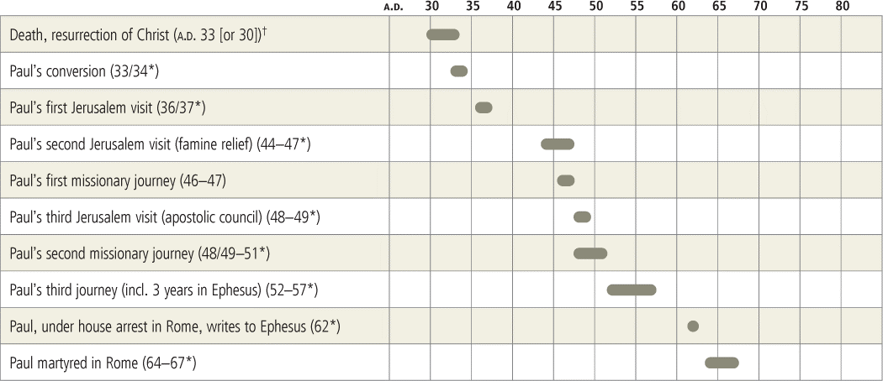

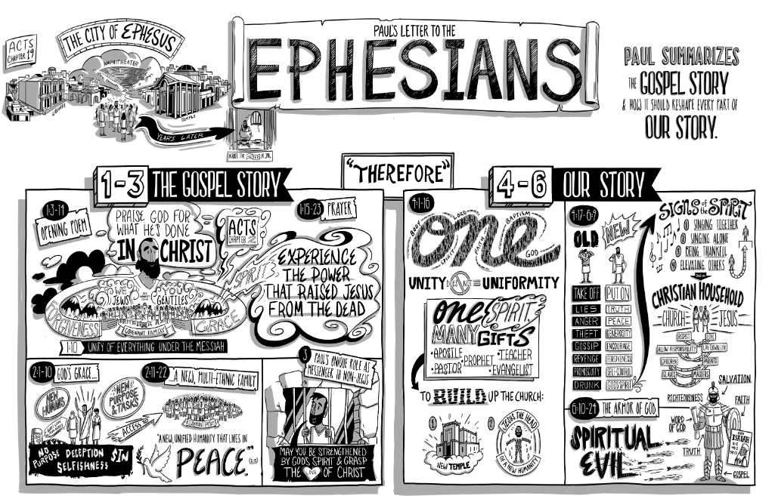
What then can we say by way of summation and application?

Having gone through this entire sentence, the redemptive panorama is now complete. The Trinitarian pattern is intentional and obvious. Redemption was decreed by the Father before time began. Redemption was accomplished by Jesus Christ during his time on earth. Redemption was applied to us by the Holy Spirit when the gospel was preached to us and we believed in Jesus. Our salvation begins with God’s decree. It is accomplished for us by Christ’s death and resurrection. It is applied to us by the Holy Spirit, through the preaching of the gospel. And this glorious salvation will come to fruition on the last day when God raises us from the dead. Indeed, we are sealed by the blessed Holy Spirit who ensures that we will be raised from the dead. The Holy Spirit is God’s pledge that all of God’s promises will be realized. God didn’t start this process with the intention of quitting in the middle of it.

Beloved, all of this take place “in Christ.” If you trust in Jesus, you are numbered among the elect. If you trust in Jesus, all of his saving benefits are yours. If you were chosen by God, redeemed by Christ, and trust in Christ, then the Holy Spirit indwells you and will do so on that final day when the dead are raised. And there may even be some here today, who will make their calling and election sure, by trusting in Jesus just as Paul has described. And God does all of this to the praise of his glory, the glory of his blessed son Jesus! Amen!

Kim Riddelbarger’s sermon at http://kimriddlebarger.squarespace.com/sermons-on-ephesians/;jsessionid=C0CB5721BCD1142AC9C91AE05F7C27FA.v5-web011

God Has Chosen Us in Him Before the Foundation of the Earth
John Piper
at https://www.desiringgod.org/messages/god-has-chosen-us-in-him-before-the-foundation-of-the-earth

God's Desire for Our Full Assurance
Three weeks ago we focused on the words of Hebrews 6:11 which go like this: "We desire each one of you to show the same earnestness in realizing the full assurance of hope until the end." In other words, God's will for us is that we live in the liberty and the joy and the power of full assurance. He means for us to know assuredly that we are bound for heaven and that we will not fail to get there.
It is possible for true Christians, with genuine saving faith, to go through periods of time in which they do not have the full assurance of hope. John said in 1 John 5:13, "I write this to you who believe in the name of the Son of God, that you may know that you have eternal life." In other words, the heart's true allegiance to Christ and true union with Christ are not completely identical with strong feelings of assurance. Faith can be real when the feelings of assurance are weak.
But God commands us to be earnest and zealous in our pursuit of full assurance. Because that is where the joy and freedom and power are found.

Two Ways to Pursue Assurance
Now there are two ways to pursue assurance. One is by examining ourselves and seeing the evidences that the dominion of sin has been broken and that we have new desires and disciplines. This is what Peter meant when he said, "Therefore brethren, be the more zealous to confirm your call and election" (2 Peter 1:10). And what Paul meant when he said, "Test yourselves to see if you are in the faith. Prove yourselves. Or do you not know yourselves that Jesus Christ is in you? If you are not disqualified" (2 Corinthians 13:5).
Thomas Watson put it this way 350 years ago,
If a malefactor be in prison, how shall he know that his prince hath pardoned him? If a jailer come and knock off his chains and fetters, and lets him out of prison, then he may know he is pardoned; so how shall we know God hath pardoned us? If the fetters of sin be broken off, and we walk at liberty in the ways of God, this is a blessed sign we are pardoned. (A Puritan Golden Treasury, p. 25)
But there is another way to pursue assurance. And for people who are given to excessive self-examination and doubt this is surely the more hopeful path. The book of Hebrews puts it very simply like this: "Consider Jesus" (Hebrews 3:1). Or: "Look to Jesus the pioneer and perfecter of our faith" (Hebrews 12:2). In other words, do not dwell on yourself, dwell on what God has done in Jesus Christ.
There is a paradox here. For many people—most people, I think—the more we focus on the subjective inner workings of our own soul and the relative purity or impurity of our own attitudes and behavior, the more uncertain we become of our own assessment of our authenticity. Paradoxically the path to assurance is to shift our focus off of ourselves and onto God. Off of the subjective and onto the objective.

An Illustration in the Life of William Cowper
Some of you remember William Cowper. He is an example of how this paradox works. He was melancholy and introspective, and considered himself beyond hope. Christianity was true he said, but he was not capable of faith. He was rejected.
Then one afternoon in the garden of St. Alban's Asylum he picked up a Bible. God focused his attention not primarily on the subjective reality of his own condition, but on the objective reality of God's work in Christ. He read Romans 3:25: "God put Christ forward as a propitiation by his blood to be received by faith. This was to show God's righteousness, because in his divine forbearance he had passed over former sins." This is what Cowper later wrote about that moment:
Immediately I received the strength to believe it, and the full beams of the Sun of Righteousness shone upon me. I saw the sufficiency of the atonement He had made, my pardon sealed in His blood, and all the fullness and completeness of His justification. In a moment I believed, and received the gospel . . . Unless the Almighty arm had been under me, I think I should have died with gratitude and joy. My eyes filled with tears, and my voice choked with transport; I could only look up to heaven in silent fear, overwhelmed with love and wonder. (Gilbert Thomas, William Cowper and the Eighteenth Century, p. 132)

The Conviction Behind This Series
In other words, in this second way of pursuing assurance we focus our attention not on what we are doing to prove that we are saved (neither faith, nor the obedience of faith), but we focus on what God has done to save his people. And our confidence is this: as we focus on the great objective work of God, God himself will glorify that work in us by creating faith and assurance and joy and freedom and obedience and power.
That's the conviction that moves me now to take up eight messages leading up to Easter under the theme: God's Invincible Purpose: Foundations for Full Assurance. God has an unstoppable, undefeatable, invincible purpose to save his people, and the more we dwell on what he has done to infallibly achieve his purpose, the more deep and lively will be our assurance. God loves to glorify the worth of his objective work by making it the basis of our subjective assurance.

God's Invincible Purpose in Our Salvation
We begin where Paul begins in Ephesians 1:3–4.
Blessed be the God and Father of our Lord Jesus Christ, who has blessed us in Christ with every spiritual blessing in the heavenly places, even as he chose us in him before the foundation of the world . . .
Paul begins by blessing God. He blesses him as one who has blessed us with every blessing that heaven can give. And the first foundation that Paul mentions for this assured fact is that "God chose us in Christ before the foundation of the world."
God's Choice of Individuals for Salvation
So that is my first message: God's purpose in the salvation of his people is invincible—it cannot fail—because it is based first not on our choosing God but on God's choosing us. Verse 4: "He [God] chose us in him [Christ] before the foundation of the world."
Your salvation did not begin with your choice to believe in Christ—a choice which was real and necessary. Your salvation began before the creation of the universe when God planned the history of redemption, ordained the death and the resurrection of his Son, and chose you to be his own through Christ. This is a great objective ground for assurance. And we should consider it deeply.
Many Deny That God Elects Individuals
There are many, many people who do not believe this. They do not believe that God chose who will be saved and who will be passed over and left to unbelief and rebellion. They insist that this text only teaches that God chose Christ and an undefined number of those who choose to be in Christ by faith. They say that Ephesians 1:4 is not an election or choosing of individuals, but an election of Christ and the church; but what individuals are part of the church, God does not decide. It's like the Super Bowl. The national officials don't choose a specific team of men to go to the Super Bowl; they choose that the winners of the playoffs go, whoever they are. God does not choose who will be in Christ and who will be saved. That lies ultimately in the power of man's autonomous will, which God does not rule.

"Chose Us in Him"
They say that the wording of verse 4 proves this interpretation: "God chose us in him." But this wording will not settle the issue. If anything the wording points the other way: it says he chose us. Not an undefined mass of people, but us, you and me personally. He chose us. The word means select from a larger group. And the way he did it was in relation to Christ. Christ was not an afterthought to election. God chose us to come to salvation in Christ, not apart from Christ. But it was us that he chose. These words are not strained at all in carrying this meaning that God chose particular people to be his children through their union with Christ.
But I say the words of verse 4 alone will probably not settle this issue. But if we look at what Paul says elsewhere about this, we can be sure about what he means, namely, that God chose his people individually and personally before the foundation of the world to be saved; and he chose them to be saved through union with Christ.
1 Corinthians 1:27–30
First notice what the point of God's choosing is in 1 Corinthians 1:27–30.
27 God chose what is foolish in the world to shame the wise, God chose what is weak in the world to shame the strong, 28 God chose what is low and despised in the world, even things that are not, to bring to nothing things that are, 29 so that no human being might boast in the presence of God.
What this text says very clearly is that God chose particular kinds of people to be in the church. He did not just choose the church and leave its composition to man. He chose foolish individuals and called them into Christ. He chose some weak individuals and called them into Christ. He chose some low and despised individuals and called them into Christ. So that no one might boast in anyone but the Lord.
And then to make this crystal clear he said in verse 30 (literally): "From him [God] you are in Christ Jesus." Or as the NASB says, "By his doing you are in Christ Jesus." Or the NIV: "It is because of him that you are in Christ Jesus." In other words, it is just as though Paul knew that someone would come along some day and say that God does not choose who is in Christ, but only chooses Christ and any who put themselves in Christ. So he says, in verses 27–29, that God chose the individuals who would make up the church in Christ. And he says in verse 30 that it is by God's doing that they are put in Christ.
The glorious, unshakable, objective foundation of your being a Christian is that God chose you to be one. God put you in Christ. So I say with Paul (in verse 26) "Consider your calling!" Consider how you came to be in Christ! Think about it. It will take all boasting off of man and put it all on God. So verse 31 ends the section: "Let him who boasts boast in the Lord." This is the boast of assurance. This is the exultation of considering our calling and our election, and seeing that it's all of God, and feeling a tremendous peace and confidence and courage and strength and love well up inside to keep us going in the face any opposition. Because "who can bring any charge against God's elect!" (Romans 8:33).
James 2:5
James (2:5) teaches the very same thing from a slightly different angle: God chose the poor to come to faith and be in the church, so be careful that you not discriminate against him.
Listen, my beloved brethren. Has not God chosen those who are poor in the world to be rich in faith and heirs of the kingdom which he has promised to those who love him? But you have dishonored the poor man.
Here again God has chosen not an undefined mass of people, but particular poor individuals to be rich in faith and to be treated a certain way. The personal, individual nature of election has very practical consequences. If God has chosen to bring the poor into Christ, don't dishonor them!

Closing Confession of Faith
So I come back to Ephesians 1:4, "God chose us in Christ before the foundation of the world." And I close with my own personal confession of faith in this great biblical truth of election.
Before the creation of the universe God thought of me. He fixed his gaze on me and chose me for himself. He did not choose me because I was already in Christ of my own doing, but that I might be in Christ. He did not choose me because he saw me as a believer, but so that I might become a believer. He did not choose me because I chose him, but so that I might choose him. He did not choose me because I was holy or good but so that I might become holy and good.
Everything I am and all I hope to be is rooted in God's freely choosing me. My faith, my hope, my work are not the ground of electing grace but only its effect. And so there is no ground for boasting except in God. And in the face of fear and loss of assurance and all my own defect, I speak this word of trust: "Who shall bring any charge against the Lord's elect!" (Romans 8:33).

