Ephesians: The Whole Gospel for the Whole People of God
Message #1, Ephesians 1:1-3 September 6, 2020
Paul, an apostle of Christ Jesus by the will of God,
To the saints in Ephesus, the faithful in Christ Jesus:
Grace and peace to you from God our Father and the Lord Jesus Christ.
Praise be to the God and Father of our Lord Jesus Christ, who has blessed us
in the heavenly realms with every spiritual blessing in Christ.
Ephesians 1:1-3

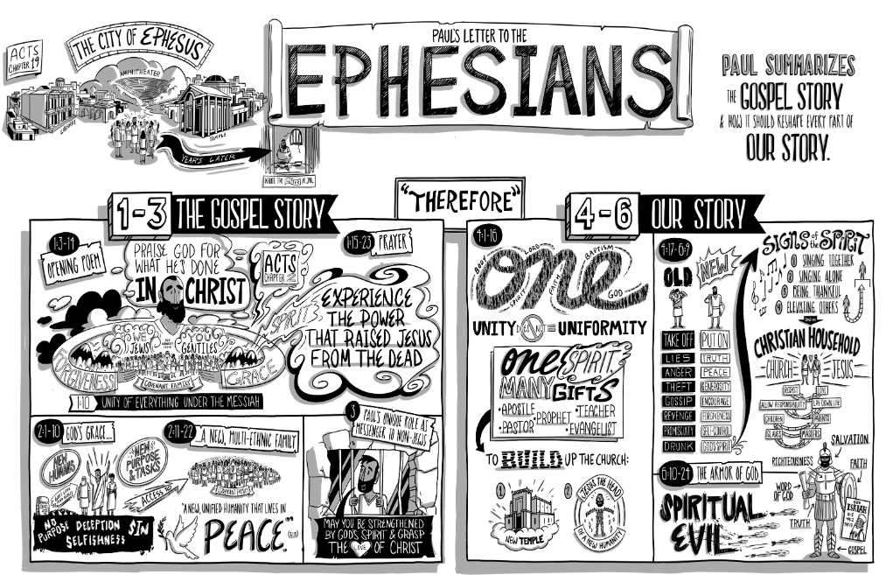
Pastor Fakkema’s Coloring Challenge: I’ll have a reward for evey Ephesians coloring page I receive this week!
The Ephesian ministry team
¹⁸ Paul stayed on in Corinth for some time. Then he left the brothers and sisters and sailed for Syria, accompanied by Priscilla and Aquila. Before he sailed, he had his hair cut off at Cenchreae because of a vow he had taken. ¹⁹ They arrived at Ephesus, where Paul left Priscilla and Aquila. He himself went into the synagogue and reasoned with the Jews. ²⁰ When they asked him to spend more time with them, he declined. ²¹ But as he left, he promised, “I will come back if it is God’s will.” Then he set sail from Ephesus. ²² When he landed at Caesarea, he went up to Jerusalem and greeted the church and then went down to Antioch.
²³ After spending some time in Antioch, Paul set out from there and traveled from place to place throughout the region of Galatia and Phrygia, strengthening all the disciples.
²⁴ Meanwhile a Jew named Apollos, a native of Alexandria, came to Ephesus. He was a learned man, with a thorough knowledge of the Scriptures. ²⁵ He had been instructed in the way of the Lord, and he spoke with great fervor ^{t} and taught about Jesus accurately, though he knew only the baptism of John. ²⁶ He began to speak boldly in the synagogue. When Priscilla and Aquila heard him, they invited him to their home and explained to him the way of God more adequately.
Acts 18:81-26

Paul

Priscilla and Aquila (see Acts 18:1-4)

Apollos

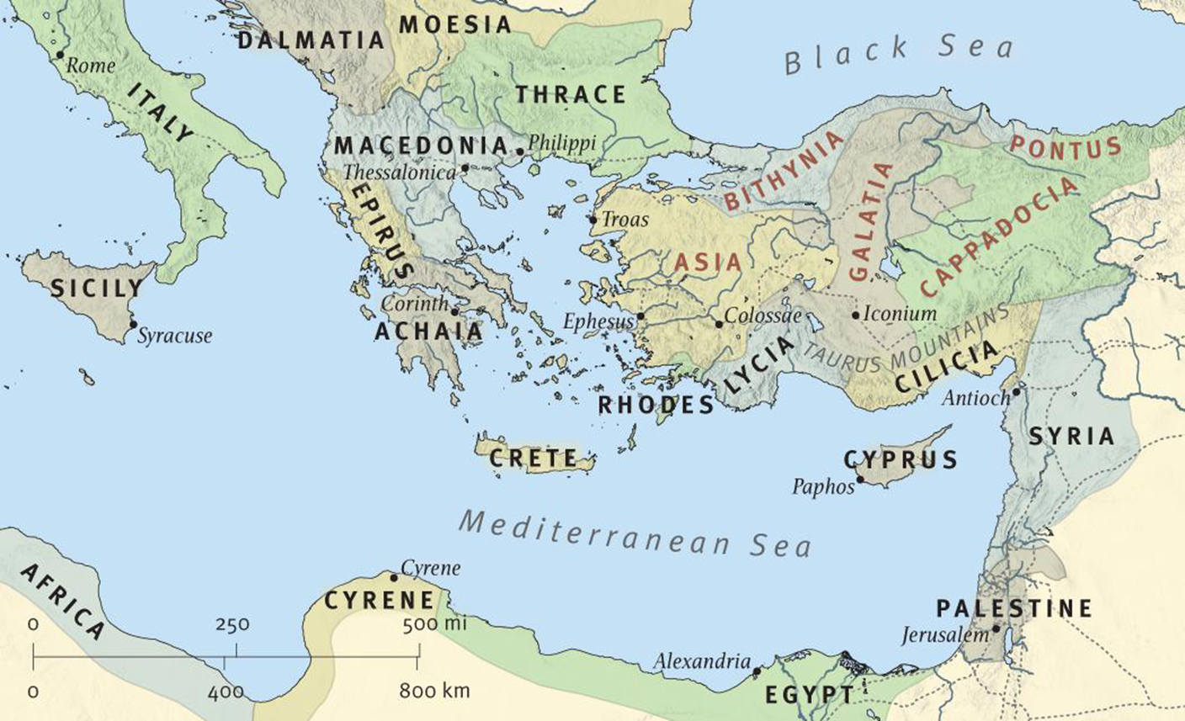
The saints in Ephesus
Paul, an apostle of Christ Jesus by the will of God,
To God’s holy people in Ephesus, ^{d} the faithful in Christ Jesus: ² Grace and peace to you from God our Father and the Lord Jesus Christ.
Ephesians 1:1-2

1) They had some great teaching (and will receive more from Peter and John!)

2) They are in a spiritually oppressive community facing a generation of challenge (leading off Rev. 2!)

3) They are located _________________________ in Ephesus and in Christ Jesus

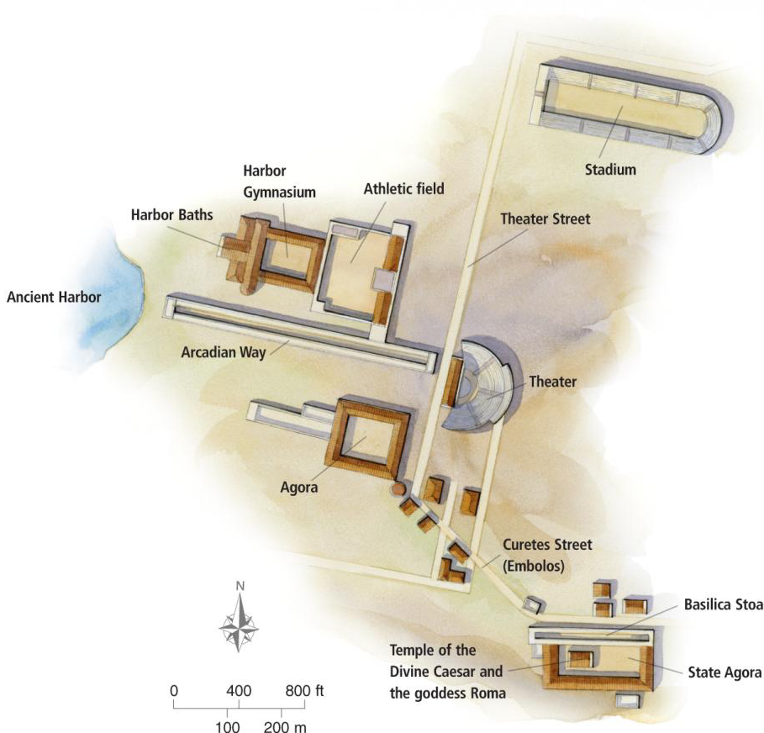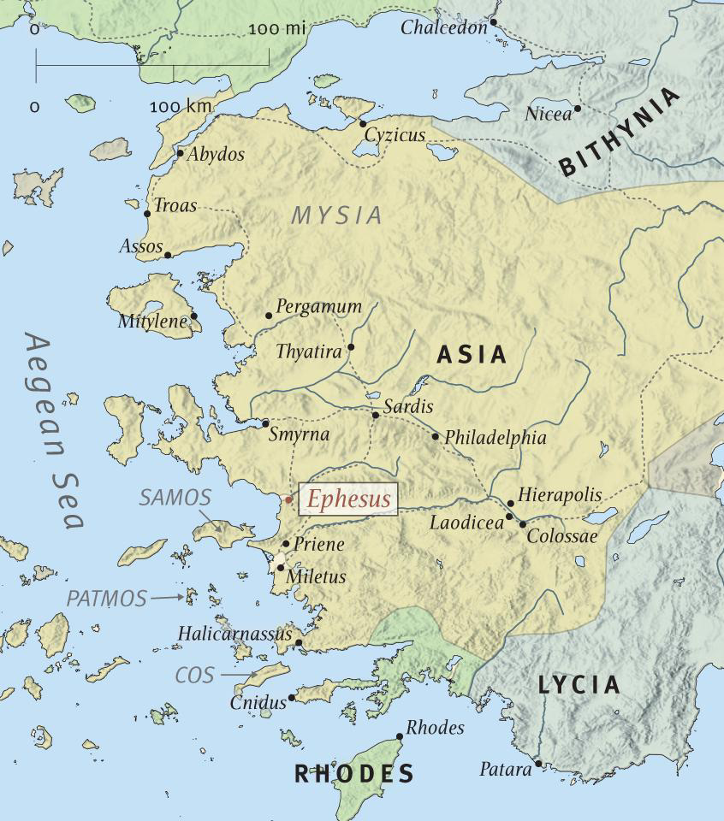

Paul’s theme
³ Praise be to the God and Father of our Lord Jesus Christ, who has blessed us in the heavenly realms with every spiritual blessing in Christ.
Ephesians 1:1-3

1) You are richer than you think

2) location, location, location: in ________________________________ and in ____________________

3) God gets a new __________________________ !

How to get the most out of this incredible letter

1) Pray to have your eyes opened
¹⁵ When the servant of the man of God got up and went out early the next morning, an army with horses and chariots had surrounded the city. “Oh no, my lord! What shall we do?” the servant asked.
¹⁶ “Don’t be afraid,” the prophet answered. “Those who are with us are more than those who are with them.”
¹⁷ And Elisha prayed, “Open his eyes, Lord, so that he may see.” Then the Lord opened the servant’s eyes, and he looked and saw the hills full of horses and chariots of fire all around Elisha.
2 Kings 6:15-17 (be sure to read the unexpected ending to this wonderful story!)

2) Read Ephesians in at least 4 different translations or paraphrases

i. The Mystery of God's Eternal Purpose (Ch. 1: 4-12)
(a) Salutation (Ch. 1: 1-2)
To the people of God [at Ephesus]. believers in Christ Jesus, this letter comes from Paul. apostle of Christ Jesus by the will of God. Grace and peace be yours from God our Father and Jesus Christ our Lord!
(b) Doxology (Ch. 1: 3-14)
All blessings be ascribed to the God and Father of our Lord Jesus Christ! In Christ He has blessed us with every spiritual blessing in the heavenly realm.
F.F. Bruce’s paraphrase at https://www.biblicalstudies.org.uk/pdf/eq/1962-3_163.pdf

3) As we read and study Ephesians, summarize the structure of each section. Included below is the
simple structure suggested by Bob Deffinbaugh
Chapters 1-3 of the Epistle to the Ephesians urge us to be more heavenly minded so that, in obedience to the instruction laid down in chapters 4-6, we may be of more earthly good, to the glory of God.
May God grant us an appetite for the “meat” of this great epistle, and may He also grant us the ability to grasp the breadth and length and height and depth of God’s glory, as seen in Christ and in His church.
Bob Deffinbaugh’s closing words in his “The Uniqueness of Ephesians” sermon
My working outline of Ephesians

Overall Theme:

Chapters 1-3 |  | The Glory of God in the Church
 | Chapter 1 |  | The glory of God in redemption
 | Chapter 2 |  | The glory of God in reconciliation
 | Chapter 3 |  | The glory of God in the revelation of the mystery of the church
Chapters 4-6 |  | The Glory and Pleasure of God through the Church
 | Chapter 4 |  | The glory of God in the unity and growth of the church
 | Chapter 5 |  | The glory of God in the imitation of Christ by the saints
 | Chapter 6 |  | The glory of God in victory of Christ

Resources for further studies of Ephesians
This is a wonderful Bible Project introduction on youtube: https://www.youtube.com/watch?time_continue=12&v=Y71r-T98E2Q&feature=emb_logo
Bob Deffinbaugh’s Ephesian series is at https://bible.org/series/ephesians-glory-god-church
Spurgeon’s series of messages on Ephesians are at http://www.romans45.org/spurgeon/index/r_eph.htm
Kim Riddlebarger’s sermons on Ephesians are at http://kimriddlebarger.squarespace.com/sermons-on-ephesians/;jsessionid=3799445CA50CA06F2F395D4FBE89D586.v5-web017
ThirdMill has produced “Paul and the Ephesians” at https://thirdmill.org/seminary/lesson.asp/vid/19/version/
Desiring God, John Piper’s media ministry, has some wonderful resources at https://www.desiringgod.org/scripture/ephesians/1/messages
Mark Johnston’s “Preaching Ephesians” at https://www.reformation21.org/articles/preaching-ephesians.php
Doug’s favorite commentaries are John R. W. Stott’s The Message of Ephesians (IVP, 1979), William Hendriksen, Exposition of Ephesians (Baker Book House, 1967) and, much shorter, F. F. Bruce’s The Epistle to the Ephesians (Revell, 1961).
Martyn Lloyd-Jones has a wonderful seven volume series on Ephesians (Baker Books, 1978).
The text we spent the most time on in Darrell Johnson’s class was Timothy Gombis’ The Drama of Ephesians (IVP Academic, 2010)
The Gospel Coalition has some wonderful resources on Ephesians at https://www.thegospelcoalition.org/course/ephesians/
F.F. Bruce’s paraphrase is available at https://www.biblicalstudies.org.uk/pdf/eq/1962-3_163.pdf

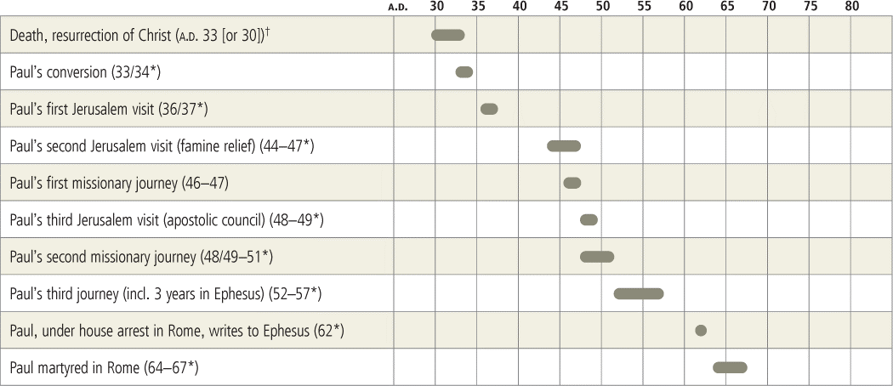

The Uniqueness of Ephesians Among the Epistles
Bob Deffinbaugh at https://bible.org/series/ephesians-glory-god-church

Introduction
While I was a student in college, I took a class in economics. The professor was a gracious and dignified scholar. He seldom laughed, but on one occasion, I managed to evoke a genuine laugh. He was lecturing on the desert, and at one point he referred to the horse as the “Rolls Royce of the desert.” This was my chance. I raised my hand, and said to him, “Sir, I believe that the camel is the ‘Rolls Royce of the desert.’” I then went on to explain that the camel should be given the higher status because it, and not the horse, had ‘bucket seats.’
Apart from the Epistle to the Romans, few who have studied Paul’s Epistle to the Ephesians would challenge the statement that it is the “Rolls Royce of the epistles.” F. F. Bruce, noted New Testament scholar, calls Ephesians “the quintessence of Paulinism.”¹ C. H. Dodd called Ephesians “the crown of Paulinism.”² According to William Hendriksen, Ephesians has been called “the divinest composition of man,” “the distilled essence of the Christian religion,” “the most authoritative and most consummate compendium of the Christian faith,” “full to the brim with thoughts and doctrines sublime and momentous.”³
I was tempted to sub-title this lesson, “Kicking the Tires of Ephesians. ” If you’ve ever looked at cars, especially used cars, this is one of the first things you do—kick the tires. In this lesson, we will commence our study of the Book of Ephesians. We will begin by briefly noting the author and recipients of the epistle. We will then turn to the characteristics of Ephesians, focusing our attention on the distinctive contribution of the epistle. It is hoped that this will set the tone for our entire study, and will motivate you to take the message of this epistle very seriously.

Author and Destination of Ephesians
Unless you read the commentaries, you probably would not even expect the authorship and destination to be mentioned, other than as a part of the exposition of the very first verse of the Book of Ephesians:
Paul, an apostle of Christ Jesus by the will of God, to the saints who are at Ephesus, and who are faithful in Christ Jesus (Ephesians 1:1).
Who would have thought that there was a need to debate the veracity of this statement? You will discover, if you have not already, that the critics want to discuss everything. And so, while time is largely wasted in debating the obvious, our attention is diverted from the weightier matters. As Jesus put it long ago, men who like to think of themselves as students of the word are often guilty of “straining gnats and swallowing camels” (Matthew 23:24).
One must deny the undisputed text of Ephesians to question the authorship of this epistle. The recipients of the letter is not, in my opinion, a matter of great importance, but at least it is an issue which arises out of the text itself. In verse one, there is a marginal note in some versions like the NASB, which indicates to us that some manuscripts omit “at Ephesus.” There are a very few (three to my knowledge) which omit it, and hundreds which do not. The problem is that these few manuscripts also happen to be the oldest. Some conclude that because they are the oldest, they are also the most reliable texts. There are those who would dispute this fact (and, to some degree, I agree with them).
In the final analysis, it really doesn’t matter that much, because the epistle is a very general one. Its message and its application apply as directly to us as it did to its first recipients. It is my personal opinion that the epistle was probably sent first to Ephesus, and from there sent to all the churches of Asia, certainly including the 7 churches addressed in Revelation 1:20–3:22.
Ephesians does seem to be written to a broader group of individuals than just a few individuals or a particular church. As you can see in Revelation, chapters 2 and 3, in the 7 letters to the churches of Asia (one of which is the Ephesian church), and as is evident in certain of Paul’s epistles (e.g. Corinthian epistles, or Philippians), some epistles are addressed to a specific church. This letter has a broader, more universal, feel. Just as the gospel was preached in Ephesus, and from there resounded to all Asia (Acts 19:10, 26). so Paul’s epistle was first sent to Ephesus, and from there it was likely circulated among the other churches in Asia (for this practice, see Colossians 4:16).
We should also note that Ephesians is not the first epistle written to the Ephesians (or, if you would, to this group of believers). Paul refers to a previous, shorter, epistle, which was written some time before this epistle:
For this reason I, Paul, the prisoner of Christ Jesus for the sake of you Gentiles—if indeed you have heard of the stewardship of God’s grace which was given to me for you; that by revelation there was made known to me the mystery, as I wrote before in brief (Ephesians 3:1-3).

Historical Setting
In the Book of Acts, the history of church at Ephesus begins with the ministry of Paul on his second missionary journey, as recorded in Acts 18:18-28. Paul, accompanied by Priscilla and Aquila, arrived in Ephesus. Paul went to the synagogue in Ephesus and proclaimed Christ, and was asked to stay on and teach further. Paul declined, promising to return later in the will of the Lord, leaving behind Priscilla and Aquila. During Paul’s absence, Apollos arrived, and began to preach those things which pertained to Jesus, based on the Old Testament and on the preaching of John the Baptist. Apollos seems to have been an Old Testament saint, but does not seem to have known about or trusted in Jesus Christ personally. Priscilla and Aquila took Apollos aside and filled him in on that which was lacking in his preaching. In time, he was sent to Achaia, where he powerfully and publicly refuted the Jews, showing that Jesus was indeed the promised Messiah.
After strengthening the believers in “the Galatian region and Phrygia” (18:23), Paul returned to Ephesus, where he spends nearly three years, preaching and teaching. For three months, Paul taught in the synagogue, but then opposition caused him to change his meeting place to the school or Tyrannus, where he reasoned daily for two years (Acts 19:8-10). During this time, God gave supernatural witness to the ministry of Paul by empowering him to perform many miracles (19:11-12). As a result of the chastening of the seven sons of Sceva, many in Ephesus renounced their magical practices, which was demonstrated when they publicly burned their magical books, worth a considerable amount of money. This, in turn, had a great impact on the city (Acts 19:13-20).
Paul planned to leave Asia, planning to visit Macedonia and Achaia, where he would gather a collection for the poor in Jerusalem and Judea, and then deliver the gift to the church in Jerusalem, and then press on to Rome. He sent Timothy and Erastus ahead, staying behind in Asia for a while (19:21-22).
It was during this brief stay that a serious crisis arose in Ephesus, as a direct result of the preaching of the gospel. The gospel had not only caused many to turn from their magical practices, it also turned many from the worship of Artemis, the goddess whose elaborate temple was constructed in Ephesus, over a period of more than 200 years. This specifically impacted the idol-making industry which had developed in the city. A near riot was instigated by Demetrius, which was finally dissipated by an appeal from the town clerk. This incident caused Paul to move on to Macedonia (Acts 19:23–20:1).
On his way to Jerusalem, Paul’s travels took him to Macedonia, and then Greece, where he spent three months (Acts 20:2-3). His eagerness to reach Jerusalem by Pentecost caused him to sail past Ephesus and to make port at Miletus, not far from Ephesus. And so he called for the elders of the church at Ephesus, giving them a final word of encouragement and admonition. After a tearful farewell, Paul sailed on toward Jerusalem (Acts 20:17-38).
As Paul had purposed, he did reach Jerusalem, and then Rome, but not in a way that we would have anticipated.⁴ When Paul reached Jerusalem, he took the advice of the (Jewish) leaders of the church there, and as a result was arrested on false charges. Through a sequence of events, Paul felt compelled to appeal to Caesar, and thus he was taken to Rome for trial. There in Rome, he was granted considerable freedom of access, and thus he continued to minister. It is here, in Rome, that the history of the Apostle Paul (and the church) ends in the Book of Acts (see chapter 28).
While in prison,⁵ Paul penned several epistles, which came to be known as the “prison epistles:” Ephesians, Philippians, Colossians, and Philemon. Philippians was delivered by Epaphroditus, who was sent home by Paul after his recovery from a serious illness (Philippians 2:25-30). Tychicus (see Acts 20:4), accompanied by the returning slave, Onesimus, would deliver the Epistle of Colossians and the letter to Philemon (Colossians 4:7-9), and also the Epistle to the Ephesians (Ephesians 6:21-22).

Characteristics of Ephesians (What Makes Ephesians So Special?)
A few years ago, I was given an “automobile” that most of you would not even recognize as a car, either by name or appearance. The car was a Messerschmidt (I am not even sure any more how to spell it). If all you can think of is a German war plane, you’re not that far from the truth. This “car” was made from the surplus of parts for the Messerschmidt aircraft. The car had three wheels, two in front and one in back. It was powered by a one cylinder motorcycle engine. It was the predecessor, as I recall, of the Isetta, another three-wheeler. To enter the car, you tilted up the cockpit cover, which was from the fighter plane.
I mention all this because the Messerschmidt was a very distinctive motor vehicle, different from any other automobile. While Paul’s epistle to the Ephesians is but one of 66 books of the Bible, its contribution is directly related to its distinctives, those characteristics which set it apart from every other book of the Bible.
The Bible teaches that every Christian is unique, and has a particular contribution to make to the body of Christ. I believe that the same is true of each book of the Bible. Each book has its own setting, audience, and message. If we are to appreciate a particular book of the Bible, we must first come to recognize its unique contribution. As we begin our study of the Book of Ephesians, I would like to draw attention to some of its characteristics, and then to attempt to identify its unique identity and contribution to the revelation of the Scriptures. Let us consider, then, the characteristics of the Book of Ephesians.
(1) Ephesians is a “prison epistle.” Ephesians was written by Paul when imprisoned in Rome. His ministry may have appeared to have been hindered. His character and perhaps even his teaching seem to have been questioned by some, as a result of his imprisonment (Philippians 1:15-17). While he had been given considerable freedom, the possibility of his execution was very real (Philippians 1:19-26). Apart from a couple very general references to his imprisonment (3:1; 4:1; 6:20), no one would have ever guessed that this epistle was penned by a man in chains. Even if Paul’s body was in the dungeon (unlike as this is, see Acts 28:30-31), his heart, mind, and spirit were in the heavenlies.
As I read the Epistle of Paul to the Ephesians, recalling the circumstances of the apostle when he wrote, and then considering the elevated tone of the epistle itself, I am rebuked. I am also informed that it is possible for one whose circumstances are less than desirable to dwell on a much higher plane. The content of Ephesians not only tells us that Paul was a man filled with praise, and with the knowledge of God, but what it was that gave Paul such confidence and optimism.
As we look about, it is indeed difficult to find much cause for optimism in this world in which we live. Our environment is slowly being polluted, the ozone layer is disappearing, diseases like aids are on the verge of decimating the population of some nations, our economy is faltering, politicians are corrupt, and government is not able to solve the problems facing it. There is room for hope, for confidence, for joy, but it is not in the world around us, it is in the God whom Paul served, the God of whom he writes, whom he worships, and to whom he prays in Ephesians. The truths of this great epistle can transform your life, and the God of this epistle can give you faith, hope, and love.
(2) Ephesians is not a personal epistle. The message of Ephesians is much more general, and much less personal than some of his other epistles. First and Second Timothy and Titus were written personally to Timothy and Titus. Philemon was written to Philemon, concerning the return of his slave, Onesimus. Philippians deals with the personal affairs of Paul (chapter 1), Timothy, and Epaphroditus (chapter 2), and Euodia and Syntyche (chapter 4). In the 15th chapter of Romans, Paul spells out his personal plans for his ministry. Ephesians does not deal with personal matters.
(3) Ephesians is not a “problem-solving epistle.” Some epistles were occasioned by problems, which the letter seeks to correct. Galatians is a “hot letter” shot off to rebuke the Galatians for giving in to the legalism of the Judaisers. Philippians deals with the problems occasioned by Paul’s imprisonment, along with the scrap which was going on between Euodia and Syntyche. The Corinthian epistles are oozing with problems which required correction by letter, including divisions, conflict, lawsuits, immorality (chapters 1-7), and abuses in worship (chapters 11-13), not to mention an attack on the doctrine of the resurrection (chapter 15). Ephesians, on the other hand, is not a problem-centered epistle.
(4) Ephesians is not a didactic (teaching) epistle. The Epistle to the Ephesians is written to one of the most well-taught churches that ever existed. Paul spent nearly 3 years teaching in Ephesus. Apollos had ministered there as well. And in Paul’s absence he wrote two epistles to this group of believers. He also sent Timothy to minister at Ephesus as his representative (some would call Timothy an ‘apostolic legate’). While He was at Ephesus, Paul wrote two personal letters to Timothy, which contained instructions that applied to this church (1 & 2 Timothy).
One would hardly think that another epistle was needed to further teach the Ephesian saints. As you read and study the Epistle to the Ephesians it becomes increasingly evident that it is not a teaching document. Paul writes to those who have been well taught. He uses terms with very precise theological meanings, terms like “chose” (1:4), “predestined” (1:5), “redemption” (1:7), and “sealed” (1:13). Yet Paul neither defines, develops, or defends these theological concepts, he simply declares them. He calls these truths to the attention of his readers, knowing that they understand what he means by them.
In contrast to the simple declarations of Ephesians, Paul’s epistle to the Romans very carefully defines his terms and develops his arguments. He even raises objections which could be made, and answers them
(5) Ephesians is not a “need-meeting” epistle, nor is it a book which tells us how to be successful or effective. In writing Ephesians, Paul breaks the rules of homiletics,⁶ as often taught today. Generally, sermon introductions try to address a “felt need” in the listener, which the preacher tries to convince his audience his message will address and meet.
I believe that it is accurate to say that no book of the Bible is written primarily to “meet our needs.” It is the false teachers who appeal to the flesh, perverting and distorting the truth so as to cater to our fleshly desires. And they succeed at it because this is what we want to hear. All of us, to some extent, have “itching ears,” and are therefore more drawn to those teachers who tell us what we want to hear.
A few years ago, I read a book entitled The Total Man. It was a book addressed to husbands, about the marriage relationship. It was not until chapter 5 that the author addressed the sexual relationship of the husband and the wife. I’ll never forget how that chapter began. It went something like this: “I have the sneaking suspicion that some of you have turned to this chapter first.” Now there’s a man who knows his reading audience. He knew that men would be more interested in what he had to say about sex than about most anything else. I think he was right.
You and I read the Bible in the same way that author knew his readers would approach his book—looking for what they wanted to hear and ignoring the rest. The Bible may be abused by those who read it selectively, but it was not written to cater to our wants or our perceived “needs.” It was written to challenge us to evaluate, and in many cases, to renounce our fleshly “needs.” It calls us to “take up our cross” and to crucify the flesh. It declares a whole new system of needs, needs which are primarily spiritual, and which can only be met in God. We are assured that these needs will always be met because of the sufficiency and faithfulness of our God, who has promised to provide for them.
(6) Paul is not preaching or teaching in Ephesians as much as he is praising, praising God for who He is and what He has done, as evidenced in the person and work of Jesus Christ and in the gospel. After a brief greeting in verses 1 and 2, Paul’s first words in Ephesians begin, “Blessed be the God and Father of our Lord Jesus Christ …” The tone of Ephesians, and especially the first three chapters, is one of praise toward God. The first three chapters are addressed to God as much as to men, with the reader being given the privilege of overhearing Paul’s response to God in both praise and petition, and then having the opportunity to join with him. In the midst of chapters 1 and 3, Paul turns to prayer.
(7) Ephesians is the “Waterloo of biblical commentators.” This characterization of Ephesians by E. J. Goodspeed⁷ suggests to us that this book has proven to be greater than the minds of those who have studied it. Ephesians is one of those books which, like the God of whom it speaks, is beyond the grasp of the finite minds of men.
For now we see in a mirror dimly, but then face to face; now I know in part, but then I shall know fully just as I also have been fully known (1 Corinthians 13:12).
It is not that Ephesians is unclear, but that the truths of which it speaks are beyond our grasp. We should not be frustrated by the fact that we cannot “master” this epistle (or any other book of the Bible), but we should be humbled by the vastness of God’s being, and of the finiteness of our own existence and intelligence.
(8) Ephesians is the “high road” of New Testament revelation, changing our perspective from that of a citizen of this world to that of a citizen of heaven. Faith in Jesus Christ, often spoken of as being “born again” (see John 3:3ff.), brings about a radical change. If salvation brings one from “death” to “life,” from the “kingdom of darkness” to the “kingdom of light,” then one would expect that conversion would likewise bring about a vastly different way of viewing life.
And so it does. In brief, becoming a Christian requires us to think not so much in physical terms, but in spiritual terms, not so much in earthly terms as heavenly terms, not only in terms of time, but also in terms of eternity. No epistle penned by the Apostle Paul is so extensive in the change of perspective which it challenges us to adopt.
Some years ago, the drug culture was born. As I remember those early days of this devastating phenomenon, hallucinatory drugs were advocated by the radical fringe for their “mind expanding” effects. The Book of Ephesians is mind-expanding, yet without any harmful effects. (It may become habit-forming, however.) It seeks to expand our thinking in virtually every dimension. Listen to what Paul himself says about this matter:
For this reason I too, having heard of the faith in the Lord Jesus which exists among you, and your love for all the saints, do not cease giving thanks for you, while making mention of you in my prayers; that the God of our Lord Jesus Christ, the Father of glory, may give to you a spirit of wisdom and of revelation in the knowledge of Him. I pray that the eyes of your heart may be enlightened, so that you may know what is the hope of His calling, what are the riches of the glory of His inheritance in the saints, and what is the surpassing greatness of His power toward us who believe (Ephesians 1:15-19).
For this reason, I bow my knees before the Father, from whom every family in heaven and on earth derives its name, that He would grant you, according to the riches of His glory, to be strengthened with power through His Spirit in the inner man; so that Christ may dwell in your hearts through faith; and that you, being rooted and grounded in love, may be able to comprehend with all the saints what is the breadth and length and height and depth, and to know the love of Christ which surpasses knowledge, that you may be filled up to all the fulness of God (Ephesians 3:14-19).
Our spiritual “center of gravity” is too low, too human, too temporal, too material, too earthly, too self-centered. Ephesians is written to challenge and to change our “center of gravity.” In this epistle, Paul writes to change our perspective, to see earthly appearances in the light of heavenly realities, time in the light of eternity, the spiritual life as a struggle a spiritual warfare, not merely with human opponents, but with a host of heavenly forces.
(9) Ephesians seeks to change our orientation from one which is man-centered to one which is God-centered. We smile to ourselves when we think of the ancient view that the world is flat, or that the earth is the center of the universe. And yet, we see man as the central focus, rather than God. Ephesians unapologetically challenges this view, and calls us to a God-centered focus.
I have recently been reading a very excellent book by John Piper, entitled, The Pleasures of God. In this book, he speaks of this need to change our perspective from one which is man-centered to one which is God-centered:
We begin with the most fundamental truth, namely, that from all eternity God has been supremely happy in the fellowship of the Trinity. From this inexhaustible fountain of self-replenishing joy flows the freedom of God in all his sovereign work, creating the universe, spreading his fame, choosing a people, and bruising his Son.
… We need to see first and foremost that God is God—that he is perfect and complete in himself, that he is overflowingly happy in the eternal fellowship of the Trinity, and that he does not need us to complete his fulness and is not deficient without us. Rather we are deficient without him; the all-sufficient glory of God, freely given in fellowship through his sacrificed Son, is the stream of living water that we have thirsted for all our lives.
Unless we begin with God in this way, when the gospel comes to us, we will inevitably put ourselves at the center of it. We will feel that our value rather than God’s value is the driving force in the gospel. We will trace the gospel back to God’s need for us instead of tracing it back to the sovereign grace that rescues sinners who need God.
But the gospel is the good news that God is the all-satisfying end of all our longings, and that even though he does not need us, and is in fact estranged from us because of our God-belittling sins, he has, in the great love with which he loved us, made a way for sinners to drink at the river of his delights through Jesus Christ. And we will not be enthralled by this good news unless we feel that he was not obliged to do this. He was not coerced or constrained by our value. He is the center of the gospel. The exaltation of his glory is the driving force of the gospel. The gospel is a gospel of grace! And grace is the pleasure of God to magnify the worth of God by giving sinners the right and power to delight in God without obscuring the glory of God.⁸
(10) To sum up the essence of the contribution of Ephesians, this epistle draws our attention to the glory of God. The glory of God is not only the motivation, but the goal of God’s sovereign work among men. There is no more majestic theme, no more noble pursuit than the glory of God. Moses’ highest ambition and most noble request was to see the glory of God (Exodus 33:17–18:8). The first coming of Christ was a display of the glory of God (John 1:14; see also Matthew 16:27–17:8). The Apostle Paul was encouraged and sustained by his awareness of God’s glory (see 2 Corinthians 3:7-18; 4:3-6, 16-18). The apostle Peter found the revelation of the “Majestic Glory” of our Lord a witness to the truthfulness of the prophetic word revealed through the apostles (2 Peter 1:16-19). Our Lord’s second coming will be a revelation of His glory, and the cause for the saints’ rejoicing (1 Peter 4:12-13). Every supreme goal of our every action is the glory of God (1 Corinthians 10:31). The Epistle to the Ephesians is all about the glory of God.

Overview of Ephesians
I was fascinated to read in Piper’s introduction how he had organized the material in his book. The first six chapters speak of the pleasure of God in His own person, and in the outworking of His plans and purposes, especially in the sending of the Son to provide salvation for lost sinners. The final chapters focus on the pleasure of God in the responses of His people.⁹
The parallel of Piper’s structure and that found in Ephesians is strikingly similar. Ephesians 1-3 concentrate on the glory of God as brought about by the gospel—the glory of God in His church. Ephesians 4-6 focus on the glory of God in man’s obedience to the gospel—the glory of God through His church. Consider, then, this very simplistic outline of the content of Ephesians, remembering that this epistle is the “Waterloo of commentators”:
Chapters 1-3 | The Glory of God in the Church
Chapter 1 | The glory of God of God in Redemption
Chapter 2 | The glory of God in reconciliation
Chapter 3 | The glory of God in the revelation of the mystery of the church
Chapters 4-6 | The Glory and Pleasure of God through the Church
Chapter 4 | The glory of God in the unity and growth of the church
Chapter 5 | The glory of God in the imitation of Christ by the saints
Chapter 6 | The glory of God in victory of Christ
Chapters 1-3 of the Epistle to the Ephesians urge us to be more heavenly minded so that, in obedience to the instruction laid down in chapters 4-6, we may be of more earthly good, to the glory of God.
May God grant us an appetite for the “meat” of this great epistle, and may He also grant us the ability to grasp the breadth and length and height and depth of God’s glory, as seen in Christ and in His church.

1 As cited by F. F. Bruce in The Epistles To The Colossians, To Philemon, and To the Ephesians (Grand Rapids, William B. Eerdmans Publishing Company, 1984), p. 229.
2 Ibid.
3 William Hendriksen, Exposition of Ephesians (Grand Rapids: Baker Book House, 1967), p. 32.
4 This is not to say that we should find the means by which Paul reached Rome altogether surprising. At his conversion, Paul was informed that he would bear the name of Christ “before the Gentiles and kings …” (Acts 9:15). And on his way toward Jerusalem, Paul was informed of his coming arrest (Acts 20:22-23; 21:10-14).
5 There is considerable discussion as to where this prison was located. Some believe it was in Rome, others, Caesarea, and some elsewhere. From the information which the New Testament provides, I have no difficulty in accepting Rome as the place of his imprisonment. The place of his incarceration is of little importance to our understanding of his epistles.
6 Homiletics of the study of the development and delivery of sermons.
7 As cited by Bruce, p. 229.
8 John Piper, The Pleasures of God (Portland: Multnomah Press, 1991), pp. 18-19.
9 Piper, p. 18.

