Promise #1: Rest for the Weary
COVID Promises: Matthew 11:25030 August 9, 2020
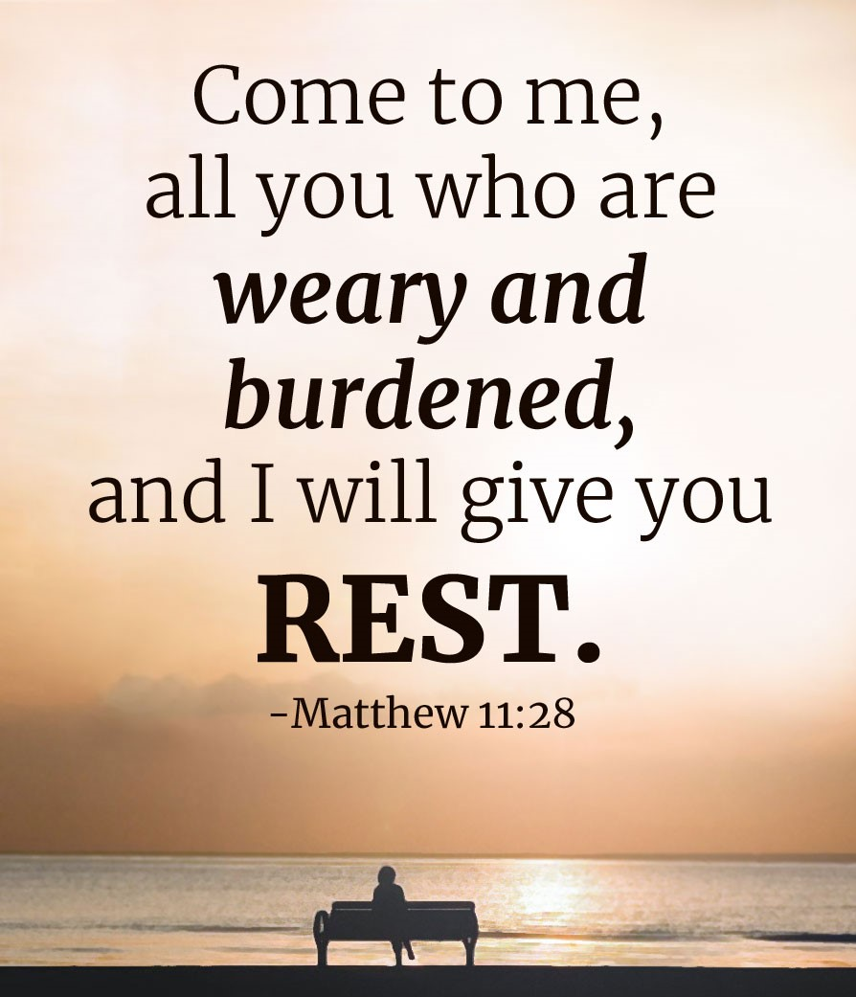

Woe, woe, woe
²⁰ Then Jesus began to denounce the cities in which most of his miracles had been performed, because they did not repent. ²¹ “Woe to you, Korazin! Woe to you, Bethsaida! If the miracles that were performed in you had been performed in Tyre and Sidon, they would have repented long ago in sackcloth and ashes. ²² But I tell you, it will be more bearable for Tyre and Sidon on the day of judgment than for you. ²³ And you, Capernaum, will you be lifted up to the skies? No, you will go down to the depths. If the miracles that were performed in you had been performed in Sodom, it would have remained to this day. ²⁴ But I tell you that it will be more bearable for Sodom on the day of judgment than for you.”
²⁵ At that time Jesus said, “I praise you, Father, Lord of heaven and earth, because you have hidden these things from the wise and learned, and revealed them to little children. ²⁶ Yes, Father, for this was your good pleasure . . . .
Matthew 11:25-30

1) Korazin and the Pharisees know that Jesus is talking about them

2) The “wise and learned” only _______________________ they have insight into God’s kingdom plan

3) Jesus celebrates the child/Father relationship

Athens and Anacortes
²² Paul then stood up in the meeting of the Areopagus and said: “Men of Athens! I see that in every way you are very religious. ²³ For as I walked around and looked carefully at your objects of worship, I even found an altar with this inscription: to an unknown god. Now what you worship as something unknown I am going to proclaim to you.
²⁴ “The God who made the world and everything in it is the Lord of heaven and earth and does not live in temples built by hands. ²⁵ And he is not served by human hands, as if he needed anything, because he himself gives all men life and breath and everything else. ²⁶ From one man he made every nation of men, that they should inhabit the whole earth; and he determined the times set for them and the exact places where they should live. ²⁷ God did this so that men would seek him and perhaps reach out for him and find him, though he is not far from each one of us.
Acts 17:22-27

1) You gotta serve _________________________________________

2) Paul begins by introducing Athens to the God of creation, the God who is present

How to know the Father
²⁵ At that time Jesus said, “I praise you, Father, Lord of heaven and earth, because you have hidden these things from the wise and learned, and revealed them to little children. ²⁶ Yes, Father, for this was your good pleasure.
²⁷ “All things have been committed to me by my Father. No one knows the Son except the Father, and no one knows the Father except the Son and those to whom the Son chooses to reveal him.
²⁸ “Come to me, all you who are weary and burdened, and I will give you rest. ²⁹ Take my yoke upon you and learn from me, for I am gentle and humble in heart, and you will find rest for your souls. ³⁰ For my yoke is easy and my burden is light.”
Matthew 11:25-30

1) To know the Son, I need to take the ________________________________ path

2) To know the Father, I need to “come” and “take” and “learn”

3)

Living into the promise of rest
²⁸ “Come to me, all you who are weary and burdened, and I will give you rest. ²⁹ Take my yoke upon you and learn from me, for I am gentle and humble in heart, and you will find rest for your souls. ³⁰ For my yoke is easy and my burden is light.”
Matthew 11:28-30

1) this is a serious warning for leaders
Then Jesus said to the crowds and to his disciples: ² “The teachers of the law and the Pharisees sit in Moses’ seat. ³ So you must obey them and do everything they tell you. But do not do what they do, for they do not practice what they preach. ⁴ They tie up heavy loads and put them on men’s shoulders, but they themselves are not willing to lift a finger to move them.
Matthew 23:4

2) commands

Everyone who believes that Jesus is the Christ is born of God, and everyone who loves the father loves his child as well. ² This is how we know that we love the children of God: by loving God and carrying out his commands. ³ This is love for God: to obey his commands. And his commands are not burdensome, ⁴ for everyone born of God overcomes the world. This is the victory that has overcome the world, even our faith. ⁵ Who is it that overcomes the world? Only he who believes that Jesus is the Son of God.
1 John 5

3) “to” rather than “after” THIS is the good will of the Father!

Then Jesus declared, “I am the bread of life. He who comes to me will never go hungry, and he who believes in me will never be thirsty. ³⁶ But as I told you, you have seen me and still you do not believe. ³⁷ All that the Father gives me will come to me, and whoever comes to me I will never drive away . . . .”
⁴¹ At this the Jews began to grumble about him . . . .
⁴³ “Stop grumbling among yourselves,” Jesus answered. ⁴⁴ “No one can come to me unless the Father who sent me draws him, and I will raise him up at the last day. ⁴⁵ It is written in the Prophets: ‘They will all be taught by God.’ Everyone who listens to the Father and learns from him comes to me.”
John 6

Resources for further study
J. C. Ryles’ tract “Come” at https://www.monergism.com/come
I appreciated Bob Deffinbaugh’s message on Matthew 11 at https://bible.org/seriespage/22-jesus-john-baptist-and-jews-matthew-111-30
Spurgeon’s “Christ Given Rest” at https://www.spurgeon.org/resource-library/sermons/the-christ-given-rest/#flipbook/

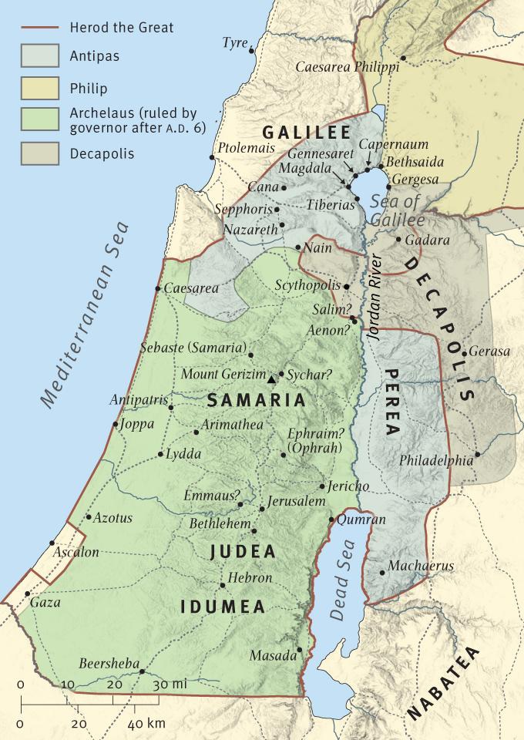

Mt. 11:25–27 has dealt with both the revealing and the concealing activity of the Father and the Son. Where the failure of response in vv. 20–24 corresponds to the concealing activity, the fresh invitation in vv. 28–30 is probably intended to correspond to the revealing activity. The claim is that it is Jesus who delivers on Wisdom’s promises and offers rest and a gentle yoke.
Various features of the unit suggest that it is likely to be formally structured in a careful manner: there are paired words and phrases; there is repetition of key elements;⁸⁸ and there is an evident balancing and linking of clauses. But the successful structuring proposals that have been offered all structure something different from the present text.⁹⁰ Most agree that it is likely that Matthew has disturbed the structure by his own development of the inherited tradition. On the basis of Matthean interests and techniques, maximally, the whole of v. 29 might represent development. Or, less drastically, the development may be restricted to the double ὅτι (‘for/because/that’) clause in v. 29.
Reconstructions generally keep ‘and you will find rest for yourselves’ from v. 29 for the sake of the parallelism with the final clause of Mt. 11:28, but as a quotation from Je. 6:16 it represents an obvious kind of gloss for the ‘rest’ clause of Mt. 11:28. The other parallelism within the unit achieves synthetic development; here we have close paraphrase (admittedly with added interest because of the OT link).
The maximal excision leaves a text in which the doubling in the opening clause is matched by the doubling in the final clause, with ‘and I will give you rest’ in the central place of emphasis. The less drastic excision gives a text in which the imperatival clause in v. 28 with its double description of those addressed is matched by the doubling of verbs for the imperatival section of v. 29; and the promise clause at the end of v. 28 is supported and expanded in the γάρ (‘for’) clause in v. 30, which, following from the earlier doubling, makes use of two forms of doubling, built up chiastically from the use of ‘burdened’ in v. 28 and ‘yoke’ in v. 29. The place of emphasis for this second form would be v. 30. Since the evidence for Matthean interest in the opening double clause of v. 29 is modest, it is not clear which source form is the more likely. Perhaps the difficulty with the image of taking the yoke on oneself (see below) tips the scales in favour of the more radical excision.
Such direct statements as we have in Mt. 11:28–30 are normally denied to the historical Jesus, but there is certainly more of a christological claim in the core historical materials than is often allowed. There is a formal similarity to the call of the fishermen (Mt. 4:19), though the generality here is distinctive. As appears to be the case with some of the Johannine materials, it is possible that we have here a (possibly early church?) verbal formulation of what was more enacted than verbalised by the historical Jesus.
11:28 The call to come to Jesus partly echoes the call of the disciples of 4:19; cf. 9:9, but it is a coming to rather than a coming after. What is implied is developed in v. 29. ‘Come to me’ language belongs on the lips of personified Wisdom or of a teacher of wisdom. But here, for Matthew, the thought of the Son as revealer is also carried forward. It is with him that ultimate wisdom is to be found. At some level this probably makes Jesus ‘Wisdom incarnate’, but while Matthew exploits the wisdom imagery, he is not specifically investing in a wisdom christology.⁹⁴
Who are the ‘weary and burdened’? The reference is not very likely to be to disciples, stressed by the demands of discipleship. Though in Matthew the demands of discipleship are extreme, to identify the disciples as specifically addressed here would produce the convoluted thought that disciples are to come to Jesus to find relief, in a fresh round of learning and taking on the yoke, from pressure created by what has already been taken on from Jesus.⁹⁶ Alternatively, ‘weary and burdened’ could characterise those in favour of whom the Son exercises the choice identified in v. 27—a kind of priority for the poor. This has more to commend it, especially if ‘weary and burdened’ can evoke the people in favour of whom the beatitudes of 5:3–10 are spoken: God’s people chastened by the humiliation of exile and beyond and ready to look to God for help. But perhaps there is no close link with the choice aspect of v. 27 and nothing more is being focussed on than the neediness of God’s people, together and in all their individual circumstances.
‘I will give you rest (ἀναπαύσω)’ implies either support in the task of bearing the load or more likely the removal of the burdens (but implicitly in v. 29 and explicitly in v. 30 this becomes replacement with an easier burden). The rest on offer is presumably intended to be immediately available. In the LXX the use of the ἀναπαυ- root is closely related to ideas of peace and security and, more broadly, to fundamental human well-being. Though the root is used regularly in relation to the sabbath, it is unlikely that an idea of eschatological sabbath rest is to be invoked. The concrete form of Jesus’ ministry in Matthew suggests that we should think broadly of relief brought by Jesus to people from the various kinds of pressures under which they labour. The wisdom allusion is likely to continue, with an echo of Sir. 51:27, where the wisdom teacher testifies to his own experience of drawing near to Wisdom: ‘See … that I have laboured but little and found for myself much rest (ἀνάπαυσιν)’.
11:29 Though a yoke normally linked two animals together for work, the idea of pairing plays no role in the extensive metaphorical use of ‘yoke’ in the OT and Apocrypha. A yoke is seen rather as a means of placing the animal in service: burden, obedience, subordination, and servitude are in view.
We have here in Matthew the unusual imagery of an animal placing a yoke on itself (ἄρατε is literally ‘lift up’). The imperatival structure required to parallel v. 28 means that the initiative must lie with those addressed, but in comparable Jewish sources where human initiative is involved the animal imagery is respected by using qbl (‘accept, receive, choose’). The unusual imagery in Matthew may count in favour of identifying this material as a secondary development (to move directly from v. 28 to v. 30 would allow Jesus to be the one who placed the yoke). Presumably one comes to the person who has the yoke in order to put it on.
The addition of ‘and learn from me’ shapes the image to place the emphasis on obedience to instruction. The challenge to learn has appeared in 9:13 and will come again in 24:32. Its correlates are the description of Jesus as a teacher and his extensive engagement in teaching. The allusion to Sir. 51 is likely to continue: v. 26 has ‘put your neck under her [i.e., Wisdom’s] yoke, and let your souls receive instruction’.¹⁰⁴ It is Jesus who delivers on Wisdom’s promises.
The ὅτι could introduce a supporting reason for learning from Jesus (so: ‘because/for’), or it could identify what is to be learnt (so: ‘that’). But since the learning is linked to the yoke and thus to the content of the servitude intended, learning that Jesus is ‘gentle and humble in heart’ is hardly fitting. The ὅτι clause is motivational: the demands imposed by this yoke will bring relief to the weary and burdened because they are imposed by one who is ‘gentle (πραΰς) and humble in heart’.
πραΰς is a difficult word to translate. It can simply describe the person whose circumstances are humble. In Greek ethical discussion, however, the πραΰς is the one who manifests a well-regulated mastery of his anger (see discussion at 5:5). And the description of Moses as ‘very humble (πραΰς), more so than anyone else on the face of the earth’ identifies him as one who was free of the self-importance of those who are focussed on their own interests. Moderation and other-centredness fit the context in Mt. 11:29. Matthew’s interest in Jesus as πραΰς is reflected in his use in a fulfilment citation in Mt. 21:4–5 of Zc. 9:9 with its identification of the coming king as πραΰς.
Matthew does not use ταπεινός elsewhere. The word normally designates a person who is in or has been reduced to a lowly position. But like πραΰς, it also has an ethical use. An ethical use is signalled here by the addition of τῇ καρδίᾳ (‘in heart’), which performs much the same role as τῷ πνεύματι (‘in spirit’) in Mt. 5:3. The one who is ταπεινός τῇ καρδία is unassuming and demonstrates humility. The link with πραΰς is obvious.
The verse concludes with a quotation from Je. 6:16. Matthew has a text that agrees with the LXX in verb form and in the use of the plural for ψυχαῖς (‘selves’), but with the MT for ‘rest’ (the LXX has ἁγνισμόν [‘sanctification’]). The value to Matthew of the link with Je. 6:16 is that it connects the present offer of peace with God’s offer of peace which, when rejected, led to the Exile.
The inclusion of Mt. 11:29, especially if Matthew is responsible for this verse, strengthens the link with the following material to 12:21: the disciples have taken the yoke and are permitted to satisfy their hunger on the sabbath; the Pharisees are critical of this only because they have yet to learn what Jesus drew their attention to already in 9:13 and will remind them of again in 12:7; in Jesus’ regime ‘it is lawful to do good on the sabbath’, and so the man with the withered hand is healed (vv. 10–13); Jesus is gentle and humble in heart, so ‘he will not wrangle’ and ‘he will not break a bruised reed’ (vv. 19–20).
11:30 We are now told why the yoke of Jesus is to be preferred to that under which people are presently labouring. It is not clear precisely what is meant by saying that the yoke is χρηστός. χρηστός is a broad word and means anything from ‘useful’ and ‘suitable’ to ‘good’ and ‘kind’. The reference is probably to a well-designed yoke which distributed the load comfortably, for the weariness of load bearing can be considerably reduced by a well-designed yoke. However, a yoke which was the means of harnessing the animal to a heavy burden was, by a kind of metonymy, spoken of as a heavy yoke. So an alternative metonymy might allow us to understand a yoke that is χρηστός as the kind of burden that might be imposed by an owner who is kind. From the yoke we turn to the load itself. The weary and burdened of v. 28 are offered a substitute burden that is light.
The text leaves totally unexplained the sense in which coming to Jesus results in carrying a lighter and more comfortable load. At the most general level it clearly reiterates here the claim that Jesus brings good news (see, e.g., the discussion at 4:23 of ‘gospel of the kingdom’). It is unlikely that any of the precise proposals offered in the scholarship represents the express intention of the Matthean text. Perhaps we are intended to sense the paradox in being told by a man who makes such stringent demands on his disciples that the burden he imposes is light! The paradox is to be resolved in the experience of the Christian life.¹¹¹

 | 25 |  | Ἐν |  | ἐκείνῳ |  | τῷ |  | καιρῷ |  | ἀποκριθεὶς |  | ὁ |  | Ἰησοῦς |  | εἶπεν | ·
 |  |  | ἐν |  | ἐκεῖνος |  | ὁ |  | καιρός |  | ἀποκρίνομαι |  | ὁ |  | Ἰησοῦς |  | εἶπον
 |  |  | In |  | that |  | the |  | season |  | having answered |  | the |  | Jesus |  | said
 |  |  | PD |  | OADMSD |  | AMSD |  | NMSD |  | VAPPMSN |  | AMSN |  | NMSN |  | V3SAAI | SJ

ἐξομολογοῦμαί |  | σοι | , |  | πάτερ | , |  | κύριε |  | τοῦ |  | οὐρανοῦ |  | καὶ |  | τῆς |  | γῆς | ,
ἐξομολογέω |  | σύ |  |  | πατήρ |  |  | κύριος |  | ὁ |  | οὐρανός |  | καί |  | ὁ |  | γῆ
I confess out |  | to you |  |  | father |  |  | Master |  | of the |  | heaven |  | and |  | the |  | land
V1SPMI |  | OP2 SD | SN |  | NMSV | SN |  | NMSV |  | AMSG |  | NMSG |  | CCK |  | AFSG |  | NFSG | SN

ὅτι |  | ἔκρυψας |  | ταῦτα |  | ἀπὸ |  | σοφῶν |  | καὶ |  | συνετῶν |  | καὶ |  | ἀπεκάλυψας
ὅτι |  | κρύπτω |  | οὗτος |  | ἀπό |  | σοφός |  | καί |  | συνετός |  | καί |  | ἀποκαλύπτω
because |  | you hid |  | these |  | from |  | wise |  | and |  | understanding |  | and |  | you uncovered
CSN |  | V2SAAI |  | ODENPA |  | PG |  | JMPGX |  | CCK |  | JMPGX |  | CCK |  | V2SAAI

αὐτὰ |  | νηπίοις | · |  |  |  | 26 |  | ναὶ |  | ὁ |  | πατήρ | , |  | ὅτι |  | οὕτως |  | εὐδοκία |  | ἐγένετο
αὐτός |  | νήπιος |  |  |  |  |  |  | ναί |  | ὁ |  | πατήρ |  |  | ὅτι |  | οὕτως |  | εὐδοκία |  | γίνομαι
them |  | to infants |  |  |  |  |  |  | yes |  | the |  | father |  |  | because |  | thusly |  | good thought |  | it became
OP3NPA |  | JMPDX | SJ |  |  |  |  |  | TM |  | AMSV |  | NMSV | SN |  | CSC |  | BX |  | NFSN |  | V3SAMI

ἔμπροσθέν |  | σου | . |  |  |  | 27 |  | Πάντα |  | μοι |  | παρεδόθη |  | ὑπὸ |  | τοῦ |  | πατρός |  | μου
ἔμπροσθεν |  | σύ |  |  |  |  |  |  | πᾶς |  | ἐγώ |  | παραδίδωμι |  | ὑπό |  | ὁ |  | πατήρ |  | ἐγώ
in front |  | of you |  |  |  |  |  |  | All |  | to me |  | was given over |  | by |  | the |  | father |  | of me
MG |  | OP2 SG | SJ |  |  |  |  |  | JNPNX |  | OP1 SD |  | V3SAPI |  | PG |  | AMSG |  | NMSG |  | OP1 SG

, |  | * | καὶ |  | οὐδεὶς |  | ἐπιγινώσκει |  | τὸν |  | υἱὸν |  | εἰ |  | μὴ |  | ὁ |  | πατήρ | , |  | οὐδὲ
 |  |  | καί |  | οὐδείς |  | ἐπιγινώσκω |  | ὁ |  | υἱός |  | εἰ |  | μή |  | ὁ |  | πατήρ |  |  | οὐδέ
 |  |  | and |  | no one |  | perceives |  | the |  | son |  | except |  | [n/a] |  | the |  | father |  |  | but not
SN |  |  | CCK |  | JMSNX |  | V3SPAI |  | AMSA |  | NMSA |  | CSE |  | TN |  | AMSN |  | NMSN | SN |  | CCD

τὸν |  | πατέρα |  | τις |  | ἐπιγινώσκει |  | εἰ |  | μὴ |  | ὁ |  | υἱὸς |  | καὶ |  | ᾧ
ὁ |  | πατήρ |  | τὶς |  | ἐπιγινώσκω |  | εἰ |  | μή |  | ὁ |  | υἱός |  | καί |  | ὅς
the |  | father |  | any |  | perceives |  | except |  | [n/a] |  | the |  | son |  | and |  | to whom
AMSA |  | NMSA |  | OIFMSN |  | V3SPAI |  | CSE |  | TN |  | AMSN |  | NMSN |  | CCK |  | ORRMSD

ἐὰν |  | βούληται |  | ὁ |  | υἱὸς |  | ἀποκαλύψαι | .
ἐάν |  | βούλομαι |  | ὁ |  | υἱός |  | ἀποκαλύπτω
if |  | might plan |  | the |  | son |  | to uncover
TU |  | V3SPMS |  | AMSN |  | NMSN |  | VAAN | SJ

 | 28 |  | Δεῦτε |  | πρός |  | με |  | πάντες |  | οἱ |  | κοπιῶντες |  | καὶ |  | πεφορτισμένοι | ,
 |  |  | δεῦτε |  | πρός |  | ἐγώ |  | πᾶς |  | ὁ |  | κοπιάω |  | καί |  | φορτίζω
 |  |  | Come |  | toward |  | me |  | all |  | the ones |  | laboring |  | and |  | ones having been packed
 |  |  | I |  | PA |  | OP1 SA |  | JMPVX |  | AMPV |  | VPAPMPV |  | CCK |  | VRPPMPV | SN

 | κἀγὼ |  | ἀναπαύσω |  | ὑμᾶς | . |  |  |  | 29 |  | ἄρατε |  | τὸν |  | ζυγόν |  | μου |  | ἐφʼ |  | ὑμᾶς |  | καὶ
 | καί |  | ἀναπαύω |  | ὑμεῖς |  |  |  |  |  |  | αἴρω |  | ὁ |  | ζυγός |  | ἐγώ |  | ἐπί |  | ὑμεῖς |  | καί
 | and I |  | will give rest |  | you |  |  |  |  |  |  | Lift up |  | the |  | yoke |  | of me |  | on |  | you |  | and
 | OP1 SN |  | V1SFAI |  | OP2 PA | SJ |  |  |  |  |  | V2PAAM |  | AMSA |  | NMSA |  | OP1 SG |  | PA |  | OP2 PA |  | CCK

μάθετε |  | ἀπʼ |  | ἐμοῦ | , |  | ὅτι |  | πραΰς |  | εἰμι |  | καὶ |  | ταπεινὸς |  | τῇ |  | καρδίᾳ | ,
μανθάνω |  | ἀπό |  | ἐγώ |  |  | ὅτι |  | πραΰς |  | εἰμί |  | καί |  | ταπεινός |  | ὁ |  | καρδία
learn |  | from |  | me |  |  | because |  | gentle |  | I am |  | and |  | humble |  | in the |  | heart
V2PAAM |  | PG |  | OP1 SG | SN |  | CSC |  | JMSNX |  | V1SPAI |  | CCK |  | JMSNX |  | AFSD |  | NFSD | SN

καὶ |  | εὑρήσετε |  | ἀνάπαυσιν |  | ταῖς |  | ψυχαῖς |  | ὑμῶν | · |  |  |  | 30 |  | ὁ |  | γὰρ |  | ζυγός |  | μου
καί |  | εὑρίσκω |  | ἀνάπαυσις |  | ὁ |  | ψυχή |  | ὑμεῖς |  |  |  |  |  |  | ὁ |  | γάρ |  | ζυγός |  | ἐγώ
and |  | you will find |  | rest |  | to the |  | souls |  | of you |  |  |  |  |  |  | The |  | for |  | yoke |  | of me
CCK |  | V2PFAI |  | NFSA |  | AFPD |  | NFPD |  | OP2 PG | SJ |  |  |  |  |  | AMSN |  | CCX |  | NMSN |  | OP1 SG

 | χρηστὸς |  | καὶ |  | τὸ |  | φορτίον |  | μου |  | ἐλαφρόν |  | ἐστιν | .
 | χρηστός |  | καί |  | ὁ |  | φορτίον |  | ἐγώ |  | ἐλαφρός |  | εἰμί
 | kind |  | and |  | the |  | pack |  | of me |  | light |  | is
 | JMSNX |  | CCK |  | ANSN |  | NNSN |  | OP1 SG |  | JNSNX |  | V3SPAI | SJ

Nolland, J. (2005). The Gospel of Matthew: a commentary on the Greek text (pp. 474–478). Grand Rapids, MI; Carlisle: W.B. Eerdmans; Paternoster Press.
Nestle, E., Nestle, E., Aland, B., Aland, K., Karavidopoulos, J., Martini, C. M., & Metzger, B. M. (1993). The Greek New Testament (27th ed., Mt 11:25–30). Deutsche Bibelgesellschaft: Stuttgart.

