1 Peter: Living Stone and living stones
Living Hope Series #2, 1 Peter 1:13-2:12 June 14, 2020
Therefore, prepare your minds for action . . . .
As you came to him, the Living Stone –
rejected by men but chosen by God and precious to him – you also,
as living stones, are being built into a spiritual house to be a royal priesthood, offering spiritual sacrifices acceptable to God through Jesus Christ.
1 Peter 1:13-2:5

Total salvation

For you have been born again . . . .
¹³ Therefore, prepare your minds for action; be self-controlled; set your hope fully on the grace to be given you when Jesus Christ is revealed. ¹⁴ As obedient children, do not conform to the evil desires you had when you lived in ignorance. ¹⁵ But just as he who called you is holy, so be holy in all you do; ¹⁶ for it is written: “Be holy, because I am holy.”
¹⁷ Since you call on a Father who judges each man’s work impartially, live your lives as strangers here in reverent fear. ¹⁸ For you know that it was not with perishable things such as silver or gold that you were redeemed from the empty way of life handed down to you from your forefathers, ¹⁹ but with the precious blood of Christ, a lamb without blemish or defect. ²⁰ He was chosen before the creation of the world, but was revealed in these last times for your sake. ²¹ Through him you believe in God, who raised him from the dead and glorified him, and so your faith and hope are in God.
²² Now that you have purified yourselves by obeying the truth so that you have sincere love for your brothers, love one another deeply, from the heart. ²³ For you have been born again, not of perishable seed, but of imperishable, through the living and enduring word of God.
1 Peter 1:13-23 (quoting Leviticus 19:2; see also Isaiah 40:6-8)

1) This is Peter’s Romans 12 moment:_____________________________________________________

2) Peter points us to ____________________________

3) Then Peter points us to ________________________________ (see Romans 12:9-21)

The first sign of new life
Therefore, rid yourselves of all malice and all deceit, hypocrisy, envy, and slander of every kind. ² Like newborn babies, crave pure spiritual milk, so that by it you may grow up in your salvation, ³ now that you have tasted that the Lord is good.
1 Peter 2:1-3

1) ____________________________________ is the first sign of the New Birth

2) Maturity means I know what to ___________________________________________

Union with Christ and connection to each other
⁴ As you come to him, the living Stone—rejected by men but chosen by God and precious to him— ⁵ you also, like living stones, are being built into a spiritual house to be a holy priesthood, offering spiritual sacrifices acceptable to God through Jesus Christ. ⁶ For in Scripture it says:
“See, I lay a stone in Zion,
a chosen and precious cornerstone,
and the one who trusts in him
will never be put to shame.”
⁷ Now to you who believe, this stone is precious. But to those who do not believe,
“The stone the builders rejected
has become the capstone,”
⁸ and,
“A stone that causes men to stumble
and a rock that makes them fall.”
They stumble because they disobey the message—which is also what they were destined for.
⁹ But you are a chosen people, a royal priesthood, a holy nation, a people belonging to God, that you may declare the praises of him who called you out of darkness into his wonderful light. ¹⁰ Once you were not a people, but now you are the people of God; once you had not received mercy, but now you have received mercy.
1 Peter 2:4-11

1) Five pictures of our connection:

to Jesus: _________________________________________________________

to each other: _________________________________________________________

living stones built into spiritual house:

chosen people:

royal priesthood:

holy nation:

people belonging to God:

2) ________________________________ comes before ______________________________

Good lives in an age of pandemic and protest
Dear friends, I urge you, as aliens and strangers in the world, to abstain from sinful desires, which war against your soul. ¹² Live such good lives among the pagans that, though they accuse you of doing wrong, they may see your good deeds and glorify God on the day he visits us.
1 Peter 2:11-12 (be sure to look at the “submit yourselves” passage which follows)

________________________________________ is our first response to pandemic and violence:

1) Be present in our community so that we have a voice in what comes next

3) Commit first to non-violence (“with malice toward none, with charity toward all”)

Resources for further studies of 1 Peter
I found Kenneth Wuest’s “First Peter in the Greek New Testament” very helpful (Eerdmans, 1942).
Bob Deffinbaugh’s sermons on 1 Peter at https://bible.org/series/glory-suffering-studies-1-peter
Spurgeon’s series of messages on 1 Peter at https://www.spurgeon.org/resource-library/sermons/by-scripture/1-peter
ThirdMill has a collection of sermons on 1 Peter at https://thirdmill.org/sermons/series.asp/srs/1%20Peter
John Piper has a wonderful series of sermons at desiringgod.org but the best might be “God’s Great Mercy and Our New Birth” at https://www.desiringgod.org/messages/gods-great-mercy-and-our-new-birth. He borrows from John Bunyan’s “Last Sermon” on John 3:13 at https://biblehub.com/library/bunyan/
the_works_of_john_bunyan_volumes_1-3/mr_bunyans_last_sermon_.htm
Reformation21’s “resident aliens” blog on suffering at https://www.reformation21.org/blog/suffering-and-redemption
Ligon Duncan, and other First Presbyterian, Jackson, preachers has a wonderful series of messages at https://www.fpcjackson.org/resource-library/sermons/scripture/1-peter
Karen H. Jobes’ commentary of 1 Peter in the Baker Exegetical Commentary series (Baker Academic, 2005).
The Gospel Coalition produced this animated introduction (on which this week’s coloring page is based) and study taken from the ESVSB at https://www.thegospelcoalition.org/course/1-peter-introduction/#overview
Jonathan Edwards’ wonderful 1 Peter 2:9-10 sermon at https://www.biblebb.com/files/edwards/chosen.htm
The Gospel Coalition offers a introductory lecture series on 1 Peter at https://www.thegospelcoalition.org/course/study-1-peter/#course-introduction

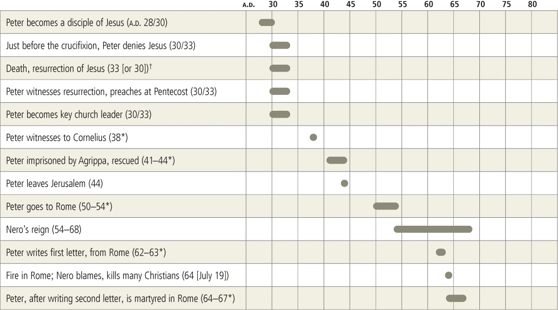

Foreigners (1:1a)
Most modern interpreters understand the address to Peter’s readers as “foreigners” to be a metaphor that describes the Christian’s relationship to the world. By virtue of faith in Christ, home is heaven, and Christians therefore are just passing through this world as foreigners (see “Recipients” in the introduction). The term parepidēmos (plural, parepidēmoi) was used in the first century to designate someone who did not hold citizenship in the place where he resided and was therefore viewed as a foreigner. The lack of citizenship implied that such people did not enjoy all the rights and privileges of citizens. Moreover, as foreigners, they were not necessarily expected to hold the values and practice the customs of their host culture. Because of such differences, foreigners were often looked upon suspiciously as potentially subversive to the established social order, an attitude not unfamiliar even today.
J. H. Elliott (1981) argues that this term should be understood as describing the actual sociopolitical situation of the people to whom Peter was writing before their conversion to Christ, a conversion that only further marginalized them from the dominant society. Although Elliott’s argument has been unconvincing to most interpreters, it has called attention to the issue of the social and historical setting of the addressees and the occasion that prompted the letter to be written (Achtemeier 1984; Chin 1991; Clowney 1988: 228; Dalton 1983; Danker 1983; Hemer 1985; Porter 1993. McKnight 1996: 48–51 stands alone in following Elliott).
This commentary presents the possibility that the people to whom Peter writes were Christians from Rome who were deported to Roman colonies in Asia Minor during one of the several expulsions in the first century (see “Roman Colonization and the Origin of 1 Peter” in the introduction). Peter, the apostle associated with Rome, uses their disorienting experience to instruct and encourage them with his insight that all Christians are in a real sense foreigners to their place of residence, regardless of where they are living, whenever Christian values and customs conflict with those of the dominant society.
Peter again describes his readers as parepidēmoi in 2:11: “Dear friends, I urge you, as resident aliens [paroikoi] and foreigners [parepidēmoi], to abstain from the carnal desires, which war against your soul.” Other than these two occurrences in 1 Peter, the word parepidēmoi occurs elsewhere in the NT only in Heb. 11:13: “All these people were still living by faith when they died. They did not receive the things promised; they only saw them and welcomed them from a distance, admitting that they were strangers and foreigners [parepidēmoi] on earth.” The word occurs only twice in the LXX. In Gen. 23:4 LXX Abraham describes himself as an alien (paroikos) and a foreigner (parepidēmos) while living among the Hittites. In Ps. 38:13 LXX (39:12 MT/Eng.), the psalmist likewise refers to himself as a foreigner (parepidēmos) as well as an alien (paroikos) with respect to the Lord. These two OT occurrences of parepidēmos do not seem to constitute a biblical metaphor that Peter is extending to his readers. (A different case may perhaps be made for paroikos, but that word does not appear in the opening address. See comments on 2:11.)
Rather than understanding parepidēmos in 1:1 as describing the believers’ transitory life on this earth as a journey toward their heavenly home, it should be understood primarily as defining the relationship between the Christian and unbelieving society. Goppelt (1993: 67–68) explains:
The sociological effect of being a foreigner is in view: Christians distance themselves as nonconformists from handed-down life-styles (1:17f.); therefore, those around them are “estranged” regarding them (4:3f.). In both Christians and those around them the effects of this foreignness can or should be felt—the letter speaks of this in the parenesis—but the foreignness is established by election.
These foreigners are not addressed as a single group. That is, in contrast to Paul, Peter notably does not address his readers as the ἐκκλησίαι (ekklēsiai, assemblies, churches) in the named provinces. Goppelt (1993: 64) sees this as
characterizing them in the horizontal dimension in light of their relationship to the world around them: They have been set apart from the nations of the world by election and live scattered among them as foreigners who have no homeland here. The very address thus envisages the theme of the letter: Christians in society. It does not have particular churches in mind, but Christians in the everyday world living among their fellow human beings.
Peter uses the term “foreigner” to distance his readers from the hold their society may have over them. Nevertheless, Peter does not call them to withdraw from society but will instead present Christian engagement with society in the mode that might be expected of foreigners who wish to maintain their identity of origin. That is, foreigners dwell respectfully in their host nation but participate in its culture only to the extent that its values and customs coincide with their own that they wish to preserve. In this way the salutation of the letter introduces a concept of a differentiated engagement with society that subsequently will be expanded in terms of neither full assimilation nor complete withdraw

Jobes, K. H. (2005). 1 Peter (pp. 61–62). Grand Rapids, MI: Baker Academic.

