Meeting the Redeemer in the Prophets
Luke 24:44-47; Isaiah 59:15-21 May 10, 2020
“The Redeemer will come to Zion,
to those in Jacob who repent of their sins,” declares the Lord.
Isaiah 59:20
And so all Israel will be saved, as it is written:
“The deliverer will come from Zion; he will turn godlessness away from Jacob.
And this is my covenant with them when I take away their sins.”
Romans 11:26-27 (Paul quotes Isaiah 59, 27:9 and Jeremiah 31:33-34)
The Scriptures and “what is written”
He said to them, “This is what I told you while I was still with you:
Everything must be fulfilled that is written about me in the Law of Moses, the Prophets and the Psalms.”
Then he opened their minds so they could understand the Scriptures. He told them,
“This is what is written: The Christ will suffer and rise from the dead on the third day,
and repentance and forgiveness of sins will be preached in his name to all nations, beginning in Jerusalem.”
Luke 24:44-47

1) The Old Testament is ____________________ searching for __________________________________

2) Repentance (especially in the OT) means ____________________________________________

3) In the prophets, theology is __________________________ on ________________________________
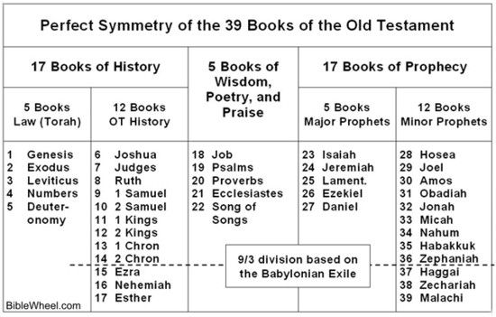

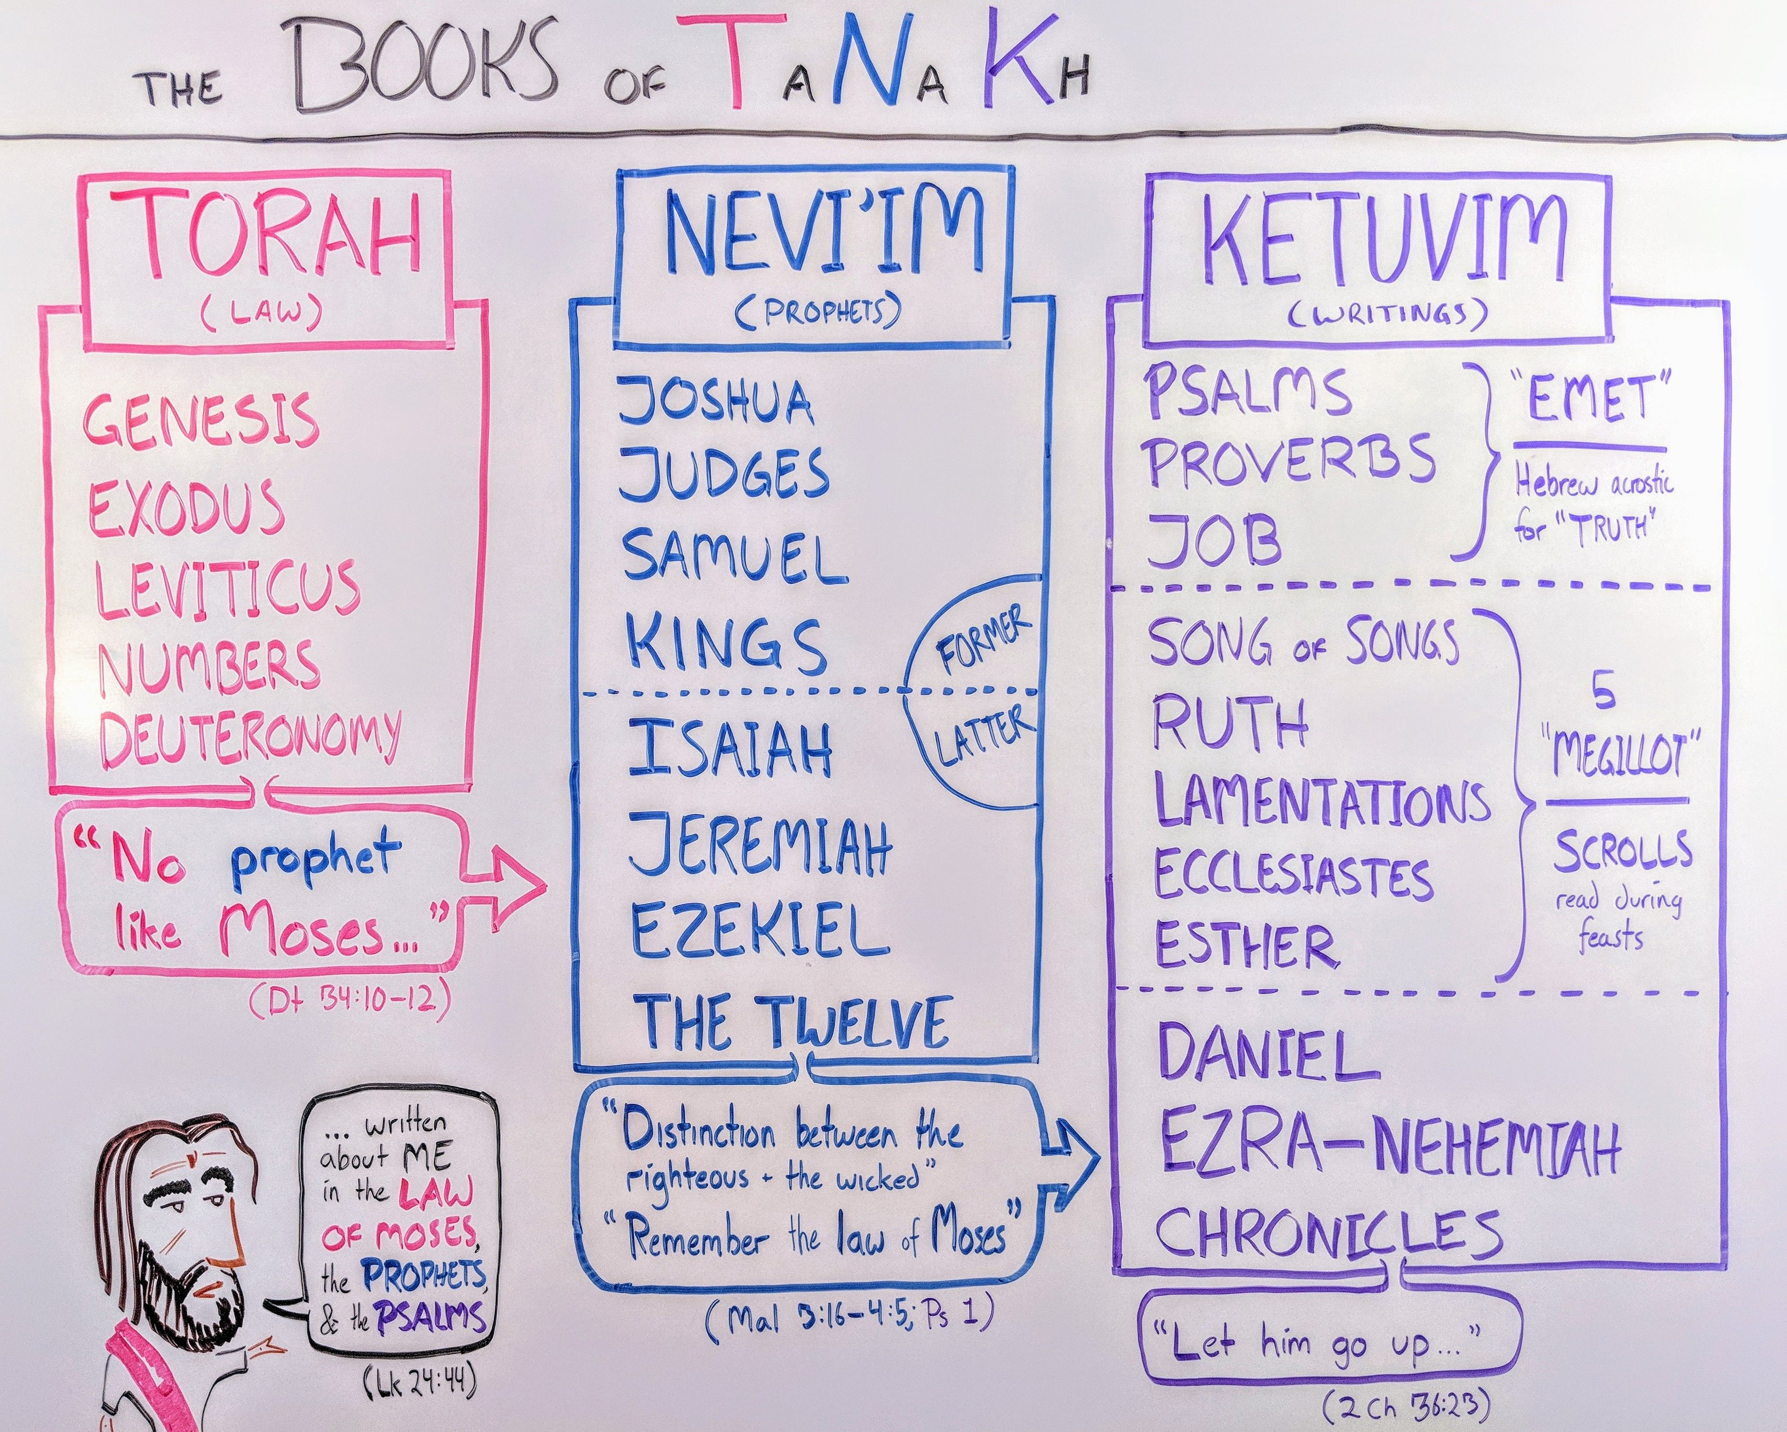
When Prophets speak today
Now these things occurred as an example to keep us from setting our hearts on evil things as they did . . . .
These things happened to them examples and were written down as warning for us
on whom the fulfillment of the ages has come. So if you are standing firm, be careful that you don’t fall!
1 Corinthians 10:6-13

1) Prophets present a different hermeneutic challenge because

1. the _______________________________________ is not as clear at in Torah

2. we need to learn the discipline of reading ___________________________________

2) Finding my ______________________________________________ :

1. in the “former prophets”: Joshua, Judges, Samuel, Kings and Ruth(?)

2. in the “latter prophets” (760-460 BC)

3) Three lenses for the Prophets (often combined in a particular passage):

1. Covenant lawsuit: Isaiah 1:2, 3:13-4:1 (but see 4:2-6 for restoration!); Hosea 3:3-17

2. Woe oracles: Habakkuk 2:6-8; Micah 2:1-5

3. Promise oracles: Amos 9:11-15; Isaiah 60-66
note: remember the multiple fulfillments of the “Day of the Lord” eschatology

Finding Jesus in Isaiah 59
Surely the arm of the Lord not too short to save, nor his ear to dull to hear.
But your iniquities have separated you from your God . . . .
The Lord look as was displeased that there was no justice.
He say that there was no one, he was appalled that there was no one to intervene;
so his own arm worked salvation for him, and his own righteousness sustained him . . . .
“The Redeemer will come to Zion, to those in Jacob who repent of their sins,” declares the Lord.
“As for me, this is my covenant with them,” declares the Lord.
“My Spirit, who is on you, and my words that I have put in your mouth will not depart from your mouth,
or from the mouths of your children, or from the mouths of their descendants
from this time on and forever,” says the Lord.
Isaiah 59:1-21

1) Summarize the covenant commentary of this text.

What are the important Old Testament parallels and New Testament discussions of this text?

Exodus 6:6

Ruth (especially 4:1-12)

Acts 2:38-39

Romans 11:25-32

2) What did I learn about the Suffering Messiah?

3) What did I learn about the Exalted Christ?

4) What did I learn about repentance and forgiveness of sins?

5) Application:

-- what is the Holy Spirit telling me about my relationship with the suffering and exalted Christ?

-- what is the Holy Spirit telling me about my role as herald to the nations?

Resources for “Meeting the Redeemer in the Prophets”
Spurgeon’s sermon on Ruth at http://spurgeon.org/resource-library/sermons/thy-redeemer
Third Mill does a great job on the introducing the tough job of interpreting the prophets at https://thirdmill.org/seminary/lesson.asp?vs=HGP&ln=1&df=y
Ladd’s “The Hermeneutics of Prophecy” at https://www.google.com/url?sa=t&rct=j&q=&esrc=
s&source=web&cd=4&ved=2ahUKEwjp3smFl6PpAhVXj54KHVoqDlMQFjADegQIBBAB&url=https%3A%2F%2Fplace.asburyseminary.edu%2Fcgi%2Fviewcontent.cgi%3Farticle%3D1941%26context%3Dasburyjournal&usg=AOvVaw2CsmTnBsXGALlM5hQyI4M-
There are many good introductions to the prophets, but Allen Ross’ introduction to Isaiah at Bible.org is very good at https://bible.org/seriespage/introduction-study-book-isaiah
Christ Presbyterian Church, New Haven, CT, has produced an interesting study in hermeneutics at https://www.cpcnewhaven.org/bible-interpretation-hermeneutics
Bryan Chapell’s Christ-Centered Preaching (Baker Academic, 2005) is my favorite contemporary book on Christological preaching in the Old Testament.
Paul Scott Wilson’s The Four Pages of the Sermon (Abingdon Press, 1999) is the preaching text used at Calvin Seminary.
There is a good summary of the canon of the Old Testament in Wegner’s “The Canon of Scripture in Jesus’ Day at https://arcapologetics.org/objections/the-canon-of-scripture-in-jesus-day/
Richard Pratt has some interesting warnings about prophecy at https://thirdmill.org/newfiles/ric_pratt/ric_pratt.OT.prophecy.html
J. C. Ryle’s work on sin in the prophets in http://articles.ochristian.com/article15970.shtml
I still am using the themes from J. C. Ryle’s short commentary on the Luke 24 at https://www.gracegems.org/Ryle/l24.htm

