Lament and Hope:
Meeting the Redeemer in the Writings
Luke 24:44-47; Psalm 143; May 17, 2020
O Lord, hear my prayer, listen to my cry for mercy;
in your faithfulness and righteousness come to my relief . . . .
For your name’s sake, O Lord, preserve my life;
in your righteousness, bring me out of trouble.
In your unfailing love, silence my enemies;
destroy all my foes, for I am your servant.
Psalm 143:1, 11-12

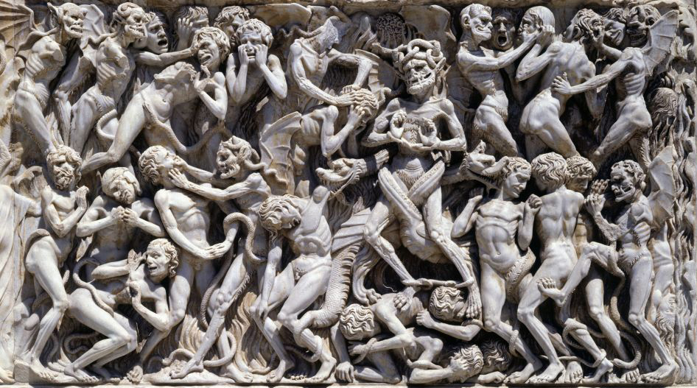
A 14th-century “Last Judgment” relief from a facade of Orvieto cathedral in Umbria. Italy.
See Kim Haines-Eitzen’s “Ancient Texts” article at
https://getpocket.com/explore/item/ancient-texts-encouraged-hope-and-endurance-
when-they-spoke-of-end-times?utm_source=pocket-newtab

The Scriptures and “what is written”
He said to them, “This is what I told you while I was still with you:
Everything must be fulfilled that is written about me in the Law of Moses, the Prophets and the Psalms.”
Then he opened their minds so they could understand the Scriptures. He told them,
“This is what is written: The Christ will suffer and rise from the dead on the third day,
and repentance and forgiveness of sins will be preached in his name to all nations, beginning in Jerusalem.”
Luke 24:44-47

1) The Old Testament is ____________________ searching for __________________________________

but, don’t allow type to become allegory:

2) For a Redeemer, God’s OT poets and sages and priests were looking for ________________________

3) In the writings, theology is first of all _______________________ to God’s _____________________

When the Writings speak today
Now these things occurred as an example to keep us from setting our hearts on evil things as they did . . . .
These things happened to them examples and were written down as warning for us
on whom the fulfillment of the ages has come. So if you are standing firm, be careful that you don’t fall!
1 Corinthians 10:6-13

1) The Writings are different:

1. A variety of ______________________________________________________________

2. An outpouring of _____________________ (but not ______________________________ )

2) Two keys to the Writings

1. Wisdom reflects life ________________________________________________________

2. The Writings give me ___________________________ to respond to

my ________________________________________________________

God’s ______________________________________________________

3) Hermeneutic helps:

1. Walk through the Writings with a _____________________________________________

2. Find the question that ____________________________________________ answers

3. _________________________ more than __________________________

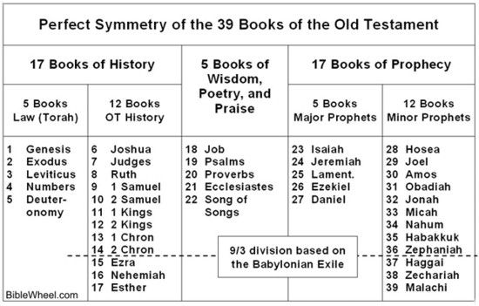

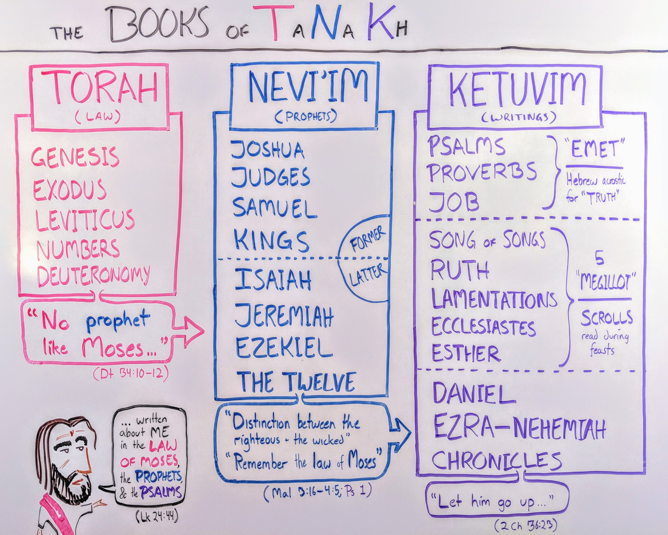
Finding Jesus in Psalm 143
A psalm of David.
¹ O Lord, hear my prayer, listen to my cry for mercy;
in your faithfulness and righteousness come to my relief.
² Do not bring your servant into judgment,
for no one living is righteous before you.
³ The enemy pursues me, he crushes me to the ground;
he makes me dwell in darkness like those long dead.
⁴ So my spirit grows faint within me;
my heart within me is dismayed.
⁵ I remember the days of long ago;
I meditate on all your works and consider what your hands have done.
⁶ I spread out my hands to you;
my soul thirsts for you like a parched land. Selah
⁷ Answer me quickly, O Lord; my spirit fails.
Do not hide your face from me or I will be like those who go down to the pit.
⁸ Let the morning bring me word of your unfailing love, for I have put my trust in you.
Show me the way I should go, for to you I lift up my soul.
⁹ Rescue me from my enemies, O Lord, for I hide myself in you.
¹⁰ Teach me to do your will, for you are my God;
may your good Spirit lead me on level ground.
¹¹ For your name’s sake, O Lord, preserve my life;
in your righteousness, bring me out of trouble.
¹² In your unfailing love, silence my enemies;
destroy all my foes, for I am your servant.

1) Summarize the “voice” I am given in this prayer. Hint: watch for the changes in pronouns!

What are the important Old Testament parallels and New Testament discussions of this text?

1. Psalm 77:7-15 reflects the same emphasis on remembering (see 143:5)

2. For the “bookends” of God’s righteousness see the Genesis 15 – Romans 4 connection

3. For a discussion on the character of God, Exodus 34:1-7 and Romans 2:1-4 are a good start

2) What did I learn about the Suffering Messiah?

3) What did I learn about the Exalted Christ?

4) What did I learn about repentance and forgiveness of sins?

5) Application:

-- what is the Holy Spirit telling me about my relationship with the suffering and exalted Christ?

-- what is the Holy Spirit telling me about my role as herald to the nations?

Resources for “Meeting the Redeemer in the Writings”
Spurgeon’s sermon on Ruth at http://spurgeon.org/resource-library/sermons/thy-redeemer
John Piper has an interesting sermon on Psalm 143 at https://www.desiringgod.org/messages/how-to-argue-with-god
Third Mill study notes on Psalm 143 at https://web.archive.org/web/20150425055317/http://thirdmill.org/studybible/note.asp/id/45433
Third Mill does a great job on the introducing the tough job of interpreting the prophets and writings at https://thirdmill.org/seminary/lesson.asp?vs=HGP&ln=1&df=y
Reformed Perspectives has 180+ articles and sermons on wisdom literature in Scripture at http://reformedperspectives.org/search.asp/kw/Poetry%20and%20Wisdom/kwtype//scat//st/articles/au//rpc/1/apc//vpc//qpc//Rrpp/10/Vrpp//Qrpp//Arpp/
Peter Kroll has a very interesting article on the canonicity of the Writings at https://www.knowableword.com/2013/03/27/11-old-testament-books-never-quoted-in-the-new-testament/
Kim Haines-Eitzen, religion professor at Cornell, has an interesting article on hope at https://getpocket.com/explore/item/ancient-texts-encouraged-hope-and-endurance-when-they-spoke-of-end-times?utm_source=pocket-newtab
Alexander Maclaren’s commentary at https://thirdmill.org/magazine/article.asp/link/ale_maclaren%5Eale_maclaren.ES.4B.html/at/Expositions%20of%20Holy%20Scripture
Bob Deffinbaugh has an accessible introduction to the Psalms at https://bible.org/seriespage/wisdom-literature-psalms-part-i and Proverbs at https://bible.org/seriespage/wisdom-literature-proverbs
Christ Presbyterian Church, New Haven, CT, has produced an interesting study in hermeneutics at https://www.cpcnewhaven.org/bible-interpretation-hermeneutics
Bryan Chapell’s Christ-Centered Preaching (Baker Academic, 2005) is my favorite contemporary book on Christological preaching in the Old Testament.
Paul Scott Wilson’s The Four Pages of the Sermon (Abingdon Press, 1999) is the preaching text used at Calvin Seminary.
There is a good summary of the canon of the Old Testament in Wegner’s “The Canon of Scripture in Jesus’ Day at https://arcapologetics.org/objections/the-canon-of-scripture-in-jesus-day/
Richard Pratt has some interesting warnings about prophecy at https://thirdmill.org/newfiles/ric_pratt/ric_pratt.OT.prophecy.html
J. C. Ryle’s introduction to the Psalms at https://www.studylight.org/commentaries/ryl/psalms.html
I still am using the themes from J. C. Ryle’s short commentary on the Luke 24 at https://www.gracegems.org/Ryle/l24.htm

Psalm 143 (reorganized by Pastor Fakkema, but see the ESV for another organization)
A psalm of David.
opening theme: hear me
¹ O Lord, hear my prayer, listen to my cry for mercy;
in your faithfulness and righteousness come to my relief.
² Do not bring your servant into judgment,
for no one living is righteous before you.
the lament cry of the victim
³ The enemy pursues me, he crushes me to the ground;
he makes me dwell in darkness like those long dead.
⁴ So my spirit grows faint within me;
my heart within me is dismayed.
the same refocus on God as Psalm 77: remember God’s work in creation and redemption (but make it personal)
⁵ I remember the days of long ago;
I meditate on all your works and consider what your hands have done.
⁶ I spread out my hands to you;
my soul thirsts for you like a parched land. Selah
second request and repeat of opening theme: answer me
⁷ Answer me quickly, O Lord; my spirit fails.
Do not hide your face from me or I will be like those who go down to the pit.
Psalmist’s response to God’s hesed love in five “fors”
⁸ Let the morning bring me word of your unfailing love,
for I have put my trust in you.
Show me the way I should go,
for to you I lift up my soul.
⁹ Rescue me from my enemies, O Lord,
for I hide myself in you.
¹⁰ Teach me to do your will,
for you are my God;
shift from “I” to “your” with an appeal to God’s presence in his Spirit (with a reflection of Psalm 23)
may your good Spirit lead me on level ground.
celebration of God’s character with the inlcusio of righteousness, but steadfastness changed to hesed, loyal love
¹¹ For your name’s sake, O Lord, preserve my life;
in your righteousness, bring me out of trouble.
¹² In your unfailing love,
silence my enemies;
destroy all my foes,
for I am your servant.

