“Fish and Repentance” Bible Study Notes
Luke 24:36-49 April 25, 2020
While they were still talking about this, Jesus himself stood among them and said to them,
“Peace be with you.” They were startled and frightened, thinking they had seen a ghost.
He said to them, “Why are you troubled, and why do doubts rise in your minds?
Look at my hands and my feet. It is I myself . . . .”
When he had said this, he showed them his hands and feet. And while they still did not believe it because of joy and amazement, he asked them, “Do you have anything here to eat?” They gave him a piece of broiled fish, and he took it and at it in their presence.
Then he opened their minds so that they could understand the Scriptures.
He said to them, “This is what I told you while I was still with you: Everything must be fulfilled that is written about me in the Law of Moses, the Prophets and the Psalms.
He told them, “This is what is written: The Christ will suffer
and rise from the dead on the third day, and repentance and forgiveness of sins
will be preached in his name to all nations, beginning in Jerusalem.
You are witnesses of these things. I am going to send you what my Father has promised;
but stay in Jerusalem until you have been clothed with power from on high.”
Luke 24:30-31
Walking through Jerusalem (or, how walking can help us observe the text)

1) notes on our walk through Jerusalem

2) Observations (or, what I should explore further)

1. “assembled together” (24:33) must be important, geographically and spirtiually

2. Why was resurrection “to good to be true” (24:41, Doug’s translation)

3. _________________________________________________________________________________

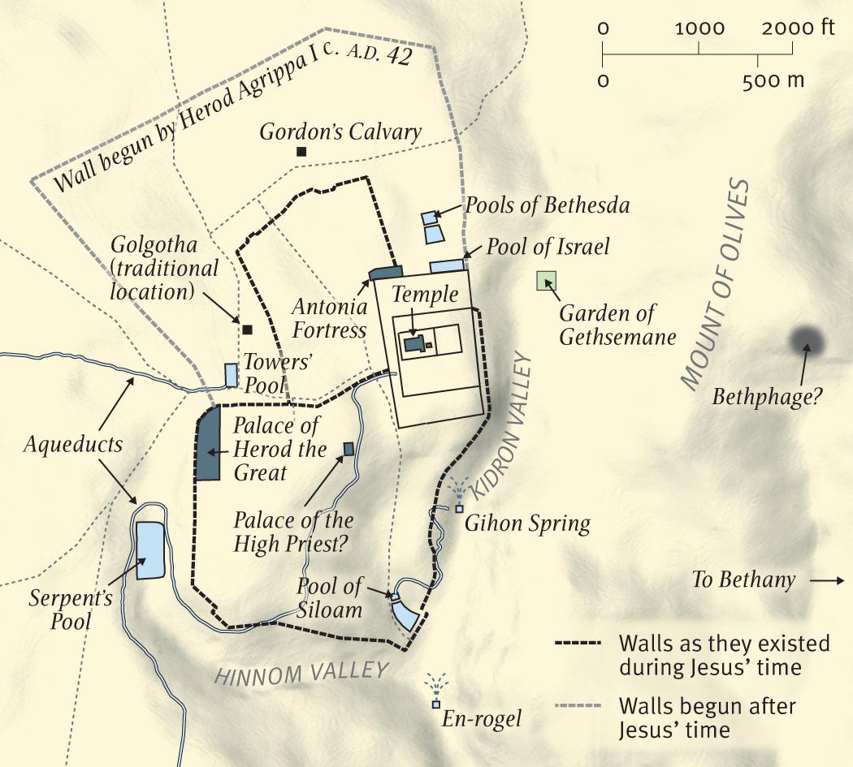

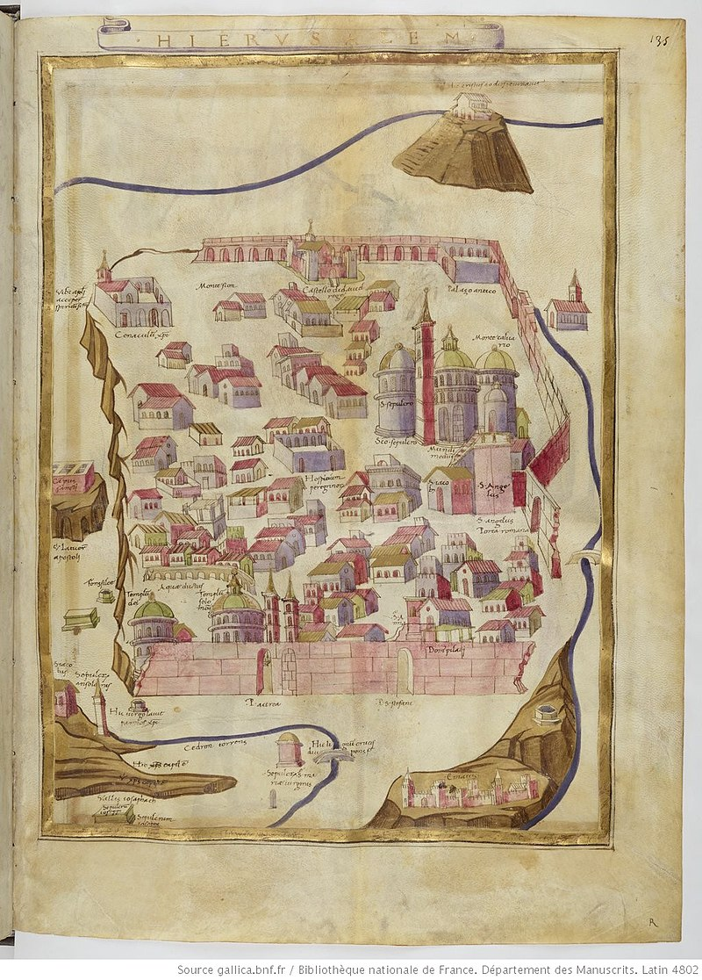
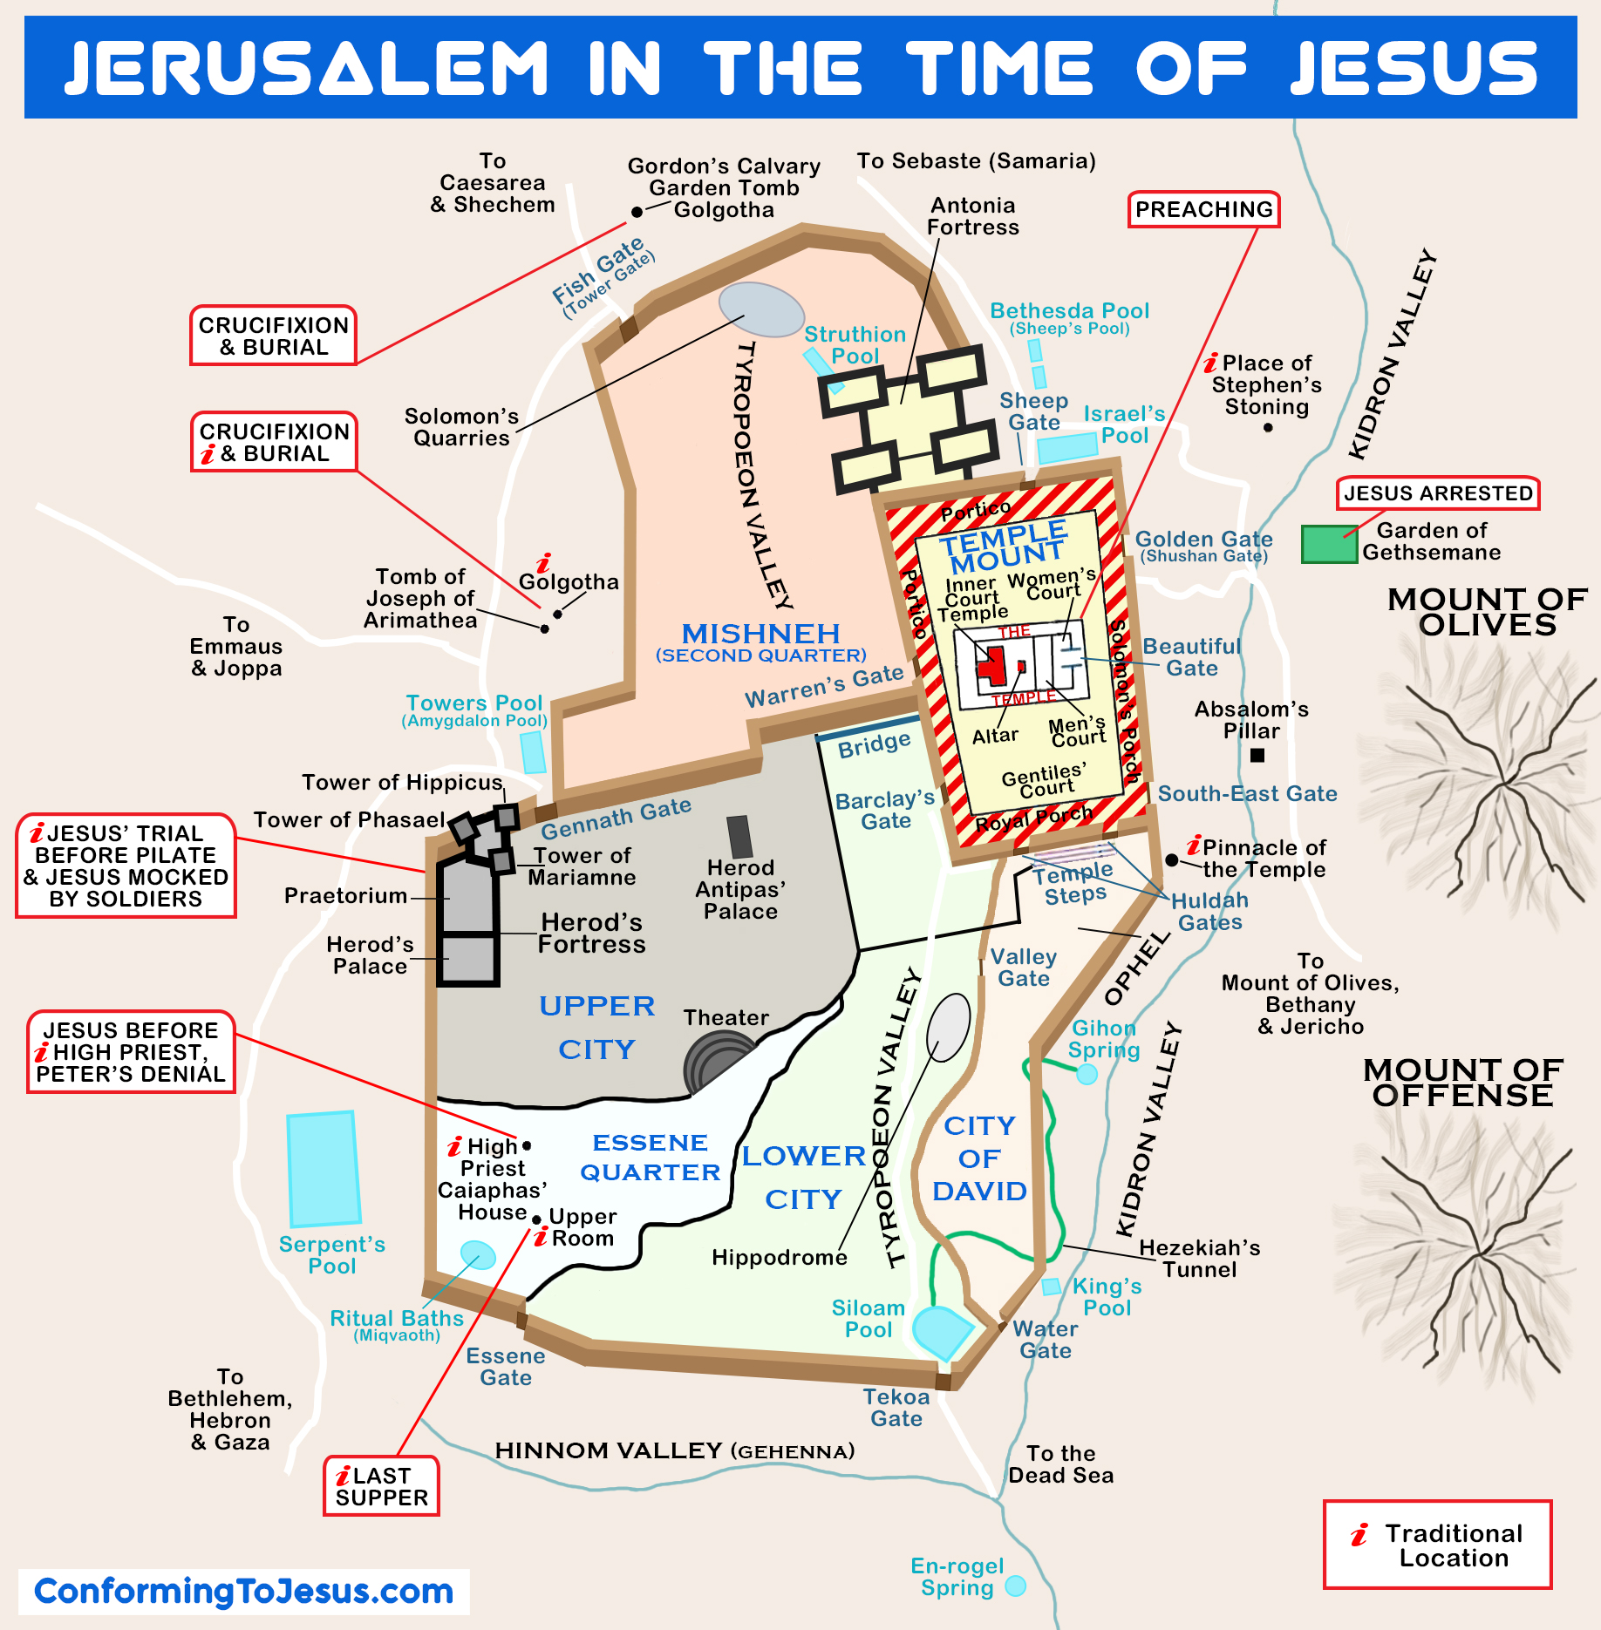

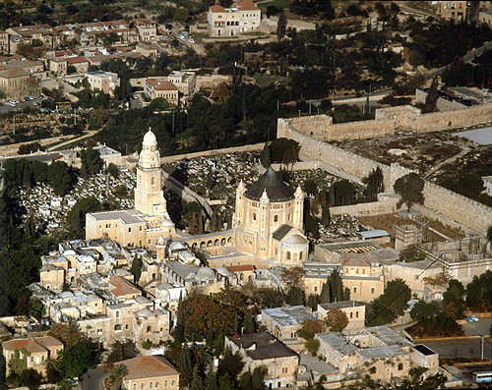

Exegetical matters that call out for a deeper look

1) “flesh and bones” in a resurrection body. What do we learn from Jesus’ resurrection body?

2) Broiled fish, sacraments and celebrating the presence (real? spiritual?) of Jesus in our lives

3) The “Scriptures,” that “written,” the TaNaKh and the gospel of repentance (next three weeks!)

4) Better understanding our religious language:

repentance, a metanoia experience

preaching, kerygma with authority

witnesses,a martus lifestyle

“send”, an apostellō church

promise and power, the epaggelia that ends with dunamis

Application matters

- Dealing with spiritual anxiety and doubt

2) An apologetic of wounds and fish

3) Repentance and Presumption

4) Reflecting again on “my Jerusalem”

Resources on Luke 24:36-49
Spurgeon’s sermon on Luke 24:36-49 at https://www.spurgeon.org/resource-library/sermons/joy-hindering-faith#flipbook/ and https://www.spurgeon.org/resource-library/sermons/folly-of-unbelief#flipbook/ and most importantly, “Beginning in Jerusalem” at https://archive.spurgeon.org/sermons/1729.php
Allistair Begg’s sermons on Luke 24 at https://www.truthforlife.org/bible/Luke%2024:13-35/
Bunyan’s “The Jerusalem Sinner Saved” at https://www.gutenberg.org/files/3270/3270-h/3270-h.htm
Deffinbaugh’s sermon on the resurrection at https://bible.org/seriespage/invisibility-invincibility-luke-2436-53
Horatio Bonar’s thoughts on resurrection as a part of his commentary on Revelation at https://awakeninggracedotorg.wordpress.com/2011/12/19/horatius-bonar-three-reasons-to-fear-not-from-the-risen-jesus/
I like J. C. Ryle’s short commentary on the Luke 24 at https://www.gracegems.org/Ryle/l24.htm
BAR’s article on the Upper Room at https://www.biblicalarchaeology.org/daily/biblical-topics/post-biblical-period/hunting-for-the-upper-room-in-jerusalem/

