Notes on the Ascension
Luke 24:50-53; May 27, 2020

Reading from the Writings: Psalm 8
The Ascension
⁵⁰ When he had led them out to the vicinity of Bethany, he lifted up his hands and blessed them. ⁵¹ While he was blessing them, he left them and was taken up into heaven. ⁵² Then they worshiped him and returned to Jerusalem with great joy. ⁵³ And they stayed continually at the temple, praising God.

Observations
1) Note the difference in the disciples response in John 16:16 and earlier in this chapter

2) Bethany and home

3) blessing and wounds

4) __________________________________________________________________

Three key questions
1) Why is it so important that Jesus ascended bodily to the Father?
Note how the Apostles’ Creed connects resurrection, ascension, intercession and Second Advent.

2) Jesus blessed his disciples, but how is the Ascension itself a blessing to the believer?
See HC, #49, Lord’s Day 18, for a beginning of the answer.

2) What is the role of joy in the life of the early church?
Note the lack of reference to joy in the resources included with the sermon notes.

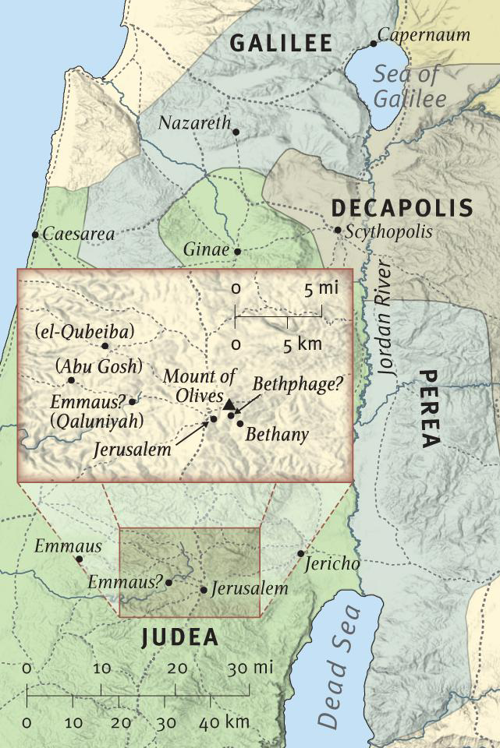
Resources for further studies of Christ’s ascension
Bob Deffinbaugh’s sermon on the end of Luke at https://bible.org/seriespage/77-invisibility-invincibility-luke-2436-53
Spurgeon’s “Our Lord’s Attitude in Ascension” on Luke 24 (ending attached below) at
https://www.google.com/url?sa=t&rct=j&q=&esrc=s&source=web&cd=&ved=2ahUKEwimrNzoqMvpAhXiHTQIHYJxDOUQFjAJegQIBRAB&url=https%3A%2F%2Fwww.spurgeongems.org%2Fvols49-51%2Fchs2949.pdf&usg=AOvVaw0iZNKGoXv4O8fiDSxNjt1L
I like Kevin DeYoung’s “Primer” on the Ascension at https://www.thegospelcoalition.org/blogs/kevin-deyoung/theological-primer-the-ascension/
Kim Haines-Eitzen, religion professor at Cornell, has an interesting article on hope at https://getpocket.com/explore/item/ancient-texts-encouraged-hope-and-endurance-when-they-spoke-of-end-times?utm_source=pocket-newtab
John Calvin’s Institutes has a good summary at https://www.monergism.com/3-benefits-imparted-our-faith-christs-ascensionhttps://www.monergism.com/3-benefits-imparted-our-faith-christs-ascension
Ligon Duncan has a helpful message at https://www.fpcjackson.org/resource-library/sermons/i-believe-in-jesus-christwho-ascended-into-heaven
Timothy Keller’s audio of a sermon on “The Real Jesus” (he calls the Ascension the “detonator”) in Acts 1 is available at https://gospelinlife.com/downloads/the-ascension-6496/
Alexander Maclaren’s commentary at https://thirdmill.org/magazine/article.asp/link/ale_maclaren%5Eale_maclaren.ES.4B.html/at/Expositions%20of%20Holy%20Scripture
Bryan Chapell’s Christ-Centered Preaching (Baker Academic, 2005) is my favorite contemporary book on Christological preaching in the Old Testament.
Paul Scott Wilson’s The Four Pages of the Sermon (Abingdon Press, 1999) is the preaching text used at Calvin Seminary.
Heidelberg Catechism, Lord’s Day18, discusses the Apostles’ Creed statement on the ascension at https://www.crcna.org/welcome/beliefs/confessions/heidelberg-catechism
N.T. Wright’s Pentecost sermon at http://www.ntwrightpage.com/sermons/Pentecost07.htm
I still am using the themes from J. C. Ryle’s short commentary on the Luke 24 at https://www.gracegems.org/Ryle/l24.htm

The Holy Bible: New International Version. (1984). (Lk 24:50–53). Grand Rapids, MI: Zondervan.

