Three on the Road to Emmaus
Luke 24:13-35 April 19, 2020
When he was at the table with them, he took bread, gave thanks, broke it,
and began to give it to them. Then their eyes were opened and they recognized him.
Luke 24:30-31
The problem with recognizing Jesus
Now that same day two of them were going to a village called Emmaus,
about seven miles from Jerusalem. They were talking with each other about everything
that had happened. As they talked and discussed these things with each other,
Jesus came up and walked along with them; but they were kept from recognizing him.
He asked them, “What are you discussing together as you walk along?”
They stood still, their faces downcast . . . .
Luke 24:13-14 (Marshall, below, has discussion of alternate sites for the biblical Emmaus)

1) “Them” are the ______________________________________________________________________

2) Kept by _________________________ because ____________________________________________

3) Downcast is ________________ a _______________________________________________________

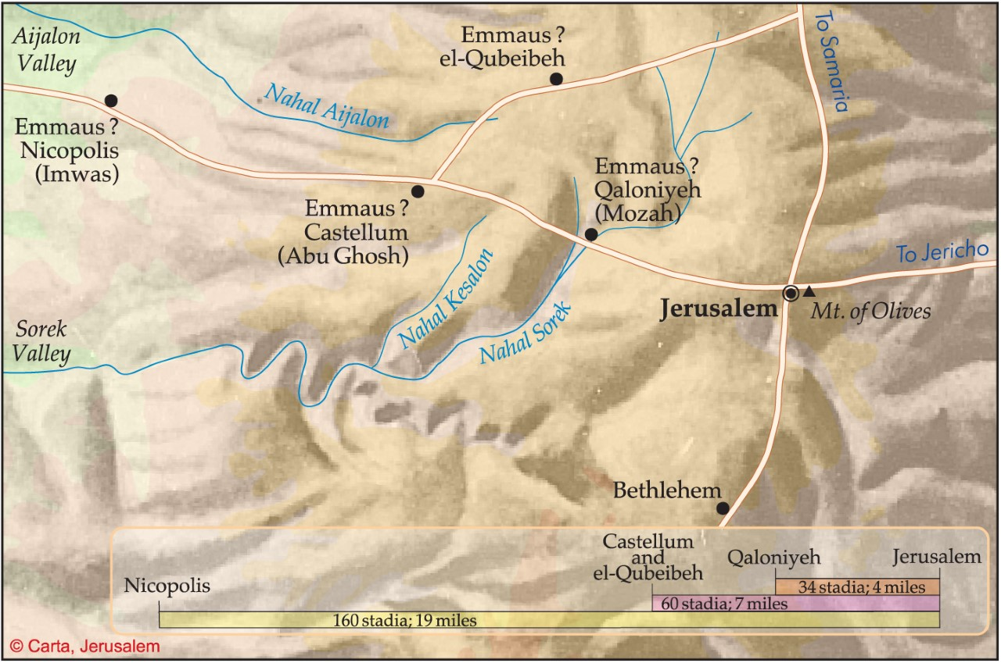

Us “slow of heart” ones
He said to them, “How foolish you are, and how slow of heart to believe all that the prophets have spoken!
Did not the Christ have to suffer these things and then enter his glory?”
And beginning with the Moses and all the Prophets, he explained the Scriptures concerning himself.
Luke 24:25-27 (see 24:44 for Jesus’ expansion of this theme)

1) The TaNaKh is ______________________________________________________________________

2) There is _____________________________ even for us “slow of heart” (see J. C. Ryle’s commentary)

When they believed
Then their eyes were opened and they recognized him, and he disappeared from their sight.
They asked each other, “Were not our hearts burning within us
while he talked with us on the road and opened the Scriptures to us”
Luke 24:31-32

- Opened by ______________________ because ___________________________________________

2) Even the “slow of heart” eventually _____________________________________________________

Keeping your pronouns and verbs straight
They got up and returned at once to Jerusalem.
There they found the Eleven and those with them, assembled together and saying,
“It is true! The Lord has risen and has appeared to Simon.”
Then the two told what had happened on the way,
and how Jesus was recognized by them when he broke the bread.
Luke 24:33-35 (this would be another great time for S.M. Lockridge’s “That’s My King”!)

- __________________________________ matters ESPECIALLY for those who missed the event

2) Sacraments still matter because _____________________________________________________

3) My sacrament this week: ___________________________________________________________

Kireath Jearim near Abu Ghosh, site of recent excavations of a possible location for Emmaus

Second Century BC coins
from Emmaus-Nicopolis, site of a Byzantine church at an unlikely location for Emmaus

Roman tombstone inscription from Nicopolis with reference to the Tenth Legion during the First Jewish Revolt
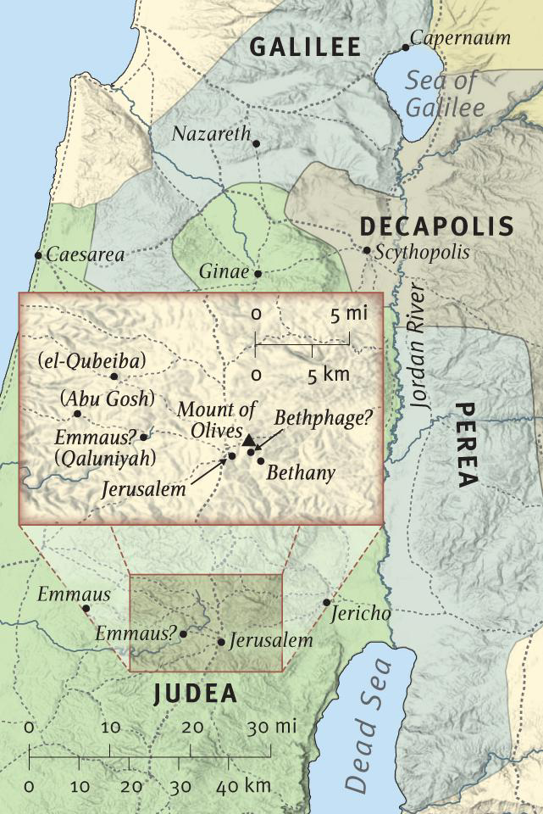
Resources on Emmaus
Spurgeon’s sermon on Emmaus at https://www.ccel.org/ccel/spurgeon/sermons28.xix.html and https://www.spurgeongems.org/sermon/chs1180.pdf
Biblical Archeological Review’s article on Emmaus at https://www.biblicalarchaeology.org/daily/emmaus-where-jesus-first-appeared-after-the-resurrection/
Allistair Begg’s sermons on Luke 24 at https://www.truthforlife.org/bible/Luke%2024:13-35/
Deffinbaugh’s sermon on the resurrection at https://bible.org/seriespage/heartbreak-heartburn-luke-2354-2435
Horatio Bonar’s thoughts on resurrection as a part of his commentary on Revelation at https://awakeninggracedotorg.wordpress.com/2011/12/19/horatius-bonar-three-reasons-to-fear-not-from-the-risen-jesus/
I like J. C. Ryle’s short commentary on the Luke 24 at https://www.gracegems.org/Ryle/l24.htm
S.M. Lockridge’s “That’s My King” sermon at https://www.youtube.com/watch?v=4BhI4JKACUs&t=3338s
The well known section begins at the :55 minute mark.
This is an interesting news report on the excavations at Kereath Jearim: https://www.youtube.com/watch?v=HnEly2xElA4
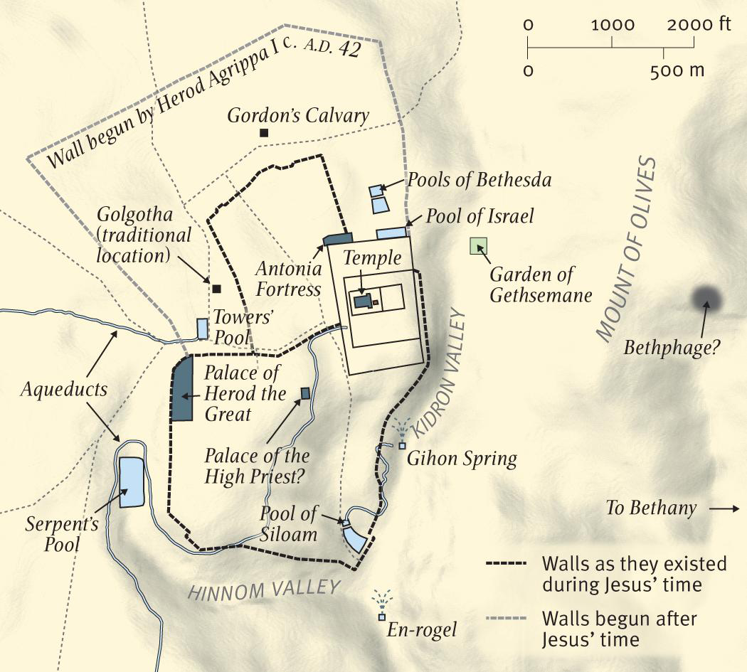

The Blessed Guest Detained (No. 1655)
C. H. Spurgeon, DELIVERED ON LORD'S-DAY MORNING, APRIL 23, 1882,
"Then they drew near unto the village where they were going, and He made as though He would have gone further. But they constrained Him, saying, Abide with us, for it is toward evening, and the day is far spent. And He went in to stay with them." Luke 24:28,29.

WHAT a blessed walk was that from Jerusalem to Emmaus! Were they not highly favored men to have such a companion as the Lord Jesus, to hear Him converse upon such a subject and to feel their hearts burning within them with so Divine a flame? Brothers and Sisters, these are not the only men who have walked with the Lord Jesus. I trust I look into the eyes of full many who can say, "We, too, have communed with the Son of the Highest. The eyes of our faith have seen Him and our ears have heard His voice. We have known that Jesus, Himself, drew near, and we have heard the Words of Holy Scripture as though they fell fresh from His lips, and thus they have, by the power of the Holy Spirit, burned in our hearts and made our hearts to burn like coals of juniper which have a most vehement flame."
Thank God, our Divine Master is still the familiar Friend of His disciples and our walk is with Him. In one sense, "He is not here, for He is risen." But in another sense He is more peculiarly here because He has risen and, whereas, un-risen He could only have been in one place at a time, now that He is risen He is, by His Spirit, present with thousands of His people at the same moment and He walks not only from Jerusalem to Emmaus, but to many a village, through many a garden, along many a street! Jesus delights to manifest Himself to His people—He is not strange unto His own flesh. We are bound to bear witness to the fact that He is not ashamed to call us Brothers and Sisters and to be found walking with us.
Yes, even to those who are not His people, Jesus comes very near at times. And though they know Him not, He walks at their side and this not in silence, for He instructs them by His Word and makes their hearts warm by His sacred influence. I pray that any remark, this morning, which shall be made to Believers may also lay hold of those attentive hearers to whom the kingdom has come very near, for some of you have often been moved in this House of Prayer as you have heard Jesus speak, and speak to you! And if you have not been able to call Him, Friend, yet you have heartily wished you could do so. You have been more than half inclined to cast in your lot with His disciples because their Master has warmed your hearts, if He has not made them burn—and if there has not been the glow of life, yet there have been many flickering desires. I pray that Jesus may never leave you, but that your intimacy with Him may be growing till at last you shall know Him and He shall know you—and there shall be a union formed between you which never shall be broken.
To return to that walk to Emmaus. How short it must have seemed! By far too short for hearts so sad, who at every step found solace. I forget how many miles it was, just now. It does not matter. I should think it seemed as if it had scarcely begun when it ended—with such light feet they tripped over that pathway that they thought Emmaus had been attracted nearer to the city! It was so short because it was so sweet. The conversation was such as good men prize more than dainties. The intonations of that Voice must often have awakened memories within them which half compelled them to recognize their Lord!
His sweet voice must have charmed them and the words He uttered, the wondrous words of exposition and consolation, how much they enriched them! Nor was that walk more sweet than solemn, for it is no mean thing to walk with the risen Son of God! Kings might fling their crowns away to enjoy five minutes of such honor—it was nothing less than sublime! Those Brothers must have often, during the rest of their lives, looked at each other and said, "We walked with Jesus!" I should think whenever they met, their conversation would have in it fresh recollections of that walk and each
one would say to his fellow, "Brother, I have just remembered a point whereon the Lord spoke to us. Do you not recollect the significant hint which He gave us as to the meaning of the Prophet?"
If you and I had ever actually walked with Jesus, I am half afraid we might have grown proud of it. At any rate, if we were helped not to be proud, yet it would always be a sublime memory. How sublime a thing to have kept pace with Incarnate Deity and marched foot to foot with Him who is God over all, blessed forever! No angel has ever walked with Jesus—they cast their crowns before Him and fly upon His errands—but He has not given unto angels the privilege of such familiar conversation. How solemn to those who all unwittingly had enjoyed it! I think when they knew Him, they must have been overwhelmed with the thought that they had been so near!
And they must have feared, in the silence of their souls, that possibly they had been rashly familiar. Surely they said, each one to Himself, "Did we say anything improper? Was it this which made Him call us fools? When we were expressing our doubts, did we not grieve Him? Alas, that we should have so misbehaved ourselves!" They must have looked back upon that high honor with great awe, even as Jacob did after he had communed with God at Bethel and said, "Surely the Lord was in this place and I knew it not. How dreadful is this place! This is none other than the House of God, and the very gate of Heaven."
Brothers and Sisters, it is a great thing to come near to Christ! And you who have not yet believed in Him, I should like you to feel in what a solemn position you have sometimes been placed, when, "He has been evidently set forth, crucified, among you!" And you have felt somewhat of that Presence. Jesus does not draw near to a man for nothing. He has an influence upon all whom He visits. Your sense of His Presence has left upon you a deep responsibility, especially if you have remained chill under the influence of His holy love and have refused to believe in Him. Oh, that you would think of this! Before our Lord passes on and leaves you to your own devices, I would have you know that the King of Heaven has been very near to you! Oh that you would cry out to Him, nor cease the cry till He comes and abides with you!
I. This must suffice for an introduction. Oh that the Spirit of God may give the sermon! My subject runs thus— First, observe in the text, COMPANIONS LIKELY TO PART. The walk had come to an end, for they had reached Em-maus where they were going and now the Master made as though He would have gone further. And so the holy talk was likely to end. Jesus is going on and they may never see Him again. The choicest of all conversations now draws to a close unless the Speaker can be induced to stop with the two favored travelers. We are told that our Lord Jesus would have gone further. He did not pretend that He would have gone, but He was actually going. It is the way of Him not to stay anywhere unless He is invited and pressed. I know not where He would have gone, but with that glorified body of His, He was under no necessity of finding shelter!
He could have gone further and lodged elsewhere, or He could have suddenly returned to Jerusalem and in a moment have entered into the Apostles' meeting room though the doors were shut. It would not have been the first night that—
"Cold mountains and the midnight air Witnessed the fervor of His prayer." Certainly He would have gone further. He says not where, but He knew right well. Under the circumstances, He and His companions seemed likely to part. Now, observe the reason of parting. They were not about to separate because of any ill-will on the part of those who had walked with Him. No anger had broken out—nothing that He had said had awakened any animosity— very, very far from it! They felt an intense reverence for the unknown Stranger and sincere gratitude to Him for the charming words which He had addressed them. He was likely to have gone further, but not because of any argument between them.
Nor would they have parted because of any weariness of Him on their part. He had not talked away and tired them out so that they would be glad to see the back of Him. The rest of the narrative shows that they were in a very different condition of heart from that. If Jesus had gone further, they would have lost His delightful society through forgetfulness. Turning into his house—for I suppose one of them lived there and there does not appear to have been anybody else in the house—one of them spread the simple repast for his friend. And what if in his care about the evening meal he had forgotten to invite the wonderful Stranger? If Jesus had gone further, it would have been entirely because they forgot to invite Him, or failed to urge Him to stay! They could not have felt an utter indifference to Him, but they might have forgotten to press their hospitality upon Him.
Many have short memories when hospitality is concerned. Sometimes we have failed to invite a friend when he needed our kindness—and we have felt sorry for it afterwards. They might have supposed that if He went further, so important a Person was too great to tarry with them and, perhaps, so wise a Person had an errand further on which required immediate dispatch and, therefore, He could not remain with them. Thus they might have let Him go. Had they lost Him it would have been simply through forgetfulness and inadvertence. Brothers and Sisters, I hope there are very few of us, who love the Lord, who are likely ever to lose communion with Him through any weariness of Him, or distaste of Him.
Oh no—the happiest moments we have ever had have been spent in Jesus' company—and we are never so blessed as when He opens the Scriptures to us and opens our hearts to receive them. But we are in danger lest in the press of worldly cares; lest in our frequent conversations with our fellow men; lest, even, in our attendances upon the domestic concerns of our own little home, we may forget to invite Jesus to abide with us! Communion with the Lord is more often broken by lack of thought than by lack of heart, though, alas, when the lack of thought has let Him, "go further," then it has cooled down into that rock of ice which we have called a lack of heart. Therefore, Brothers and Sisters, let us charge our hearts that we never forget to entertain the Savior.
Let this be our first thought—that we give Jesus a lodging in our souls. Be this our morning prayer, "Abide with us." Be this our evening petition, "Abide with us." Be this the prayer all day long, "Abide with us." May we resolve that under no circumstances will we permit our souls to be at rest unless we rest in Him, or to be happy except He shall be our joy! You see, if the two disciples had lost our Lord's company, it would have been simply through neglect. And if you and I lose Him, it may be through a neglect which we think excusable because we were so very busy and so intensely occupied. But this will not alter the fact, nor bring back our Lord. Oh do not let us treat Him so badly! Are there other objects beneath the sun or above the sun, on earth or in Heaven, that are worthy to come between us and Christ for a single moment? Will a wife treat her loving husband with coldness and then excuse herself that she had other matters on her hands? It may be so, but never, never let the Lord's redeemed treat their Redeemer as though He might be left in any hole or corner till a more convenient time!
The point at which they were at all likely to part company with Christ is worth noting, for it may give us timely warning. It was, first, a point of change. They had been walking with Him and the journey was over. They had been out of doors, but now they have come to their house and are about to enter. Always there is a danger to us of missing fellowship with Christ at points of change—and especially at seasons of greatly altered circumstances. I do not wish, Brethren, that you and I should be often transplanted—trees do not flourish well when this happens to them. I knew a friend who appeared to be wedded to the Gospel and was zealous in promoting it when he was persecuted very severely by his father. His father died and he inherited the old man's property—and from that hour he was not seen in his former place—nor did he manifest any love to the Lord. This is sad.
I would hardly dare to pray for some men that they might have a change from persecution to prosperity—plants that flourish amid ice and snow are burned up when placed beneath a tropical sun. I have known those who appeared to love their Master right heartily when they were poor! They have become rich and now where is their ardor? I hope they have not altogether cast off affection for the sacred name, but certainly the people with whom they once associated know nothing of them, now, and they are not engaged in those holy works in which they formerly delighted. How dare I pray for the temporal prosperity of those who would degenerate beneath its influence?
On the other hand, I have known many who once were in comfortable circumstances and when prosperous they appeared to walk with God. As far as we could judge, they were patterns of godliness. But they fell upon hard times and they grew poorer and poorer till they tasted the bitterness of need—and now they say they do not like to be seen by those who knew them and, therefore, they stay away from the House of God. They have lost the comforts of religion when they most need them! They have lost worldly substance and, alas, lost fellowship with Christ as well! This is equally sad, for whether Jesus leaves us at the golden gate, or at the broken-down door of poverty, His departure is equally a calamity! I am mentioning facts. I give no names, but I have seen these things many times and, therefore, I have drawn this deduction, that at points of change there is danger. I suppose there is upon the railway a measure of peril at the switches where the train is turned upon another line—and it is certainly so on the main line to Glory. At all times it is well to watch, but especially when we are entering upon new duties, new trials, new temptations. Lord, let not the novelty of our position fascinate us even for a moment, but evermore You abide with us!
It was a point, too, where something had been accomplished. They had finished their journey and reached their homes. Oh, we are such poor things that we can hardly complete anything without being self-satisfied. As little a thing as a finished walk will exalt little minds. But if it is some greater work, the peril is increased. When Christ said, "It is finished," He opened a river of comfort. But when we exclaim, "I have finished it," we too often set our minds on fire with pride! Certain men have undertaken a work for Jesus and they have done it by the Holy Spirit's blessing—and now they feel so pleased with themselves and so satisfied that they are likely to spoil all and give their Lord occasion for grief! The lowly Jesus does not seek self-exalting companions! I have known Him go many a mile to speak with the contrite, and it is His delight to dwell with the broken-hearted—but with those who have done something and, therefore, feel that they do not further need His Presence, He soon parts company. Nothing drives Christ and holy angels out of a room like the foul odor of pride!
Then, dear Friends, they were now about to rest for a time. They had reached home and they looked for repose after the excitements of the week. They had been detained at Jerusalem by grand, yet terrible events, and one of them was glad, that day, to lodge in his own house. As for the other, he was glad to get out of the city and retire with his friend, for a little till good news should come from the Apostles. They both hoped for a little peace. Just then the Master made as though He would have gone further—and when you and I are promising ourselves repose, such as we have known little of upon earth—it is especially well, at such times, to ask the Master to abide with us!
When we are in the battle we are sure to beg Him to abide with us because He covers our head and we cannot live without Him. And when we are proceeding in a weary walk we are likely to pray Him to remain with us, for we are then leaning on our Beloved. But when we sit down upon the seat of ease, sleep too often creeps over us. Having put off our traveling sandals and stretched ourselves at ease—ah, then there is the possibility, the sad possibility—of the Master's going further while we take our rest. He is always going further and when we resolve to go no further, but to consider ourselves to have attained, then our Lord will soon be gone! We must not take the slogan of the famous statesman who has been so often laughed at for his finality—we must not say, "Rest and be thankful"—or we shall soon come to grief. If we fall into that vein, it is well to remember that just at such a point Jesus and the disciple are apt to break fellowship. I mention this that we may be wise in the hour of trial.
Now, had they parted company, the act would have been most blameworthy on their part. To have lost the society of such a Friend, how foolish! Here was One who had instructed them with tenderness and skill—One who spoke as never man spoke—would they let Him go? Here was One who evidently could explain their mysterious sorrows and take the sting out of their grief—would they let Him pass on? They had been fools, indeed, if they had done so! It would have shown that they did not appreciate His teaching, nor feel grateful for His opening to them the Scriptures. It would have been gross folly!
And yet there is another thought. It was toward evening, and night was lowering and, therefore, they said, "Abide with us, for it is toward evening." It would have been very cruel to have allowed Him to journey on in the dark and the dews. Would we thus treat any friend of ours? Could we allow a beloved one to abide abroad all night? Was not that His own argument in the Golden Canticle, when He knocked and said, "Open to Me, My sister, My love, My dove, My unde-filed: for My head is filled with dew, and My locks with the drops of the night"? It would have been inhospitable on their part—inhuman for them to leave Him to continue His journey in the darkness of the gathering night when they had a home in which they could entertain Him!
And so I charge it upon my own soul to never let Jesus be left unhoused; a Stranger who has not where to lay His head! All hearts are cold in every place towards the Well-Beloved! It is a cold world for Jesus, today, even as at the time of His life below. Then, "He came unto His own and His own received Him not." Let not that be said over, again, and said of us who are, in a more special sense, His own than were His brothers and sisters according to the flesh. "Be you not forgetful to entertain strangers" is a Gospel command—but be you especially eager to entertain your Lord! Shall your Lord ever say to any of you who are called Christians, "I was a stranger, and you took Me not in"? Oh, no! Let us invite Him, beg Him, entreat Him, constrain Him to abide with us for His own dear sake—and let us give Him, in our warm hearts, the best entertainment that we can!
Surely we never received such a guest, before, and another such we shall never see again! Men are willing to give up their estates and houses for a time to entertain royalty—they reckon them to be increased in value when once a monarch
has sojourned in them—and shall not we be more than willing to open wide our hearts, minds and homes, that Jesus may enter and be entertained by us as the King of kings? There is something, then, to be learned from companions likely to part. May the Holy Spirit sweetly teach us!
II. Now, I change the scene, and notice, next—THE GUEST NEEDING TO BE PRESSED. The guest is Jesus and He is about to go further. And He will go further unless they invite Him, yes, unless, according to the 29th verse, they constrain Him. It is a very strong word that, "they constrained Him." It is akin to the one which Jesus used when He said, "The kingdom of Heaven suffers violence." They not only invited Him, but they held Him, they grasped His hand, they tugged at His clothes—they said He should not go. They would not have it—the cold night should not accuse them of being churls. He should not go another yard along that dangerous road—they must have Him for a guest—and they would not take no for an answer!
Let us remember why this Guest needs constraining, and the first thought is, He could not very well have tarried, otherwise. If I were a stranger and walked along the road with two persons who did not know me—if I were able to talk to them ever so instructively—I should not think of intruding into their house when the conversation was over! You never see anything in Jesus approaching roughness or want of delicacy—He exhibits the manners of the noblest Man that ever lived! He does not force His acquaintance upon any, but He goes where He is constrained. Besides, what pleasure could it have been for Him or for them for Him to have lodged in their house if He had not been wanted? Without a welcome, few of us would care to accept a lodging. Jesus, therefore, naturally, because the other thing was scarcely feasible, waited till He was asked and even pressed. And had they not constrained Him, He would have gone further.
Remark that this is a characteristic of the Son of God at all times. I have not time, this morning, otherwise I could show you that all through the Old Testament as well as the New, when the Lord reveals Himself in any visible form, He has to be pressed before He will abide with any. The Lord came to Abraham and Abraham said, "My Lord, if now I have found favor in Your sight, pass not away, I pray You, from Your servant: let a little water, I pray You, be fetched, and wash Your feet, and rest Yourselves under the tree: and I will fetch a morsel of bread, and comfort Your hearts; after that You shall pass on: for therefore are You come to your servant" (Gen. 18:3-5). Abraham constrains these wondrous guests, or otherwise they will pass on!
Look at chapter 19 and see what Lot did when two angels came to him. Even supposing these were nothing more than angels, they show the manners of the court of Heaven, so that it is an equally good illustration for me. He said, "Behold now, my lords, turn in, I pray you, into your servant's house, and tarry all night, and wash your feet, and you shall rise up early, and go on your ways. And they said, No; but we will abide in the street all night. And he pressed upon them greatly; and they turned in unto him, and entered into his house" (vs. 2, 3). Joseph was, in this, a type of Jesus, for you know how slow he seemed to reveal himself to his brothers, though all the while he was full of love to them. To Moses the Lord said, "Let Me alone," and only by mighty pleading could the man of God prevail!
When an angel came to Manoah and his wife, to tell them about Samson, we find that He had to be detained, or else He would have departed speedily. "And Manoah said unto the Angel of the Lord, I pray You, let us detain You, until we shall have made ready a kid for You." (Judges 13:15, 16). You see, the heavenly messenger needed to be detained, or He would have gone at once. And then comes in that instance of which you have already thought, when the angel said to Jacob, "Let Me go, for the day breaks. And he said, I will not let You go, except You bless me." It is clear that the Lord will be entreated of by the house of Israel to do good things for them. We shall have to cry—
"In vain You struggle to get free,
I never will unloose my hold!
Are You the Man that died for me?
The secret of Your love unfold:
Wrestling, I will not let You go,
Till I Your name, Your nature know.
I know You, Savior, who You are,
Jesus, the feeble sinner's Friend;
Nor will You with the night depart,
But stay and love me to the end;
Your mercies never shall remove
Your nature and Your name is Love." We know that our Lord had a shy habit—He often withdrew Himself—and the multitude sought after Him. He walked upon the sea and they in the vessel saw Him and He would have gone by them, but they cried out to Him. The Syro-Phoenician woman, who sought for the healing of her daughter, found Him, at first, very cold to her, and only by the greatest faith did she win her desire! He needed earnest pressure before He yielded to her request.
The blind men cried unto Him for sight, but He passed on till louder and louder went up their piteous cries, and they held Him, for Jesus stood still. The nobleman, when he came about his son, pleaded with tears till he cried, "Lord, come down before my child dies." It has been often so with our gracious Lord. He would not come until He saw that the desire for Him was intense. He gives us two parables—one tells us of the man in bed who must be awakened with many a knock and many a call before he would rise to give bread to his friend who sought it. The other parable is that of the unjust judge who must be wearied by the woman's importunate entreaties before he will vindicate her cause. From all this you see it is the Master's habit to hold back till He is pressed and constrained.
If we must give a reason for this I would remind you of the jealousy of His Character. He is jealous of our love! He says, "Give Me your heart," and so He pauses a while that He may see that we love Him and prize His benefits. Of old the Father said, "The Lord your God is a jealous God," and Jesus, the Incarnation of the Divine Love, has told us that, "love is strong as death; jealousy is cruel as the grave" and, therefore, it is that He will not give His company to those who have no heart for it. You shall not have His smiles if the smiles of the world will do as well. If union with worldlings will please you as much as union with Him, you shall have none of His company! It is only when you languish for Him, sigh for Him and cry for Him that He will abide with you!
He has another reason and that is, His anxiety to do us good! He wisely wishes that we should value the mercy which He gives by being led to consider what a case we should be in if He did not give it. He stirs up our prayers and then answers them—and so we get a double blessing—the prayers, themselves, being of much service to us, and then the answer being all the more a blessing! It was good to these two disciples to be allowed to be hospitable. It was good for them to rouse themselves to entreat Him. They valued the company of Jesus all the more when they had diligently persuaded Him to sit at their table and partake of their simple meal.
Now, Beloved, let us look at Jesus in this light, and say within ourselves, "I am fearful lest I should do anything to excite His jealousy. And I am anxious to show my eager longing for His Presence lest He should think me unkind. I would not make Him 'go further' and leave me, but I would hold Him fast, constraining Him to abide with me."
III. I have said that here was a Guest who needed pressing—there will be no necessity to enlarge upon the remark that here was A GUEST WORTH PRESSING. He was, indeed, worth pressing when we consider what He had done for them. He had given them comfort and instruction and He was worth detaining if only for that. Had they known Him they would have felt still more that they could not let Him go. Would they not have borne Him on their shoulders into the house and said, "Good Master, we cannot think of letting You go, for You are He whom our souls love—our Master and our Lord—over whom we have been mourning as one dead, and lo, You are alive"? So much were they indebted to Him that they could not fail to make Him their guest!
They must press Him again, for how comfortless the house would have been without Him! I think I see those two disciples sitting down to their meal, supposing the Master had gone on. Suddenly, one would have remembered, and said, "My heart feels heavy, now that He is gone." And the other would have said, "How came it that we let Him go? Why did we not entreat Him to stay the night with us?" Their meal would have half choked them! They would have gone to their beds and tossed about throughout a sleepless night if they had failed in hospitality to Him. This is what has happened to some of us when we have carelessly let our Lord slip away—we have been like widows who have newly lost their husbands—sore in heart and desolate.
"Should the children of the bridegroom fast?" Not while the bridegroom is with them! But if he is taken from them, then shall they fast. Better to have been outside in the open air, or to have gone further with the unknown Traveler, than to have been comfortably housed and to have treated Him ill. He was a Guest worth constraining to remain when we think of the vacuum there would have been if He had gone further! Besides, we know what they did not then know, that this unknown One would make Himself known to them, as He has done to us. Knowing Him, now, as they knew Him
afterwards in the breaking of the bread, we ought to feel, we must feel, we do feel, that we cannot, will not let Him go, but will detain Him, for He is Christ our Lord!
I spoke at the beginning to some here who have never known our Lord and yet He has been very close to them frequently, in hearing sermons and the like. Dear Friends, I earnestly beseech you to receive Christ as a Stranger, and you shall soon know Him as a Friend! You only know of my Lord, that He makes you have the heartburn every now and then. And when we talk about Him, you go home very uncomfortable. How I wish that you knew Him better! Oh, that you would entertain Him, for then you would know His excellence! Bid Him come into your heart and He will be infinitely more to you than He is now.
You have no idea what He is. He seems a well-spoken Friend, but He will prove to be a Brother! He promises to instruct you, but He will love you, enrich you, and glorify you. Oh dear child of God, not yet well-instructed, your eyes are weak and you see not Jesus as you shall see Him! Still, I pray you heartily entertain the Savior, even if your eyes are blind. Take Him in and let Him lodge with you, and you will know more and yet more of Him! You will know most of Him as you break your bread to the hungry, and so break it to Him. You will know more as you break the bread at the Communion Table and so commune with Him. Only remember, He is a Guest worth pressing, and be sure you do your best humbly, but earnestly, to detain Him!
IV. I close by telling you of AN ARGUMENT WITH WHICH TO HOLD HIM. Here it is in the text. "They constrained Him, saying, Abide with us, for it is toward evening, and the day is far spent." My first way of using this text does not commend itself to my judgment, but yet it is necessary. All the commentators and preachers I have ever met with suppose that these disciples meant, by this argument, that it was dreary for themselves to be alone and, therefore, for their own comfort and protection, they begged the stranger to remain. I do not believe it for a moment! Still, that would have been a good argument with the tender-hearted Savior and if you and I cannot attain to anything else, let us use that plea.
It is toward evening with many of you. You are in affliction and the shadows thicken. Your light has departed and you are afraid. Sorrows come on like the darkness of night. You know not what approaches—you are heavy of heart. Ah, then that is a blessed prayer—
"Fast falls the eventide! The darkness thickens: Lord, abide with me."
You can bear any trouble with Christ. No adversities shall hurt you, no afflictions shall grieve your spirit if He is with you. Pray, therefore, this prayer, and no longer fear as you enter into the cloud. Or it may be that some of you are falling into depression of spirit through the loss of the Light of God's Countenance. You are not as joyful a Christian as you used to be. The high felicities of your spirit have burned down and all is dim. Now is the time to say, "Lord, abide with me. If I have no joy, still let me have Yourself." It is a blessed thing when a Believer does not set his affection so much upon the joy of the Lord as upon the Lord of his joy—when he says not only, "Lord, I will rejoice in You while You smile," but cries with Job, "Though He slay me, yet will I trust in Him." Better to have to do with a killing God than to have God gone!
So, cry, "Lord, if I never get a smile from You; if I am never again cheered and comforted by You; if I never sing a hymn of gladness, yet still abide with me! Be near, even if I know it not." It was a beautiful expression of David, who often asked the Lord to shine upon him, when he said, "In the shadow of Your wings will I rejoice." As much as to say—If I have no light from God's face, I will be glad to be hidden beneath His wings. Abide with me, then, even if my reason almost fails me, and my darkened soul dreads a yet more tremendous night. Abide with me, O Lord, even should my sorrow seal my eyes in death. "Abide with me" is a blessed prayer for those Believers who are getting aged. With them it is toward evening and the day is far spent. Now should they cry, "Abide with me." Then will you sweetly go to your chamber and fall into your last, most blessed sleep, and obtain the fulfillment of yours prayer that you may be forever with the Lord.
I have used the text in this way because everybody has used it so, but I believe that these disciples meant it in quite another sense. They used the argument to detain Christ because it was evening, for His sake—because the night was coming on and they could not think of His being out in it. They knew how heavy the Eastern dews are and so they pressed
Him with this—"Abide with us, for it is toward evening, and the day is far spent." Let each one of us use that argument with our Lord even now—Lord, the world has no entertainment for You! Unbelieving hearts give You no shelter. The self-righteous repel You from their doors. The worldly see no beauty in You; carnal hearts refuse You; every house is locked against You! Therefore come in and abide with me. Here is lodging for You! Come in, Blessed One, and stay with me. If You lack shelter in king's palaces, abide with me! If there is no room for You in the inn, yet come in here and find Yourself at home, for I shall count myself greatly honored by receiving You. Therefore, dear Master, abide with me.
How we ought to long to cheer the Blessed One with our love because He is still so despised and rejected everywhere else. Everywhere else they treat Him ill. O do not let Him be wounded in the house of His friends! If He had 50 houses to go to, I might say, "Lord, they can give You better entertainment than lies in my power." But when it is "toward evening" and no other door is open, Lord come into my poor cottage! I will set all that I have before You and be Your willing servant. That is the plea!
Another form of the plea is this. The ages are growing old and dark. What a plea that is for the Church to put up now, for the coming of her Lord. "O Lord, it is toward evening, the world's sun is setting. It is nearly 1,900 years since you ascended and still, the world lies in the Wicked One! Lord, come to Your Church! Come and abide with her, for as the world grows old, good Master, a chill night comes on and the love of many waxes cold—and there are some that turn aside who once ran well. Dire evils walk abroad in the dark and blasphemy and rebuke are rife! Good Master, come unto Your Church and dwell in her, and find, there, Your home!
"And the night of all nights is coming on, even the end of the world. We know not when, but we know we are getting nearer to it every day. Earth's day is far spent. Her day of mercy comes toward its eventide and the night draws on, therefore, Master, come and abide with us, that we may win the world for you. Come, come that we may convert the heathen to Your Cross and that You may have them for Your inheritance. It is with Your Church that You will do this! Come, then, and abide with her ministers and her missionaries, and all her living membership, that yet the prophecies may be accomplished and Your purpose may be fulfilled! And Your reward may be the salvation of Your own."
Is not that a good missionary text, after all, a blessed prayer with which to begin this missionary week—"Abide with us for it is toward evening, and the day is far spent"? In the Romish church there is a chant which they use from Easter to the day of Ascension, and though I care nothing for liturgies or anything of the sort, yet it is certainly a suggestive canticle. The first line of the chant is—
"Abide with us. Hallelujah."
And the next is—
"For it is toward evening, And the day is far spent. Hallelujah." With that I close. May we use that argument well, until our Lord shall, in very deed, abide with us!

(13) Luke’s story is about two of the disciples of Jesus mentioned in vs. 9, 11, and it takes place on the same day as the discovery of the empty tomb. Ellis’s claim, 276, that Luke’s time references identify this as the ‘eighth day’, the beginning of a new creation (cf. 9:28; Barn. 15:8f.; Justin, Dial. 138) is a doubtful attempt to explain Lk. in the light of later Christian thought and has no real basis in the text. ἦσαν πορευόμενοι is placed before ἐν αὐτῇ τῇ ἡμέρᾳ (on which see note) by most authorities (so TR; Diglot), except 𝔓⁷⁵ (א) B which preserve the slightly more awkward and therefore original order. The disciples were possibly returning home after the celebration of the festival (cf. SB II, 147f.; Jeremias, Words, 72 n. 2; see further C. F. D. Moule*; J. Carmignac*). Their destination was a village not far from Jerusalem (Lohfink, 207f., 264f., argues that the point of the geographical note is to emphasise that the appearance of Jesus took place in the vicinity of Jerusalem.) The distance is measured in terms of the στάδιον, i.e. 600 Greek feet (equivalent to 625 Roman feet; or 607 English feet; or 192 metres; cf. AG s.v.; the noun can have a neuter or masculine plural (BD 49³); cf. Mt. 14:24; Jn. 6:19; 11:18; Rev. 14:20; 21:16; also meaning ‘stadium, arena’, 1 Cor. 9:24**). 60 stades is thus roughly 7 miles. Instead of ἑξήκοντα some MSS have ἑκατὸν ἑξήκοντα (א K* N Θ Π 079^{vid} 1079* sy^{pal} arm Eus Hier), i.e. about 18 1/2 miles; this reading is due to an attempt to find a reference to Amwas (mod. Nicopolis), 20 miles from Jerusalem on the road to Joppa (cf. Lagrange, 617–622; Metzger, 184f.). The similarity in spelling quickly led to the identification of this well-known site with the mere village mentioned here (1 Mac. 3:40, 57; 4:3; cf. 9:50; Jos. Ant. 12:306f.; Bel. 1:222 and frequently); so Eusebius and Jerome, and in modern times SB II, 269–271; Dalman, Sites, 226–232; Abel, II, 314–316; Bouwman, 13; Finegan, 177–180; J. Wanke*, 37–42. If so, either Luke got the distance wrong, or the variant reading is a correct emendation of a primitive textual corruption. The obvious difficulty is the great distance from Jerusalem, but Abel asserts that this is no problem to those familiar with the capabilities of Palestinian people. Other identifications, more in accord with a seven-mile radius from Jerusalem, have been suggested. Of these the favourite is El-Qubeibeh, a village seven miles NW of Jerusalem where Crusaders found a fort (1099) called Castellum Emmaus, and where recent archaeology has found a village of first-century date (so Zahn, 716–720; Plummer, 551f.; Rengstorf, 271; Geldenhuys, 636). The difficulty here is the lack of firm evidence for the name of the site in the first century. Also, the Hebrew word means ‘spring’, and there are no springs at this site (cf. Rengstorf). Third, Josephus mentions a military colony of Vespasian 30 stadia W of Jerusalem at Ἀμμαοῦς (Bel. 7:217). This site has been identified with modern Kaloniye (i.e. Latin colonia) some four miles W. of Jerusalem or with Mozah (a village just north of Kaloniye; modern Kh. Beit Mizza; cf. SB II, 271, for rabbinic evidence suggesting that the old village became a Roman camp). This site is accepted by Schürer, History, 512 n. 142; Wellhausen, 138; J. Weiss, 523; K. Lake*, 99f.; Harvey, 297 n.; Benoit, Passion, 271–274. The difficulty here is that the distance is half that given by Luke; Benoit suggests that Luke has mistakenly given the distance for the journey there and back. It must be admitted, therefore, that in both of the two possible identifications the distance given by the present text of Luke is wrong. On the whole Amwas has more to be said for it, since later on the point of the story is the return of the disciples to Jerusalem despite an apparently lengthy journey; but certainty is impossible.

Section 141. The Road to Emmaus, Luke 24:13-35
Commentary by J. C. Ryle
And, behold, two of them went that same day to a village called Emmaus, which was from Jerusalem about threescore furlongs. And they talked together of all these things which had happened. And it came to pass, that, while they communed together and reasoned, Jesus himself drew near, and went with them. But their eyes were held that they should not know him. And he said unto them, What manner of communications are these that you have one to another, as you walk, and are sad? And the one of them, whose name was Cleopas, answering said unto him, Are you only a stranger in Jerusalem, and have not known the things which are come to pass there in these days? And he said unto them, What things? And they said unto him, Concerning Jesus of Nazareth, which was a prophet mighty in deed and word before God and all the people: And how the chief priests and our rulers delivered him to be condemned to death, and have crucified him. But we trusted that it had been he which should have redeemed Israel: and beside all this, to day is the third day since these things were done. Yes, and certain women also of our company made us astonished, which were early at the sepulcher; And when they found not his body, they came, saying, that they had also seen a vision of angels, which said that he was alive. And certain of them which were with us went to the sepulcher, and found it even so as the women had said: but him they saw not. Then he said unto them, O fools, and slow of heart to believe all that the prophets have spoken: Ought not Christ to have suffered these things, and to enter into his glory? And beginning at Moses and all the prophets, he expounded unto them in all the scriptures the things concerning himself. And they drew near unto the village, where they went: and he made as though he would have gone further. But they constrained him, saying, Abide with us: for it is toward evening, and the day is far spent. And he went in to tarry with them. And it came to pass, as he sat at meat with them, he took bread, and blessed it, and brake, and gave to them. And their eyes were opened, and they knew him; and he vanished out of their sight. And they said one to another, Did not our heart burn within us, while he talked with us by the way, and while he opened to us the scriptures? And they rose up the same hour, and returned to Jerusalem, and found the eleven gathered together, and them that were with them, Saying, The Lord is risen indeed, and has appeared to Simon. And they told what things were done in the way, and how he was known of them in breaking of bread.
The history contained in these verses, is not found in any other Gospel but that of Luke. Of all the eleven appearances of Christ after His resurrection, none perhaps is so interesting as the one described in this passage.
Let us mark, in these verses — what encouragement there is to believers to speak to one another about Christ. We are told of two disciples walking together to Emmaus, and talking of their Master's crucifixion. And then come the remarkable words, "As they talked and discussed these things with each other — Jesus Himself came up and walked along with them."
Conference on spiritual subjects is a most important means of grace. As iron sharpens iron — so does exchange of thoughts with brethren, sharpen a believer's soul. It brings down a special blessing on all who make a practice of it. The striking words of Malachi were meant for the Church in every age — "Then those who feared the LORD talked with each other — and the LORD listened and heard. A scroll of remembrance was written in His presence concerning those who feared the LORD and honored his name. 'They will be Mine,' says the LORD Almighty, 'in the day when I make up My jewels.'" (Malachi 3:16, 17.)
What do we ourselves know of spiritual conversation with other Christians? Perhaps we read our Bibles, and pray in private, and use public means of grace. It is all well, very well. But if we stop short here — then we neglect a great privilege and have yet much to learn. We ought to "consider how to provoke one another to love and good works." We ought to "exhort" and "edify one another." (Hebrews 10:24; 1 Thessalonians 5:11.)
Have we no time for spiritual conversation? Let us think again. The quantity of time wasted on frivolous, trifling, and unprofitable talk — is fearfully great. Do we find nothing to say on spiritual subjects? Do we feel tongue-tied and speechless on the things of Christ? Surely if this is the case — then there must be something wrong within. A heart right in the sight of God, will generally find words to speak about eternal realities. "Out of the abundance of the heart, the mouth speaks." (Matthew 12:34.)
Let us learn a lesson from the two travelers to Emmaus. Let us speak of Jesus — when we are sitting in our houses, and when we are walking along the way, whenever we can find a disciple to speak to. (Deuteronomy 6:7.) If we believe we are journeying to a Heaven where Christ will be the central object of every mind — let us begin to learn the conduct of Heaven, while we are yet upon earth. So doing, we shall often have One with us whom our eyes will not see, but One who will make our hearts "burn within us" by blessing the conversation.
Let us mark, secondly, in these verses — how weak and imperfect was the knowledge of some of our Lord's disciples. We are told that the two disciples frankly confessed that their expectations had been disappointed by the crucifixion of Christ. "We had hoped," said they, "that it had been He who would have redeemed Israel." A temporal redemption of the Jews by a conqueror — appears to have been the redemption which they looked for. A spiritual redemption by a sacrificial death — was an idea which their minds could not thoroughly take in.
Ignorance like this, at first sight, is truly astounding. We cannot be surprised at the sharp rebuke which fell from our Lord's lips, "how foolish you are, and slow of heart to believe."
Yet ignorance like this is deeply instructive. It shows us how little cause we have to wonder at the spiritual darkness which obscures the minds of careless Christians. Myriads around us are just as ignorant of the meaning of Christ's sufferings, as these travelers to Emmaus. As long as the world stands, the cross will seem foolishness to natural man.
Let us bless God that there may be true grace hidden under much intellectual ignorance. Clear and accurate knowledge is a most useful thing — but it is not absolutely needful to salvation, and may even be possessed without grace. A deep sense of sin, a humble willingness to be saved in God's way, a teachable readiness to give up our own prejudices when a more excellent way is shown — these are the principal things. These things the two disciples possessed, and therefore our Lord "went with them" and guided them into all truth.
Let us mark, thirdly, in these verses — how full of Christ the Old Testament is. We are told that our Lord began "with Moses and all the prophets, and expounded in all the Scriptures the things concerning Himself."
How shall we explain these words? In what way did our Lord show "things concerning Himself," in every part of the Old Testament? The answer to these questions is short and simple. Christ was the substance of every Old Testament sacrifice, ordained in the law of Moses. Christ was the true Deliverer and King — of whom all the judges and deliverers in Jewish history were types. Christ was the coming Prophet greater than Moses, whose glorious coming filled the pages of prophets. Christ was the true seed of the woman, who was to bruise the serpent's head — the true seed in whom all nations were to be blessed — the true Shiloh to whom the people were to be gathered — the true scape-goat — the true bronze serpent — the true Lamb to which every daily offering pointed — the true High Priest of whom every descendant of Aaron was a figure. These things, or something like them, we need not doubt — were some of the things which our Lord expounded in the way to Emmaus.
Let it be a settled principle in our minds, in reading the Bible — that Christ is the central sun of the whole book. So long as we keep Him in view — we shall never greatly err in our search for spiritual knowledge. Once losing sight of Christ — we shall find the whole Bible dark and full of difficulty. The key of Bible knowledge is Jesus Christ.
Let us mark, finally, in these verses — how much Christ loves to be entreated by His people. We are told, that when the disciples drew near to Emmaus, our Lord "made as though he would have gone further." He desired to see if they were weary of His conversation. But it was not so. "They constrained Him, saying, 'Abide with us — for it is toward evening, and the day is far spent.' And He went in to tarry with them."
Cases like this are not uncommon in Scripture. Our Lord sees it good for us to prove our love — by withholding mercies until we ask for them. He does not always force His gifts upon us, unsought and unsolicited. He loves to draw out our desires, and to compel us to exercise our spiritual affections — by waiting for our prayers. He dealt so with Jacob at Peniel. "Let me go," He said, "for the day breaks." And then came the noble declaration from Jacob's lips, "I will not let you go — unless you bless me." (Genesis 32:26.)
The story of the Canaanite mother, the story of the healing of two blind men at Jericho, the story of the nobleman at Capernaum, the parables of the unjust judge and friend at midnight — are all meant to teach the same lesson. All show that our Lord loves to be entreated, and likes importunity in prayer.
Let us act on this principle in all our prayers, if we know anything of praying. Let us ask much, and ask often, and lose nothing for lack of asking. Let us not be like the Jewish king who smote on the ground three times, and then stopped. (2 Kings 13:18.) Let us rather remember the words of David's Psalm, "Open your mouth wide — and I will fill it." (Psalm 81:10.) It is the man who puts a holy constraint on Christ in prayer — who enjoys much of Christ's manifested presence.

Marshall, I. H. (1978). The Gospel of Luke: a commentary on the Greek text (pp. 892–893). Exeter: Paternoster Press.

