Seeing Jerusalem
Luke 11:4 (p. 1632) April 5, 2020
As [Jesus] approached Jerusalem and saw the city, he wept over it and said,
“If you, even you, had only known on this day what would bring you peace –
but now it is hidden from your eyes.
Luke 19:41-42
The Messiah’s up and down arrival
After Jesus had said this, he went on ahead, going up to Jerusalem . . . .
When he came near the place where the road goes down the Mount of Olives,
the whole crowd of disciples began joyfully to praise God in loud voices for the all the miracles they had seen:
“Blessed is the king who comes in the name of the Lord!” “Peace in heaven and glory in the highest.”
Luke 19:28-38
The stone the builders rejected has become the capstone;
the Lord has done this, and it is marvelous in our eyes.
This is the day that the Lord had made; let us rejoice and be glad in it.
O Lord, save us. O Lord, grant us success.
Blessed is he who comes in the name of the Lord. From the house of the Lord, we bless you.
Psalm 18:24-26 (p. 957)

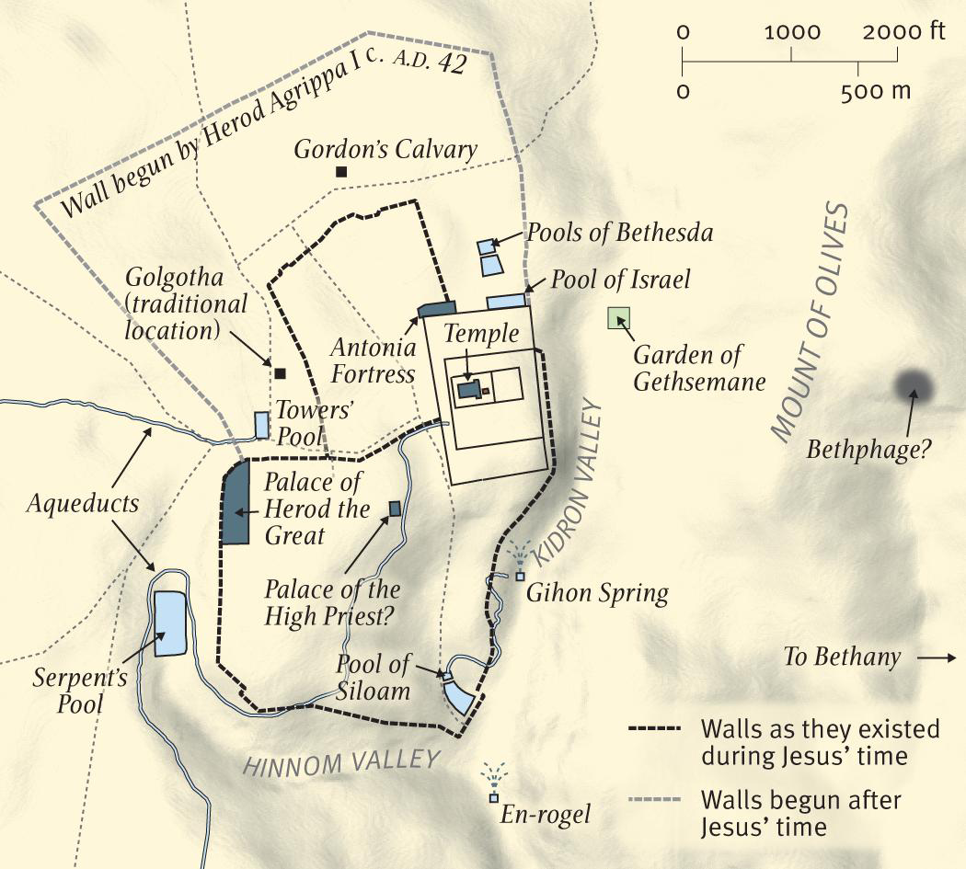

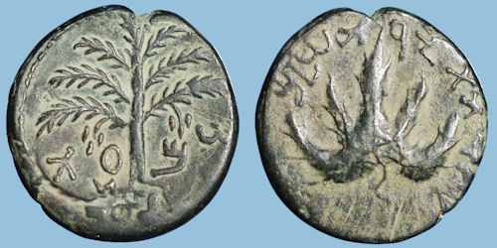

1) Up and down reflects __________________________

2) Jesus arrives as _______________________________

A short history of stones
Some of the Pharisees in the crowd said to Jesus,
“Teacher, rebuke your disciples.” “I tell you,” he replied,
“if they keep quiet, the stones will cry out.”
Luke 19:40

1) Stones cry out in _______________________ (Habakkuk 2:2-20)

2) ______________________________ stone leads to ______________________________ stones

Seeing the city as Jesus sees it
As he approached Jerusalem and saw the city, he wept over it . . . .
Luke 19:41 (see John 12:37-40 and Isaiah 6:10, 53:1)

- Now Jesus ___________________________ sees the city

2) ________________________________ has become _______________________________

Three years later . . . . (or, missing Jesus matters)
“The days will come upon you when your enemies will build an embankment against you
and encircle you and hem you in on every side . . . . They will not leave one stone on another,
because you did not recognize the time of God’s coming to you.”
Luke 19:43-44 (with reference to John 1:1-14, 12:37-40)

- THIS is the __________________________________________opportunity

2) “Recognize” is a ____________________________________________ issue
