Three on the Road to Emmaus: Study Notes
Luke 24:13-35 April 22, 2020
When he was at the table with them, he took bread, gave thanks, broke it,
and began to give it to them. Then their eyes were opened and they recognized him.
Luke 24:30-31
Biblical archeology, textual criticism and lessons from history
Now that same day two of them were going to a village called Emmaus, about seven miles from Jerusalem.
Luke 24:13-14 (Marshall, below, has discussion of alternate sites for the biblical Emmaus)
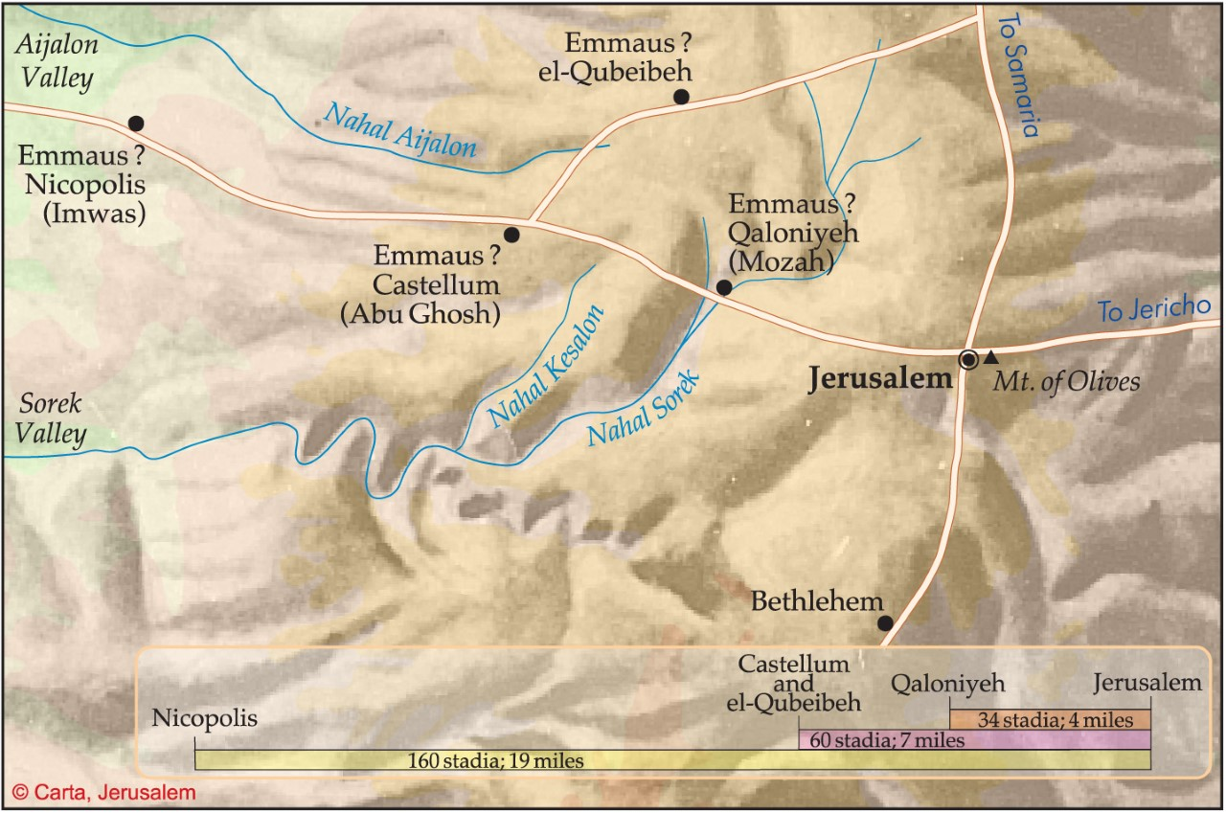

24:13 ἐξήκοντα {B}
The variant reading ἑκατὸν ἑξήκοντα (א K* Θ Π syr^{pal} arm) seems to have arisen in connection with patristic identification of Emmaus with ‘Amwâs (mod. Nicopolis), about twenty-two Roman miles (176 stadia) from Jerusalem (thus Eusebius, Jerome, Sozomen, though they do not mention the distance). This, however, is too far for the travelers to have re-traversed that same evening (ver. 33). The “seven” of [Old Latin] is undoubtedly due to a scribal blunder. [Metzgar’s A Textual Commentary, UBS]

1) _________________________ because study Bibles, commentaries and sermons notes can be wrong

2) Geography and history help to __________________________________________________________

3) ___________________________ with biblical archeology – most archeologists are really after the truth
Observation questions

1) Who is doing the closing and opening (krateō and dianoigō)?

2) How the triple repetition of “recognize” (epiginōskō the first two uses) bookend this passage?

3) How did these “others” (24:9) recognize Jesus in the “breaking of the bread”?

Interpretation notes
Then their eyes were opened and they recognized him, and he disappeared from their sight.
They asked each other, “Were not our hearts burning within us
while he talked with us on the road and opened the Scriptures to us?”
Luke 24:31-32

- “eyes were opened” and “opened the Scriptures” dianoigō used literally and metaphorically

2) What are “all the Scriptures” and how does Jesus explain (diermēneuō = dia + hermeneutics) them?

Application

- There is sacramental blessing in the way Jesus’ presence is hidden and then revealed in Scripture and breaking bread. That’s why we speak of Word and sacrament. How am I welcoming (“entreating” in Spurgeon and Ryle) Jesus’ presence in these days when physical presence is so limited?

2) Luke places Christ at the center of Scripture and conversation. What are the discipleship and
mission implications of this structure? How does this keep us from “great error” (see Ryle)?

3) Resurrection joy is contagious, and it ends up being a powerful apologetic (Acts 2:31, 4:1-12). How is
God moving us from downcast to joyous even before all the questions get answered?

