Fish and Repentance
Luke 24:36-49 April 25, 2020
Then he opened their minds so that they could understand the Scriptures.
He told them, “This is what is written: The Christ will suffer
and rise from the dead on the third day, and repentance and forgiveness of sins
will be preached in his name to all nations, beginning in Jerusalem.
You are witnesses of these things. I am going to send you what my Father has promised;
but stay in Jerusalem until you have been clothed with power from on high.”
Luke 24:30-31
The continuing story of resurrection
While they were still talking about this, Jesus himself stood among them and said to them,
“Peace be with you.” They were startled and frightened, thinking they had seen a ghost . . . .
Luke 24:36

1) Am I at the _______________________________ or the _________________________________ ?

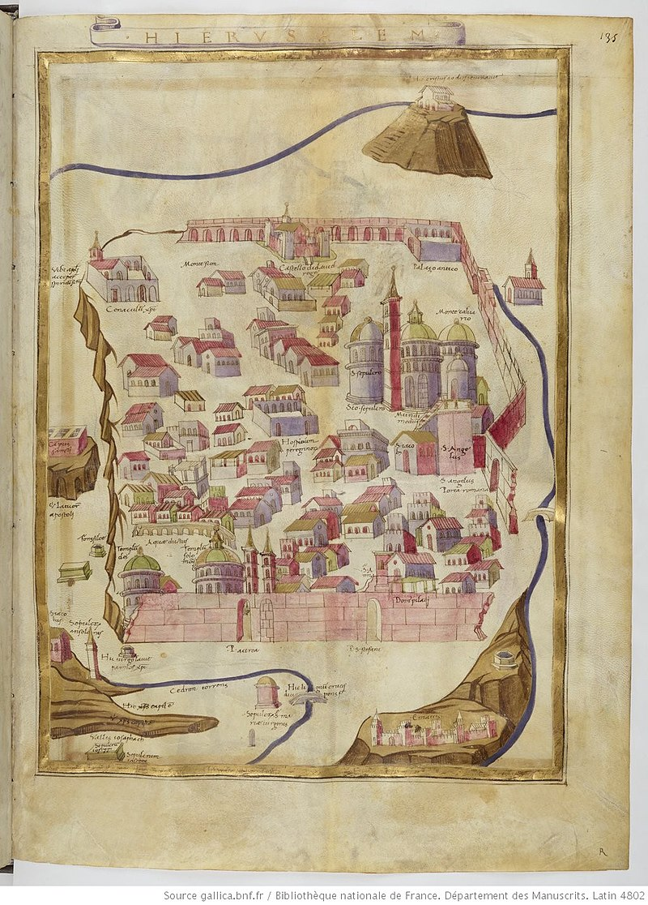
2) Resurrection faith is often ______________________________________________________________
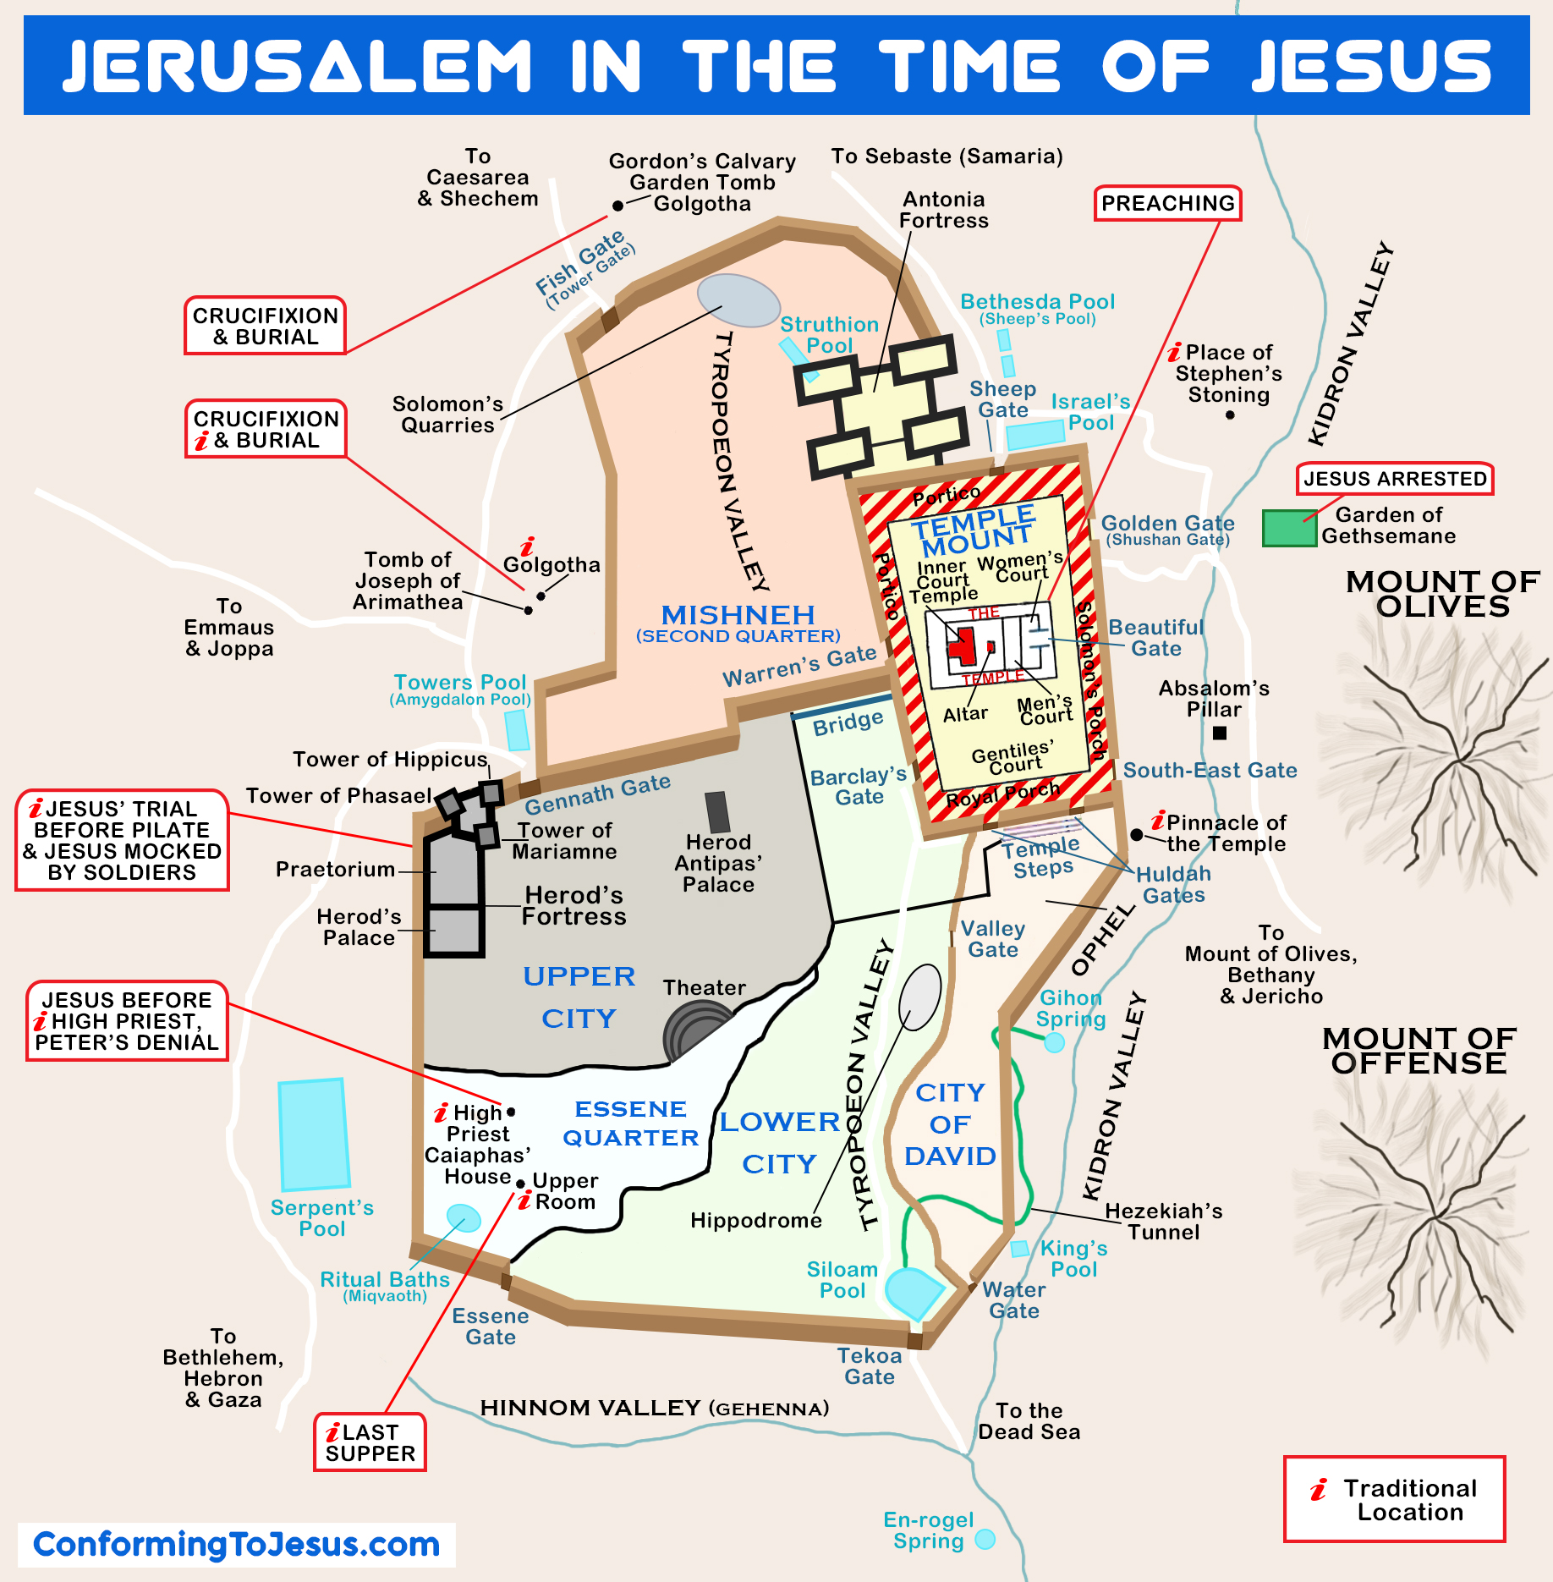
Proof by fish
He said to them, “Why are you troubled, and why do doubts rise in your minds? Look . . . .”
When he had said this, he showed them his hands and feet. And while they still did not believe it because of joy and amazement, he asked them, “Do you have anything here to eat?” They gave him a piece of broiled fish . . . .
Luke 24:38-43

1) When something is too good to be true, ask _______________________________________________

2) A sacrament of fish because ___________________________________________________________

3) Wounds and appetite teach that resurrection is _____________________________________________

He opened their minds
He said to them, “This is what I told you while I was still with you:
Everything must be fulfilled that is written about me in the Law of Moses, the Prophets and the Psalms.”
Then he opened their minds so they could understand the Scriptures.
Luke 24:44-45 (see Romans 12:1-2)

- ______________ am the “______________________________”

2) God is the ______________________________ , but I have to ________________________________

Beginning in Jerusalem (or, the Great Commission, Luke style)
He told them, “This is what is written: The Christ will suffer and rise from the dead on the third day,
and repentance and forgiveness of sins will be preached in his name to all nations, beginning in Jerusalem.
You are witnesses of these things. I am going to send you what the Father has promised;
but stay in the city until you have been clothed with power from on high.”
Luke 24:46-49

- The “bud” of the gospel flower: _______________________________________________________

2) No sending (= “apostolic”) ministry without ______________________________________________

3) Beginning in Jerusalem because _________________________________________________________
Resources on Luke 24:36-49
Spurgeon’s sermon on Luke 24:36-49 at https://www.spurgeon.org/resource-library/sermons/joy-hindering-faith#flipbook/ and https://www.spurgeon.org/resource-library/sermons/folly-of-unbelief#flipbook/ and most importantly, “Beginning in Jerusalem” at https://archive.spurgeon.org/sermons/1729.php
Allistair Begg’s sermons on Luke 24 at https://www.truthforlife.org/bible/Luke%2024:13-35/
Bunyan’s “The Jerusalem Sinner Saved” at https://www.gutenberg.org/files/3270/3270-h/3270-h.htm
Deffinbaugh’s sermon on the resurrection at https://bible.org/seriespage/invisibility-invincibility-luke-2436-53
Horatio Bonar’s thoughts on resurrection as a part of his commentary on Revelation at https://awakeninggracedotorg.wordpress.com/2011/12/19/horatius-bonar-three-reasons-to-fear-not-from-the-risen-jesus/
I like J. C. Ryle’s short commentary on the Luke 24 at https://www.gracegems.org/Ryle/l24.htm
BAR’s article on the Upper Room at https://www.biblicalarchaeology.org/daily/biblical-topics/post-biblical-period/hunting-for-the-upper-room-in-jerusalem/

